المملكـة العـربية السعـودية  وزارة التعليم  الإدارة العامة للتعليم .................  ابتدائية .................... |  |  | السؤال | الدرجة |  | اسم المصحح وتوقيعه | اسم المراجع وتوقيعه
 |  |  | السؤال | رقما | كتابة | اسم المصحح وتوقيعه | اسم المراجع وتوقيعه
 |  | الاختبار النهائي للفصل الدراسي الثالث  ( الدور الأول )  للعام الدراسي  1446 هـ | الأول
 |  |  | الثاني
التاريخ | / / 1446 هـ |  | الثالث
المادة | اللغة الانجليزية |  | الرابع
الزمن | ساعة ونصف |  | الخامس
الصف | السادس |  | السادس
 |  |  | المجموع
اسم الطالب : ........................................................................................... |  |  |  | رقم الجلوس : ............................

- General Questions:
/ 6
- Choose the correct answer:
- What’s the matter? |  | I love rabbits
- What’s your favorite animal? |  | It is very hot.
- What’s your favorite season? |  | I work at the zoo.
- Do you need a doctor? |  | I had a stomachache.
- Where do you work? |  | Yes, I do.
- What is the weather like today? |  | I like winter.

- Controlled Writing:
/ 5
cage – x-ray – cold – kangaroo
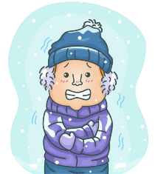  He is in the ……………. climate. | 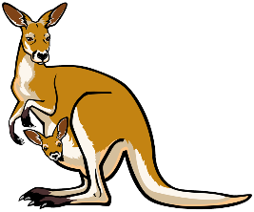  This animal jumps and has big legs.  ……………… | 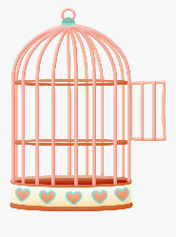  In zoos, some birds often live in this.  ………………. | 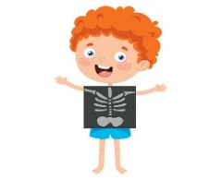  Fahad is having an ………………
- Fill in the missing words:

- Rearrange the words to form a sentence:
1 - should – the medicine – take – Omar
………………………………….…………………………………..
- Reading Short Sentence:
/ 4
- Read the sentences then choose the correct sentence for each picture:
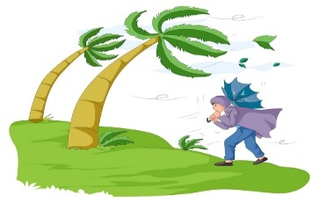 |  |  | 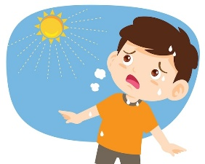
a-_It’s going to be windy.  b-It’s going to be cloudy. | a-_He has an earache.  b-_He has a cough. | a-_He is a vet.  b-_He is a zookeeper. | a-_It is summer.  b-_It is winter.

- Grammar:
/ 5
- Choose the correct answer:
1 – They are going to (go – went – going) swimming next week.
2 – The cheetah is the (fast – faster – fastest) animal in the world.
3 – You ( must - mustn’t) shout in the hospital.
4 – What (am – is – was) the weather like yesterday?
5 – Cat is ( cute – cutest – cuter ) than monkey.
- Vocabulary:
/ 6
- Choose the correct answer:
polar bear – band aid – owl – umbrella – temperature – medicine

 |  |  |  | 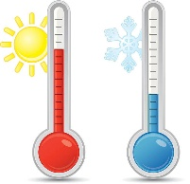 | 

- Orthography:
/ 4
- Choose the correct missing letters:
  s _ ow |  |   c _ y |  |   rain__ow |  |   pan _ a
m | n | r | a | j | b | n | d


Kingdom of Saudi Arabia 4th, 5th & 6th Elementary Grade
Ministry of Education Time: An hour and a half
3rd Elementary School Number of papers: 3 . Final Exam – Third Term – 1446 AH
- General Questions:
/ 6
- Choose the correct answer:
- What should you do if you have a toothache?
- Visit the dentist | - It’s moving slowly | - I work at the zoo
- Where do you work?
- Visit the dentist | - It’s moving slowly | - I work at the zoo
- How is the tortoise moving?
- Visit the dentist | - It’s moving slowly | - I work at the zoo
- What is the weather like today?
- It is windy. | - I like winter. | - Yes, it was.
- Was it sunny on Sunday?
- It is windy. | - I like winter. | - Yes, it was.
- What’s your favorite season?
- It is windy. | - I like winter. | - Yes, it was.

- Controlled writing:
/ 5
- Rearrange the words to form a sentence:
animals – are – quiet – Cats
……………………………………………………………………………..
- Fill in the missing words:
cage – hot – wet – stomach

  He is in the ……………. climate. | In zoos, some birds often live in this. (………………. ) | 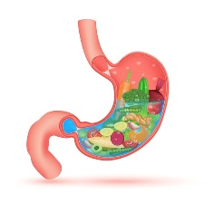  The part of your body where food goes. (……………….) | He is in the ……………. climate.
- Reading Short Sentences:
/ 4
- Match the sentences with the correct pictures:
- I like rabbits. 3- He is ill.
- He is a vet. 4- I’m going to go skiing.
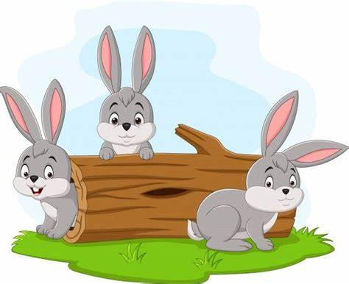
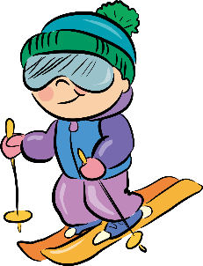
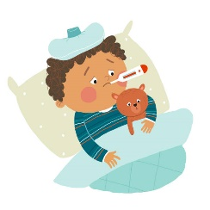

( ) ( ) ( ) ( )
/ 5
- Grammar:
- Choose the correct answer:
- You …………… shout in the hospital.
- must | - mustn’t | - have to
- I think there is …………… at the door.
- someone | - everywhere | - anything
- The girl …………… wears pink is my sister.
- who | - when | - whose
- The cheetah is the …………… animal in the world.
- fast | - faster | - fastest
- They are going to …………… swimming next week.
- go | - went | - going

- Vocabulary:
/ 6
- Write the word under the pictures:
cough – giraffe – flashlight – medicine – owl – melting
 |  | 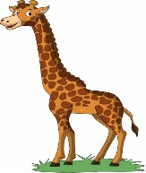 |  | 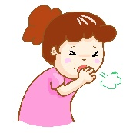

- Orthography:
/ 4
- Choose the correct missing letters:
rain__ow |  | 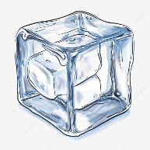  i__e |  | s__ow |  | 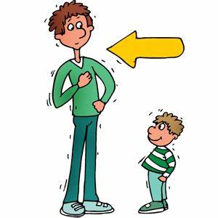  t__ll
b | d | s | c | n | m | o | a
  as__eep |  |   bra__e |  | 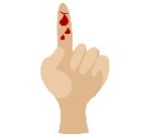  c__t |  | c__y
l | i | f | v | k | u | r | i

BEST OF LUCK
Ms. Tahani Al-Ghamdi



اختبار نهاية الفصل الثالث( الدور الأول)
للعام الدراسي 1446هـ
المادة /اللغة الانجليزية
الصف :رابع، خامس،سادس (.......)
زمن الإجابة / ساعة ونصف
التاريخ : 12/7/1443 هـ

المملكة العربية السعودية
وزارة التعليم
الإدارة العامة للتعليم بالمنطقة ....
مكتب التعليم ب....
مدرسة ....................

30

الدرجة كتابة :

اسم الطالب ……………………………………………………………………….……………………………………………رقم الجلوس …………………………
Answer the questions:




- What’s the matter? I have a …………………………
- What’s your favorite animal? My favorite animal is ……………………..

- What color is your favorite animal? It’s ………………………….

4-What is the weather like? It’s ………………………….
5-What’s your favorite season? My favorite season is ……………………..

Reorder the words:
- sit down. / have to / You
………………………………………………………………………………………………………………………………....
- shouldn’t / I / eat fast food.
………………………………………………………………………………………………………………………………….
- more dangrous than / rabbits. / Lions are
…………………………………………………………………………………………………………………………………..
- going to / sleep. / She is
………………………………………………………………………………………………………………………………….
- Summer / cold. / isn’t
…………………………………………………………………………………………………………………………………..

Match:
1- I have a stomachache You should get an X-ray.
2- My leg hurts. Stop eating fast food.
3- What does your favorite animal eat? at the zoo.
- Dr. Sullivan works… My favorite animal eats meat.
- Is the weather cloudy? No, It’s sunny.

أقلب الورقة
Choose the correct words:
- I can't see ( anything - somebody )
- Cats are (cuter – more cute ) than monkeys.
- Parrot is the ( intelligentest - most intelligent ) bird.
- I am ( go - going ) to swim tomorrow.
- It ( is - was ) windy yesterday.

Circle the correct word:
  band aid  slow | 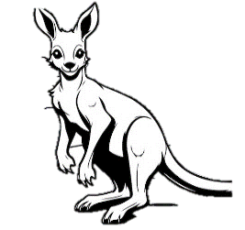  headache  Kangaroo | 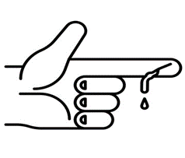  cut  cool |   winter  sun | 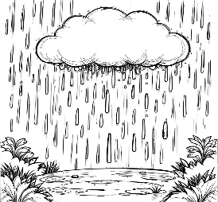  back  rain

Circle the missing letter:
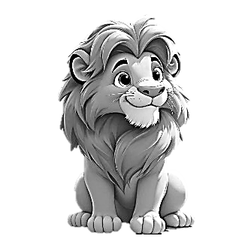  li_n  s  o | 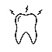  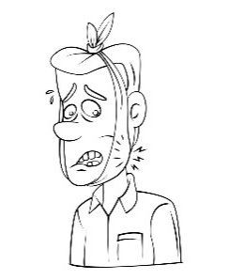  toot_ache  g  h |   ho_  t  k | 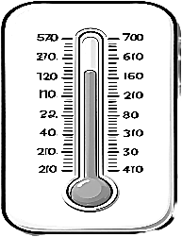  te_ perature  m  z | 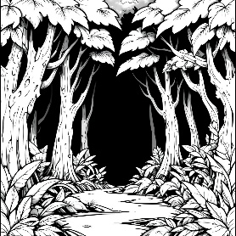  jun_le  g  w

انتهت الأسئلة

