|  |  |  |  |  |  |  |  |  |  |
| --- | --- | --- | --- | --- | --- | --- | --- | --- | --- |
| **المملكة العربية السعودية** | |  | | | | **المادة:** | | **اللغة الانجليزية (شفوي)** | |
| **وزارة التعليم** | | **الصف** | | **رابع + خامس+ سادس** | |
| **الادارة العامة للتعليم ب______** | | **المقرر:** | | **Top Goal 1.3** | |
| **مدرسة___________الابتدائية** | | **الزمن:** | | **20 دقيقة** | |
| **الاستماع 5** |  | **التحدث 5** |  | **المجموع 10** |  | | | | |
| **الاسم ثلاثي** |  | | | **الفصل** | **/** | | **رقم الكشف** | |  |

**Listen and circle the right answer:**

|  |  |  |
| --- | --- | --- |
| 1. Sarah has a bad ____________. | |  |
| 🔿 | earache. |
| 🔿 | toothache. |
| 🔿 | stomachache. |

|  |  |  |
| --- | --- | --- |
| 1. You_________ play with cables. | |  |
| 🔿 | must |
| 🔿 | mustn’t |
| 🔿 | shouldn’t |

|  |  |  |
| --- | --- | --- |
| 1. That’s a _______ polar bear. | |  |
| 🔿 | big |
| 🔿 | white |
| 🔿 | danger |

|  |  |  |
| --- | --- | --- |
| 1. The weather is very______ today. | |  |
| 🔿 | hot. |
| 🔿 | cool |
| 🔿 | cold |

|  |  |  |
| --- | --- | --- |
| 1. All Sorts are going to an ________ | |  |
| 🔿 | zoo |
| 🔿 | island |
| 🔿 | animal shelter |

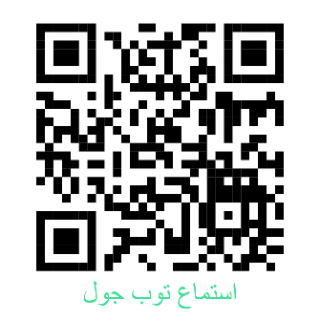

[](https://salla.sa/khaled-alrajeh)[](https://forms.office.com/Pages/ShareFormPage.aspx?id=b4OQU5QpqkK9sELnf3f9C84PUFGeBGBFuY4-jPdGsvZUQTNZV1QxOFBJVDMzQzFZSlVaOVZHUUk5UyQlQCNjPTEu&sharetoken=diHsH9RHH5urWPOxSbvM)[](https://youtu.be/-YttYwyM8Z8)

|  |  |  |  |  |  |  |  |  |  |
| --- | --- | --- | --- | --- | --- | --- | --- | --- | --- |
| **المملكة العربية السعودية** | |  | | | | **المادة:** | | **اللغة الانجليزية (شفوي)** | |
| **وزارة التعليم** | | **الصف** | | **رابع + خامس+ سادس** | |
| **الادارة العامة للتعليم ب______** | | **المقرر:** | | **Top Goal 1.3** | |
| **مدرسة___________الابتدائية** | | **الزمن:** | | **20 دقيقة** | |
| **الاستماع 5** |  | **التحدث 5** |  | **المجموع 10** |  | | | | |
| **الاسم ثلاثي** |  | | | **الفصل** | **/** | | **رقم الكشف** | |  |

**Listen and circle the right answer:**

|  |
| --- |
| 1. Are you hungry? I have some salad – snacks – sandwiches . |

|  |
| --- |
| 1. Jake is upstairs. His arm – leg – hand is hurt. |

.

|  |
| --- |
| 1. Tigers live in the zoo – forest – jungle . |

|  |
| --- |
| 1. Kai has a bad cut – fall – cough . |

|  |
| --- |
| 1. You must - should – have to close your front door… |

|  |
| --- |
| 1. Rabbits live in one - big – small groups . |

|  |
| --- |
| 1. Benny is a friendly cat – parrot – elephant . |

|  |
| --- |
| 1. The weather on Sunday is hot and warm – windy – sunny . |



** Write or :**

|  |
| --- |
| 1. The boy doesn’t like winter. ( )   10. Her favourite animal is tiger. ( ) |

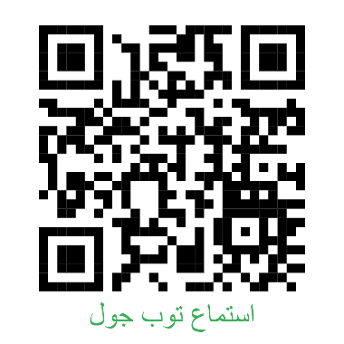

[](https://forms.office.com/Pages/ShareFormPage.aspx?id=b4OQU5QpqkK9sELnf3f9C84PUFGeBGBFuY4-jPdGsvZUQlU3VDZZUE42VUo1VU5QNzVTMUpEWlBCTiQlQCNjPTEu&sharetoken=diHsH9RHH5urWPOxSbvM)

[](https://youtu.be/Mv46ejwaHBk)

[](https://salla.sa/khaled-alrajeh)

**المملكة العربية السعودية**

**وزارة التعليم**

**الإدارة العامة للتعليم بالمنطقة الشرقية**

**مدرسة.....**

اختبار الفصل الثالث (إستماع )

للعام الدراسي 1446 هـ

المادة / اللغة الإنجليزية

الصف : رابع، خامس، سادس (.........)

|  |
| --- |
|  |
| **5** |

**اسم الطالب …………………………………………………………….....……………………الفصل(....... )**

**Choose the correct answer:**

**1-What’s the matter?**

*a headache. b stomachache. c earache***.**

**2-What’s your favorite animal?**

*a cat. b lion. c tiger.*

**3- What does your favorite animal eat?**

*a meat. b grass. c candy.*

**4- What weather do you like?**

*a sunny. b cloudy. c windy.*

**5-What’s the weather going to be like this afternoon?**

*a rainy. b snowy. c hot.*

**انتهت الأسئلة**

|  |  |  |  |
| --- | --- | --- | --- |
| **المملكة العربية السعودية** |  | **المادة:** | **اللغة الانجليزية (استماع)** |
| **وزارة التعليم** | **الصف** |  |
| **الادارة العامة للتعليم بـــ** | **التاريخ:** | **/ /1446 هـــ** |
| **مدرسة الابتدائية** | **الزمن:** | **نصـف ساعة** |
| **اختبار نهاية الفصل الدراسي الثالث – الدور الأول للعام الدراسي 1446 هـ**  5  **اسم الطالب ___________________________________ الصف_______** | | | |

Listen, then choose the word you hear :

1. cough **b**. back **c**. toothache
2. It's asleep **b**. It's fast **c**. It's slow

**a**. vet **b**. cage **c**. rabbit

1. brave **b**. tall **c**. smart
2. cloudy **b**. sunny **c**. rain

