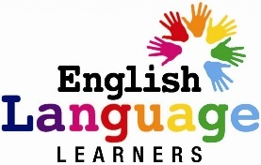
المملكة العربية السعودية
وزارة التعليم
إدارة التعليم بــ ..............................
مكتب التعليم بــ ............................
مدرسة .......................................
للفصل الدراسي _________
للعام الدراسي - هـ
قائد/ة المدرسة :
..........................
دفتر تحضير اللغة الانجليزية
معلمـ/ة المادة :
...............................
English Preparation Book

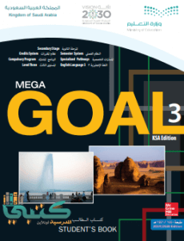
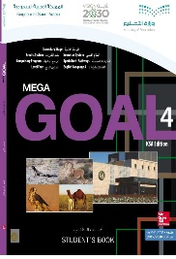
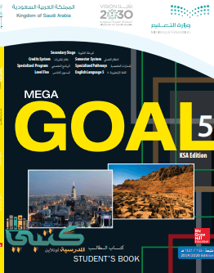
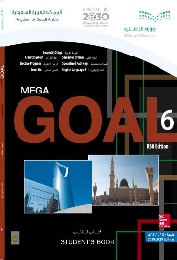
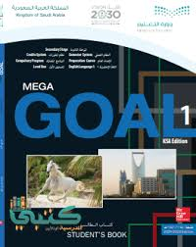
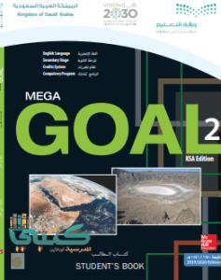

Education and 2030 Vision :
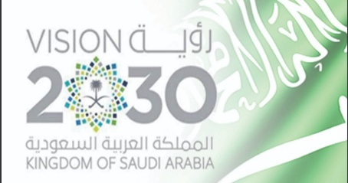

Ways of educational development :

- Developing philosophy, policy and goals of curricula, means of development, mechanism activation and connecting all these means with the programs of teacher preparation and his professional development .
- Developing such teaching methods, that focus on learner not on teacher, and concentrate on inculcating skills, personality development, improving confidence, and promoting spirit of creativeness.
- Developing attractive, preferred, and simulant school environment, connecting it with supportive and integrated services systems.
- Comprehensive education for persons with disabilities, and providing appropriate support to all its categories.
- Providing pre-primary education opportunities and expanding it, providing kindergartens, and activating its link with education system.

Ways of administrative development :

- Redefine school as an educational institution, that hones talent, inculcates skills, and nurtures generation of ambitious future adults who have the spirit of facing challenges, competitiveness, and loves work, and production.
- Assuring discipline in the educational system, seriousness in educational practice, starting activities and attending conferences and events.
- Restructuring education sector, modernization of systems, instructions, and bylaws to control curricula development, staffing teachers in educational services, organizing the process of educational supervision, and continuously raise the competence of development and vocational training.
- Raising efficiency of operational performance, reducing the waste cost, maximizing use of human potential, resources, equipment, and buildings.

Changing trends :

- Improving and developing the administrative environment in the Ministry and its Education departments, approving decentralization of the administration, delegating powers to departments and schools to serve the education system.
- Developing rules and procedures to ensure work seriousness, and discipline in education system, promote justice, and reward excellent performance.
- Raising the efficiency of performance, employing modern support technologies in education system.

The General goals of the Saudi Vision 2030 in Education :

- Provide education opportunities for all the students in a suitable educational environment in light of the educational policy of the Kingdom .
- Raising the quality of education outputs .
- Increase the effectiveness of scientific research .
- Encourage creativity and innovation .
- Develop community partnership .
- Upgrade the abilities and skills of all the Ministry of Education staff .
- Bridging the gap between higher education outputs and labor market requirements .
- Develop general education and guide students towards appropriate career options .
- Provide the students with all the opportunities to rehabilitate the flexibility to move between different educational tracks .

Teacher : …………………………………………………..
School Leader : ………………………………………
Supervisor : ……………………………………………..

Objectives of Teaching English in the Kingdom:

- To enable pupils to survive in the real world using English.
- To give them a foundation for secondary English course.
- To teach them about 1500 of the most useful English words.
- To give them a clear understanding of the basic tenses for the past, present and future.
- To teach them the basic grammatical structures of English.
- To enable them to understand what they hear on a variety of topics.
- To enable them to speak (ask and answer questions, give descriptions, etc.) on the same variety of topics.
- To prepare them to read simple text by themselves without depending on the teacher for explanations or translation.
- To enable them to write a simple guided paragraph of linked sentences.

Objectives of Teaching English in the Secondary Stage:

- Use English structures and analyze them to understand the relationships among them .
- Learn the assigned vocabulary , idioms , and expressions and understand their meanings .
- Acquire the ability to listen to comprehend English and to distinguish between different intonations .
- Participate in conversations and discussions using proper English .
- Acquire the ability to read and comprehend English contexts through different reading types ( i.e. loud reading ) and reading strategies ( i.e. scanning ) .
- Write a free-essay using correct English .
- Translate English words , and phrases into Arabic and vise versa .
- Realize the importance of the English language in the local job market .
- Be aware of the importance of English as an international language of communication for introducing Islam ,our culture ,and our national achievements to others .

Timetable

Tr. Name:
Class:

 | 1 | 2 | 3 | 4 | 5 | 6 | 7
Sun
Mon
Tue
Wed
Thurs

Headmaster
Name : ………………………………
Signature : …………………………

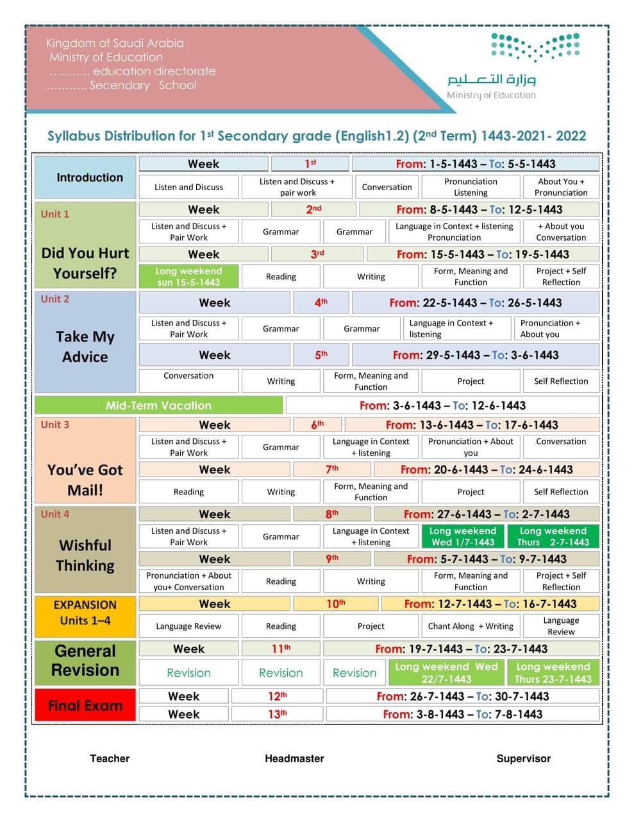

Lessons Distribution
Listen and Discuss + Pair Work

Grammar

Language in Context + listening + Pronunciation + Conversation

Reading

Writing

Form , Meaning and Function

Project

Kingdom of Saudi Arabia
Ministry of Education
English preparation QR Code
Mega Goal 1
Unit 1 : Did You Hurt Yourself ?
Date | lesson | Content | Objectives | Strategies
 | 1 |  | Correct a sentence about home safety.  .Match car accident cause with its description  Find out ways to prevent accidents from happening  Combine the reason with the injury.  Formulate a survey about type of injury.  Tell a story about someone who hurt his self.  Name some injuries. | Brainstorming  Active Learning  Role-play  Concept Mapping  Critical Thinking  Creative Thinking  Inquiry Strategy  Science Processes  Formative Assessment  Think , pair , share  Cooperative learning  Mastery  Flipped classroom  Problem solving  Explicit instructions
 | 2 |  | Decide when to use "so" and " because " .  Build correct responses using ( so / neither ).  Use reflexive pronouns to emphasize an information
 | 3 |  | Describe an accident according to a picture.  Recognize words that end with if ,it ,in, st or nd.  Compose a sentence to describe an injury.  Recognize some household dangers for children.  Make up a short conversation including the real talk phrases.  Rephrase the audio text in their own words.
 | 4 |  | Find out the meaning of new words .  Determine the happy ending and the unhappy one.  Complete sentences about the text.  Compile an article contains stories of accidents .  Translate new words by reading the whole sentence
 | 5 |  | Write information about accident.  Analyze an accident article to its main points .
 | 6 |  | Use "must-should" to form advices and rules.  Describe a position correctly.  Apply using imperatives for directions.  Express how a design is being done from a video  Motive a classmate to volunteer for charity work.  Write a rule for organizing the classroom.  Express attitude using adverbs of manner.
 | 7 |  | Organize a campaign about accidents in Saudi Arabia.

Kingdom of Saudi Arabia
Ministry of Education
English preparation QR Code
Mega Goal 1
Unit 2 : Take My Advice
Date | lesson | Content | Objectives | Strategies
 | 1 |  | Recognize expressions of advice.  Ask about a websites facts.  Form an advice.  List type of advice they get from a website.  Name a helping website .  List some of their generation problems | Brainstorming  Active Learning  Role-play  Concept Mapping  Critical Thinking  Creative Thinking  Inquiry Strategy  Science Processes  Formative Assessment  Think , pair , share  Cooperative learning  Mastery  Flipped classroom  Problem solving  Explicit instructions
 | 2 |  | Form correct three word verbs.  Form correct two word verbs.  Use should, ought to, might, and could to give advice  Build a correct three/two words verb .  Rephrase an advice to become firmer.  Find out which sentence is suitable with : ought to
 | 3 |  | Recognize the stress in a verb.  Write an advise based on an information.  Make a conversation using the "real talk".  Rephrase the conversation with a partner .  Summarize the problems and the advices in audio text
 | 4 |  | Find sign fast food addiction.  Find the symptoms associated with comfort food .  Correct information from the text.  Find missing words through out reading the text.  List junk food attractive ingredients.  List factors that lead to addiction to junk food.  Organize the check list according to the text.
 | 5 |  | Write notes about a letter.  Find advice and solution in a text.  Find the problem in a text.  Ask friends about their problems .
 | 6 |  | Express quantity in a sentence.  Connect clauses with "when".  Connect words with Medicine.  Formulate a question asking about the quantity.
 | 7 |  | Create a poster or power point show for a Saudi organization they select

Kingdom of Saudi Arabia
Ministry of Education
English preparation QR Code
Mega Goal 1
Unit 3 : You've Got Mail
Date | lesson | Content | Objectives | Strategies
 | 1 |  | Decide the purpose of each email form  Find whether the sentence is true or false  Write Islamic sentences to start a letter.  Use Islamic sentences to end a letter.  Find ways to start or end letters or emails.  Use apologies forms correctly. | Brainstorming  Active Learning  Role-play  Concept Mapping  Critical Thinking  Creative Thinking  Inquiry Strategy  Science Processes  Formative Assessment  Think , pair , share  Cooperative learning  Mastery  Flipped classroom  Problem solving  Explicit instructions
 | 2 |  | Build a correct sentence with (although and even though).  Select the correct preposition for the adjective.  Select the correct preposition for the verb.  Write the correct word form after (in spite of).  Use the correct verb tense with (as soon as, when).  Form a sentence with (so).
 | 3 |  | Express a habit using " used to "  Recognize the short vowels.  Use new expressions in "real talk"  Complete sentences according to the audio.  Ask and answer questions about conversation details.  Construct correct conversation.
 | 4 |  | Find the meaning of new words in the text.  .Recognize sentences about means of communication  Illustrate how drummer simulate speech.  Explain the reason Tomlinson want to develop email.  Demonstrate the meaning of @.
 | 5 |  | Analyze email format and details.  Find information about an email.  Write a correct email.  List correct greetings for an email.  Write a correct sign for an email.  Use formal and informal style to address a letter.
 | 6 |  | Express past states, habits, and situations with (used to).  Model a sentence with "would".  Use "there is/there are “correctly.  Form correct plural (regular nouns).  Form correct plural (irregular nouns).  Use "the" correctly.
/ / 1442 AH | 7 |  | Design a greeting card

Kingdom of Saudi Arabia
Ministry of Education
English preparation QR Code
Mega Goal 1
Unit 4 : Wishful Thinking
Date | lesson | Content | Objectives | Strategies
 | 1 |  | Understand person's wish.  Use new expressions.  Recognize the correct/false sentences.  Answer the questions about the article.  Use wishes to form questions.  Ask and answer questions about wishes. | Brainstorming  Active Learning  Role-play  Concept Mapping  Critical Thinking  Creative Thinking  Inquiry Strategy  Science Processes  Formative Assessment  Think , pair , share  Cooperative learning  Mastery  Flipped classroom  Problem solving  Explicit instructions
 | 2 |  | Express possibility with (might)  Use conditional sentence (if-clause ) to express imaginary situations.  Use (could) in if-clause.  Use the verb (wish) with the present tense.  Use the verb (wish) with the future tense.
 | 3 |  | Find out wishes on an audio.  Compare wishes with a classmate.  Practice the pronunciation of (could-would).  Ask about hypothetical situations.  Use the "real talk" in short conversation.  Answer the questions about the conversation.
 | 4 |  | Find problems of winning money in the reading text.  Find money expressions in the reading text.  Make notes about ideas in the text.  Find the meaning of new words in the text.  Find the main idea of a paragraph.
 | 5 |  | Complete the dialogue  Write a description of a day in your life as a game show winner.  Analyze a text to its main events.  Write the positive/negative aspects of a celebrity lifestyle.
 | 6 |  | Identify count nouns and noncount nouns.  Express quantity correctly.  Use words connected with money, shopping habits and prices  Practice using shopping terms.  Write a conversation about shopping situation.  Differentiated between count/non count nouns.
 | 7 |  | Design a PowerPoint presentation about a show game.

