Q1. General questions:
1- Hello,
a-Hi. B- Thank you.
2- What is your name?
a- I am 10 years old. B- My name is Ali.
3 - How are you?
a- I am fine, thank you. B- Thank you.
How old are you? 4-
a- Bye. B- I am 25 years old.
5- Where are you from?
a- I am from Saudi Arabia. B- He is six years old.
Nice to meet you. 6-
a- Nice to meet you, too. B- your welcome.

Q2. Controlled writing: Complete:
Sunday- ………….. Tuesday. (Monday - Wednesday
First- ……………… - third. (Second - fifth)
I have a sister, ……………name is Layla. (her - his)

1- What time is it?
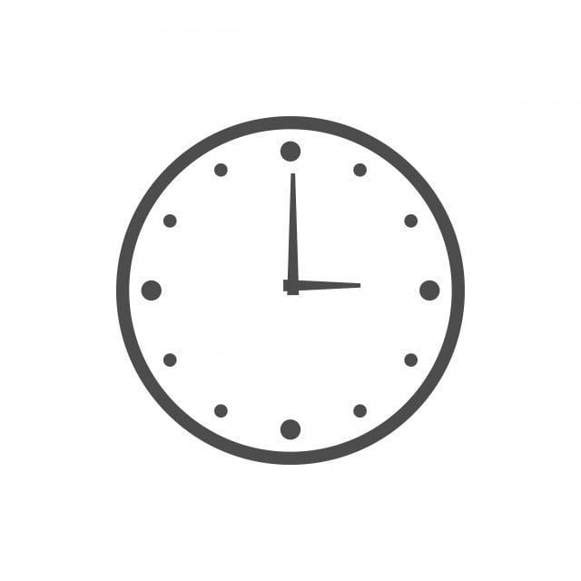
a. It is 3 o'clock. b- It is 5 O'clock.
2- He wakes up early…………………..
a - in the morning. b- in the afternoon.
3- Re- arrange (it \ rainy \ is )
a – It rainy is b- It is rainy

Q3. Reading sentences:
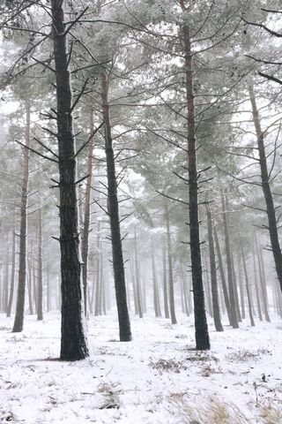
Put ( √ ) or ( x )
a. It is snowy. ( )
b. It is windy. ( )

c. it is sunny. ( )
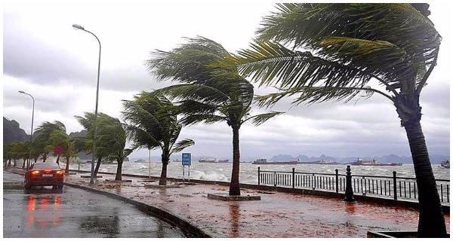

d. It is cloudy. ( )

Q4. Grammar:
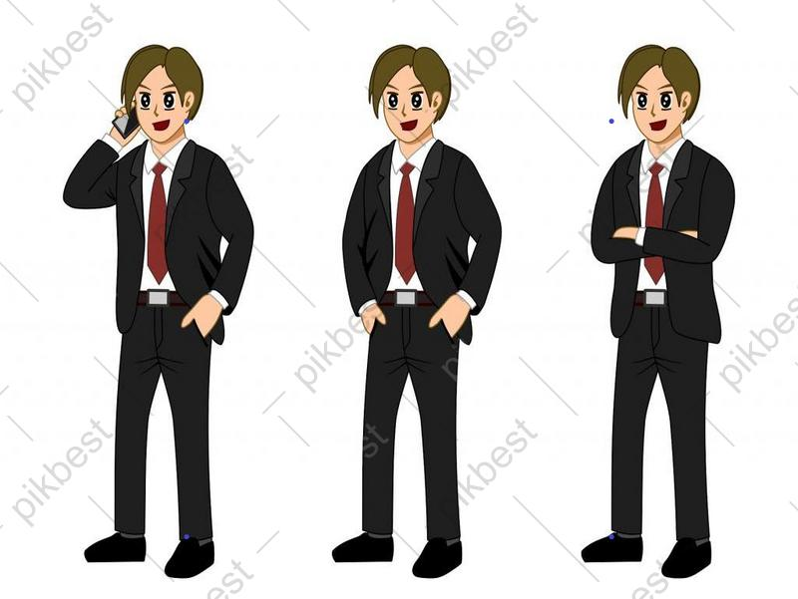
1 – They are ( men - man) .

2- It is ( tooth - teeth) .
3- She is ( a woman – women ).
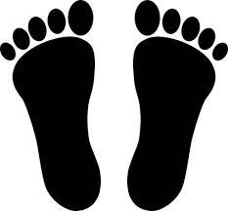
4- Look at my ( foot - feet).

Q5. Vocabulary:

1- 11 o`clock 2- Rainy 3- first 4- good morning 5- Early 6- Eid Al Adha
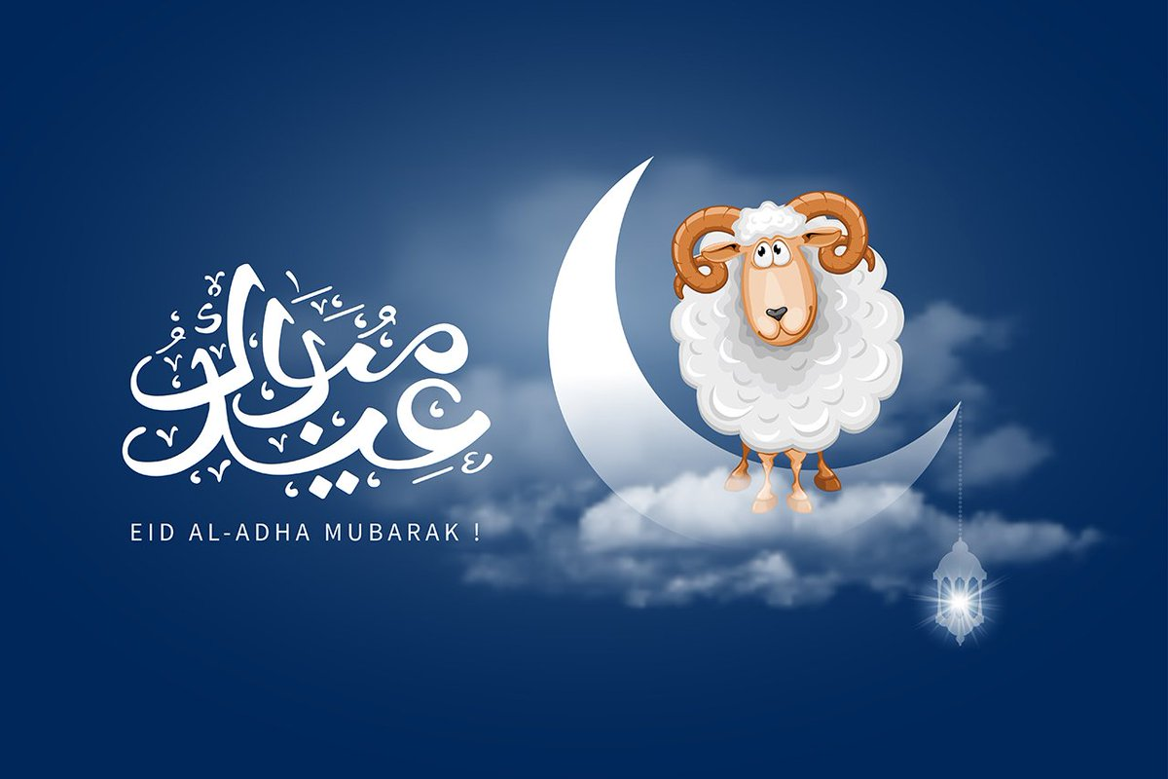
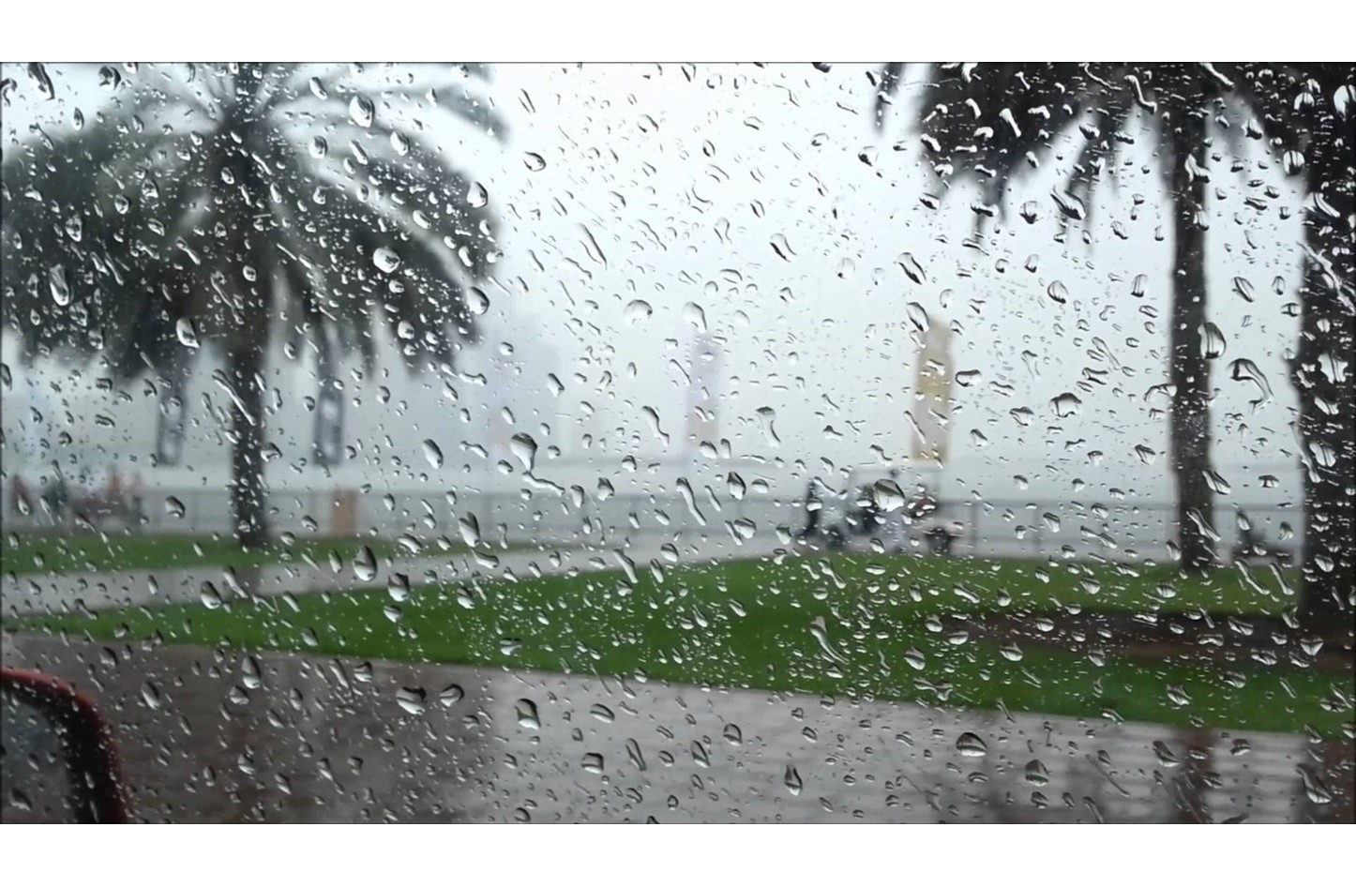
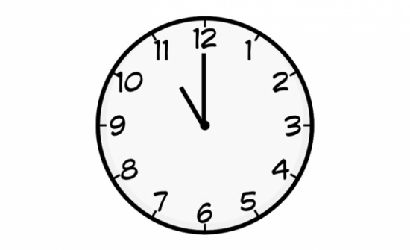

( ) ( ) ( ) ( ) ( ) ( )

Q6. Orthography: Write the missing letter:

( L - M - H - F )
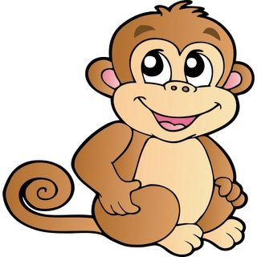

__ion __at ___onkey ___ish

انتهت الأسئلة Best wishes

