أوراق عمل

رياضيات أول متوسط

الفصل الدراسي الثالث

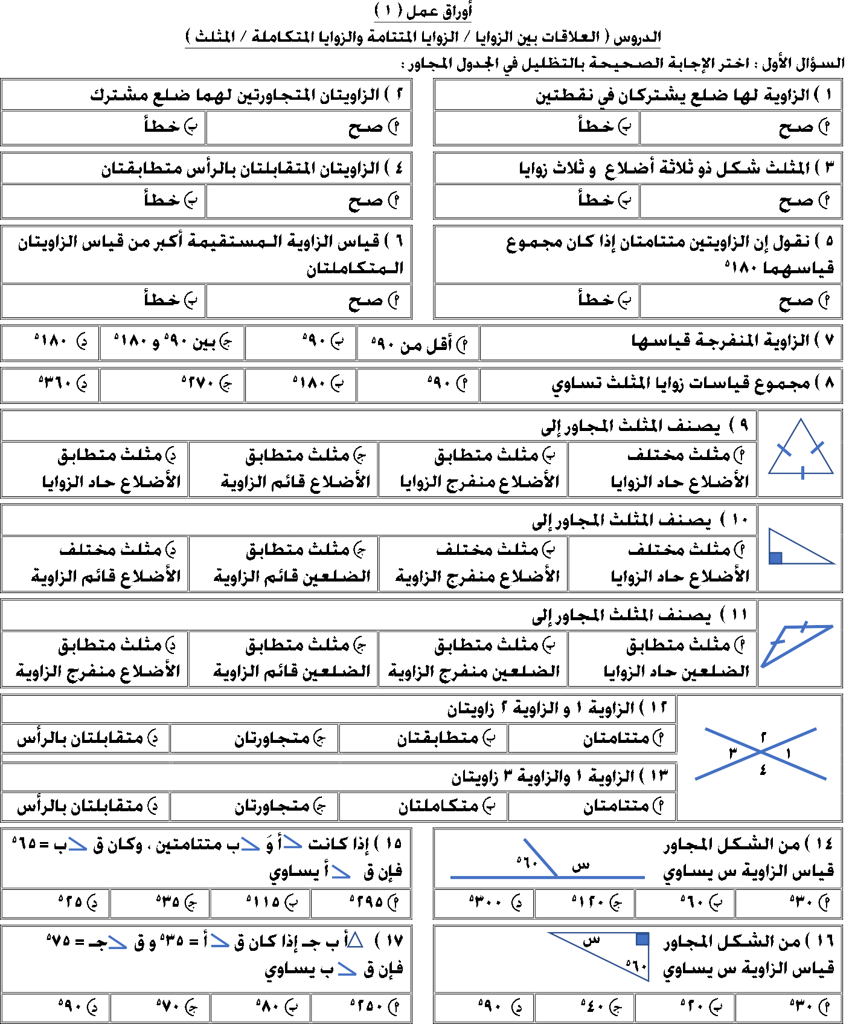

رياضيات أول متوسط الفصل



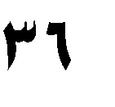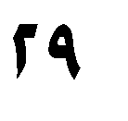

متوسطة املروج





|  |  |  |  |  |
| --- | --- | --- | --- | --- |
|  | | | | |
|  | |  |  | |
|  |  |  |  |
|  |  |  |  |



|  |  |  |  |
| --- | --- | --- | --- |
|  | | | |
|  |  |  |  |
|  |  |  |  |
|  |  |  |
|  |  |  |
|  |  |  |
|  |  |  |





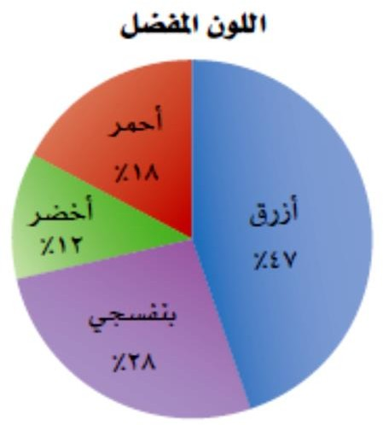





|  |  |  |  |  |
| --- | --- | --- | --- | --- |
|  | | | | |
|  | |  | ، ، ، | |
|  |  | ، ، | ، ، |
|  |  | ، ، | ، ، |

|  |  |  |  |  |
| --- | --- | --- | --- | --- |
|  | |  |  | |
|  |  |  |  |
|  |  |  |  |



|  |  |
| --- | --- |
|  |  |
|  |  |
|  |  |
|  |  |
|  |  |
|  |  |

|  |  |  |  |  |
| --- | --- | --- | --- | --- |
|  |  |  |  |  |
|  |  |  |  |  |



|  |  |  |  |  |
| --- | --- | --- | --- | --- |
|  |  |  | | |
|  |  |  | | |
|  |  |  |  | **س ص ب**  **ع د جـ** |
|  |  |  |  |



|  |  |  |  |
| --- | --- | --- | --- |
|  | | | |
|  | |  | |
|  | | | |
|  | |  | |
|  | | | |
|  |  |  |  |

|  |  |  |  |
| --- | --- | --- | --- |
|  | | | |
|  | |  | |
|  | | | |
|  | |  | |
|  | | | |
|  |  |  |  |

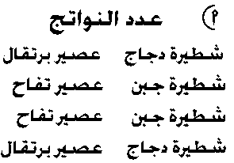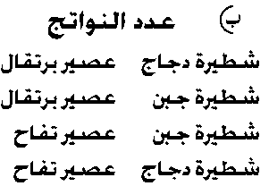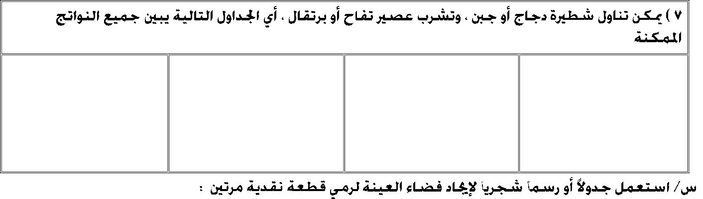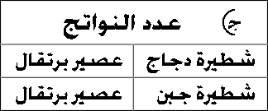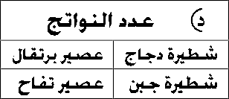

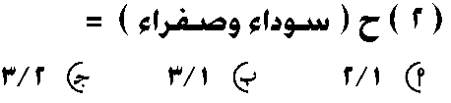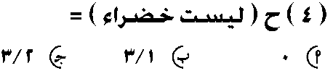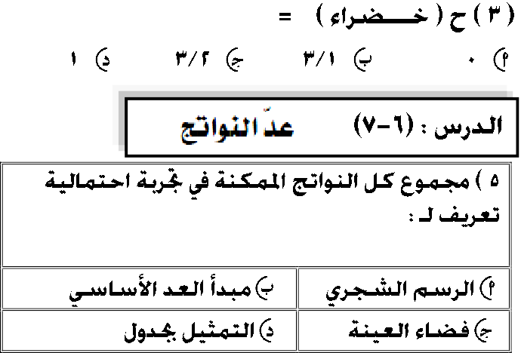**ُوضع في كيس 6 كرات زرقاء** ، **و 7 كرات سوداء** ، **و 5 كرات صفراء ، ثم سحبت كرة من الكيس عشوائيا . أوجد الاحتمالات التالية :**

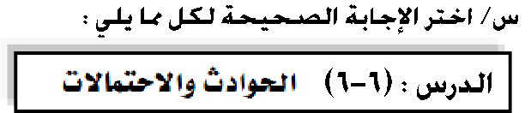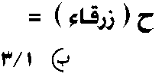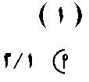

|  |  |  |  |
| --- | --- | --- | --- |
|  | | | |
|  |  |  |  |
|  | | | |
|  |  |  |  |

|  |  |  |  |
| --- | --- | --- | --- |
|  | | | |
|  |  |  |  |
|  | | | |
|  |  |  |  |

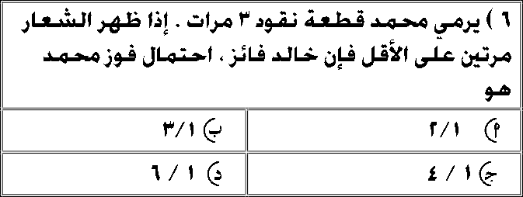

|  |  |
| --- | --- |
|  | |
|  |  |
|  |  |
|  |  |
|  |  |

|  |  |
| --- | --- |
|  | |
|  |  |
|  |  |
|  |  |
|  |  |

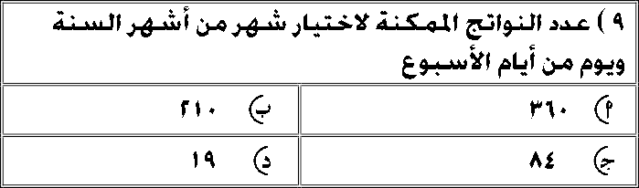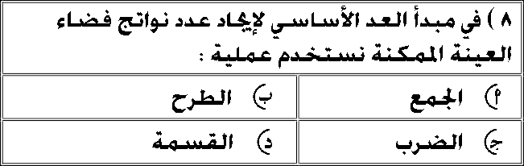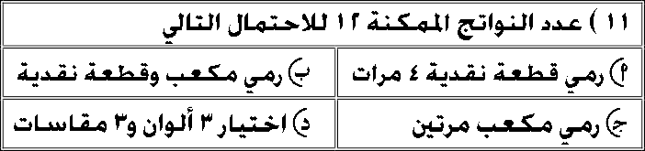

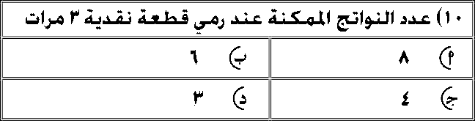

روج

رياضيات أول متوسط الفصل

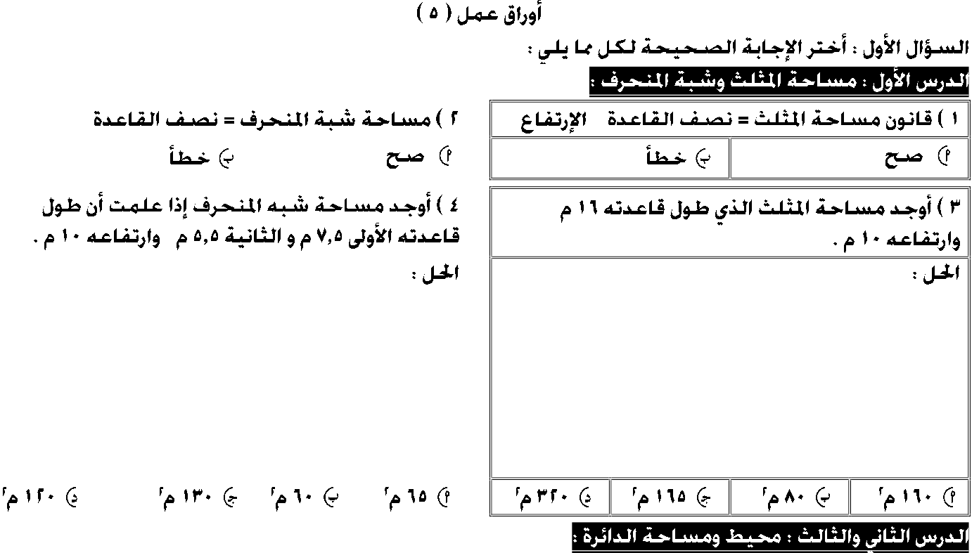

X

|  |  |  |  |
| --- | --- | --- | --- |
| + | | | |
|  | |  | |
|  | | | |
| ، | | | |
|  | | | |
|  |  |  |  |

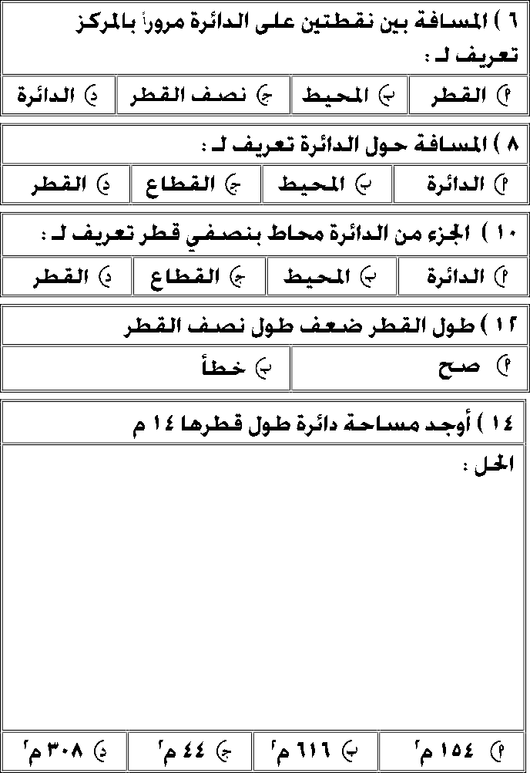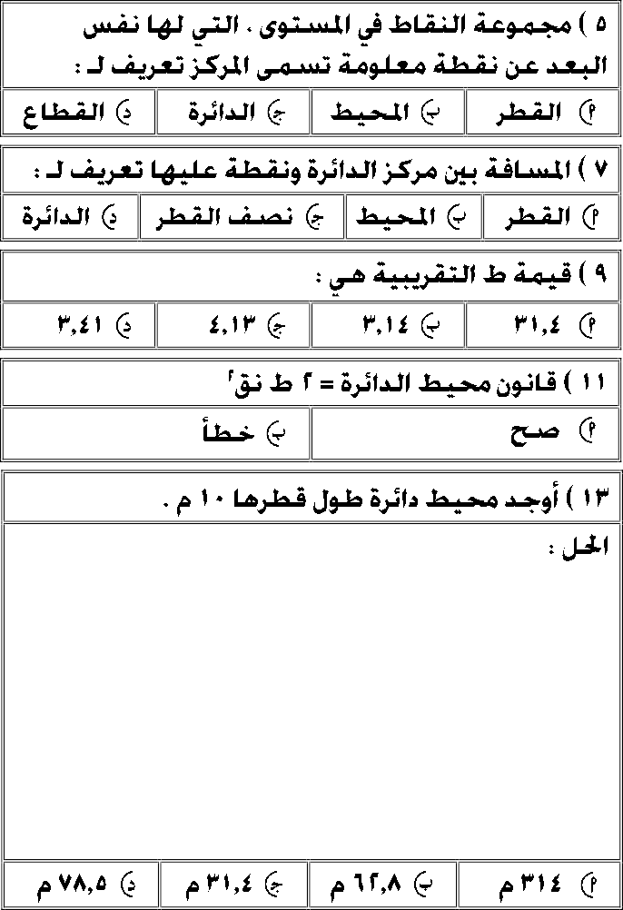



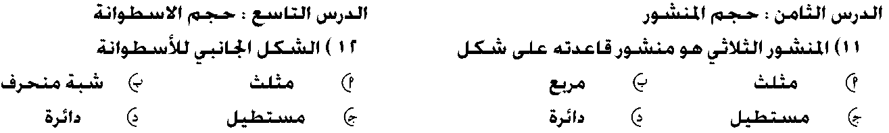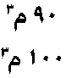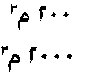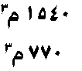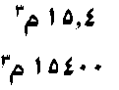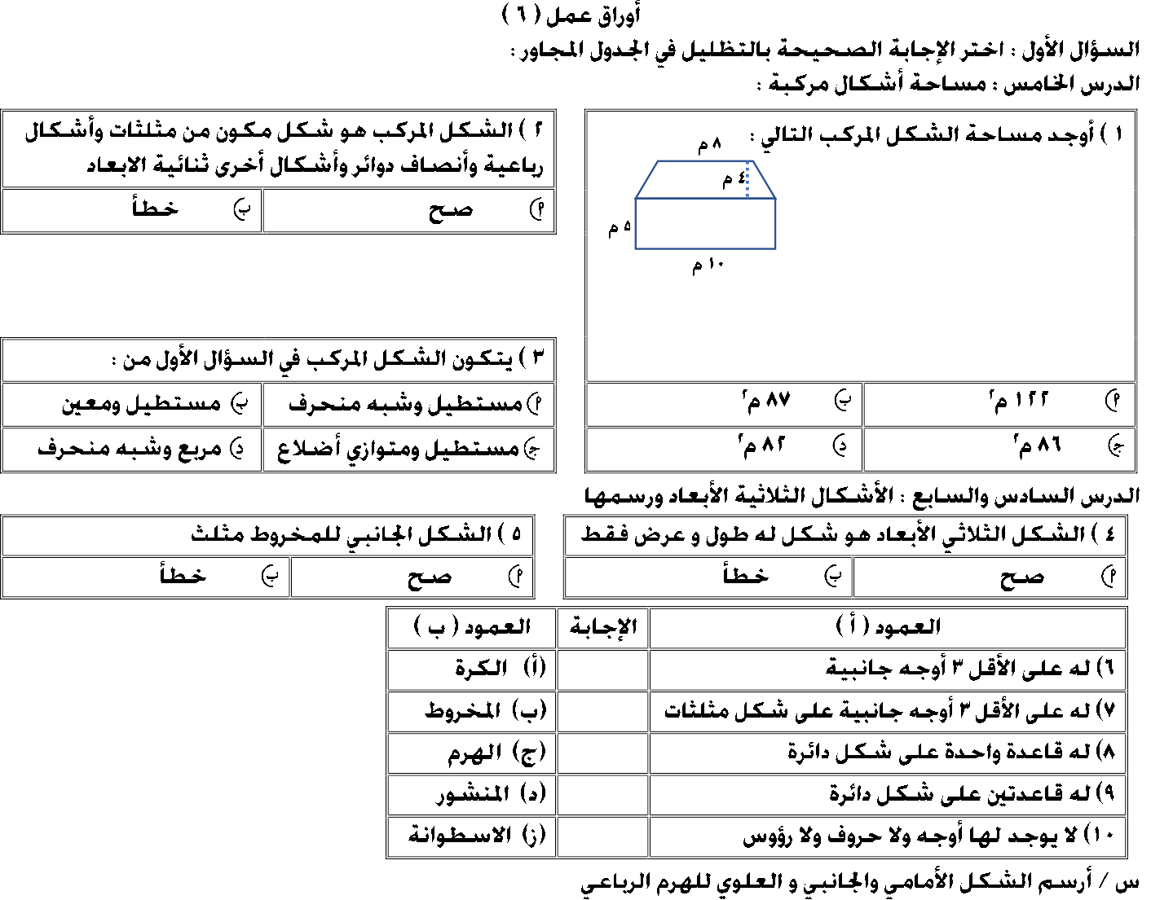

متوسطة املروج

رياضيات أول متوسط الفصل



|  |  |
| --- | --- |
|  | |
|  |  |
|  |  |
|  | |
|  |  |
|  |  |

|  |  |
| --- | --- |
|  | |
|  |  |
|  |  |
|  | |
|  |  |
|  |  |

