Kingdom of Saudi Arabia
Ministry of Education
………… Education Directorate............
…………..……………….. Intermediate School

20
Total

Midterm Test units 12 & 13
First Intermediate Grade

Name ………………………………… Class ………………………………
__________________________________________________________________________________________
/ 4
Comprehension

Read the following then answer the questions:

My favorite mall is Al-Othaim shopping Centre. It is in Riyadh. It is very big and it has two floors. There are many shops. It also has a large supermarket. There are many places that sell tasty food. Shopping in Al-Othaim is easy.
A- Put (√ ) for true or ( ᵡ ) for false :

( ) | 1. Shopping in Al-Othaim is easy.
( ) | 2. There aren't any restaurant.

B- Choose the right answer:

Tabuk | Abha | Jeddah | Riyadh | 1-The shopping Centre is in ______.
five | three | two | four | 2-It has ___ floors.
_________________________________________________________________
/ 5
Grammar

Choose the right answer:

1- I _____ play volleyball, but I can play tennis .
A. am B. can't C. can D. do
2 - Do they like to relax on the beach? Yes, ____ ___.
A. I can . B. I do . C. they do. D. he does.
3 - I’d like _____ a new laptop .
A. to buy B. buying C. buy D. buys
4 - We are _________ go to the zoo tomorrow.
A. doing B. going C. going to D. go to
5 - Sara ____ going to wear a dress in the wedding .
A. am B. are C. is D. she

/ 4
Vocabulary

A- Choose the best answer to fill in the blank:
1. Jack can _____ a boat.
D. sail | C. water-ski | B. kite surf | A. swim
2. A place you can fly to places.
D. park | C. Bus station | B. Airport | A. Train station
3- I need to put on my ____________. My feet are cold.
D. shorts | C. shirt | B. shoes | A. coat
4- You need_____clothes. It’s cold in Abha.
D. formal | C. warm | B. cold | A. hot
B- Put the right word under its picture:
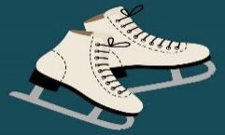 | 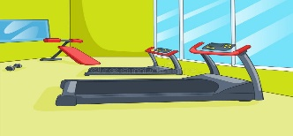 | 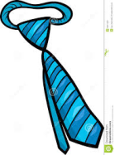 | 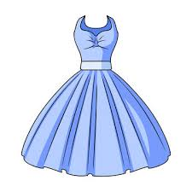
Gym , Tie , Dress , Ice-skate
/ 4

_______________________________________________________________________________
/ 3
Orthography

Choose the correct letter:
g | k | v | 1. Fred plays bas__etball.
r | b | d | 2. I’m going to a we__ding on the weekend.
n | h | f | 3. The weat__er is very hot.

Good luck T.

