المملكة العربية السعودية
وزارة التعليم – إدارة التعليم بمحافظة ........
اختبار مادة اللغة الإنجليزية الصف الأول متوسط الفصل الدراسي الأول ( الدور الأول ) للعام 1444هـ
متوسطة .........................................
الزمن : ساعة ونصف

 | الاسم الرباعي
 | رقم الجلوس
رقم السؤال | الدرجة رقماً | الدرجة كتابة | اسم المصحح | التوقيع | اسم المراجع | التوقيع | اسم المدقق | التوقيع
الأول

الثاني

الثالث

الرابع
الخامس
مجموع الدرجات

معلم المادة : مدير المدرسة :
التوقيع : التوقيع :

Q1 - Composition

Write a paragraph about ( yourself ) not less than 6 sentences using the following words .

6

(Name – age – favorite sport – live – like)
……………………………………………………………………………………………………………………………………………………………………………………………………………………………………………………………………………………………………………………………………………………………………………………………………………………………………………………………………………………………………………………………………………………

Q2 - Reading Comprehension

6
Read the following passage and choose the correct answer below:

Ahmad is from Jeddah. Every morning, he goes to his beautiful school.
He goes by bus He meets his friends in the playground. He likes his teachers and
his friends. His favorite subject is science. His favorite sport is football. At home, He sees
his lovely family. He does his homework. He goes to bed at 9 o'clock.

1- How does Ahmad go to school? He goes (by bus - by car - on foot )
2- What is his favorite subject? He likes ( English - Science - History )
3- When does he sleep ? He goes to bed at ……..o'clock. ( seven - eight - nine )
4- Is Ahmad from Jeddah? ( Yes, he is - No, they are not - Yes, it is )
5- Ahmad likes his …………………. ( birds - teachers - animals )
6- Ahmad favorite sport is ………….. ( tennis - swimming - football )

Q3 – Grammar

7
Choose the correct answer

1- He … … … … … … … … .. a doctor . ( am - are - is )
2- I … … … … … … … … … .. a student ( am - are - is )
3- My brother has a cat . that's my … … cat ( brother's - brother - sister )
4-Do you … … … any brothers and sister? ( Have - Has - does )
5- The final test is … … … … … . December. ( in - from - at )
6- … … … … … …February , March , April . ( January - October - July )
7- Goodbye. ( Bye, take care - Hi - Hello )

7
Q4- Vocabulary
Choose the correct answer
eraser - scissors - television - lamp – headphones - notebook - airplane
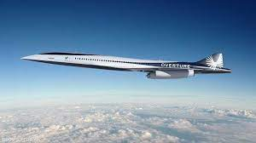
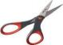
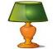
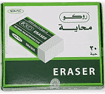
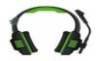
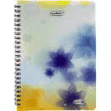

Q5- Orthography “Spelling”

4
Choose the missing letters:

1-came … .a. ( r – n - b ) 2- museu … .. (z - m - b )
3- notebo…._k ( o - a – s ) 4- ….hoto ( p - n - h )
انتهت الأسئلة

