Name: …………… Date: / / 143

1-Match the words :

Watch Do football

Play TV homework

2-Choose the correct answer:
1- The student is ( doing _ watching _ playing ) his homework .
2- We are ( playing - eating – doing ) cakes
3- Dad is (doing – watching – cooking ) TV .
4- The teacher ( am – is – are ) marking the books .
5- We are doing ( tennis _ karate _ basketball )
6-The second day is (Sunday_ Wednesday_ Monday).

3-Rearrange the sentences :
are _ doing- what _ you ?
..........................................................................................................................................................................................................................................................................................................................................................................................................

4- Answer:
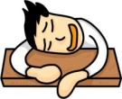
a- What's he doing ?
He 's ………………….

b- What are doing ?

I'm………………………. TV .

c- What is he doing ?
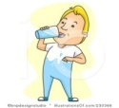
He's ……………………… water

..........................................................................................................................................................................................................................................................................................................................................................................................................

..........................................................................................................................................................................................................................................................................................................................................................................................................

..........................................................................................................................................................................................................................................................................................................................................................................................................

