***LISTENING QUIZ-1-***

2

***Name:………………………………………………….Class:……….***

----------------------------------------------------------------------------------------------------------

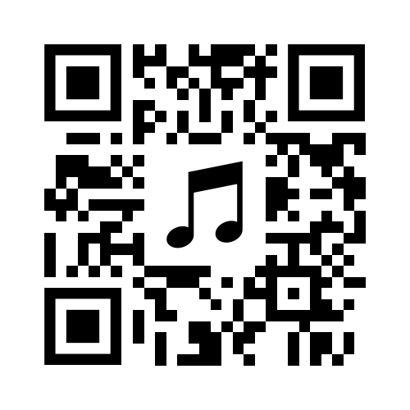-***Scan the QR Code to listen to the conversation between a customer and a shop assistant, then answer the following questions:***

1. What does a customer want to buy?   
A. glasses.  
B. a T-shirt.  
C. a jacket.

3 . She likes to pay with:  
A. credit card  
B. cash  
C. None

4. Who said: (Is it OK?)  
A. a customer.  
B. a shop assistan.

2. What size does she want?  
A. Medium  
B. Small.  
C. Large.

------------------------------------------------------------------------------------------------------------------------

***LISTENING QUIZ-1-***

2

***Name:………………………………………………….Class:………***

-***Scan the QR Code to listen to the conversation between a customer and a shop assistant, then answer the following questions***:

3 . She likes to pay with:  
A. credit card  
B. cash  
C. None

4. Who said: (Is it OK?)  
A. a customer.  
B. a shop assistan.

1. What does a customer want to buy?   
A. glasses.  
B. a T-shirt.  
C. a jacket.

2. What size does she want?  
A. Medium  
B. Small.  
C. Large.

***LISTENING QUIZ-1-***

2

***Name:………………………………………………….Class:……….***

----------------------------------------------------------------------------------------------------------

-***Scan the QR Code to listen to the conversation between a customer and a shop assistant, then answer the following questions:***

1. What does a customer want to buy?   
A. glasses.  
B. a T-shirt.  
C. a jacket.

3 . She likes to pay with:  
A. credit card  
B. cash  
C. None

4. Who said: (Is it OK?)  
A. a customer.  
B. a shop assistan.

2. What size does she want?  
A. Medium  
B. Small.  
C. Large.

------------------------------------------------------------------------------------------------------------------------

***LISTENING QUIZ-1-***

2

***Name:………………………………………………….Class:………***

-***Scan the QR Code to listen to the conversation between a customer and a shop assistant, then answer the following questions***:

1. What does a customer want to buy?   
A. glasses.  
B. a T-shirt.  
C. a jacket.

3 . She likes to pay with:  
A. credit card  
B. cash  
C. None

4. Who said: (Is it OK?)  
A. a customer.  
B. a shop assistan.

2. What size does she want?  
A. Medium  
B. Small.  
C. Large.