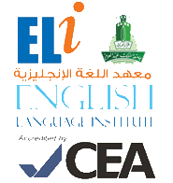
Grammar and
Vocabulary Practice
101
رؤية جامعة الملك عبد العزيز
منارة في المعرفة
تكامل في التكوين
ريادة في التنمية
رسالة جامعة الملك عبدالعزيز
الرقي بالمجتمع عبر تميز ثقافي و علمي و بحثي رائد

Student’s Name: ___________________ Level: 101 Section: ______________

- Grammar Section (Unit 7)
Fill in the blanks with the past tense of the words given in the brackets:

- I _________ (work) in a bank for 10 years.
- He _________(travel) to Malaysia last month.
- She____________(not watch) TV last night.
- We _____________(buy) a new car in August.
- He _______(try) to lift the heavy box.

- Vocabulary Section (Unit 7)
Fill in the blanks with (in, on or at):

- I will meet you _____ 6 o’clock.
- Ahmad went to Malaysia__________ 1990.
- I will go to Makkah _____ Friday.
- We arrived in Italy_____ October.
- We got up early ____ the morning.

