





**الاختبار النهائي لمادة اللغة الانجليزية الفصل الدراسي الاول الدور الاول للعام الدراسي 1445هـ**

**اسم الطالبة:........................................................... الصف :الثالث متوسط ( )**

**رقم الجلوس :....................................................**

**اليوم :....................................... التاريخ : \ \ 1445هـ عدد الصفحات : 3**

**"اللهم لا سهل إلا ما جعلته سهلا و انت تجعل الحزن إذا شئت سهلا"**

|  |  |  |  |  |  |  |  |  |  |  |
| --- | --- | --- | --- | --- | --- | --- | --- | --- | --- | --- |
| **signature** | **Checked by** | **signature** | **The reviser** | **signature** | **The corrector** | **Student’s Mark Written** | **Student`s Mark Number** | **Question** | | **Number** |
| **Mark** | **Question** |
|  |  |  |  |  |  |  |  | **6** | **Guided composition** | **Q1** |
|  |  |  |  |  |  |  |  | **6** | **Reading Comprehension** | **Q2** |
|  |  |  |  |  |  |  |  | **7** | **Grammar** | **Q3** |
|  |  |  |  |  |  |  |  | **7** | **Vocabulary** | **Q4** |
|  |  |  |  |  |  |  |  | **4** | **Orthography** | **Q5** |
|  |  |  |  |  |  |  |  | **30** | **Total** | |
|  |  |  |  |  |  |  |  | **10** | **Listening and speaking** | |
|  |  |  |  |  |  |  |  | **40** | **Total** | |

**Q1:Guided Composition:**

**6**

Write a paragraph about **( your lifestyle )** you can use these guide words

( name – wake up – brush – on time – help – watch – sleep )

……………………………………………………………………..

……………………………………………………………………………………………………………………………………………………………………………………….……………………………………………………………………………………………………………………………………………………………………………………………………………………………………………………………………………………………………………………………………………………………………………………………………………………………………………………………………………………………………………………………………………………………………………………………………………………………………………………………………………………………………………………………………………………………………………………………………………………………………………………………………………………………………………………………………………………………………………………………………………………………………………………………………………………………………………………………………………………………………………………………………………………………………………………………………………………………………………………………………………………………………………………………………………………………………………………………...

**Q2:Reading Comprehension:**

**6**

**Read the following passage then answer the question below:-**

Ahmed has got a small shop .Everyday he goes to the shop at six o’clock in the morning .There are eggs, milk, fruit and cheese at the Shop. Every Sunday he closes his shop and goes to e farm to buy new things for his shop .People come to Ahmed’s shop to buy there things because he has clean and new things. they like Ahmed. He is a good Shopkeeper .Ahmed comes back home at eleven o’clock at night .He has Dinner and goes to bed.

**A: Tick ( ) or (X):**

1-People don’t like Ahmed. ( )

2-Faud goes to bed very late. ( )

3-Oranges and apples are fruit. ( )

**B: Choose the correct answer:**

1- Ahmed ------------------ his shop every Sunday.

a) opens b) closes c) goes

2- I have fish for --------------------- tonight.

a) breakfast b)lunch c) dinner

3- we can keep tame animal on the ----------------------

a)shop b) form c)bed

**1**

***Q3:Grammar:***

***A:Choose the correct answer:***

**7**

1-I always ( do – does – doing ) my homework in the afternoon.

2-(Neither – all – both ) of them is a teacher.

3- Ali is ( write – wrote – writing ) the lesson.

4-There is ( some – any – a ) juice.

***B- Do as shown between brackets:***

1-He is going to Paris to **studying** French. **( correct )**

………………………………………………………………………………………………………

2-Omar will go to school tomorrow. **( make a negative )**

……………………………………………………………………………………………………

3-you \ need \ do \ eggs \ ? **(use How many )**

…………………………………………………………………………………………………….

***Q4:Vocabulary:***

***A:Find the ode words:***

**7**

1-Salmon – crab – taxi

2-Car – carrot – onion

3-Beef – spoon - chicken

4-mango – orange – pen

***B:Write the correct word under each picture:***

Salad – shrimp – suitcase – passport – infant – cheese – cheesecake

|  |  |  |  |  |  |
| --- | --- | --- | --- | --- | --- |
|  |  |  |  |  |  |
|  |  |  |  |  |  |

**2**

***Q5:Orthography***

***A:Choose the missing letter:***

**4**

1-toma__oes ( t – r – q ) 3-pi__ot ( r – m – l )

2-a__ocado ( r – v – x ) 4-gy__ ( m – t – k )

***B-Write the missing letter:***

r - t - g - u - m

|  |  |  |  |
| --- | --- | --- | --- |
|  |  |  |  |
| Yogu__t | S__eak | Bagga__e | so__p |

**3**

**Tr.Najah Aljuhani**

**Good luck**



##### 

##### وزارة التعليم

**الإدارة العامة للتعليم بمنطقة ----------**

**مجمع مدارس ------------------- ( بنين )**

**اختبارات نهاية الفصل الدراسي الأول 1445هـ**

|  |  |  |
| --- | --- | --- |
| **المادة:**  **لغة انجليزية** | **الصف: الثالث المتوسط رقم الجلوس : ( )** | **الزمن:**  **ساعتان** |
| **اسم الطالب: ................................................................................................................................................** |

|  |  |  |  |  |  |  |  |
| --- | --- | --- | --- | --- | --- | --- | --- |
| **Total**  **written** | **5 spelling** | **4 Vocabulary** | **3 Grammar** | **2 Comprehension** | | **1 Composition** | **Q. NO.** |
|  |  |  |  |  | |  | **Mark Given** |
| **30** | **4** | **7** | **7** | **6** | | **6** | **Mark** |
|  | | | **Reviser** | |  | | **Corrector** |
|  | |

1) **Composition**

**1- Write a paragraph about “Your Life Story"**

**You may answer these questions:**

**Where and when were you born? Where were you raised and educated?**

**Who do you live with? What do you like to be?**

…………………………………………

………………………………………………………………………………………………………………………………………………………………………………………………………………………………………………………………………………………………………………………………………………………………………………………………………………………………………………………………………………………………………………………………………………………………………………………………………………………………………………………………………………………………………………………………

**6**

**2) Comprehension**

**2- Read the following passage then answer the questions:**

Mohamed and his family were in London last week. It was very expensive. They stayed in a hotel for three days. Then they took an apartment. Mohamed stayed there until Friday. He flew back home last night. His father is still there. His mother is with his father. Next week, Mohamed is going somewhere else.

**A- Put ( ) or ( x ):**

**1. Mohamed and his family were in Paris. ( )**

**2. Staying in London was cheap. ( )**

**3. Mohamed flew back home last night. ( )**

**4. Next month, Mohamed is going somewhere else. ( )**

**5. The apartment was cheaper than the hotel. ( )**

**B- Choose the correct answer:**

**1. He stayed there until (**Friday – Saturday – Sunday**).**

**2. Mohamed and his family were in London last (**year – week – day).

**3. They took an (**hotel – apartment – house**).**

**4. Next (**week – holiday – day**), Mohammad is going somewhere else.**

**C- Answer the following questions:**

**1. Where were Mohamed and his family last week?**

----------------------------------------------------------------.

**2. How long did they stay in a hotel?**

----------------------------------------------------------------.

**3. Who stayed in London?**

----------------------------------------------------------------.

**3) Grammar**

**7**

**A: Choose the correct answer:**

**1. I rarely (**drink – drinks – drinking**) coffee.**

**2. How (**old – many – often**) do you use your cell phone?**

**3. I (**am – were – was**) born in Najran.**

**4. When I was little, I (**uses to – use to – used to**) play with toys.**

**5. My friends are (**waited – waiting – wait**) for me at the airport**

**6. Maybe I (**was – am going to – will**) stay with friends.**

**7. How (**many – much – often**) bananas do you eat?**

**8. I don’t have (**something – nothing – anything**) for lunch.**

**B: Do as shown between brackets:**

**1. How (many) milk do you drink? (Correct)**

**------------------------------------------------------------------------------------------**

**2. I eat a little seafood. (Change into Negative)**

**------------------------------------------------------------------------------------------**

**3. What – doing – you – are – tonight? (Rearrange)**

**------------------------------------------------------------------------------------------**

**4. He is going to travel this year. (Make Yes/No Question)**

**------------------------------------------------------------------------------------------**

**5. His parents were (marry) in Tabuk. (Correct the verb)**

**------------------------------------------------------------------------------------------**

**6. Ibrahim constantly talks on the phone. (rarely)**

**------------------------------------------------------------------------------------------**

**4) vocabulary:**

**7**

**A- Write the correct number under its pictures:**

**1.cell phone 2.avocado 3.suitcase 4.vegetarian 5.plane 6. blood**

****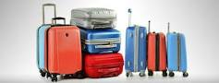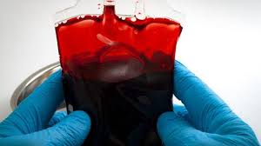****



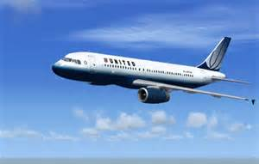

**……………. ……………. ……..……. ………..…… …………… …………..**

**B- Match the answers:**

|  |  |  |
| --- | --- | --- |
| **a. in some ways / slightly** | **1. turn (someone) off** | ------ |
| **b. does not interest at all** | **2. kind of** | ------ |
| **c. a big city** | **3. big break.** | ------ |
| **d. important opportunity** | **4. I can’t wait.** | ------ |
| **e. I am very eager for something.** | **5. metropolis** | ------ |

**C- Circle the correct spelling:**

**1. infent - infont – infant**

**2. abroad – abrood - aproad**

**3. fligt – flight – filght**

**5) Orthography**:

**4**

**A- Fill in the missing letters:**

**1. add__ct**

**z – o – i – r**

**2. bl__od**

**3. airpo__t**

**4. appeti__er**

**B- Choose the odd one out:**

**1. milk coffee school juice**

**2. nurse doctor meat dentist**

**3. always sleep usually sometimes**

**4. funny What When Where**

**End of Questions**

**Best of Luck**

 

##### 

##### وزارة التعليم

**الإدارة العامة للتعليم بمنطقة ---------**

**مجمع -------------------------- ( بنين )**

**اختبارات نهاية الفصل الدراسي الأول 1445هـ**

|  |  |  |
| --- | --- | --- |
| **المادة:**  **لغة انجليزية** | **الصف: الثاني المتوسط رقم الجلوس : ( )** | **الزمن:**  **ساعتان** |
| **اسم الطالب: ................................................................................................................................................** |

|  |  |  |  |  |  |  |  |
| --- | --- | --- | --- | --- | --- | --- | --- |
| **Total**  **written** | **5 spelling** | **4 Vocabulary** | **3 Grammar** | **2 Comprehension** | | **1 Composition** | **Q. NO.** |
|  |  |  |  |  | |  | **Mark Given** |
| **30** | **4** | **7** | **7** | **6** | | **6** | **Mark** |
|  | | | **Reviser** | |  | | **Corrector** |
|  | |

**6**

1) **Composition**

**1- Write a paragraph about: (Your Hobby or Pastime)**

**1- What is your hobby? 2- What equipment do you need?**

**3- How often do you do it? 4- Where do you do it?**

**5- Why do you like it?**

…………………………………………

……………………………………………………………………………………………………………………………………………………………………………………………………………………………………………………………………………………………………………………………………………………………………………………………………………………………………………………………………………………………………………………………………………………………………………………………………………………………………………………………………………………………………………………………….

**2) Comprehension**

**6**

**2- Read the following passage then answer the questions:**

**My brother Ali is 25 years old. He works in a furniture shop. He is a salesperson. He wants to develop his abilities so; he is studying business management in college at night. He wants to be a marketing manager.**

**A- Put ( ) or ( x ):**

**1. Ali is my friend. ( )**

**2. He is a salesperson. ( )**

**3. He is a manager. ( )**

**4. He works in college. ( )**

**5. He is forty years old. ( )**

**B- Choose the correct answer:**

**1. Ali is ………. years old.**  a) twenty b) twenty-five c) fifty-two

**2. He works in a …………. shop.**  a) clothes b) shoes c) furniture

**3. He wants to ………… his abilities.** a) develop b) decrease c) slow down

**4. He is studying in …………………...** a) school b) shop c) college

**C- Answer the following questions:**

**1. What is the name of the character?**

----------------------------------------------------

**2. What is the job of the character?**

----------------------------------------------------

**3. What does he want to be?**

----------------------------------------------------

**7**

**3) Grammar**

**A: Choose the correct answer:**

**1. He is a teacher. He (** teach – teaches – teaching **) at school.**

**2. What are you (** doing – do – does **)?**

**3. (** Who – How – Why **) often does she go shopping?**

**4. I don’t know how to (** ski – skis – skiing **).**

**5. What (** do – does – are **) you do?**

**6. (** What – Who – Where**) does he work?**

**7. I’d like (** a – an – some **) cup of coffee, please.**

**8. Are they from Egypt? Yes, (** he is – I am – they are **).**

**B: Do as shown between brackets:**

**1- you – on – Are – here – vacation? [** Unscramble **]** ----------------------------

**2- I’m (go) to the park now. [** Correct the verb **]** ---------------------------------

**3- He works in a hospital. [** Ask Yes/No Question **]** ----------------------------

**4- There is some juice. [** Make Negative **]** ----------------------------------

**5- I watch TV every day. [** Ask using: How long **]** ----------------------------

**6- I know how to ski. [** Rewrite using: can **]** ------------------------------

**4) vocabulary:**

**7**

**A- Write the correct number under its pictures:**

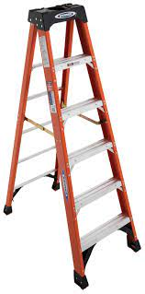**1.Karate – 2.steak – 3.nurse – 4.ladder – 5.director – 6.pasta 7. plane**

****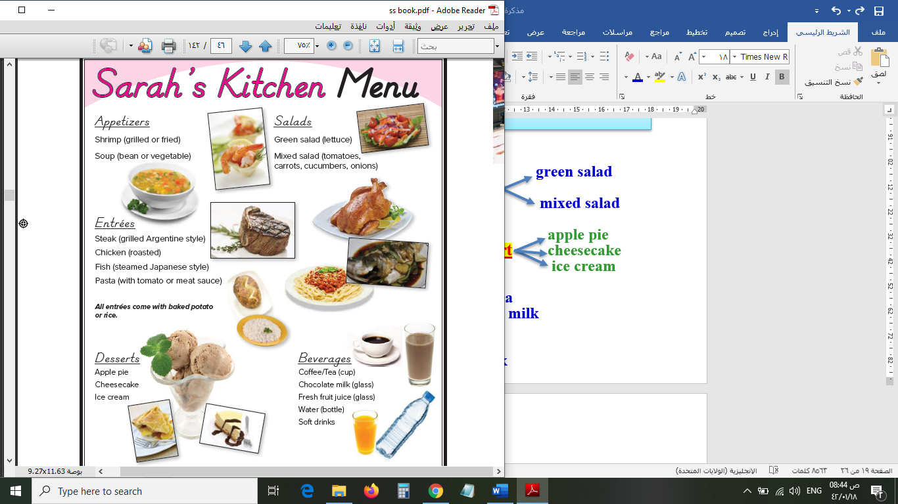

**( ) ( ) ( ) ( ) ( ) ( ) ( )**

**B- Match the answers:**

|  |  |  |
| --- | --- | --- |
| a. in a travel agency. | **1. Nice to meet you.** | **-----** |
| b. I’d like a chicken sandwich. | **2. The stuntman** | **-----** |
| c. is making dangerous scenes. | **3. A travel agent works** | **-----** |
| d. Nice to meet you, too. | **4. How often do you study?** | **-----** |
| e. I study every day. | **5. May I take your order?** | **-----** |

**C- Circle the correct spelling:**

**2. elevator – elvator - elevtor**

**3. meno – menu – manu**

**3. pasime – pastim – pastime**

**4**

**5) Orthography**:

**A- Fill in the missing letters:**

**c – t – p – e**

**1- hos__el**

**2- sales__erson**

**3- coffe__**

**4- a__tor**

**B- Choose the odd one out:**

**1. Good morning Going Good evening Good night**

**2. always often usually friend**

**3. teacher driver doctor school**

**4. bad time free time leisure time spare time**



**End of Questions**

**Best of Luck**

|  |  |  |  |  |  |  |
| --- | --- | --- | --- | --- | --- | --- |
| |  | | --- | | **المملكة العربية السعودية** | | **وزارة التعليم** | | **تبوك** | | **المتوسطة الحادية والعشرون** | |  | **اختبار الفصل الدراسي الأول**  **عام 1445**  **اللغة الإنجليزية**  **للصف الثالث متوسط**  **الزمن: 45 دقيقه** |

|  |
| --- |
| اسم الطالبة: الفصل: |

20

**1- Write at least 4 sentences about your pastime activities. Use guide words. [ free time – like – listening to music – going shopping – playing video games. With friends –]**

20

**……………………………………………………………………………………**

**…………………………………………………………………………………….**

**……………………………………………………………………………………..**

**…………………………………………………………………………………….**

2-GRAMMAR/A. Choose the correct answer.

1- I always (do - does – doing) my homework in the afternoon.

2-How (many – old -much) time do you spend in the shower?

3-(last – ago – yesterday ) year I was in Canada.

4-where did they ( work- worked- working) ?

B. Do as shown between brackets. [ Correct]

a-Ahmad and Ali born in France but all of them could speak French ……………

b--The team was call The Lions………..

3- VOCABULARY: A-Choose the correct answer:

1- - Jake never eats meat. He’s ( an Internet addict- a vegetarian).

2- Ali is online all the time, even in the park! He is(an exercise freak- an Internet addict)

4- Fill in the missing letters:

1-g…..m [ t – o -y] 2- do…..or [ n - a -y]

3- tw….ns [ i – e -h] 4- holi….ay [ u – o -d]

[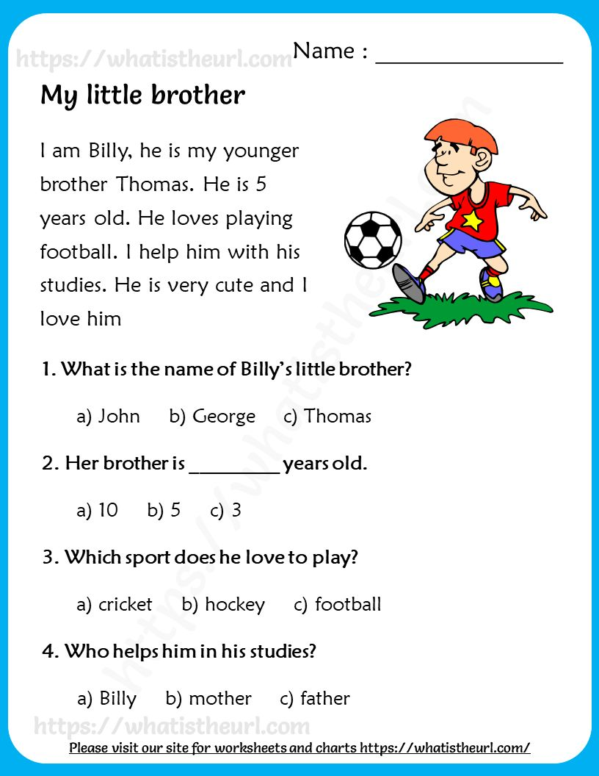](https://t.me/madtyy9)***5-Read the following passage and choose the correct answers:***

B- write the correct word[ herbal tea – infant – exercise freak -player - passport ]

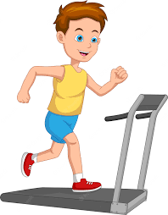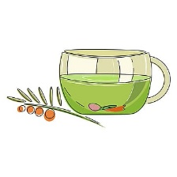

………………. …………………… ……………………. …………………..

.

***T.AFAF Salem***

|  |  |  |
| --- | --- | --- |
| **Kingdom of Saudi Arabia**  **Ministry of Education**  **…Tabuk Education Directorate**  **21ST Intermediate School** | صورة تحتوي على نص, أدوات المطبخ, مبشرة  تم إنشاء الوصف تلقائياً  **اختبار مادة اللغة الإنجليزية الصف الثالث متوسط الفصل الدراسي الأول (الدور الأول) 1443-1444** | **English Language**  **Third Intermediate Grade**  **1st Term Exam 1443 -1444**  **Time: one hour and half** |
| **Name/** ………………………………… | **Class /** …………… | **Seat No**./ …………………………… |

|  |  |  |  |  |
| --- | --- | --- | --- | --- |
| **Student’s Mark Written** | **Student’s Mark Number** | **Question** | | **Number** |
| **Mark** | **Question** |
|  |  | **6** | **Composition** | **Q1** |
|  |  | **6** | **Reading Comprehension** | **Q2** |
|  |  | **7** | **Grammar** | **Q3** |
|  |  | **7** | **Vocabulary** | **Q4** |
|  |  | **4** | **Orthography** | **Q5** |
|  |  | **30** | **Total Written Tasks** | |

|  |  |  |
| --- | --- | --- |
| **Sign** | **Name** | **Corrected by** |
| **Sign** | **Name** | **Revised by** |
| **Sign** | **Name** | **Checked by** |

صورة تحتوي على نص

تم إنشاء الوصف تلقائياً

Page 1

**اختبار الصف الثالث متوسط الفصل الدراسي الأول ( الدور الأول) 1443-1444**

***Q1 / Composition***

**6**

1.***Tea* is a popular drink. Write a paragraph with 5 sentences about how to make**   
**a cup of tea. Use the following sequence words (First -Next -After that -Finally –)**

****صورة تحتوي على منضدة

تم إنشاء الوصف تلقائياً

**6**

1-put a teabag into a cup.

2-pour very hot water into the cup.

3-leave it for three minutes.

4-take the teabag out.

5-pour some milk into the tea, but not too much.

**Reading Comprehension**

***Read the following passage and choose the correct answer below:***

**Sara is interested in Geography books. She has already read many books about India  
Indonesia, Bangladesh, and Japan. She learned a lot about these countries. Sara visits the school library almost every day where she can read a lot of Geography books. The librarian is always ready to help her choose any book which *she* likes to read about it. Last week, Sara wrote a very good note in the school Magazine and the headmaster was happy to read that note.** She **gave her some books as a gift..**

**1- What does Sara visit ? Sara visits the school ………….**

**[ a – library b- class c- office]**

**2- Sara wrote a very good ……………………**

**[ a - homework b- note c- exam ]**

**3- Is Sara interested in English books?.......................**

**[ a- No, she is not b- Yes, they do c- Yes, iam ]**

**4- The headmaster was .....................to read Sara's note**

**[ a- angry b- sad c- happy]**

**5- The headmaster gave Sara some ……… as a gift**

**[ a – books b- pencils c- flowers ]**

**6- the pronoun (she) in line 4 refers to ………………..**

**[ a- Sara b- Maha c- Huda ]**

**7**

**Q3 – Grammar**

***Choose the correct answer***

|  |  |
| --- | --- |
| **8- I go to school ……..7 a.m.**   1. **in** 2. **on** 3. **at** | **7- I eat a ………..carrots**  **a**- **little**  **b**- **few**  **c**- **any** |
| **10**- **I used to …………. With toys.** .   1. **play** 2. **plays** 3. **playing** | **9** – **I rarely ……..coffee**  **a**- **drink**  **b-drinks**  **c-drinking** |
| **12**- **I do not have ……..for lunch.**  **a- something**  **b - some**  **c- anything** | **11**- **- …………..milk do you drink?**  **a-How much**  **b-How**  **c-How many** |
| **13**- **He likes to look at ……in the mirror.**  **a – herself**   1. **him self** 2. **mine** |

**Q4- Vocabulary; *Choose [ true] for true statement and [ false] for false one***

|  |  |  |
| --- | --- | --- |
| false | true | 1-Someone who exercise a lot is **exercise freak** |
| false | true | 2-Prince Sultan flew abroad the space shuttle Discovery |
| false | true | 3- The opposite of the word [ poor] is busy. |

**7**

-**Match each word with word that has same correct meaning**

|  |  |
| --- | --- |
| a- appointment | 1- give to charity ………. |
| b- donated | 2- an arrangement to meet.. |
| c- infant | 3- supported someone to succeed |
| d - encourage  e _ gathered | 4- a baby |

**4**

**Q5- Orthography “Spelling”**

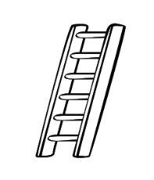***Choose the correct spelling***

|  |  |
| --- | --- |
|  | **14- I enjoy eating ……….**  **a – bread b- readb c- bird** |
|  | **15- I buy a new ……………case**  **a – sikcs b- suit c- tsicsk** |

***Choose the missing letters:***

**16-My mother finished her an av…..ado juice. [ a- oc b- oo c- dd]**

**17-He got his flight ti……et [ a- h b- ck c- ph ]**

**انتهت الأسئلة**

**T.AFAF Salem**

**المملكة العربيةالسعودية الصف: الثالث متوسط**

**وزارة التربية و التعليم مادة : اللغة الإنجليزية**

**المتوسطة ..... الزمن: ساعه ونصف**

**أسئلة اختبار الفصل الدراسي الأول للعام 1443هـ**

عدد الصفحات : 4 عدد الأسئلة :5

SG3 Units 1-2-3 and 4

++++++++++++++++++++++++++++++++++++++++++++++++++++++++

|  |  |  |
| --- | --- | --- |
|  |  |  |
| **I-Composition:** | نموذج | **6** |

"" * Habits are behaviors or actions you perform regularly.

**\*Write a paragraph about A Common Habit Among Young People. Give your opinion about it. Use the guide words:**

**Guide words:** chatting – spend – waste – harmful – spending – phones – wisely - communicate

**__________________________________________________________________**

**__________________________________________________________________**

**__________________________________________________________________**

**__________________________________________________________________**

**__________________________________________________________________**

**__________________________________________________________________**

**__________________________________________________________________**

**__________________________________________________________________**

**__________________________________________________________________**

**__________________________________________________________________**

**_________________________________________________________________**

6

**II-Comprehension:**

6

**Read the passage and answer the questions below:**

There are many kinds of boats. The first kind of boat is called a sailboat. A sailboat uses the wind to move. Wind makes a sailboat move in the water. The wind pushes the sailboat. Wind fills the sails. The sailboat moves when the wind blows. The second kind of boat is called a motorboat. A motorboat uses a motor to move. The motor gives power to the boat. The motorboat moves when the motor is running. The motorboat makes a loud noise. The third kind of boat is called a rowboat. A rowboat needs people to move it. **They** make a rowboat moves in the water. People use oars to move a rowboat. Oars are long and flat. Oars go into the water. A rowboat moves when people use the oars. As you can see, there are many kinds of boats.

|  |  |  |  |  |
| --- | --- | --- | --- | --- |
| **Multiple Choice ( 1- 35 )** | | | | |
| **Comprehension (1-4)** | | | | |
| **A*Choose the correct answer :** | | | | |
| **1**- The **main idea** of the passage is … ……………. | | | | |
| d. kinds of engines | | c- kinds of winds | b- kinds of people | a- kinds of boats |
| **2**- ***They*** in line (6) **refers to……** | | | | |
| d. noises | | c- oars | b- people | a- sails |
| 3- The **opposite** of **low** is… | | | | |
| d- old | | c- scary | b- tired | a- loud |
| **4**- ………………. makes a sailboat move in the water | | | | |
| d. Rain | | c- Wind | b- Thunder | a- Lightning |
| False\True | **B*Put ( T ) or ( F ) (1-2)** | | | |
| **T** | 1- A motorboat uses a motor to move. | | | |
| **F** | 2- Oars are short and flat | | | |

|  |  |  |
| --- | --- | --- |
| **III-Grammar:/Multiple Choice: ( 5 to 11 )** |  |  |
| **Choose the correct words:** |  | **7** |

|  |  |  |  |
| --- | --- | --- | --- |
| 5. I always _______ hard for exams. | | | |
| d- studying | c- studies | b- study | a- to study |
| 6. _______of my two sisters have fair hair. | | | |
| d- All of | c- All | b- Both | a- none |
| 7. I ______tennis with my friends yesterday. | | | |
| d- playing | c- played | b- plays | a- play |
| 8. I used to ________work at 9 o'clock. | | | |
| d- to start | c- starting | b- stars | a- start |
| 9. My sister is going to _______ TV tomorrow. | | | |
| d- watches | c- watching | b- watch | a- watched |
| 10. I _________ now. | | | |
| d- is working | c- am working | b- are working | a- be working |
| 11. _____pets do you have? | | | |
| d- How old | c- How often | b- How long | a- How many |

صورة تحتوي على نص

تم إنشاء الوصف تلقائياً

**77**76

|  |
| --- |
| **Vocabulary: ( 1 to 6 )** |
| **Pairing Question:** |

|  |  |  |  |  |
| --- | --- | --- | --- | --- |
| 1 | I **hate** winter. | f | A | to cook inside an oven |
| 2 | They **solved** the puzzle | e | B | to put something into a bag |
| 3 | You’ve done an **outstanding** job. | d | C | the people you work with |
| 4 | His **colleague** was taking notes. | c | D | excellent |
| 5 | Did you **pack** the camera? | b | E | to find an answer to a problem |
| 6 | Let's **bake** a birthday cake.. | a | F | the opposite of enjoy. |
|  | | | G | too extreme |

|  |
| --- |
| **IV-Vocabulary:/Multiple Choice: ( 12 to 19 )** |
| **Choose the correct words:** |

|  |  |  |  |
| --- | --- | --- | --- |
| **12-** I _____ regularly to keep fit. | | | |
| d- overdo | c- download | b- workout | a- remove |
| **13**- The baby is sucking his ………………….. | | | |
| d- thumb | c-head | b- eye | a- ear |
| **14**. They ________ a lot of money. | | | |
| d- join | c- donate | b- encourage | a- practice |
| **15**. Please do not leave _____ after your picnic | | | |
| d- owner | c- league | b- infant | a- litter |
| **16**. Chinese need a _____ to travel to America. | | | |
| d- suitcase | c- flight | b- visa | a- tag |
| **17**. A sponge absorbs ______. | | | |
| d- solid | c- gates | b- photos | a- liquids |
| **18**- …………………… with milk is a great choice for the breakfast. | | | |
| d- Cereal | c- Butter | b- Cheese | a- Meat |
| **19**- I just can't relax on the beach with …………… . | | | |
| d- chicken | c- grapes | b- crabs | a-corns |

**4**76

|  |
| --- |
| **V-Orthography (Spelling): ( 20 to 35 )** |

|  |  |  |  |  |  |  |  |  |  |  |  |  |
| --- | --- | --- | --- | --- | --- | --- | --- | --- | --- | --- | --- | --- |
| 20 | She is fan…..tical about healthy eating. | | | | | | | 28 | This was my mista…e. | | | |
| a. (a) | b. (i) | | c. (e) | | d. (o) | | a. (w) | b. (q) | c. (d) | d. (k) |
| 21 | We are all really p….oud of you. | | | | | | | 29 | Never trust a s…ranger. | | | |
| a. (q) | | b. (k) | | c. (n) | | d. (r) | a. (m) | b. (g) | c. (t) | d. (d) |
| 22 | He doesn't have a very healthy li**…**estyle. | | | | | | | 30 | He sticks to his pr…nciples. | | | |
| a. (z) | | b. (f) | | c. (p) | | d. (g) | a. (i) | b. (e) | c. (e) | d. (o) |
| 23 | They want to start a new football lea…ue. | | | | | | | 31 | She seld…m goes out. | | | |
| a. (g) | | b. (b) | | c. (w) | | d. (r) | a. (e) | b. (o) | c. (a) | d. (i) |
| 24 | David was cr…ppled in a car accident. | | | | | | | 32 | I fi….ally understand. | | | |
| a. (o) | | b. (a) | | c. (i) | | d. (e) | a. (z) | b. (t) | c. (g) | d. (n) |
| 25 | He regularly co…petes in races. | | | | | | | 33 | Cov…r your mouth when you sneeze. | | | |
| a. (l) | | b. (m) | | c. (x) | | d. (j) | a. (a) | b. (i) | c. (e) | d. (u) |
| 26 | He remo…ed his coat. | | | | | | | 34 | A la…b was offered in sacrifice. | | | |
| a. (n) | | b. (d) | | c. (t) | | d. (v) | a. (m) | b. (l) | c. (p) | d. (f) |
| 27 | We've got m…jor problems. | | | | | | | 35 | The avoca…o is a valuable food. | | | |
| a. (i) | | b. (u) | | c. (o) | | d. (a) | a. (x) | b. (d) | c. (j) | d. (h) |

صورة تحتوي على نص

تم إنشاء الوصف تلقائياً

**END OF QUESTIONS**

**BEST OF LUCK**

Tr. Noureyah Alghamdi

لا أحلل من ينسبها لنفسه أو ينشرها بأسمة

او ينسب جهدي وتعبي في تحضير البوربوينت واوراق العمل وتمارين المراجعة والخطط العلاجية وغيرها لنفسه

هي للنفع العام في التعليم والتدريس وتبسيط المادة للطلاب والمعلمين