We Can! Book 6 : REVISION

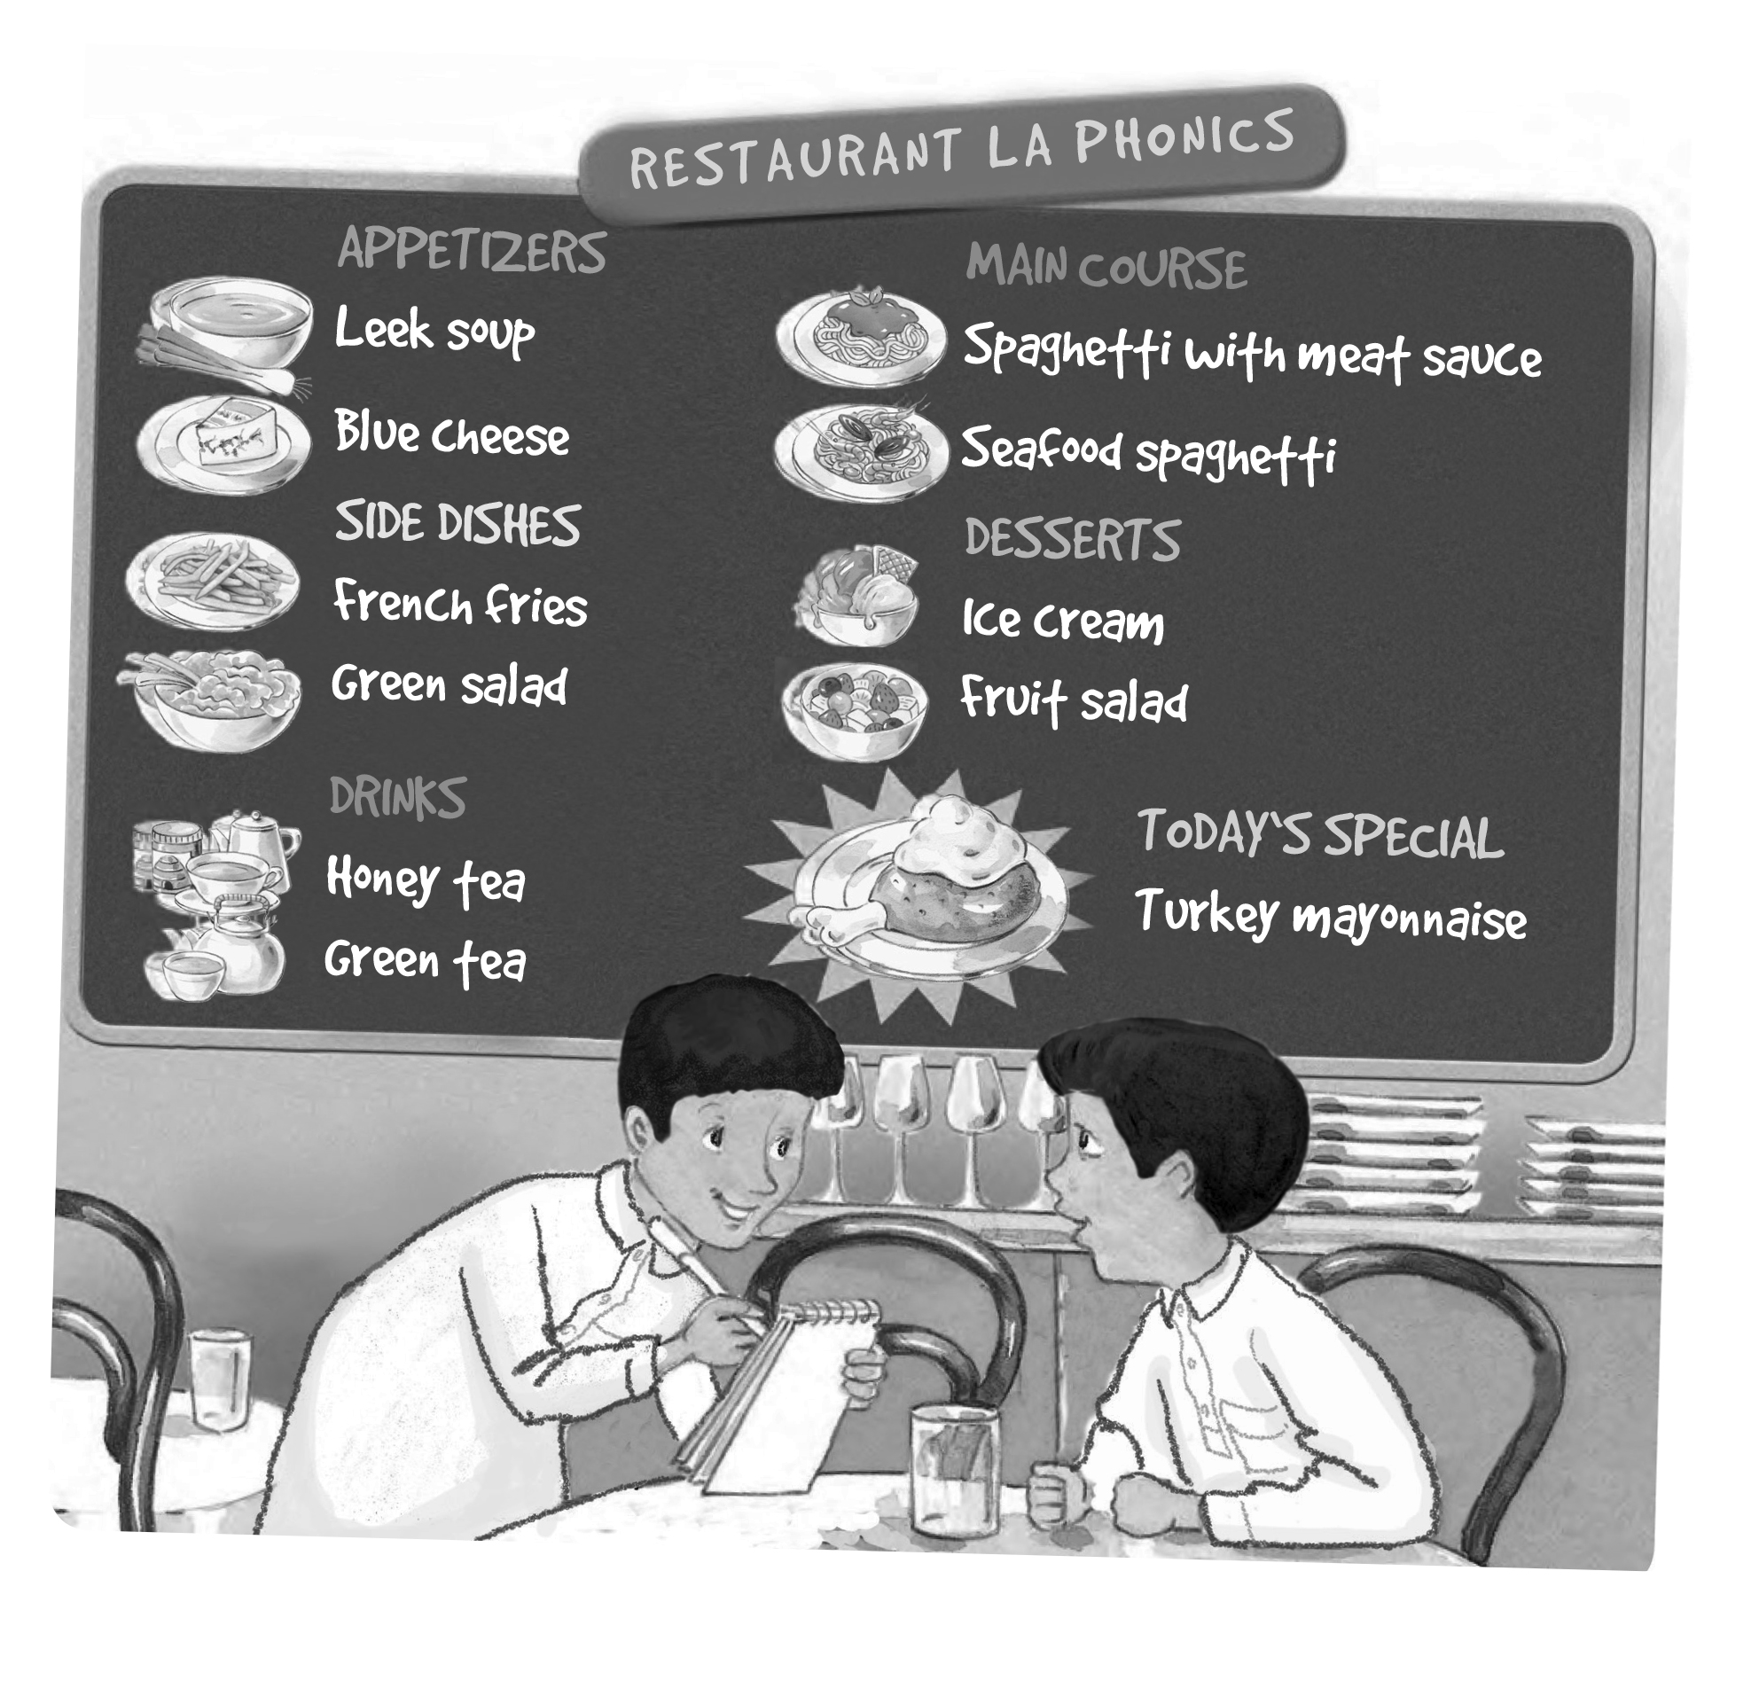
1. Listen and fill in the missing words.
[Play CD3 07 or read.]

A: What would you like?
B: I’d like a burger and fries please.
A: Sure. Just a moment.

Write your own dialog.

A: What would you like ?
B: I’d like a ___________ and ___________ please.
_________. [Answers will vary.]
A: Just a moment.

2. Read and match words and phrases. Write.

I cleaned my room yesterday. | football.
Rana cooked dinner last night. | for the test.
Ted stayed at home. last Saturday. | the ball.
My brother played football over the weekend | dinner
We practiced our English over the weekend. | our English.
They watched a DVD last night. | at home
You studied for the test last week. | a DVD.
He kicked the ball and scored a goal. | my room

3. Answer the questions about your school.

1. What’s the name of your school?
_______________[Answers will vary.]___________
2. How many students are there in your class?
There are/ I think there are [Answers will vary.]____
3. Do you have school lunch at your school?
Yes, we do. / No, we don’t.
4. Does your school have school buses?
Yes, it does. / No, it doesn’t.
5. Do you have school uniforms?
Yes, we do. / No, we don’t.
6. What time does school start in the morning?
It starts at [Answers will vary.]____
7. How do you get to school?
_______________[Answers will vary.]___________
8. Which grade are you in this year?
I’m / We’re in sixth grade.
9. Which grade were you in, last year?
I was / We were in fifth grade.
10. Which grade are you going to be in next year?

Next year I’m going to be/ We’re going to be in seventh grade.

4. Fill in the blanks with should or shouldn’t.

A: I have a headache!
B: You shouldn’t spend so much time in front of your computer.

A: I have a toothache!
B: You should brush your teeth every day.

A: I have a bad stomachache.
B: You shouldn’t eat so much junk food.

A: I feel sick in the morning.
B: You should always eat breakfast before you leave home.

5. Write 3 questions to ask your friend.

 | always | usually | sometimes | never
get up early | √
brush my teeth
eat breakfast
take a shower
eat junk food
stay up late

Example:
get up early: What time do you get up in the morning?/ Do you get up early in the morning?
1. _______________ [Answers will vary.] ________
2. _______________________________________

3. _______________________________________

6. Now write about your friend, your sister, or your brother.

Example:
get up early: My sister never gets up early in the morning.
1. _______________ [Answers will vary.] ________

2. _______________________________________

3. _______________________________________

