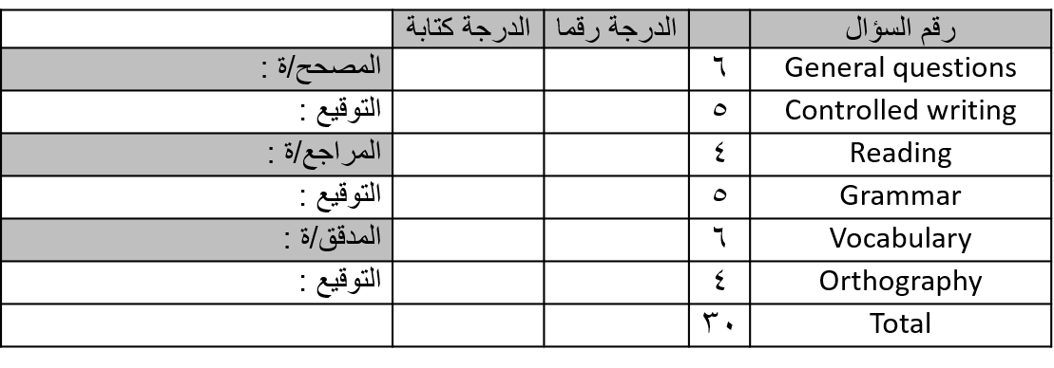
معلم/ ـة المادة: -

............................................
تعليمات عامة: -
- يسمح بالقلم الأزرق فقط.
- لا يسمح بالقلم الأزرق الذي يُمسح.
- لا يسمح باستخدام المرسام.
التوقيع: ..............................
التوقيع: ..............................
التوقيع: ..............................
جمع: ...............................
مراجعة: ...........................
تدقيق: ..............................
الاختبار النهائي لمادة اللغة الإنجليزية الصف ................... الفصل الدراسي الثاني للعام الدراسي1444 هـ
اسم الطالب / ـة ................................................................... رقم الجلوس ...................................

General Questions
6
A)- Choose the correct answer: -

1- How many seasons in the year?
a)- 12 seasons b)- 4 seasons

2- Good morning
a)- nice to meet you too b)- good morning

3)- whose book is this?
a)- It's Ahmed's b)- No, I don't

Grammar
5
A)- Choose the correct answer: -

are | is | am | 1)- She …………. playing
are | is | am | 2)- I ……………. sitting
are | is | am | 3)- They …………. cycling
is | an | a | 4)- watch out! It's …………. car
or | but | and | 5)- I have a sandwich …………. a juice

Reading short sentences
4
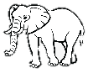
1)- Elephant is big
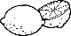
2)- Lemons are sweet
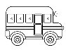
1)- It's a car
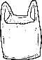
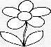
2)- Flowers are beautiful

B)- choose the correct answer: -

A)- Read the sentences the choose or :: -

Controlled writing
A)- Do as shown between brackets: -

5
 |  |  |  | 1)- is – He – playing (rearrange)
 | salty | hot | cold |  | 2)- Ice cream is
 | fall | spring | Winter |  | 3)- flower are out! it's
 | stop | wait | go |  | 4)- When you see a red light

Vocabulary
Cat – stars – bus – winter – strong – tiger
A)- Write the correct words under each picture: -

6

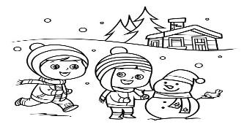 | 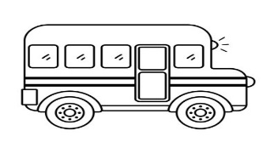 | 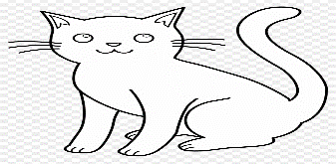
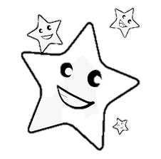 | 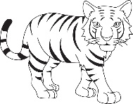 | 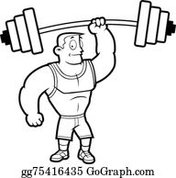

B)- Choose the correct answer: -

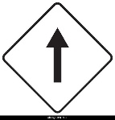  stop  Go straight | 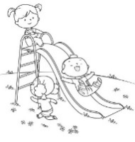  playing  walking | Bus  Car
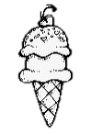  cold  hot | 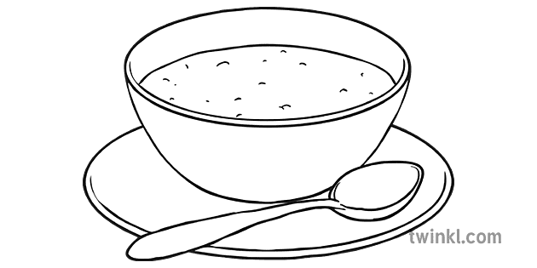  apple  soup | 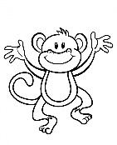  monkey  snake

Orthography
sh – oo – fl – gl – cr – sh – cl – ch – sl
A)- Fill in the missing letter: -

4
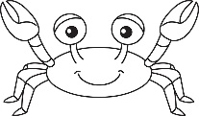 |  | 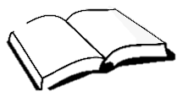
……ab | ……ass | b….k | …….ag
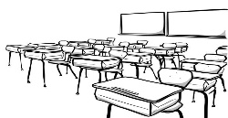 | 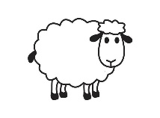 | 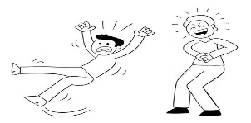 | 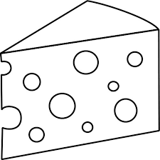
…..ass | ….. eep | …..ip | ……eese

Best of luck

