( Mega 2.1 )
U 2 , Reading
A – Answer the following questions :
1 – What is the detective’s name ?
………………………………………………………………………………………………………………………………………………………………
2 – Who was the first suspect of the burglary of the stolen jewels ?
…………………………………………………………………………………………………………………………………………………………………
3 – When did the case of the bowling alley murder happen ?
…………………………………………………………………………………………………………………………………………………………………
4 – What did the janitor find ?
…………………………………………………………………………………………………………………………………………………………………

B- Mach the words to their suitable picture :
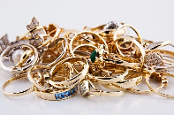
1 – detective ( )

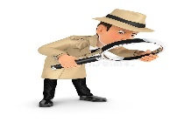
2 – Bowling alley ( )

3 – jewels ( )

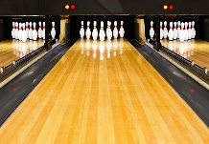
4 – janitor ( )

