We Can! Book 2 Unit 1: Toys and Things

1. Listen and number.

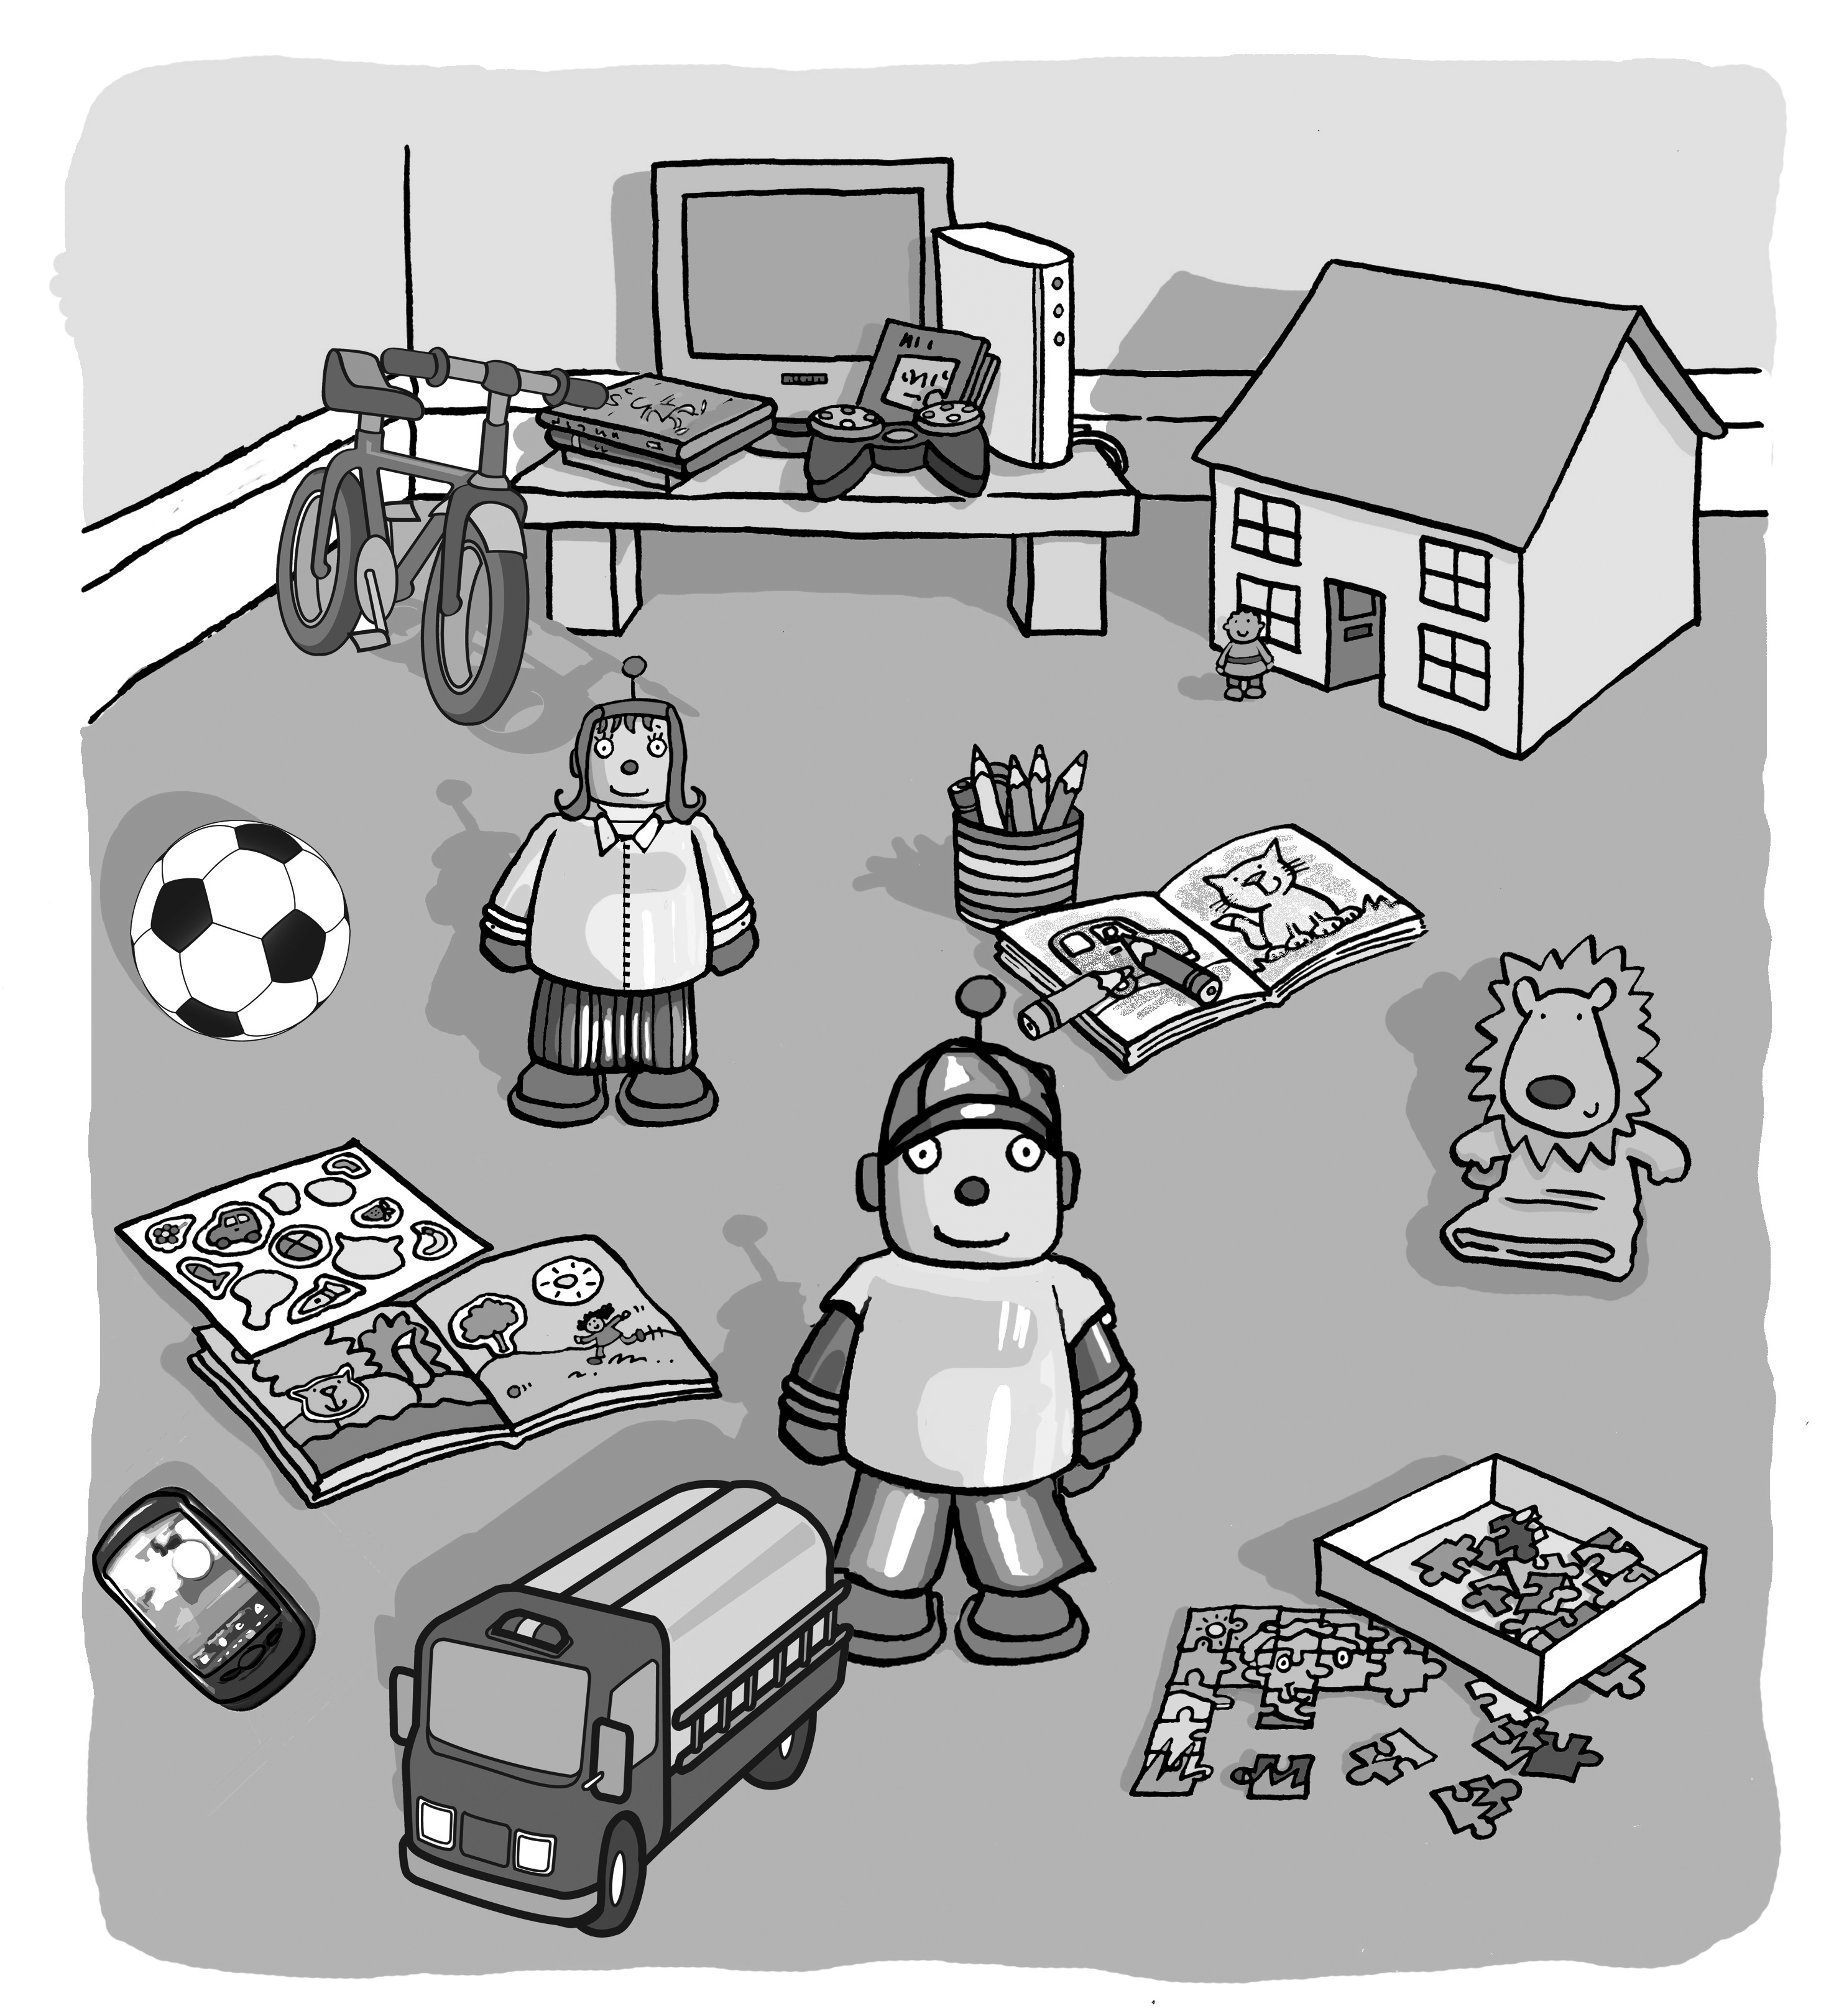

2. How many do you have? Count and write.
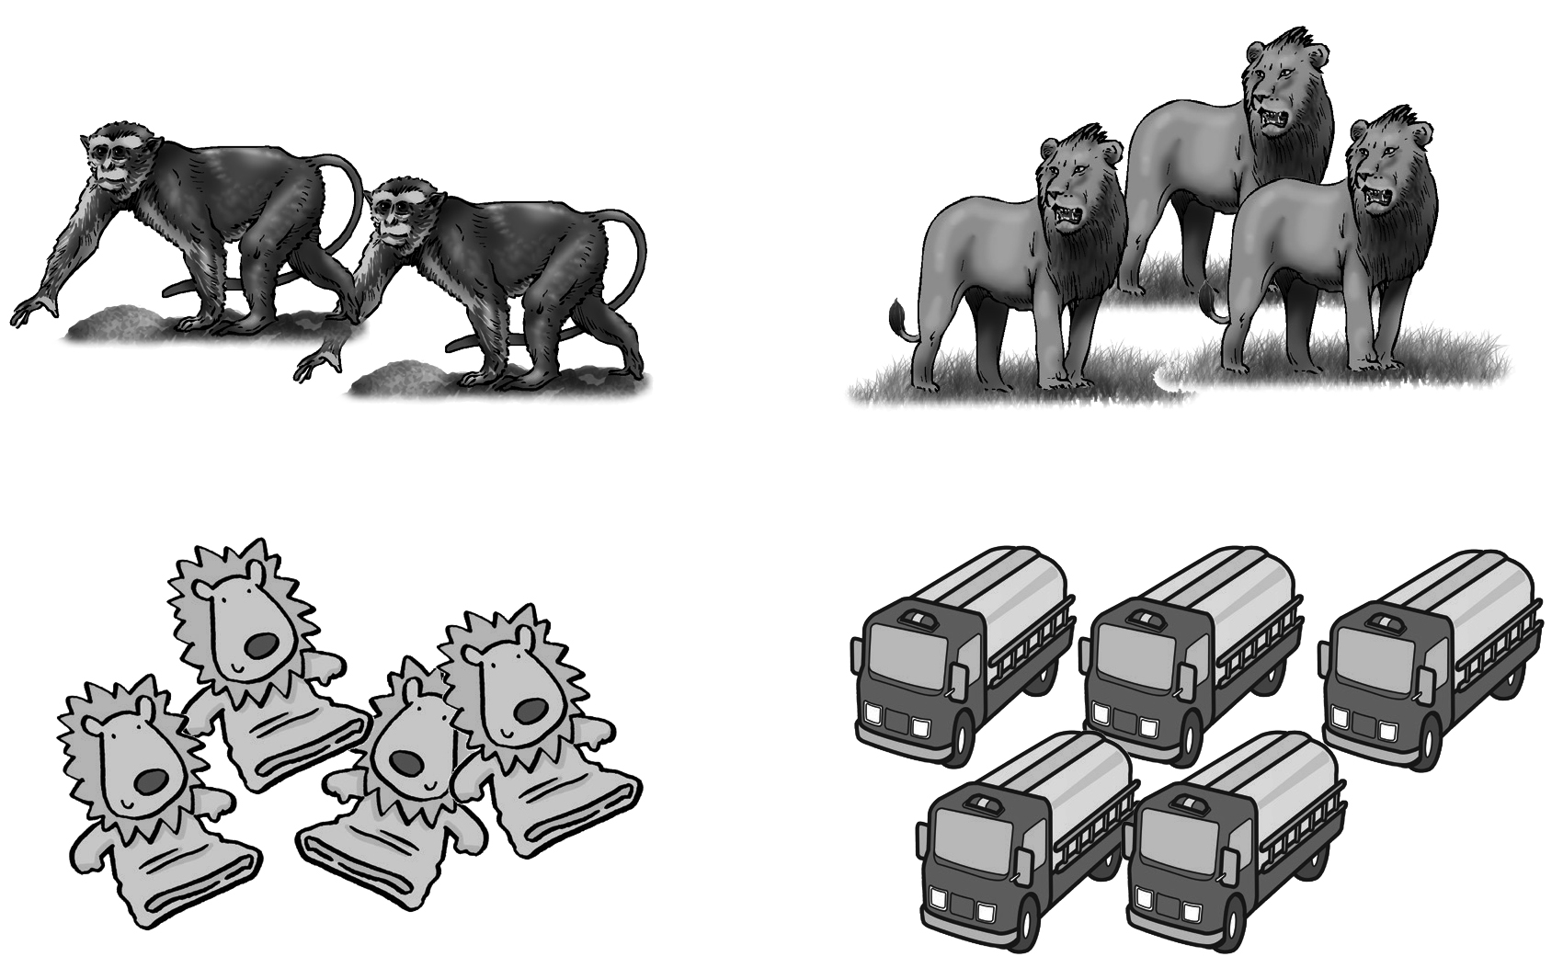
1 one 2 two 3 three 4 four 5 five

1. I have _______ monkeys.
2. I have _______ lions.
3. I have _______ puppets.
4. I have _______ trucks.
3. Draw and write.

I have __________________
4. Listen and number. Then write.

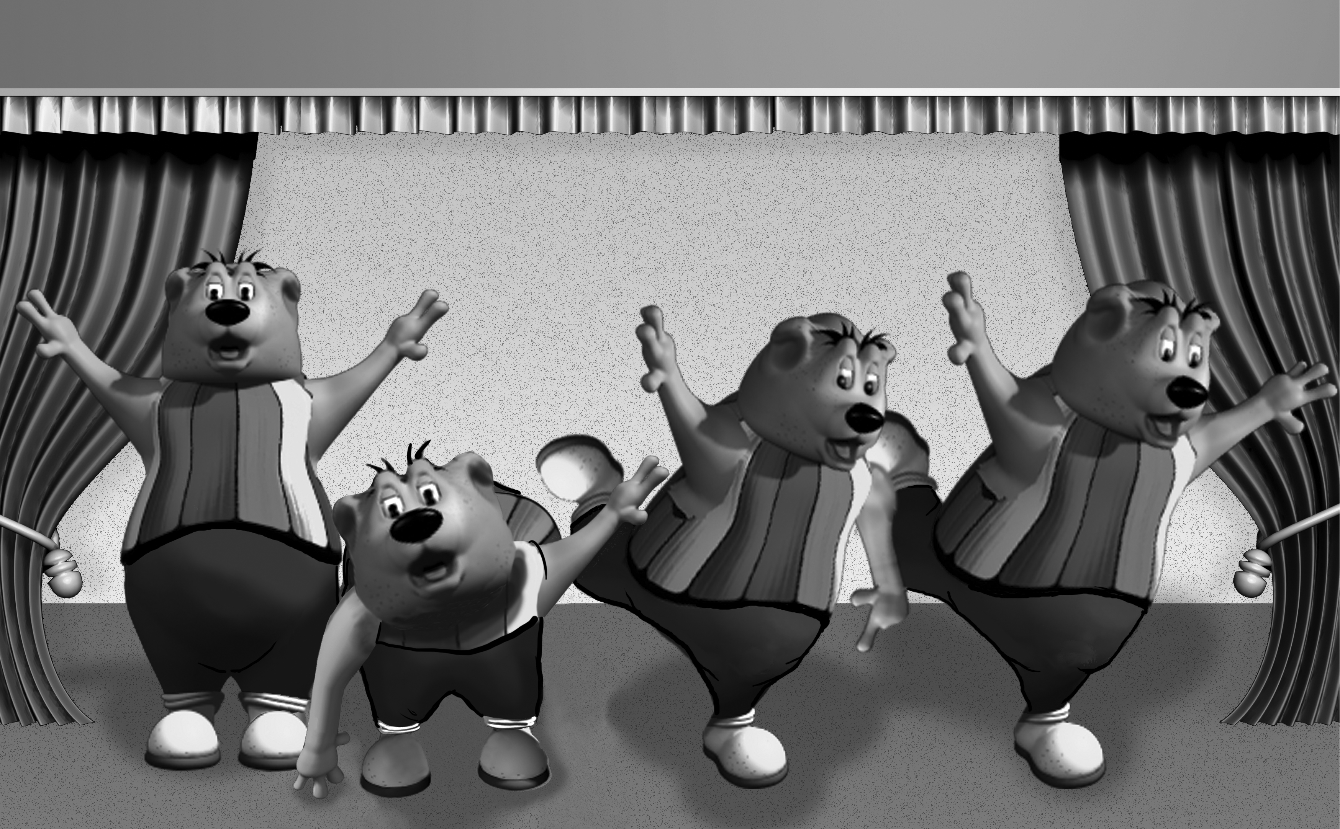

1. Robot bear, robot bear,
___________________.
2. Robot bear, robot bear,
___________________.
3. Robot bear, robot bear,
___________________.
4. Robot bear, robot bear,
___________________.

touch the ground __ | turn around __
show your shoe __ | you’re out, too __

