How is your result ?
Name : …………………………… Class : ………………
worksheet : ( 7 )
1 ) Match the words to the picture :
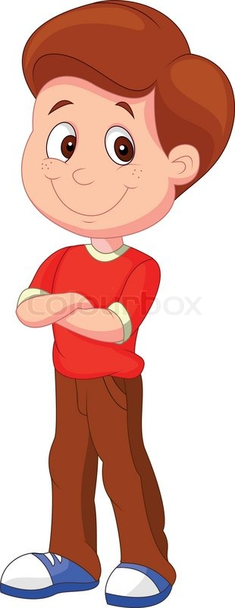
Knees – Head – Nose – Shoulders

