|  |  |  |  |  |
| --- | --- | --- | --- | --- |
| **المملكة العربية السعودية**  **وزارة التعليم**  **الإدارة العامة للتعليم .........** | **http://tabuk2day.com/wp-content/uploads/IMG_3362.jpg** **اختبار الفصل الدراسي الثاني**  **للعام الدراسي 1444 هـ** | **المادة** | لغة انجليزية | |
| **الصف** | الثاني المتوسط | |
| **الزمن** | ساعة ونصف | |
| **الدور** | الأول | |
| **الاسم: .............................................................................................................** | | | | |

**30**

1. **Composition**

***Write a paragraph about (* yourself *) not less than 6 sentences using the following words .***

**6**

***( name – age – favorite sport – live –like )***

…………………………………………………………………………………………………………………………………………………………………………………………………………………………………………………………………………………………………………………………………………………………………………………………………………………………………………………………………………………………………………………………………………………………………………………………………………………………………………………………………………………………………………………………………….

**6**

**2. Reading Comprehension**

**Read the passage and answer the questions below :**

**Every Thursday, Mr. Saleh goes shopping. He likes to buy things from the supermarket near his house. It is a big supermarket. He buys meat, fruit, milk and vegetables for the week. Today, two of his children are going with him, Maram and Basil. Maram wants to buy biscuits for her sister Hanan. Basil wants to buy ice-cream. Basil does not have much money. He asks his father to give him some money.**

**Answer :**

**1- What does Mr. Saleh like to buy ? .....................................................................**

**2- Where is the supermarket ? ...............................................................**

**Choose :**

**3- Mr. Saleh likes to…………… things from a supermarket. ( buy - drink - eat )**

**4- Basil asks his father to give him some ( money - milk - ice-cream )**

**5- Today, two of his ……… are going with him. (children - friends teachers)**

**6- It is a ……………… supermarket. ( good - big - small )**

**7**

**3. GRAMMAR**

**Choose the correct words :**

**1- Where ( was - were - am ) the football game ?**

**2- ( What - Why - Who ) are you warried ?**

**3- He didn't see the stop sign ( so - and - because ) he caused an accident .**

**4- He ( go - went - goes ) swimming three times a week .**

**5- Why ( don't - doesn't – doing ) you put on a sweater ?**

**6- You ( should - must - well ) stop at the traffic light .**

**7- The jacket is ( too - to - two ) small for me .**

**7**

**4. Vocabulary**

**A-Match the meaning and the responses to the situations :**

|  |  |  |  |
| --- | --- | --- | --- |
| **1** | **stuff** |  | **Things in general** |
| **2** | **Let down** |  | **Disappoint someone** |
| **3** | **Nothing much** |  | **Not a great amount** |
| **4** | **Why are you warried ?** |  | **Because I have a test tomorrow** |

**B-Match the picture with words:**

**( Sleepy - Scared - Angry )**

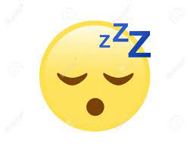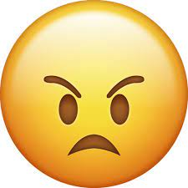

………………………………. ………………………… ....................................

**5. orthography**

**Write the missing letters :**

**4**

**1-e_e ( y – a ) 2- d_st ( u - m )**

**3- be_ts ( l- m) 4- n_se ( o - f)**

**انتهت الاسئله**