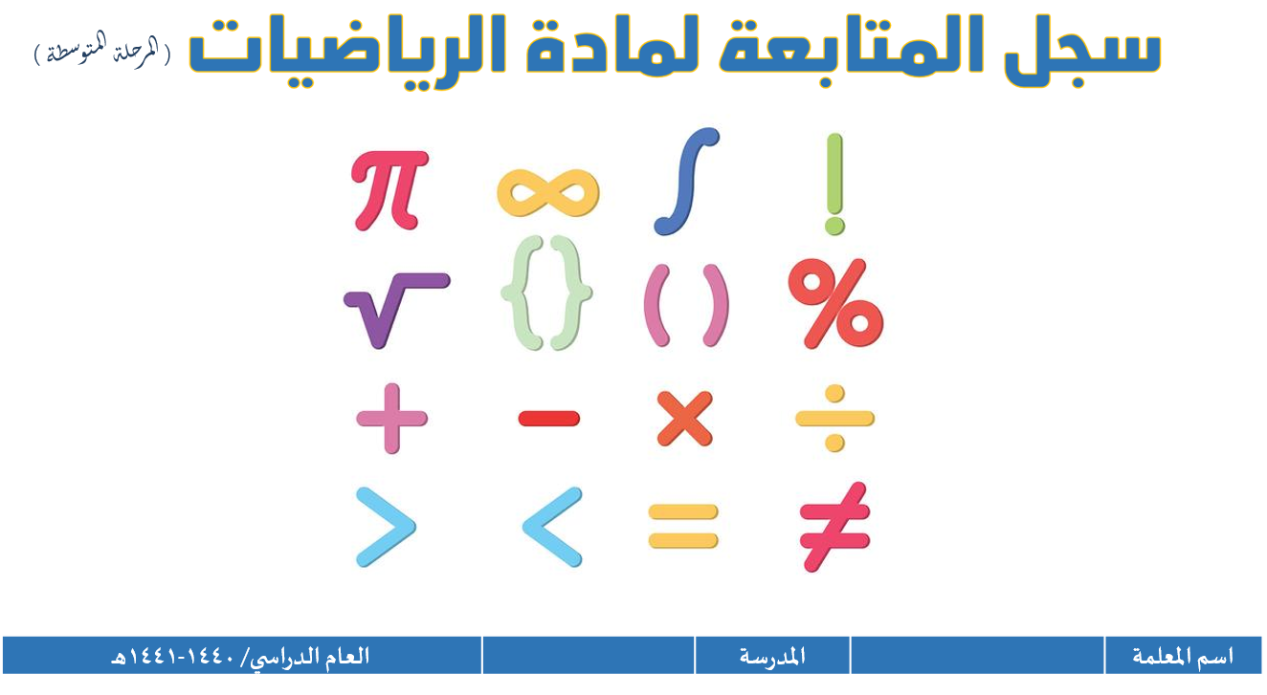

**( المرحلة المتوسطة )**

|  |  |  |  |  |  |
| --- | --- | --- | --- | --- | --- |
| **اسم المعلم / ة** |  | **المدرسة** |  | **العام الدراسي** | **1445 هـ** |

|  |  |
| --- | --- |
| الفصل الدراسي الثالث | الصف: / |

|  |  |  |  |  |  |  |  |  |  |  |  |  |  |  |  |  |  |  |  |  |  |  |  |  |  |  |  |  |  |  |  |  |
| --- | --- | --- | --- | --- | --- | --- | --- | --- | --- | --- | --- | --- | --- | --- | --- | --- | --- | --- | --- | --- | --- | --- | --- | --- | --- | --- | --- | --- | --- | --- | --- | --- |
| **م** | **اسم الطالب/ة** | **أدوات التقويم المنوعة (40)** | | | | | | | | | | | | | | | | | | | | | | | | **40** | **الاختبارات التحريرية**  **القصيرة (20)** | | | | **المجموع**  **(60)** | |
| **المشاركة الصفية** | | | | | | | | | **10** | **الواجبات المنزلية** | | | | | | | | | | **10** | **المهام الأدائية** | | **20** | **1** | **2** | **3** | **20** |
| **1** |  |  |  |  |  |  |  |  |  |  |  |  |  |  |  |  |  |  |  |  |  |  |  |  |  |  |  |  |  |  |  |
| **2** |  |  |  |  |  |  |  |  |  |  |  |  |  |  |  |  |  |  |  |  |  |  |  |  |  |  |  |  |  |  |  |
| **3** |  |  |  |  |  |  |  |  |  |  |  |  |  |  |  |  |  |  |  |  |  |  |  |  |  |  |  |  |  |  |  |
| **4** |  |  |  |  |  |  |  |  |  |  |  |  |  |  |  |  |  |  |  |  |  |  |  |  |  |  |  |  |  |  |  |
| **5** |  |  |  |  |  |  |  |  |  |  |  |  |  |  |  |  |  |  |  |  |  |  |  |  |  |  |  |  |  |  |  |
| **6** |  |  |  |  |  |  |  |  |  |  |  |  |  |  |  |  |  |  |  |  |  |  |  |  |  |  |  |  |  |  |  |
| **7** |  |  |  |  |  |  |  |  |  |  |  |  |  |  |  |  |  |  |  |  |  |  |  |  |  |  |  |  |  |  |  |
| **8** |  |  |  |  |  |  |  |  |  |  |  |  |  |  |  |  |  |  |  |  |  |  |  |  |  |  |  |  |  |  |  |
| **9** |  |  |  |  |  |  |  |  |  |  |  |  |  |  |  |  |  |  |  |  |  |  |  |  |  |  |  |  |  |  |  |
| **10** |  |  |  |  |  |  |  |  |  |  |  |  |  |  |  |  |  |  |  |  |  |  |  |  |  |  |  |  |  |  |  |
| **11** |  |  |  |  |  |  |  |  |  |  |  |  |  |  |  |  |  |  |  |  |  |  |  |  |  |  |  |  |  |  |  |
| **12** |  |  |  |  |  |  |  |  |  |  |  |  |  |  |  |  |  |  |  |  |  |  |  |  |  |  |  |  |  |  |  |
| **13** |  |  |  |  |  |  |  |  |  |  |  |  |  |  |  |  |  |  |  |  |  |  |  |  |  |  |  |  |  |  |  |
| **14** |  |  |  |  |  |  |  |  |  |  |  |  |  |  |  |  |  |  |  |  |  |  |  |  |  |  |  |  |  |  |  |