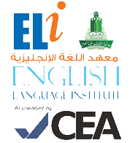
رؤية جامعة الملك عبد العزيز
منارة في المعرفة
تكامل في التكوين
ريادة في التنمية
رسالة جامعة الملك عبدالعزيز
الرقي بالمجتمع عبر تميز ثقافي و علمي و بحثي رائد
Grammar and
Vocabulary Practice
102

Student’s Name: __________________ Level: 102 Section: ____________

- Grammar Section (Units 1, 2 & 3)
Complete the conversation with the correct form of the verb between brackets:

- A. ______________ you Rob’s friend? (Be)
- B. No, I __________. I__________ his boss. (be)

Choose the correct answer:
- How ______________ meat do you eat?
a. many b. some c. much d. any

- What are you ______________ at the weekend?
a. do b. done c. doing d. to do

- Vocabulary Section (Units 1, 2 & 3)
Choose the correct word to complete each sentence:

learning driving shopping

- I enjoy going _______________ at Red Sea Mall.
- Rahaf loves _______________ new things.
- Sameer likes _______________ in the desert.

