Name :…………………………………………………………………… Class:…….……….
Super Goal 1 - Test unit 1 & 2

Reading
2 Marks
- Read the text and answer the questions. Write T or F at the end of each question/statement.
My name is Mariam. I am 13 years old. My birth date is in the ninth month of the year. It is on September 4th. My best friends’ names are Carla and Jane. They are 14 years old. Carla’s birth date is on June 3rd. Jane’s birth date is on March 31st. We are students in Mrs. Jenkin’s English class. Our class is on Mondays, Tuesdays, and Wednesdays.
- Mariam, Carla, and Jane are teenagers. ( )
- Mariam is a student, but Carla and Jane are not students. ( )
- Jane’s birth date is in the 11th month of the year. ( )
- Mariam’s birth date is in the 9th month of the year. ( )
Grammar
5 Marks
- Choose the best answer to fill in the blank in each question.
- Mr. Smith _____ a teacher.
a. am b. is c. his d. are
- _____ students.
a. I’m b. He’s c. Are d. They’re
- Asma and Nura are _____.
a. friend b. friends c. is friend d. are friend
- Their final test is __________ April 14th.
a. in b. on c. am d. are
- His driving test is __________ November.
a. on b. are c. in d. am

- Complete the sentences with possessive adjectives.
1.5 Marks
- He is a student. __________ name is Ahmad Saleh .
- I am a teacher, ____________ name is Rashed Alsulami .
- He`s the director. __________ name is Mr. Abdulaziz Alshehri

- Complete the question, use ( What – When – How old ).
1.5 Marks
- ________________ is your vacation? - our vacation is in May .
- __________________ are you ? - I'm fifteen .
- _________________ is the date tomorrow ? - It's 20th September .

Vocabulary
- Choose the best answer to fill in the blank in each question.
5 Marks
- See you _____, Faisal.
a. bye b. later c. night d. goodbye
- Good _____, Mr. Ali.
a. days b. meet c. hello d. evening
- Nice to _____ you, Mona.
a. meet b. name c. friend d. call
- June is the __________ month of the year.
a. Second b. first c. twelfth d. sixth
- Today is Tuesday. __________ is Wednesday.
a. Tomorrow b. Today c. Yesterday d. Month

- Write the correct word under the picture.
3 Marks
Pencil – Turtle – Calendar

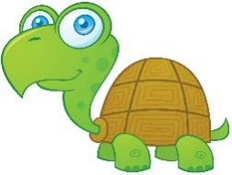
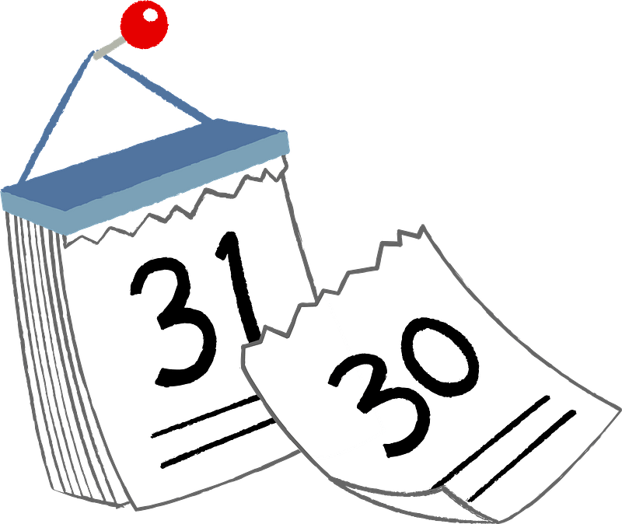

…………………………..…………………….

…………………………..…………………….

…………………………..…………………….

- Choose the correct letter.
2 Marks
- Nice to meet …ou ( v – y – r )
- He is so c….te ! ( y – u – c )

