We Can! Book 4 Unit 3: My House

1. Listen, unscramble the letters, and write the words.

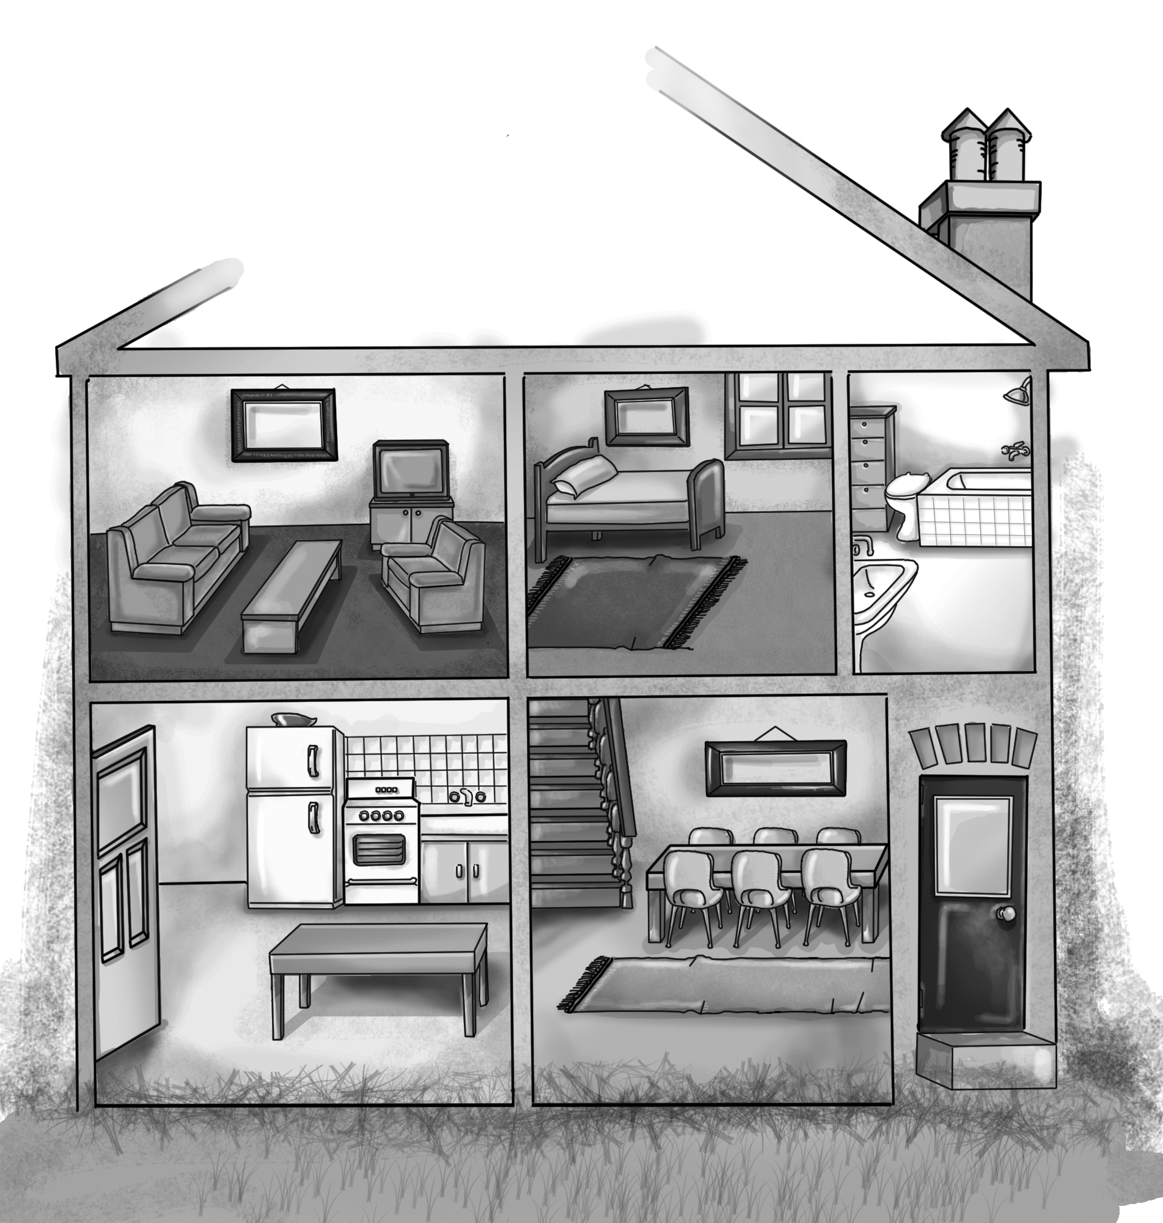  [Play CD1 26 (first part) or read.] | 1.trofn rodo  front door  2. nindig mroo  dining room  3. ntiheck  kitchen  4. rbohotam  bathroom  5. erobdom  bedroom  6. ngviil moro  living room
2. Read and circle T or F for each sentence.
1. There is a TV between the sofa and the armchair. T F
2. There is a rug under the bed. T F
3. There is an armchair opposite the sofa. T F
4. There is a rug in front of the bed. T F
5. There is a fridge behind the door. T F
3. Listen and number the pictures. Then write.
[Play CD2 21 (first part) or read.]
Mom | Joe | the boy | Joe
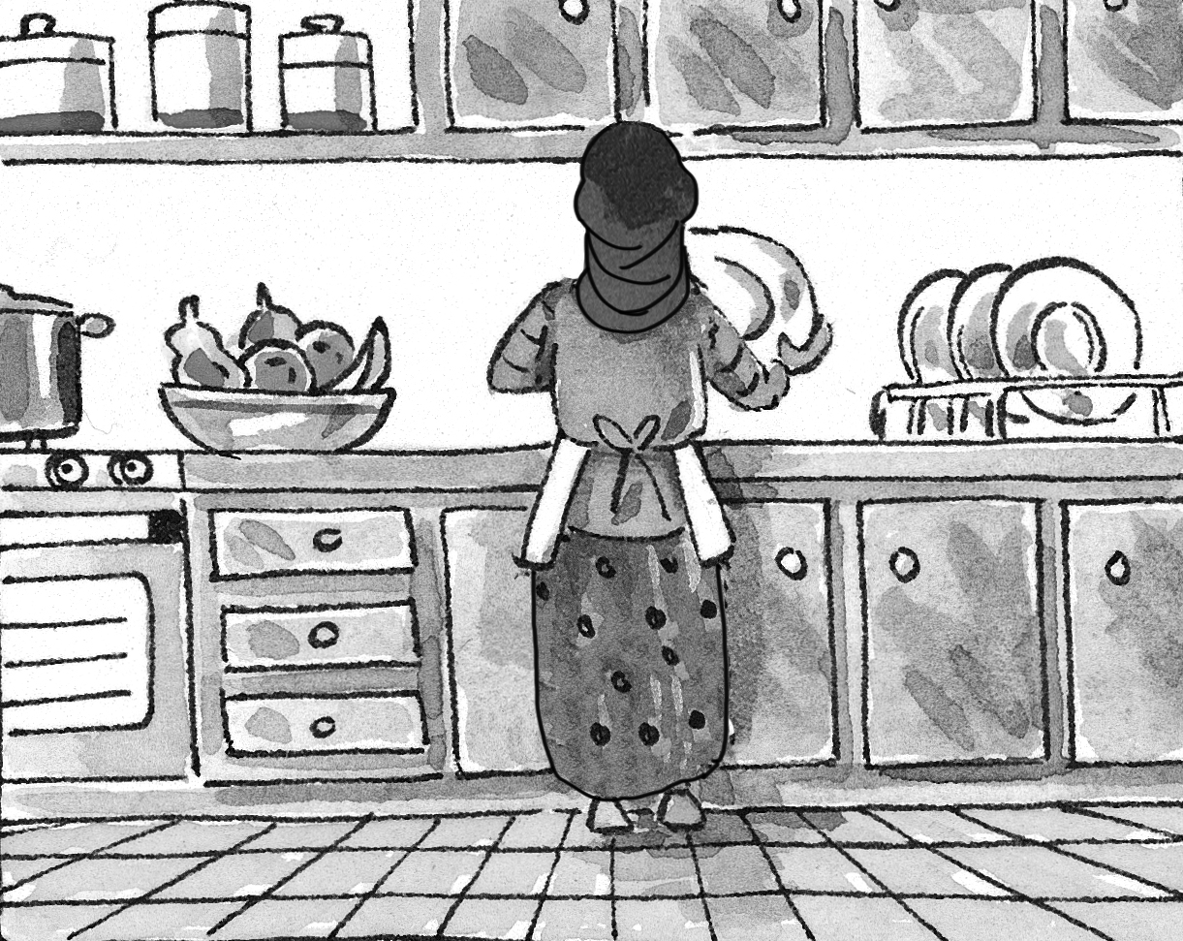 | 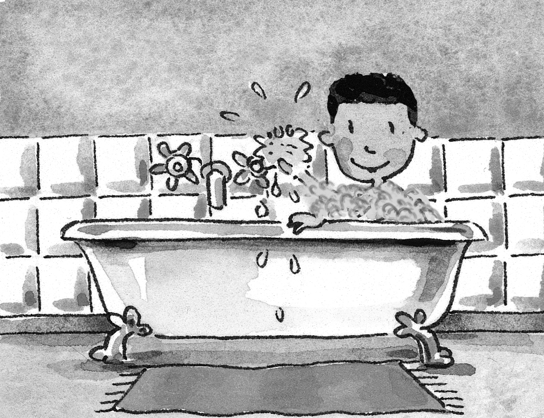 | 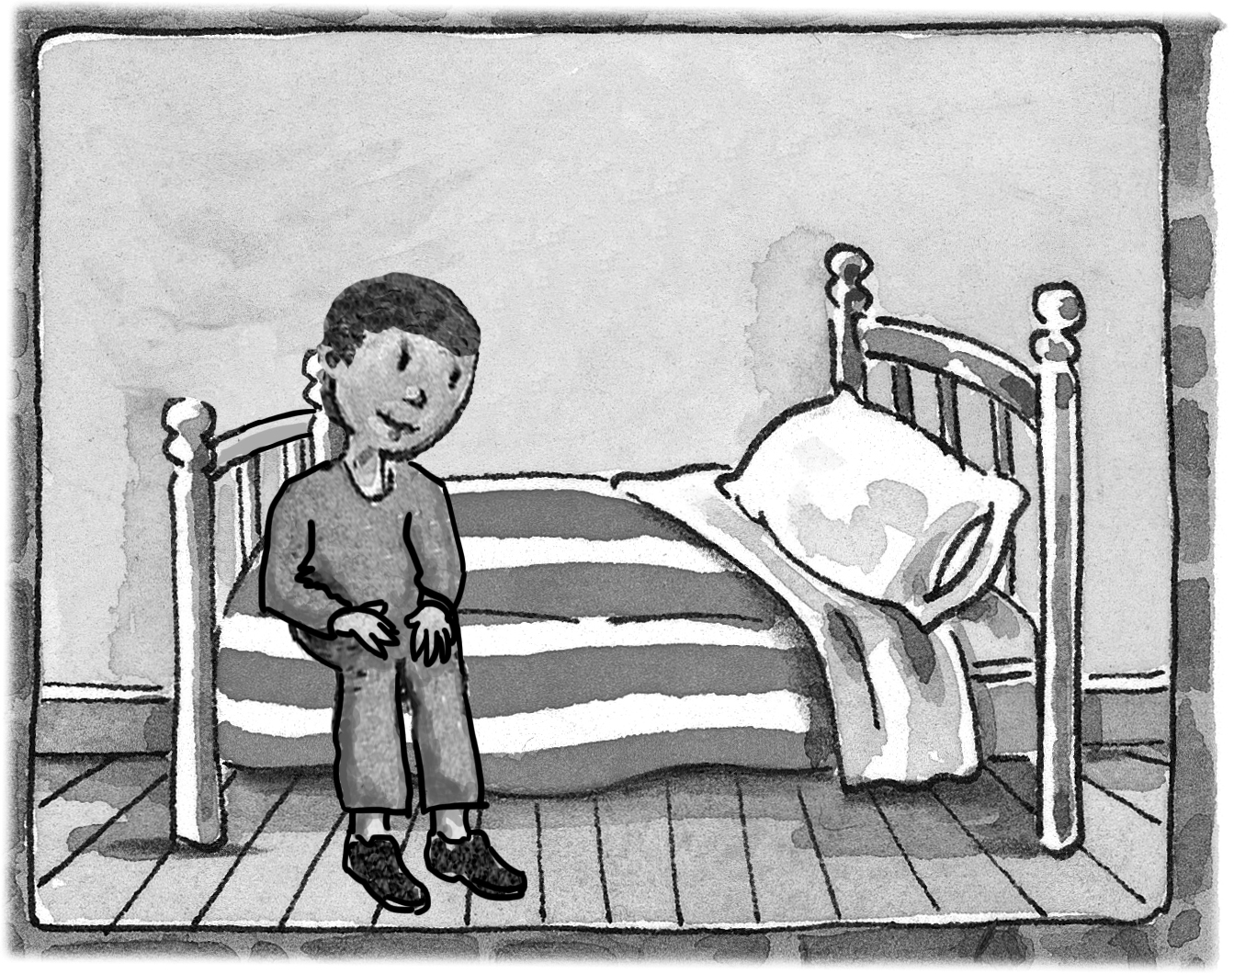 | 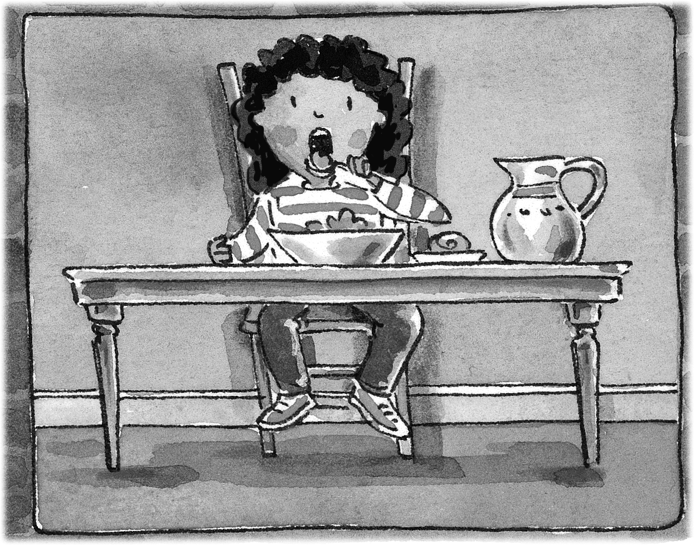
2 | 1 | 4 | 3
1. Where’s Joe? He’s in the bathroom
2. Where’s Mom? She ‘s in the kitchen.
3. Where’s Joe? He’s in the dining room.
4. Where’s the boy? He’s in the bedroom.
4. Match the words with the pictures. Then write.

do my homework __ eat lunch __ get up __ play __
go to bed __ go to school __

I get up at 7 o’clock. | Then I go to school.
I eat lunch at 2 o’clock. | 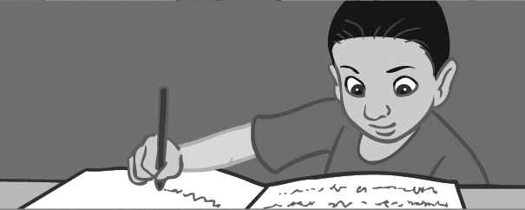  Then I do my homework.
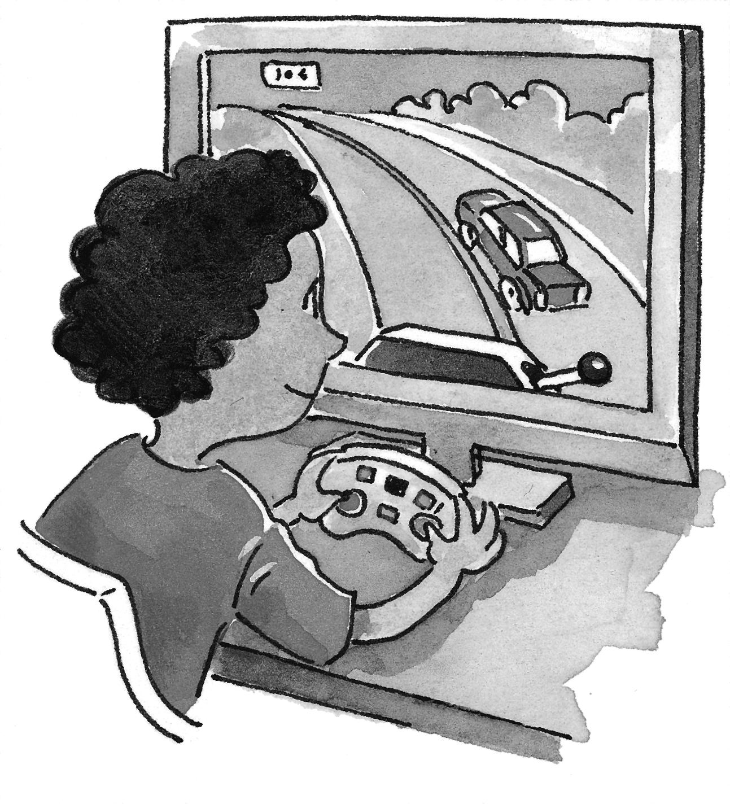  I play computer games and watch TV. | At night I go to bed.

