
اسم الطالب ……………………………………………………………………….……………………………….…………الصف……………………………….


Match the questions to the answers:ضع رقم السؤال في مربع الجواب المناسب

1-What is your favorite story? In my free time I play video games.

2- Which activities do you do in your free time? My favorite story is The City Mouse.

Choose the correct answer:ضع دائرة على الإجابة الصحيحة


- I ( play – played) tennis yesterday.
- She didn’t ( drop – dropped ) the glass.
- Did he ( call – called ) you last night?
4-I ( go – went ) to Makkah last week.
5- Did you ( win – won ) the game?
6- We didn’t ( see – saw ) Ahmed yesterday.

carry

shout
Circle the correct word:ضع دائرة على الكلمة المناسبة
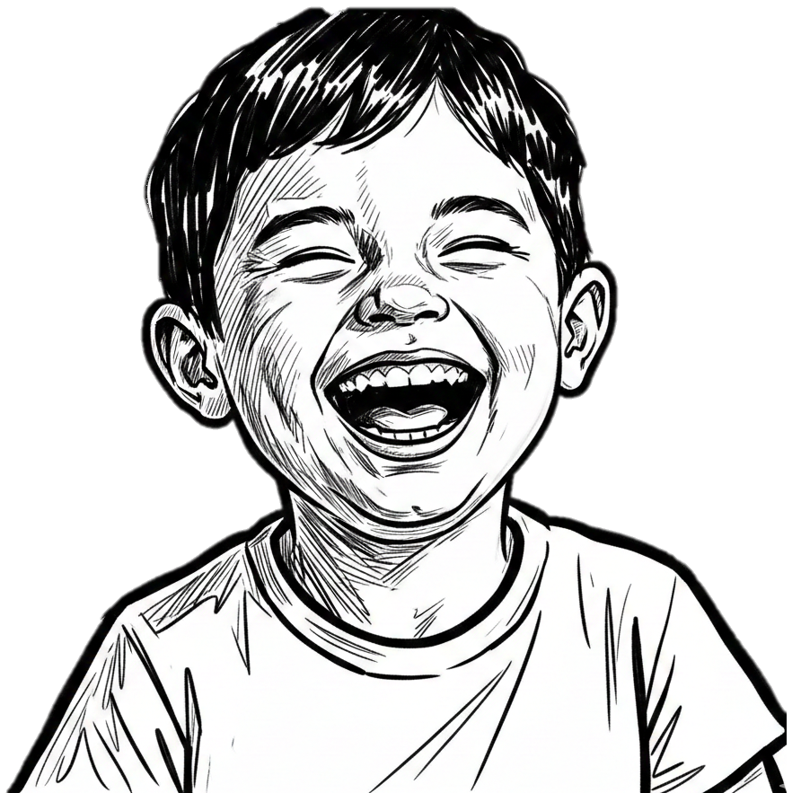  eat  laugh | play  dreamed | 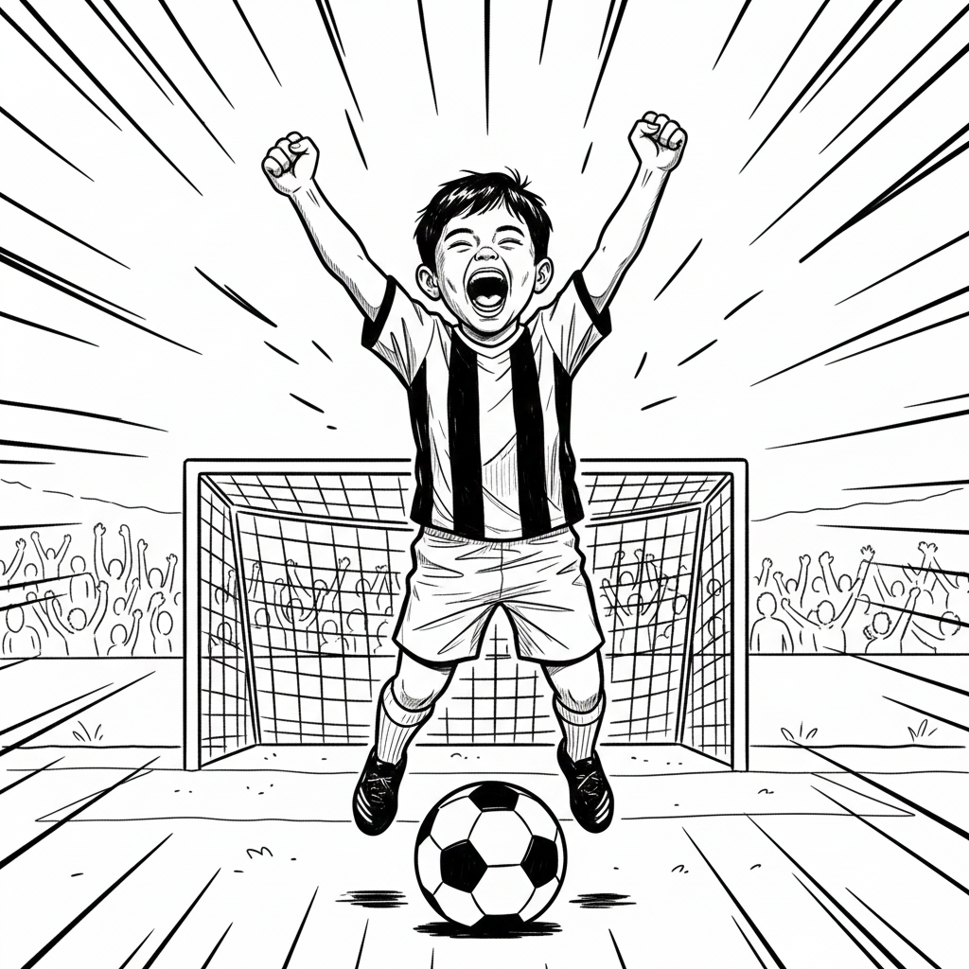  sleep  score | 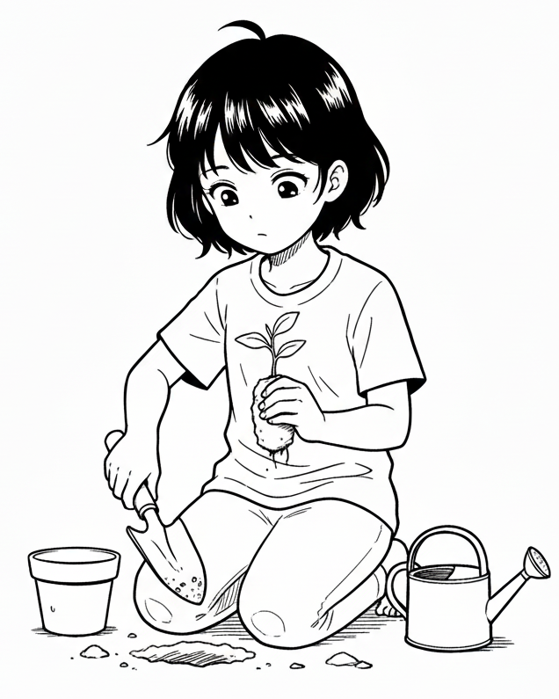  plant  cook | 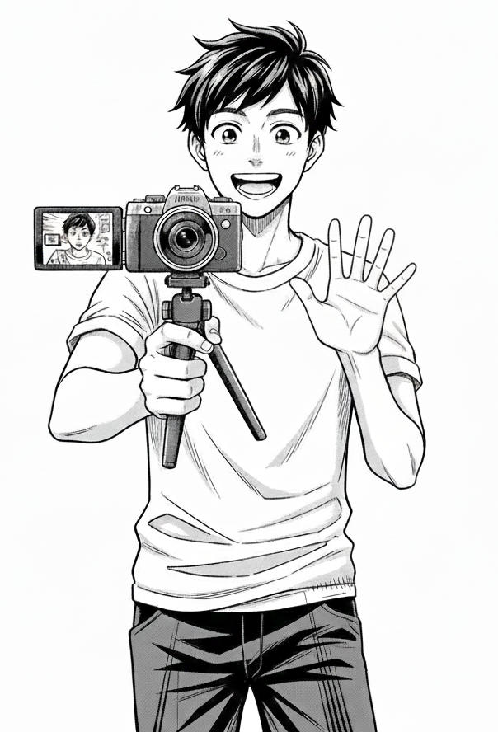  a  vlogging  hide | 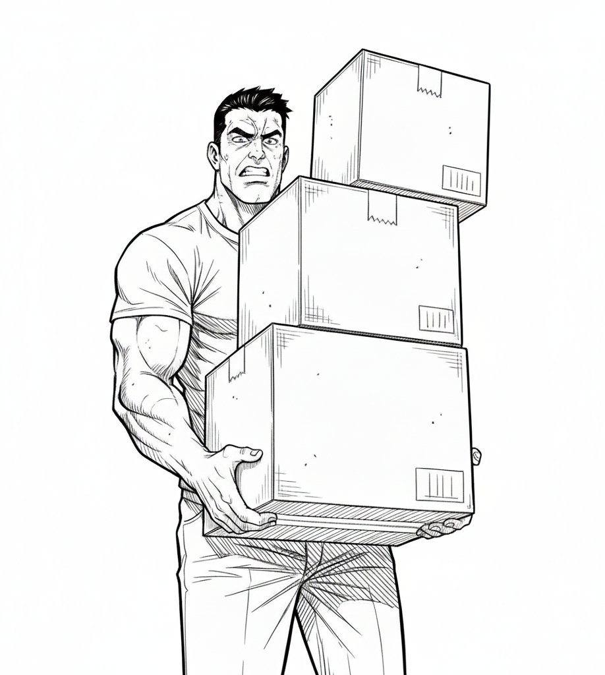

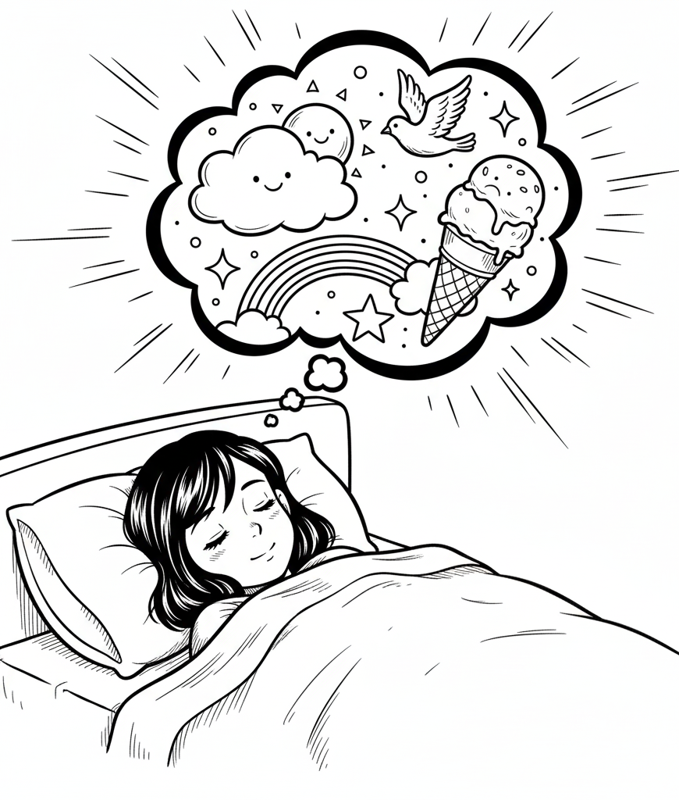

Circle the missing letter:ضع دائرة حول الحرف المفقود
Tex_ing    n  t |   Wate_ed  r  k | 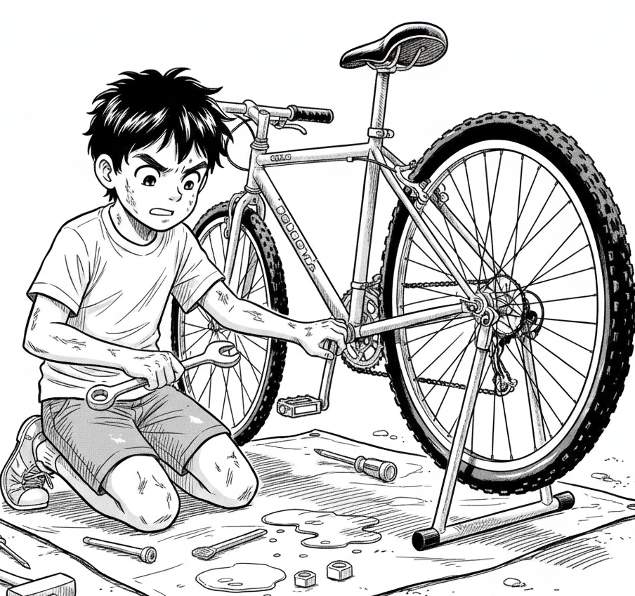  f_x  i  g | 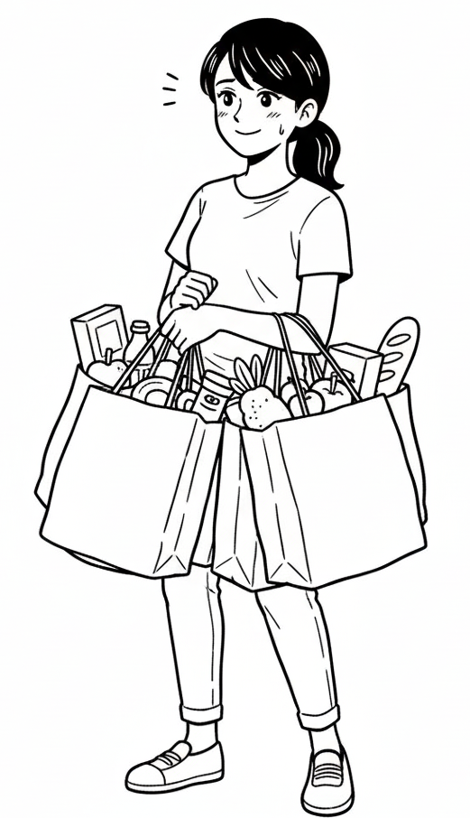  _hopping  sandwich  cookies  v  z

