|  |  |  |  |
| --- | --- | --- | --- |
| **المملكة العربية السعودية**  **وزارة التعليم**  **الإدارة العامة للتعليم ب..... ابتدائية ....** | **http://tabuk2day.com/wp-content/uploads/IMG_3362.jpgبسم الله الرحمن الرحيم** **اختبار الفصل الدراسي الأول**  **للعام الدراسي 1444 هـ** | **المادة** | لغة انجليزية |
| **الصف** | السادس |
| **الزمن** | ساعة ونصف |
| **الدور** |  |
| **الاسم: .............................................................................................................**   |  |  |  |  |  |  |  |  | | --- | --- | --- | --- | --- | --- | --- | --- | | **Total** | **6** | **5** | **4** | **3** | **2** | **1** | **Question** | |  |  |  |  |  |  |  |  | |  | | **Revised by:** | |  | | **Corrected by:** | | | | | |

**Q1General Questions:**

**6**

**A. Choose the suitable answer:**

1. **Where do you live ?**
2. I live in Qassim. **b-** I’m eleven years old. **c**- My name’s Ali.
3. **Whose shoes are these?**
4. They’re Steve’s**. b-** My name’s Hashim. **c**- Thank you.
5. **How do you go to school?**
6. I have one brother. **b-** I live in Makkah. **c-** by school bus.
7. **How old are you?**

**a-** I’m 13 years old. **b**- Thank you **c-** welcome

1. **What sport do you like?**

**a-** I like tennis **b-** Yes, I do **c-** I like English

1. **What chores do you like?**

**a-** No, I don’t **b-** I like washing dishes **c-** Nice to meet you

1. **Nice to meet you.**

**a-** thank **you b-** nice to meet you too. **c-**. Yes, I do

1. **What do you think about sharks?**

**a-** I think they’re scary **b-** yes, they are **c-** No, they aren’t

**B. Answer**

1- Do you like playing football? ……………………………………..

2- What do you think about seals? I think they’re ……………………..

**Q2.Controlled writing:**

**5**

**A-Match:**

|  |  |  |
| --- | --- | --- |
| feed |  | **1-**I think dolphins are _________. |
| golf |  | **2**-I’d like to try photography but I have no_______. |
| fast |  | **3**I usually ______________ the fish |
| camera |  | **4**- Does your brother play_______________. |

**B-Rearrange**

1. Riyadh – in – I – live . ……………………………………………………………
2. Like - basketball – I. …………………………………..….……………………..
3. is – think – I – seahorse – slow. ……………………………………………………

**5**

**Q3-Grammar:**

1. **Choose the correct answer:**
2. Seals are **(cute – cuter – cutest*)*** than starfish.
3. **(Who – What – How)** do you go to school?
4. Dolphins ( **is – are** - **am** ) cute.
5. A whale ( **is – are - am** ) big.
6. I (  **have – has** - **is** ) a bicycle.
7. Whose skirt is this ? It is ( **Nura – Nura's**).
8. My sister is a doctor. ( **Her – His -My** ) name is Nora.
9. They are my sisters. ( **My - Their – its** ) names are Nora and Alia.
10. She **( have – has – am)** a doll.
11. I think the whale is the **( big – biggest – bigger)** sea animal.

**6**

**Q4: Vocabulry:**

**Write the correct number under each picture:**

1.bicycle 2. Shark 3. Rain 4. Tie 5. Scuba diving 6.jellyfish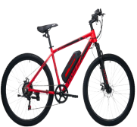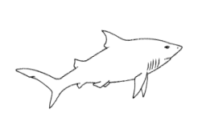

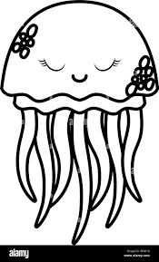

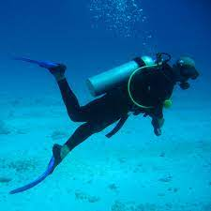

**( ) ( ) ( ) ( ) ( ) ( )**

**Q5: Reading:**

**4**

1. **Write the correct number under each picture:**
2. I am washing the dishes.
3. I like playing tennis.
4. I think whales are the biggest sea animals.
5. Bungee jumping is a dangerous sport.

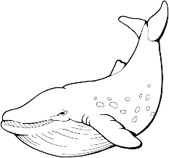 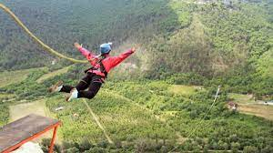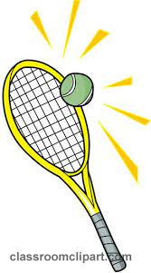

( ) ( ) ( ) ( )

**4**

**Q6: Orthography**

1. **Complete the missing letter :**

**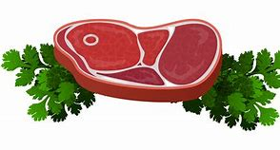****[ ee / ea / ie / i-e ]**

1) m__ __ t 2) p __n __ 3) sl__ __ p 5) p__ __

1. **Fill in the missing letters with [ oi / oy ]**

|  |  |
| --- | --- |
| **1. b____** | **3. c____n** |

1. **Unscramble**

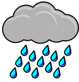

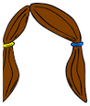

(nair) ……………… (aihr)………….

**Best Of Luck**