English Language  1st Secondary Grade, 1443-1444  Quiz 1, 2nd Term  Mega Goal 1.2 | الإجابة في ورقة التظليل الخارجية | Kingdom of Saudi Arabia  Ministry of Education  … Secondary School  نموذج  Taif . (A)
Mark: | Class | Name
1. Comprehension
Read the following passage to answer the questions:
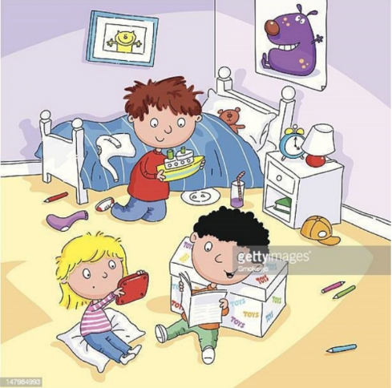
Our Room
My name is Tony, and they are my two siblings Ana and George. We are in our room. My hair is black, but Ana and George are very different. His hair is brown and her hair is yellow. He is a brunette. She is a blonde.
This is our room. It isn’t clean and organized. It is very messy and dirty. There are three beds and bedside tables but their beds aren’t in the photo. There is a white trunk with our toys, and there is a lamp and alarm clock on my table.
On the walls, there are two pictures, one poster of a purple monster and one photograph of our cat. Its name is Mr. Whiskers, it is 10 years old and it is a very nice cat. Its hair is soft and yellow and its teeth are very big.
Our toys are in the big, white trunk, but Ana prefers coloring pencils. Her pencils are on the floor.
George loves his boat; his boat is yellow and big. My favorite toys are my teddy bear, on the bed and my mystery books. Our room is our favorite place.
Questions:
- Put (T) for true sentences and (F) for false ones:
- Tony's hair is black. □ T □ F
- George is a brunette. □ T □ F
- Their room is very messy and not organized. □ T □ F
- There are two pictures on the wall. □ T □ F
- His teddy bear's name is Mr. Whiskers. □ T □ F

يتبع
3. Grammar

- Choose the correct form of the verb :

- I bought ……………. a new computer.
- herself | - myself | - himself | - itself
2. He was ill …………….he didn’t go to school yesterday.
- so | - because | - after | - before
3.You must………………….. your parents.
- respects | b. respecting | c. respect | d. respected
4. She must eat ………………to stay fit and healthy.
a. well | b. good | c. best | d. better

4. Vocabulary
- Match the word in (A) with its meaning in (B) :

A |  | B
1. stuck in |  | a. tired
2. fatigue |  | b. a day of a good fortune
 |  | c. unable to move out

- Choose the correct word under each Picture:

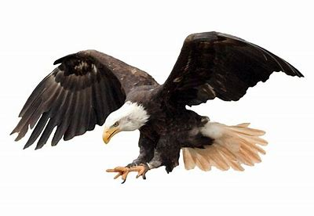  - 1. | 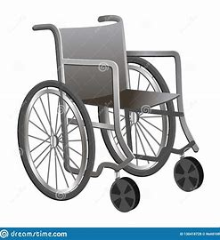  2. | 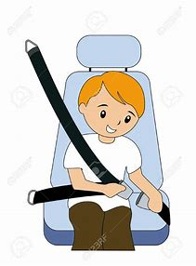 | 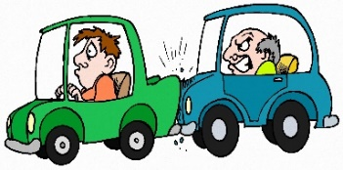
a. eagle | a. knee pads | a. pills | a. socket
b. tortoise | b. cast | b. seatbelt | b. skateboard
c. squirrel | c. wheelchair | c. matches | c. snowstorm
d. helmet | d. dynamite | d. accident | d. tailgating

☺The End ☺
انتهت الأسئلة

