

**المادة : اللغة الإنجليزية**

**المدرسة :**

**زمن الإختبار: ساعة و نصف**

**المملكة العربية السعودية**

**وزارة التعليم**

**إدارة التعليم**

**نهاية الفصل الدراسي الثالث ( الدور الأول ) للعام الدراسي 1443 ه للغة الإنجليزية للصف الخامس الإبتدائي**



|  |  |  |  |
| --- | --- | --- | --- |
| **السؤال** | **الدرجة رقماَ** | **الدرجة كتابة** | **المصححة** |
| **General Questions** | **6** |  | **الإسم : هلل آل منجم** |
| **Controlled writing** | **5** |  | **التوقيع :** |
| **.Reading short s** | **4** |  | **المراجعة :** |
| **Grammar** | **5** |  | **الإسم : نورة البعيمي** |
| **Vocabulary** | **6** |  | **التوقيع :** |
| **Orthography** | **4** |  |  |
| **مجموع الاختبار التحريري** | **30** |  |  |
| **Listening** | **5** |  | **المدققة :** |
| **Speaking** | **5** |  | **الإسم :** |
| **المجموع النهائي** | **40** |  | **التوقيع :** |

**Q1- General Questions**

**6**

**Choose the correct answer : A-**

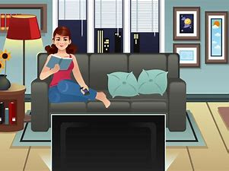

|  |
| --- |
| **1 - Do you watch TV in the evening ?**  **Yes, I am .**  **Yes, I do.** |
| **A. B. C.**  **No, I don't** |
| **2 - Can kangaroos fly ?** |
| **A. B. C.**  **No, they can't**  Y**es, they can**. |
| **3 - Can I use your pen ?**  **They are** |
| **A. B. C.**  **car**  **thanks**  **Sure. Here you go**  النص هنا |
| **4 – Would you like to come to my house ?** |
| **A. B. C.**  **Yes, please**  **Yes, I do**  **I like ice cream** |

**1**

|  |  |
| --- | --- |
| **It's …………………………………** | **1 - What is this ?** |
|  | **2 – How do you spell (sun) ?** |
|  | **3 - What time is it?** |
| **............................................**  **It's ………………. O'clock** | **4 – Nice to meet you** |

**.......................................**

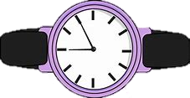

**Q2- Controlled writing**

**B - Answer the following questions :**

**5**

**A - Complete the following blanks :**

**Hospital – car – doctor – 7:30 am 6:00 pm -**

Simon is a _______ .He works in the ________ .Every day he goes

**_______ .**

to work by _______. He starts work at ________, He comes home at

**B – Do as shown between brackets :**

**3- at – I – get – 6 – up – o'clock. (Rearrange)**

|  |  |
| --- | --- |
| room sister day | . 1 -This is the living ………………. (Choose) |
| _____________________________ | **2 - are – What - ? – these ( Rearrange)** |
| _____________________________ |  |

**Q3 - Reading short sentences**

**4**

**A – Match :**

|  |  |  |
| --- | --- | --- |
|  |  | **1 – Snowy** |
|  |  | **2 – Rainy** |
|  |  | **3 – Cloudy** |
|  |  | **4 – Sunny** |
|  |  | **5 – Monday** |

**2**

**❌**



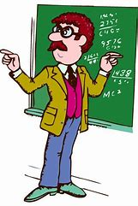

**3 - He is a teacher .**

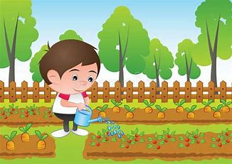

**2 - The boy is in the kitchen.**

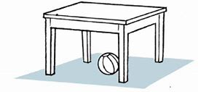

**1 - The ball is under the table**

✔️

✔️

✔️

✔️

❌

❌

❌

❌

**B - Read and put ✔️ or ❌:**

**4 – These are teeth**

**Q4 - Grammar**

**5**

|  |  |  |  |
| --- | --- | --- | --- |
| **is** | **are** | **am** | **1 - What …………… this ?** |
| **Book** | **wallets** | **a wallet** | **2 - They are ………………… .** |
| **Go** | **Does** | **Do** | **3- …………… he work in the office?** |
| **It's** | **He's** | **She's** | **4 - He is = ________** |
| **in** | **on** | **at** | **5 - I get up ……….. 6 o'clock .** |
| **in** | **have** | **has** | **6 - He …….. short hair .** |

**A - Read and choose the correct answer**

**B- Do as shown between braks :**

**1**- **They are MP3 players ________________ (change to singular)**

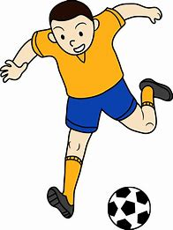

**2 – Does he play football ? ________________**

**(Answer)**

**Q5 - Vocabulary**

**A- Write the correct word under each picture :**

**Candy - snail - present - ostrich – astronaut -Scissors - swan**

**6**

|  |  |  |  |  |  |
| --- | --- | --- | --- | --- | --- |
|  |  |  |  |  |  |
| **__________** | **__________** | **__________** | **__________** | **__________** | **__________** |

**B- Circle the odd word :**

**3**

|  |  |
| --- | --- |
| **2 -white – black – Pink - chocolate** | **lion – tiger – cat – red 1 -** |
| **4 - glue – paper – car - pen** | **great – pizza – funny – happy 3 -** |

|  |  |  |
| --- | --- | --- |
| **tree** |  | **1 -**    **C- Match :** |
| **table** |  | **2 -** |
| **eraser** |  | **3 -** |
| **door** |  | **4 -** |
|  |  | **5 -** |

**D – Write the missing number :**

**10 - ____ - 30 - ____ - 50 - ____ - 70 – 80 – 90 - ____**

**Orthography Q5 -**

**4**

|  |  |  |  |  |  |
| --- | --- | --- | --- | --- | --- |
|  |  |  |  |  |  |
| **x_** | **ider_ _** | **eater_ _** | **ile_ _** | **m _ _ se** | **sh _ _ p** |

**A - Choose the correct letter: ( ee - sm - ou - sp - o - ee –s - sw)**

**B- Complete :**

**1 - _ _ ize ( pr – fr – ss ) 2 - _ _ ort (sp – ll – ea )**

**3 – r _ _ d (ea – es – id ) 4 - _ _ ane ( pl – sn – am )**

**C – Choose the correct spelling :**

**3. a - cute**

**b - cttu**

**c - ceet**

**2. a – egg**

**b– eag**

**c- eig**

**1. a – sleep**







**b – sliop**

**c - slccp**

**D - Fill in the missing letters :**

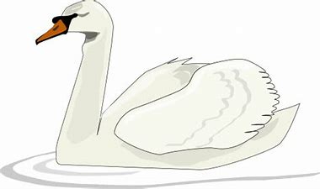

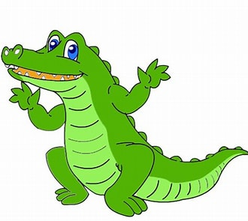

**_ _ og cro _ odile _ _ an**

**4**

