المملكة العربية السعودية  وزارة التعليم  الإدارة العامة للتعليم بـن  مدرسة م ن الابتدائية |     بسم الله الرحمن الرحيم  اختبار الفصل الدراسي الثاني  للعام الدراسي 1444 هـ  https://t.me/abokhaledamer | المادة | لغة انجليزية
 |  | الصف | السادس
 |  | الزمن | ساعة ونصف
 |  | الفصل | ----- /6
اسم الطالب رباعيا: .............................................................................................................رقم الجلوس: ------------
السؤال | 1 | 2 | 3 | 4 | 5 | 6 | المجموع
الدرجة
الدرجة | 6 | 5 | 4 | 5 | 6 | 4 | 30
المصحح

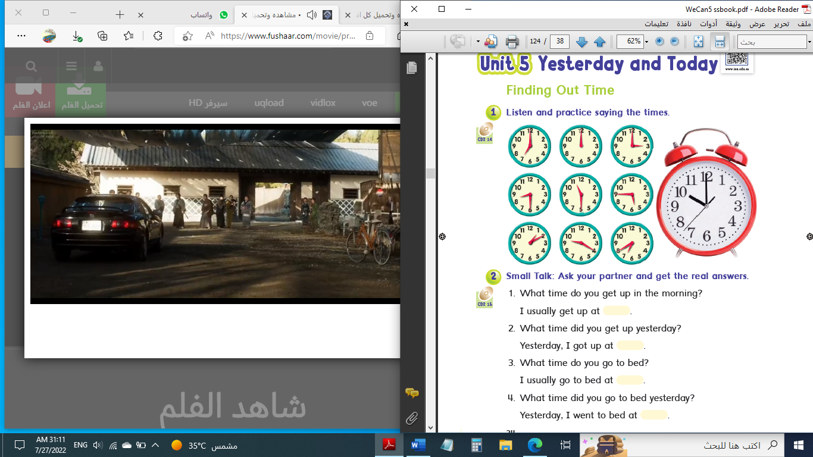

6
I- General Questions:
Q1: A. Choose the suitable answer:
1. What time is it?

( It’s one o’clock. - It’s ten o’clock. - It’s twelve o’clock. )

2. What do you do?
( I’m a doctor. – I’m fine, thank you. – I’m Ali. )
3. Ali cooked a nice ------------.
( trampoline – sharks - breakfast )
B. Answer these questions:
1.What is the past of “make”? _______________.
2. What time do you get up? ____________________.
3. Where do teachers work? _______________________________.

5
II- Controlled Writing:
Q2: Do as shown between brackets:

1. I – homework – do – at 4:00. (Rearrange) _______________.
2. When I grow up, I want to be a _______________. (Complete)
3. How many tomatoes do we need? (Answer) _______________.
4. cleaned – my – I – room. (Rearrange) _______________.
5. went – Khaled – the cupboard. – to (Rearrange)__________________.

III- Reading Short Sentence:

4
Q3: Match the sentence with the picture:

1. I go to bed at 10:00.

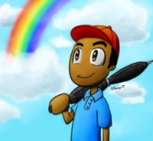
2. The cook works in a restaurant.

3. Fahad studied for 6 hours.

4. I saw a rainbow.
IV- Grammar:

5
Q4: Choose the correct answer:
1. What time ( do – does – did ) you go to bed yesterday?
2. I usually ( meet – meets – met ) my friends at the mall.
3. ( Where – When – What ) does a nurse work? She works in a hospital.
4. ( What – Who – When ) does he do? He is a student.
5. How ( many – much – old ) tea do you need?
6. We need ( some – any – not ) apples.
7. We don’t have ( some – any – no ) tomatoes.
8. Yesterday, we ( have – had – has ) some salad.
9. Yesterday, we ( don’t – doesn’t – didn’t ) have any ketchup.

6
10. Sorry ( on – to – about ) that.
V- Vocabulary:
Q5: Write the correct number under each picture:

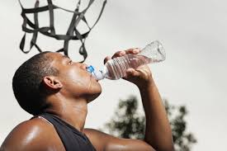

1- firefighter 2- boring 3- captain 4- ring 5- trampoline 6- drink
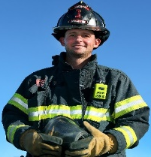
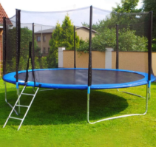
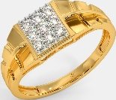

4

( ) ( ) ( ) ( ) ( ) ( )
VI- Orthography:
Q6: Fill in the missing letters: gh / sh / wh / fr / ph / nd / nt / kn
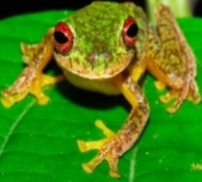
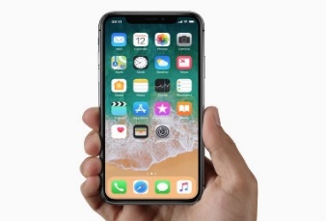
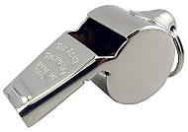

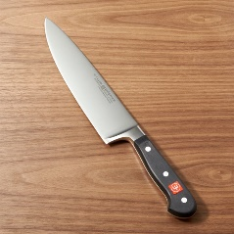

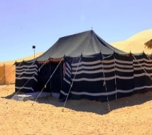
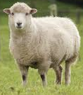

_ _ eep _ _ istle li _ _ t _ _ ife sa_ _ te_ _ _ _ one _ _ og

End of Questions
ABOKHALEDAMER
0557325813

