We Can! Book 6 Unit 5: Hanging Out in Town

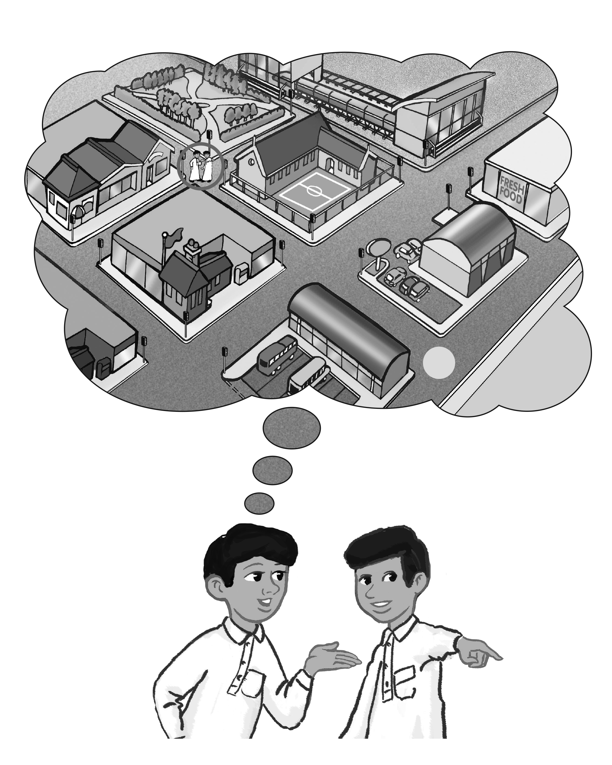
1. Match the words with the places on the map.
[Play CD3 34 or read.]

3

2
4

1 5

6
train station 3 |  | supermarket 4 | convenience store 5
post office 1 | bus stop 6 |  | elementary school 2
2. Listen, and fill in the missing words.
A: Excuse me. Where’s the post office?
B: Go straight, turn left, and you’ll find it on your right.
A: Is it far from here?
B: It’s only a few minutes.
A: Thank you.
B: You’re welcome.

3. Write how to get there using the map. Start at the circle.
1. Where’s the train station?
It’s just around the corner./ It’s near here./ Go straight and turn left. It’s right over there.
2. Where’s the bus stop?
It’s only a few minutes. Go straight and turn right. You’ll see it on your left. I’ts opposite the post office/ the convenience store.
3. Where’s the elementary school?
It’s right here. We’re standing next to it./ We’re standing by the elementary school. Look!
4. Read and write the missing words.
1. I need some pens and paper. I’m going to the
stationery store
2. I want to buy some candy. I’m going to the
candy store.
3. She wants to buy bread. She’s going to the
bakery .
4. We want to buy some books. We’re going to the
bookstore.
5. They want to buy some flowers. They’re going to the
flower store
6. We want to find a new DVD. We’re going to the
DVD store.

