ﺟﺪول اﻟﺨﻄﺔ اﻟﺪراﺳﻴـــﺔ

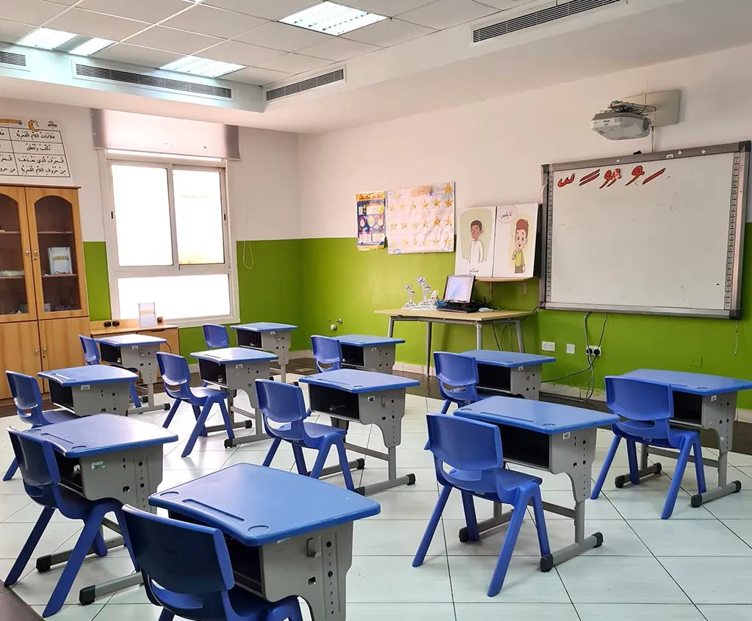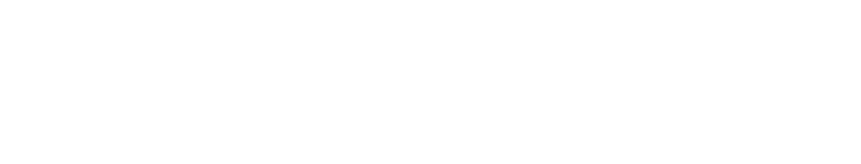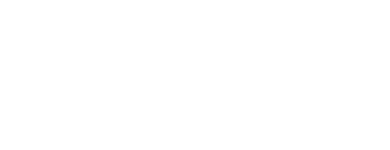

ﻟﻠﻔﺼﻞ اﻟﺪراﺳــــــﻲ اﻟﺜﺎﻧﻲ )ﺑﻨﻈﺎم اﻟﺜﻼث ﻓﺼﻮل(

ﻟﻠﻌــــــــــــــــــــ١٤٤٦)ﻫـ(ـــــــــــــــــــــﺎﻣـ

3 اﻷﺳﺒﻮع اﻟﺜﺎﻟﺚ

2 اﻷﺳﺒﻮع اﻟﺜﺎﻧﻲ

1 اﻷﺳﺒﻮع اﻷول

|  |  |  |  |  |  |  |  |  |
| --- | --- | --- | --- | --- | --- | --- | --- | --- |
|  | ٥/٢٩ | اﻷﺣﺪ |  | ٥/٢٢ | اﻷﺣﺪ |  | ٥/١٥ | اﻷﺣﺪ |
|  | ٥/٣٠ | اﻷﺛﻨﻴﻦ |  | ٥/٢٣ | اﻷﺛﻨﻴﻦ |  | ٥/١٦ | اﻷﺛﻨﻴﻦ |
|  | ٦/١ | اﻟﺜﻼﺛﺎء |  | ٥/٢٤ | اﻟﺜﻼﺛﺎء |  | ٥/١٧ | اﻟﺜﻼﺛﺎء |
|  | ٦/٢ | اﻷرﺑﻌﺎء |  | ٥/٢٥ | اﻷرﺑﻌﺎء |  | ٥/١٨ | اﻷرﺑﻌﺎء |
|  | ٦/٣ | اﻟﺨﻤﻴﺲ |  | ٥/٢٦ | اﻟﺨﻤﻴﺲ |  | ٥/١٩ | اﻟﺨﻤﻴﺲ |

6 اﻷﺳﺒﻮع اﻟﺴﺎدس

5 اﻷﺳﺒﻮع اﻟﺨﺎﻣﺲ

4 اﻷﺳﺒﻮع اﻟﺮاﺑﻊ

|  |  |  |  |  |  |  |  |  |
| --- | --- | --- | --- | --- | --- | --- | --- | --- |
|  | ٦/٢٠ | اﻷﺣﺪ |  | ٦/١٣ | اﻷﺣﺪ |  | ٦/٦ | اﻷﺣﺪ |
|  | ٦/٢١ | اﻷﺛﻨﻴﻦ |  | ٦/١٤ | اﻷﺛﻨﻴﻦ |  | ٦/٧ | اﻷﺛﻨﻴﻦ |
|  | ٦/٢٢ | اﻟﺜﻼﺛﺎء |  | ٦/١٥ | اﻟﺜﻼﺛﺎء |  | ٦/٨ | اﻟﺜﻼﺛﺎء |
|  | ٦/٢٣ | اﻷرﺑﻌﺎء |  | ٦/١٦ | اﻷرﺑﻌﺎء | إﺟﺎزة ﻣﻄﻮﻟﺔ | ٦/٩ | اﻷرﺑﻌﺎء |
|  | ٦/٢٤ | اﻟﺨﻤﻴﺲ |  | ٦/١٧ | اﻟﺨﻤﻴﺲ | ٦/١٠ | اﻟﺨﻤﻴﺲ |

اﻷﺳﺒﻮع اﻟﺜﺎﻣﻦ

إﺟﺎزة ﻣﻨﺘﺼﻒ اﻟﻌﺎم )اﻟﻔﺼﻞ اﻟﺪراﺳﻲ اﻟﺜﺎﻧﻲ( 8

7 اﻷﺳﺒﻮع اﻟﺴﺎﺑﻊ

|  |  |  |  |  |  |  |
| --- | --- | --- | --- | --- | --- | --- |
|  | ٧/١٢ | اﻷﺣﺪ | ﻣﻦ ٧/٣ إﻟﻰ ٧/١١ ١٤٤٦ﻫـ  **(٩) أﻳﺎم** |  | ٦/٢٧ | اﻷﺣﺪ |
|  | ٧/١٣ | اﻷﺛﻨﻴﻦ |  | ٦/٢٨ | اﻷﺛﻨﻴﻦ |
|  | ٧/١٤ | اﻟﺜﻼﺛﺎء |  | ٦/٢٩ | اﻟﺜﻼﺛﺎء |
|  | ٧/١٥ | اﻷرﺑﻌﺎء |  | ٧/١ | اﻷرﺑﻌﺎء |
|  | ٧/١٦ | اﻟﺨﻤﻴﺲ |  | ٧/٢ | اﻟﺨﻤﻴﺲ |

11 اﻷﺳﺒﻮع اﻟﺤﺎدي ﻋﺸﺮ

10 اﻷﺳﺒﻮع اﻟﻌﺎﺷﺮ

9 اﻷﺳﺒﻮع اﻟﺘﺎﺳﻊ

|  |  |  |  |  |  |  |  |  |
| --- | --- | --- | --- | --- | --- | --- | --- | --- |
|  | ٨/٣ | اﻷﺣﺪ |  | ٧/٢٦ | اﻷﺣﺪ |  | ٧/١٩ | اﻷﺣﺪ |
|  | ٨/٤ | اﻷﺛﻨﻴﻦ |  | ٧/٢٧ | اﻷﺛﻨﻴﻦ |  | ٧/٢٠ | اﻷﺛﻨﻴﻦ |
|  | ٨/٥ | اﻟﺜﻼﺛﺎء |  | ٧/٢٨ | اﻟﺜﻼﺛﺎء |  | ٧/٢١ | اﻟﺜﻼﺛﺎء |
|  | ٨/٦ | اﻷرﺑﻌﺎء |  | ٧/٢٩ | اﻷرﺑﻌﺎء |  | ٧/٢٢ | اﻷرﺑﻌﺎء |
|  | ٨/٧ | اﻟﺨﻤﻴﺲ |  | ٧/٣٠ | اﻟﺨﻤﻴﺲ |  | ٧/٢٣ | اﻟﺨﻤﻴﺲ |

إﺟﺎزة اﻟﺸﺘــﺎء )ﻧﻬﺎﻳﺔ اﻟﻔﺼﻞ اﻟﺪراﺳﻲ اﻟﺜﺎﻧﻲ(

13 اﻷﺳﺒﻮع اﻟﺜﺎﻟﺚ ﻋﺸﺮ

12 اﻷﺳﺒﻮع اﻟﺜﺎﻧﻲ ﻋﺸﺮ

|  |  |  |  |  |  |  |
| --- | --- | --- | --- | --- | --- | --- |
| ﻣﻦ ٨/٢٢ إﻟﻰ /٩/١ ١٤٤٦ﻫـ  **(٩) أﻳﺎم**  ﻳﺘﻀﻤﻨﻬﺎ إﺟﺎزة **ﻳﻮم اﻟﺘﺄﺳﻴﺲ** ﻳﻮم اﻷﺣﺪ ٨/٢٤ اﻟﻤﻮاﻓﻖ ٢٠٢٥/٢/٢٣م | **)اﻻﺧﺘﺒﺎرات اﻟﻨﻬﺎﺋﻴـــــــﺔ(** | ٨/١٧ | اﻷﺣﺪ |  | ٨/١٠ | اﻷﺣﺪ |
| ٨/١٨ | اﻷﺛﻨﻴﻦ |  | ٨/١١ | اﻷﺛﻨﻴﻦ |
| ٨/١٩ | اﻟﺜﻼﺛﺎء |  | ٨/١٢ | اﻟﺜﻼﺛﺎء |
| ٨/٢٠ | اﻷرﺑﻌﺎء |  | ٨/١٣ | اﻷرﺑﻌﺎء |
| ٨/٢١ | اﻟﺨﻤﻴﺲ |  | ٨/١٤ | اﻟﺨﻤﻴﺲ |

)ﻧﻬﺎﻳﺔ اﻟﻔﺼﻞ اﻟﺪراﺳﻲ اﻟﺜﺎﻧﻲ(

**وﻳﻮم اﻟﺘﺄﺳﻴﺲ**

ﺑﻨﻬﺎﻳﺔ دوام ﻳﻮم اﻟﺨﻤﻴﺲ ١٤٤٦/٨/٢١ﻫـ

**إﺟﺎزة اﻟﺸﺘﺎء**

ﺗﺴﺘﺄﻧـــــــﻒ اﻟﺪراﺳــــــﺔ ﻟﻠﻔﺼـﻞ اﻟﺪراﺳــــﻲ اﻟﺜﺎﻟﺚ

ﻳﻮم اﻷﺣـــــــــــــﺪ ١٤٤٦/٩/٢ﻫـ