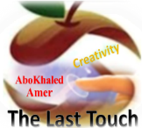

المملكة العربية السعودية
Kingdom of Saudi Arabia
Ministry of Education
------- Educational Directorate
------- Future Educational Schools
2nd Grade High School 2022
2nd Term – Final Exam

وزارة التعليم
الإدارة العامة للتعليم بن
مدارس م ن التعليمية
الصف الثاني الثانوي
الاختبار النهائي للفصل الدراسي الثاني1444هـ
Total  written | 5  Vocabulary | 4  Grammar | 3  Free Composition | 2  Guided Composition |  | 1 Comprehension | Q. NO.
 |  |  |  |  |  |  | Mark Given
30 | 6 | 6 | 6 | 6 |  | 6 | Mark
6 |  |  | Reviser |  |  |  | Corrector
زمن الاختبار: 3 ساعات
اسم الطالب: ------------------------------------ رقم الجلوس: ------------- الصف الثاني الثانوي

1.Comprehension
Read the following passage then answer the questions
The Benefits of Exercise
Getting regular exercise is good for you. Everyone knows that. But, then why doesn't everyone exercise? Some people say they don't have enough time because they are busy with work, school, and family obligations. However, making time for some exercise should be a priority for everyone. The following are just a few of the reasons why:
1) Exercising makes you feel good. When you have a bad day, or you feel stressed or angry about something, a little exercise can help you relax and improve your mood. Also, getting regular exercise can help prevent depression.
2) Physical exercise helps prevent some diseases such as high blood pressure, diabetes, and certain types of cancer. A walk a day can help keep you healthy!
3) Exercising helps you maintain a healthy weight and keeps you strong.
4) Exercising gives you more energy. You will feel less tired during the day if you are physically stronger and more active.
5) Exercising helps you sleep better. If you have been active during the day, you sleep better. And when you have slept better at night, you feel better during the day.
6) Find an activity that you enjoy. You don't have to go to the gym. You can go for a walk or a hike. Whenever you are active, you are doing something good for both your physical and mental health.

A) Answer the following questions:
1. What is the passage about? ----------------------------------------------------------------------------.
2. Does exercising help you sleep better? -------------------------------------------------------------.
3. Why do some people say they don't have enough time? -------------------------------------------.
4. What can you do if you don’t go to the gym? -------------------------------------------------------.
B) Put ( √ ) or ( X ):
5. Exercising helps you to keep strong. ( )
6. Exercising is good for both your physical and mental health. ( )

7. Cancer is a kind of disease. ( )
8. Exercising doesn't make you feel good. ( )
C) Complete:
9. Exercising gives you more -------------------------.
10. Physical exercise helps prevent some ------------------------------.
D) Choose the correct answer:
11. Getting regular exercise can help prevent (happiness – depression – devasted – drown)
12. The underlined word “they" refers to: ( school – exercise – work – people )

2) Guided Composition

6

Playing sports is a must to keep fit.
Write a paragraph about “ Your Favorite Sport”:
You many use the guiding words:
Favorite – club – gym – friends – free time – build muscles – keep fit – feel happy

-------------------------------------------------------
-------------------------------------------------------------------------------------------------------------------------------------------------------------------------------------------------------------------------------------------------------------------------------------------------------------------------------------------------------------------------------------------------------------------------------------------------------------------------------------------------------------------------------------------------------------------------------------------------------------------------------------------------------------------------------------------------------------------------------------------------------------------------------------------------------------------------------------------------------------------------------------------------------------------------------------------------------------------------------------------------------------------------------------------------------------------------------------------------------------------------------------------------------------------------------------------------------------------------------------------------------------------------------------------

3) Free Composition

6

Choose one topic from the following to write about.
1. Recycling is a must to keep our environment clean
2. Write a paragraph about "Your Dream House" in which you describe which kind of you want to live in, where, who live with, …

-------------------------------------------------------
---------------------------------------------------------------------------------------------------------------------------------------------------------------------------------------------------------------------------------------------------------------------------------------------------------------------------------------------------------------------------------------------------------------------------------------------------------------------------------------------------------------------------------------------------------------------------------------------------------------------------------------------------------------------------------------------------------------------------------------------------------------------------------------------------------------------------------------------------------------------------------------------------------------------------------------------------------------------------------------------------------------------------------------------------------------------------------------------------------------------------------------------------------------------------------------------------------------------------------------------------------------------------------------------
4) Grammar

6

A: Choose the correct answer:
1. The manager insisted that he ( worked – works – work – working ) late.
2. Quit ( using – to use – used – use ) disposable batteries.
3. She is not ( enough tall – tall enough – tall too – tall so ) to reach the shelf.
4. ( Not Warming – Not warm – Not warms – Not warmed ) up is bad.
5. This is the ( most – more – less – many ) exciting sporting event.
6. I want you ( opened – opening – open – to open ) the window.
B- Do as shown between brackets:
1. you / applying for the job / to consider / I’d like (Unscramble)
-------------------------------------------------------------------------------.
2. to buy – a hybrid – Do they – car? – intend (Unscramble)
----------------------------------------------------------------------------.
3. I bought (yellow – big – Japanese – expensive) car. (Reorder the adjectives)
-------------------------------------------------------------------.
4. She is short to play basketball. (Use: too)
---------------------------------------------------------------------------.
5. Ali is the nicest boy I (see). (Correct in present perfect)
--------------------------------------------------------------------------------.
6. (Swim) uses more muscles of the body. (Correct)
---------------------------------------------------------------------------.
5) vocabulary:

6

A- Match the words with the pictures:
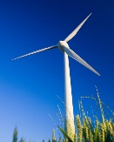
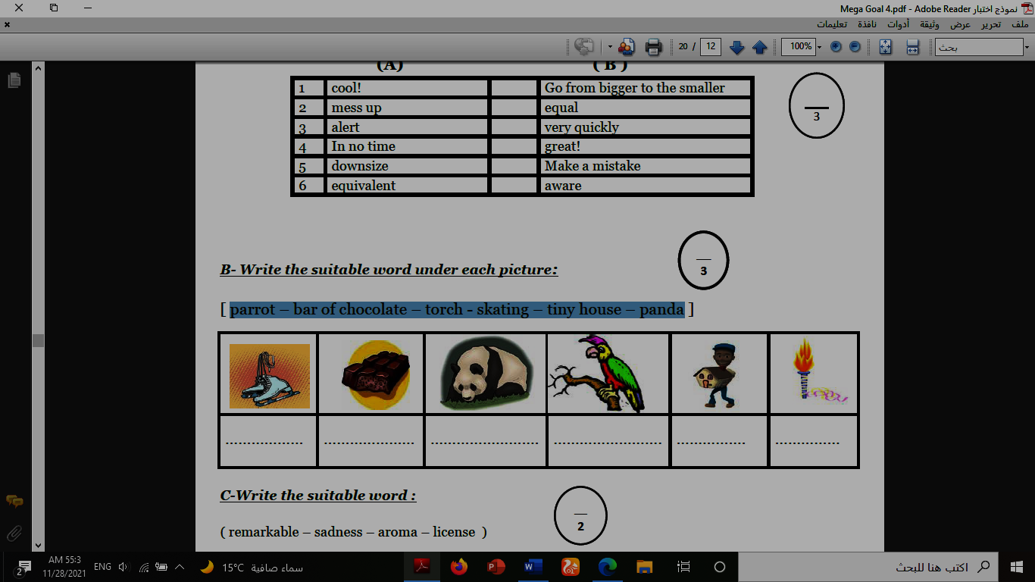
1.recycle 2.torch 3.zoologist 4.medal 5.canyon 6.windmill
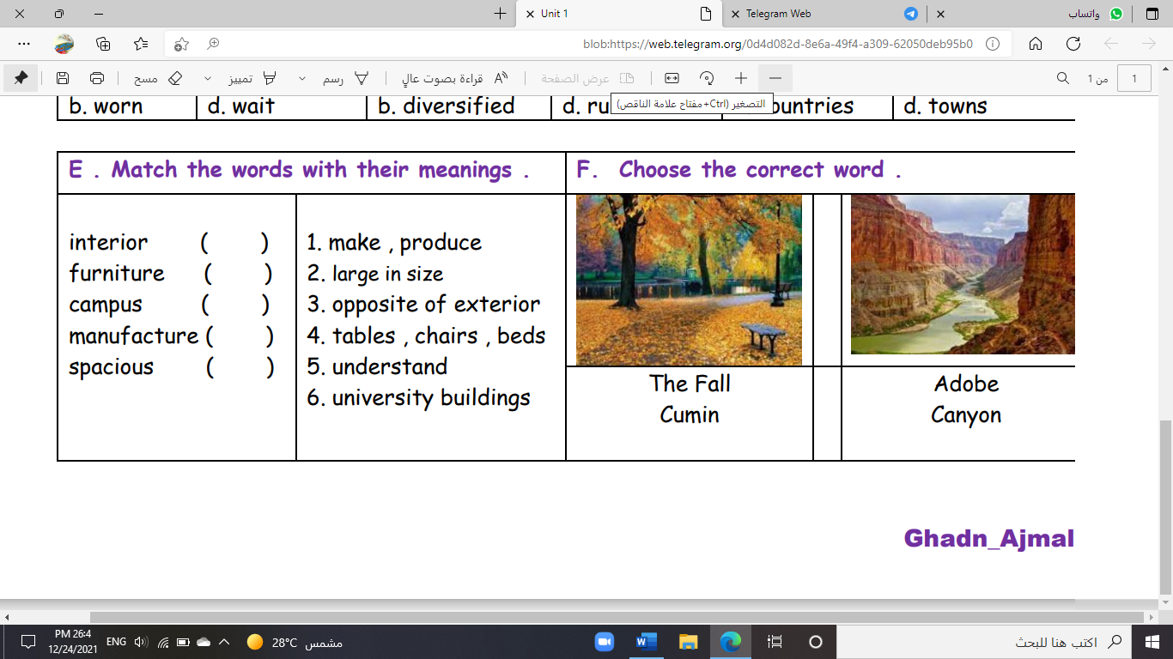
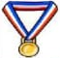


( ) ( ) ( ) ( ) ( ) ( )
B- Match to form new words or expressions:
1. satisfaction ------ a. take one’s place, often in work
2. cover ------ b. feeling of contentment
3. a piece of cake ------ c. without a soul
4. cool ------ d. ready for
5. soulless ------ e. very easy
6. up for ------ f. great

End of Questions
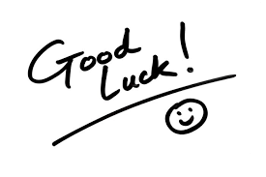
Best of Luck https://t.me/abokhaledamer


المملكة العربية السعودية
Kingdom of Saudi Arabia
Ministry of Education
------- Educational Directorate
------- Future Educational Schools
2nd Grade High School 2022
2nd Term – Final Exam

وزارة التعليم
الإدارة العامة للتعليم بن
مدارس م ن التعليمية
الصف الثاني الثانوي
الاختبار النهائي للفصل الدراسي الثاني1444هـ
Total  written | 5  Vocabulary | 4  Grammar | 3  Free Composition | 2  Guided Composition |  | 1 Comprehension | Q. NO.
 |  |  |  |  |  |  | Mark Given
30 | 6 | 6 | 6 | 6 |  | 6 | Mark
6 |  |  | Reviser |  |  |  | Corrector
زمن الاختبار: 3 ساعات
اسم الطالب: ------------------------------------ رقم الجلوس: ------------- الصف الثاني الثانوي

1.Comprehension
Read the following passage then answer the questions
The Benefits of Exercise
Getting regular exercise is good for you. Everyone knows that. But, then why doesn't everyone exercise? Some people say they don't have enough time because they are busy with work, school, and family obligations. However, making time for some exercise should be a priority for everyone. The following are just a few of the reasons why:
1) Exercising makes you feel good. When you have a bad day, or you feel stressed or angry about something, a little exercise can help you relax and improve your mood. Also, getting regular exercise can help prevent depression.
2) Physical exercise helps prevent some diseases such as high blood pressure, diabetes, and certain types of cancer. A walk a day can help keep you healthy!
3) Exercising helps you maintain a healthy weight and keeps you strong.
4) Exercising gives you more energy. You will feel less tired during the day if you are physically stronger and more active.
5) Exercising helps you sleep better. If you have been active during the day, you sleep better. And when you have slept better at night, you feel better during the day.
6) Find an activity that you enjoy. You don't have to go to the gym. You can go for a walk or a hike. Whenever you are active, you are doing something good for both your physical and mental health.

A) Answer the following questions:
1. What is the passage about? --------- The Benefits of Exercise ---------.
2. Does exercising help you sleep better? ------Yes, it does. ---------------------------.
3. Why do some people say they don't have enough time?
-- because they are busy with work, school, and family obligations.--.
4. What can you do if you don’t go to the gym? - You can go for a walk or a hike. ---.
B) Put ( √ ) or ( X ):
5. Exercising helps you to keep strong. ( √ )
6. Exercising is good for both your physical and mental health. ( √ )

7. Cancer is a kind of disease. ( √ )
8. Exercising doesn't make you feel good. ( X )
C) Complete:
9. Exercising gives you more --- energy ----.
10. Physical exercise helps prevent some --- diseases---.
D) Choose the correct answer:
11. Getting regular exercise can help prevent (happiness – depression – devasted – drown)
12. The underlined word “they" refers to: ( school – exercise – work – people )

2) Guided Composition

6

Playing sports is a must to keep fit.
Write a paragraph about “ Your Favorite Sport”:
You many use the guiding words:
Favorite – club – gym – friends – free time – build muscles – keep fit – feel happy

-------------------------------------------------------
-------------------------------------------------------------------------------------------------------------------------------------------------------------------------------------------------------------------------------------------------------------------------------------------------------------------------------------------------------------------------------------------------------------------------------------------------------------------------------------------------------------------------------------------------------------------------------------------------------------------------------------------------------------------------------------------------------------------------------------------------------------------------------------------------------------------------------------------------------------------------------------------------------------------------------------------------------------------------------------------------------------------------------------------------------------------------------------------------------------------------------------------------------------------------------------------------------------------------------------------------------------------------------------------

3) Free Composition

6

Choose one topic from the following to write about.
1. Recycling is a must to keep our environment clean
2. Write a paragraph about "Your Dream House" in which you describe which kind of you want to live in, where, who live with, …

-------------------------------------------------------
-------------------------------------------------------------------------------------------------------------------------------------------------------------------------------------------------------------------------------------------------------------------------------------------------------------------------------------------------------------------------------------------------------------------------------------------------------------------------------------------------------------------------------------------------------------------------------------------------------------------------------------------------------------------------------------------------------------------------------------------------------------------------------------------------------------------------------------------------------------------------------------------------------------------------------------------------------------------------------------------------------------------------------------------------------------------------------------------------------------------------------------
4) Grammar

6

A: Choose the correct answer:
1. The manager insisted that he ( worked – works – work – working ) late.
2. Quit ( using – to use – used – use ) disposable batteries.
3. She is not ( enough tall – tall enough – tall too – tall so ) to reach the shelf.
4. ( Not Warming – Not warm – Not warms – Not warmed ) up is bad.
5. This is the ( most – more – less – many ) exciting sporting event.
6. I want you ( opened – opening – open – to open ) the window.
B- Do as shown between brackets:
1. you / applying for the job / to consider / I’d like (Unscramble)
-----I'd like to consider applying for the job. -----.
2. to buy – a hybrid – Do they – car? – intend (Unscramble)
----Do they intend to buy a hybrid car? ----.
3. I bought (yellow – big – Japanese – expensive) car. (Reorder the adjectives)
--------(expensive, big, yellow, Japanese) ---------------.
4. She is short to play basketball. (Use: too)
--------She is too short to play.. ---------.
5. Ali is the nicest boy I (see). (Correct in present perfect)
------have seen-------.
6. (Swim) uses more muscles of the body. (Correct)
---------Swimming--------.
5) vocabulary:

6

A- Match the words with the pictures:
1.recycle 2.torch 3.zoologist 4.medal 5.canyon 6.windmill

(2) (1) (6) (3) (4) (5)
B- Match to form new words or expressions:
1. satisfaction -b- a. take one’s place, often in work
2. cover -a- b. feeling of contentment
3. a piece of cake -e- c. without a soul
4. cool -f- d. ready for
5. soulless -c- e. very easy
6. up for -d- f. great

End of Questions
Best of Luck https://t.me/abokhaledamer


المملكة العربية السعودية
Kingdom of Saudi Arabia
Ministry of Education
------- Educational Directorate
------- Future Educational Schools
2nd Grade High School 2022
2nd Term – Final Exam

وزارة التعليم
الإدارة العامة للتعليم بن
مدارس م ن التعليمية
الصف الثاني الثانوي
الاختبار النهائي للفصل الدراسي الثاني1444هـ
Total  written | 5  Vocabulary | 4  Grammar | 3  Free Composition | 2  Guided Composition |  | 1 Comprehension | Q. NO.
 |  |  |  |  |  |  | Mark Given
30 | 6 | 6 | 6 | 6 |  | 6 | Mark
6 |  |  | Reviser |  |  |  | Corrector
زمن الاختبار: 3 ساعات
اسم الطالب: ------------------------------------ رقم الجلوس: ------------- الصف الثاني الثانوي

1.Comprehension
Read the following passage then answer the questions
Water is life and the lack of water means death. Any living thing cannot go on living without water. Plants need water to grow. Animals need water to drink. People need water to drink and to use in cleaning, cooking, farming and irrigating their lands. We can get water from rivers and lakes. But the main source of water is the rain. In the desert, people dig deep wells to get water. For keeping water from being wasted, people build dams for storing water in reservoirs that form behind the dams. Water is stored in water towers that supply all the houses with pure water. Our government has set up desalination plants for treating seawater and removing the salt. Thanks be to God, the Merciful, who has created water for us. We don't need to pay for it as it is neither sold nor bought.
A) Answer the following questions:
1. What does the lack of water mean? ----------------------------------------.
2. Why do people need water? ------------------------------------------.
3. What is the main source of water? ------------------------------------------.
4. Who has created water for us? -------------------------------------------.
B) Put ( √ ) or ( X ):
5. Water is life and the lack of it means death. ( )
6.We cannot get water from rivers and lakes. ( )
7. We don't need to pay for it as it is neither sold nor bought. ( )
8. Water is stored in water towers that supply all the houses with pure water. ( )
C) Complete:
9. We can get pure water from --------------------------.
10. A reservoir is formed --------------------- a dam:
D) Choose the correct answer:
11. Plants need water to (wash – grow – remove – read).
12. In the (farms – deserts – cities – skies), people dig deep wells for getting their water.

2) Guided Composition

6

There is no place like home
Write a paragraph about "Your Dream Home" in which you describe which kind of
home you want to live in, where, who live with…

-------------------------------------------------------
-----------------------------------------------------------------------------------------------------------------------------------------------------------------------------------------------------------------------------------------------------------------------------------------------------------------------------------------------------------------------------------------------------------------------------------------------------------------------------------------------------------------------------------------------------------------------------------------------------------------------------------------------------------------------------------------------------------------------------------------------------------------------------------------------------------------------------------------------------------------------------------------------------------------------------------------------------------------------------------------------------------------------------------------------------------------------------------------------------------------------------------------------------------------------------------------------------------------------------------------------------------------------------------------------------------------------------------------------------------------------------------------------------------------------------------------------------------------------------------------------------------------------------------------------------------------------------------------------------------------------------------------------------------------------------------------------------------------------------------------------------------------------------------------------------------------------------------------------------------------------------------------------------------------------------------------------

3) Free Composition

6

Choose one topic from the following to write about:
1. “Pollution” is a serious problem that we should try to eliminate.

2. Write a paragraph about "Your Favorite Sport"

-------------------------------------------------------
---------------------------------------------------------------------------------------------------------------------------------------------------------------------------------------------------------------------------------------------------------------------------------------------------------------------------------------------------------------------------------------------------------------------------------------------------------------------------------------------------------------------------------------------------------------------------------------------------------------------------------------------------------------------------------------------------------------------------------------------------------------------------------------------------------------------------------------------------------------------------------------------------------------------------------------------------------------------------------------------------------------------------------------------------------------------------------------------------------------------------------------------------------------------------------------------------------------------------------------------------------------------------------------------------------------------------------------------------------------------------------------------------------------------------------------------------------

4) Grammar

6

A: Choose the correct answer:
1. It is important that you ( played – plays – play – playing ) well.
2. I enjoy ( watch – to watch – watches – watching ) TV.
3. I have two (large brown wooden – brown large wooden – wooden brown large) tables.
4. The film was (too – enough – to – that) boring to watch so we left the cinema early
5. ( Reading – Read – Reads – Readed ) is my favorite hobby.
6. Who is the ( good – better – best – most ) football player you’ve ever seen?
B- Do as shown between brackets:
1. this afternoon – I want you – the report – to finish (Unscramble)
------------------------------------------------------------------------.
2. to reuse – plastic – Don’t forget – containers (Unscramble)
---------------------------------------------------------------------.
3. I bought (yellow – big – Japanese – expensive) car. (Reorder the adjectives)
---------------------------------------------------------------------.
4. She is tall to play basketball. (Use: enough)
-----------------------------------------------------------------.
5. It is interesting to play tennis. (Rewrite using “Gerund")
---------------------------------------------------------------------------.
6. Nora is the most beautiful girl I (meet). (Correct in present perfect)
----------------------------------------------------------------------------.
5) vocabulary:

6

A- Match the words with the pictures:
1.marathon 2.grid 3.surgeon 4.mortar 5.grocireies 6.Olympics

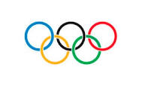
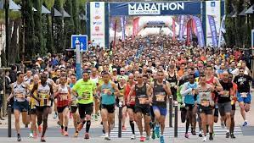
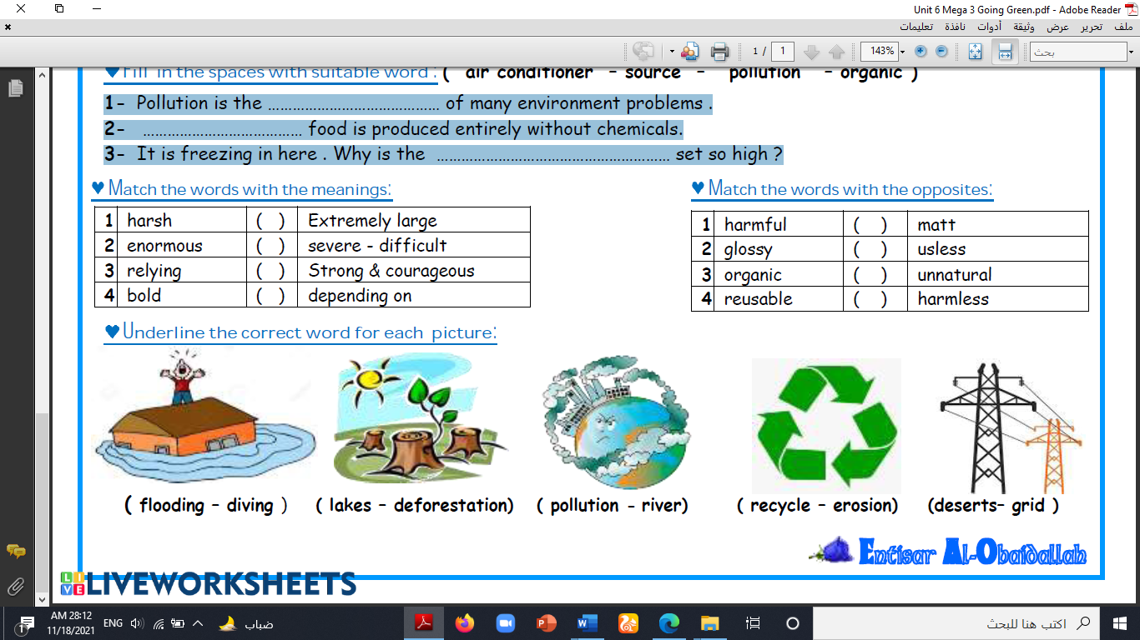
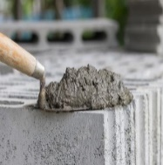

( ) ( ) ( ) ( ) ( ) ( )
B- Match to form new words or expressions:
1. status ------ a. in a difficult situation
2. in a bind ------ b. state or condition
3. a hassle ------ c. Stop for a moment!
4. lodge ------ d. make a mistake
5. Hold on ------ e. something that is inconvenient to do
6. mess up ------ f. provide accommodation

End of Questions
Best of Luck https://t.me/abokhaledamer


المملكة العربية السعودية
Kingdom of Saudi Arabia
Ministry of Education
------- Educational Directorate
------- Future Educational Schools
2nd Grade High School 2022
2nd Term – Final Exam

وزارة التعليم
الإدارة العامة للتعليم بن
مدارس م ن التعليمية
الصف الثاني الثانوي
الاختبار النهائي للفصل الدراسي الثاني1444هـ
Total  written | 5  Vocabulary | 4  Grammar | 3  Free Composition | 2  Guided Composition |  | 1 Comprehension | Q. NO.
 |  |  |  |  |  |  | Mark Given
30 | 6 | 6 | 6 | 6 |  | 6 | Mark
6 |  |  | Reviser |  |  |  | Corrector
زمن الاختبار: 3 ساعات
اسم الطالب: ------------------------------------ رقم الجلوس: ------------- الصف الثاني الثانوي

1.Comprehension
Read the following passage then answer the questions
Water is life and the lack of water means death. Any living thing cannot go on living without water. Plants need water to grow. Animals need water to drink. People need water to drink and to use in cleaning, cooking, farming and irrigating their lands. We can get water from rivers and lakes. But the main source of water is the rain. In the desert, people dig deep wells to get water. For keeping water from being wasted, people build dams for storing water in reservoirs that form behind the dams. Water is stored in water towers that supply all the houses with pure water. Our government has set up desalination plants for treating seawater and removing the salt. Thanks be to God, the Merciful, who has created water for us. We don't need to pay for it as it is neither sold nor bought.
A) Answer the following questions:
1. What does the lack of water mean? ----- It means death. ---.
2. Why do people need water? -- to drink and to use in cleaning, cooking, farming--.
3. What is the main source of water? ---- the rain ----.
4. Who has created water for us? ----- God, the Merciful ----.
B) Put ( √ ) or ( X ):
5. Water is life and the lack of it means death. ( √ )
6.We cannot get water from rivers and lakes. (X)
7. We don't need to pay for water as it is neither sold nor bought. ( √ )
8. Water is stored in water towers that supply all the houses with pure water. (√)
C) Complete:
9. We can get pure water from -- rivers and lakes --.
10. A reservoir is formed ---- behind --- a dam:
D) Choose the correct answer:
11. Plants need water to (wash – grow – remove – read).
12. In the (farms – deserts – cities – skies), people dig deep wells for getting their water.

2) Guided Composition

6

There is no place like home
Write a paragraph about "Your Dream Home" in which you describe which kind of
home you want to live in, where, who live with…

-------------------------------------------------------
-----------------------------------------------------------------------------------------------------------------------------------------------------------------------------------------------------------------------------------------------------------------------------------------------------------------------------------------------------------------------------------------------------------------------------------------------------------------------------------------------------------------------------------------------------------------------------------------------------------------------------------------------------------------------------------------------------------------------------------------------------------------------------------------------------------------------------------------------------------------------------------------------------------------------------------------------------------------------------------------------------------------------------------------------------------------------------------------------------------------------------------------------------------------------------------------------------------------------------------------------------------------------------------------------------------------------------------------------------------------------------------------------------------------------------------------------------------------------------------------------------------------------------------------------------------------------------------------------------------------------------------------------------------------------------------------------------------------------------------------------------------------------------------------------------------------------------------------------------------------------------------------------------------------------------------------------

3) Free Composition

6

Choose one topic from the following to write about:
1. “Pollution” is a serious problem that we should try to eliminate.

2. Write a paragraph about "Your Favorite Sport"

-------------------------------------------------------
---------------------------------------------------------------------------------------------------------------------------------------------------------------------------------------------------------------------------------------------------------------------------------------------------------------------------------------------------------------------------------------------------------------------------------------------------------------------------------------------------------------------------------------------------------------------------------------------------------------------------------------------------------------------------------------------------------------------------------------------------------------------------------------------------------------------------------------------------------------------------------------------------------------------------------------------------------------------------------------------------------------------------------------------------------------------------------------------------------------------------------------------------------------------------------------------------------------------------------------------------------------------------------------------------------------------------------------------------------------------------------------------------------------------------------------------------------

4) Grammar

6

A: Choose the correct answer:
1. It is important that you ( played – plays – play – playing ) well.
2. I enjoy ( watch – to watch – watches – watching ) TV.
3. I have two (large brown wooden– brown large wooden– wooden brown large) tables.
4. The film was (too – enough – to – that) boring to watch so we left the cinema early
5. ( Reading – Read – Reads – Readed ) is my favorite hobby.
6. Who is the ( good – better – best – most ) football player you’ve ever seen?
B- Do as shown between brackets:
1. this afternoon – I want you – the report – to finish (Unscramble)
---I want you to finish the report this afternoon. ----.
2. to reuse – plastic – Don’t forget – containers (Unscramble)
-------Don't forget to refuse plastic containers. --------.
3. I bought (yellow – big – Japanese – expensive) car. (Reorder the adjectives)
--------(expensive, big, yellow, Japanese) -------.
4. She is tall to play basketball. (Use: enough)
-------She is tall enough to play … ------------.
5. It is interesting to play tennis. (Rewrite using “Gerund")
-------Playing tennis is interesting. ------------.
6. Nora is the most beautiful girl I (meet). (Correct in present perfect)
----------------have met ---------------.
5) vocabulary:

6

A- Match the words with the pictures:
1.marathon 2.grid 3.surgeon 4.mortar 5.grocireies 6.Olympics

( 3 ) ( 4 ) ( 2 ) ( 4 ) ( 1 ) ( 6 )
B- Match to form new words or expressions:
1. status -b- a. in a difficult situation
2. in a bind -a- b. state or condition
3. a hassle -e- c. Stop for a moment!
4. lodge -f- d. make a mistake
5. Hold on -c- e. something that is inconvenient to do
6. mess up -d- f. provide accommodation

End of Questions
Best of Luck https://t.me/abokhaledamer

