Lab 12: Reference Planes; Vertical Bearing Support

In this Tutorial, the creation and usage of reference geometries are demonstrated. The model of Vertical Bearing Support is as shown in Figure 1.

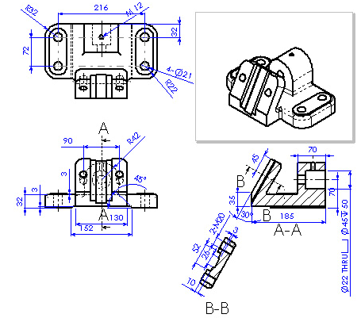

Figure 1 Vertical Bearing Support

It can be built by following the procedures as shown in Figure 2.

1. Create a base using Extruded Boss/Base.

2. Add a slot boss for creating the slot body.

3. Create a plane for slot body with At Angle, and then a Slot body.

4. Cut the Slots on the slot body and the base.

5. Add hole bosses for drilling holes.

6. Drill holes and add fillets.

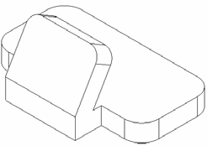

Figure 2 Modeling process of Vertical Bearing Support.
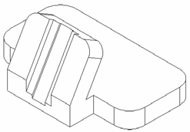

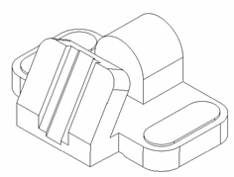

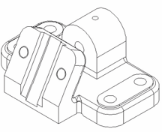

Create Support Base

1. Start Solid Works

2. Select New on the Standard toolbar, or click File, New on the menu bar.

3. Select Part from the Template tab in the dialog box, and click OK.

4. Click File, Properties on the menu bar.

5. Fill in the necessary properties in the dialog box, and click OK to accept the properties and close the dialog box.

6. Click Tools, Options on the menu bar to open the option dialog box.

7. Select the Document Properties tab, and click Unit in the properties tree text box.

8. Select Millimeter and set the decimal places to 2.

9. Click OK to close the Properties dialog box.

10. Select Top Plane in FeatureManager design Tree and click Normal To to bring Top plane parallel to the screen.

11. Select Sketch on the Sketch toolbar to open a new sketch on the Top Plane.

12. Select Rectangle on the Sketch Tools toolbar, and draw a rectangle.

13. Select Fillet on the Sketch Tools toolbar to fillet the four corners of the rectangle.

14. Select Dimension on the Sketch Relation toolbar, and dimension the sketch as shown in Figure 3. To change the fillet radius to 32 mm, double click on fillet dimension, Modify dimension window will open, type 32 and press Enter.

15. Click Zoon to Fit to see the entire sketch.

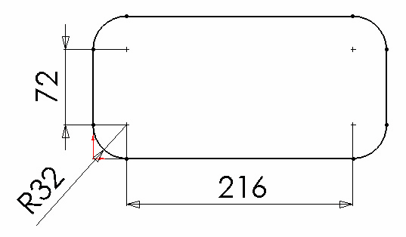

Figure 3 Base sketch and dimensions

16. Select Extrude Boss/Base on the Features toolbar. The Base-Extrude
PropertyManager appears.

17. Select Blind in the End Condition drop down list box.

18. Type 32mm in the distance 1 box as shown in Figure 4.

19. Click OK  to finish the base extrusion.
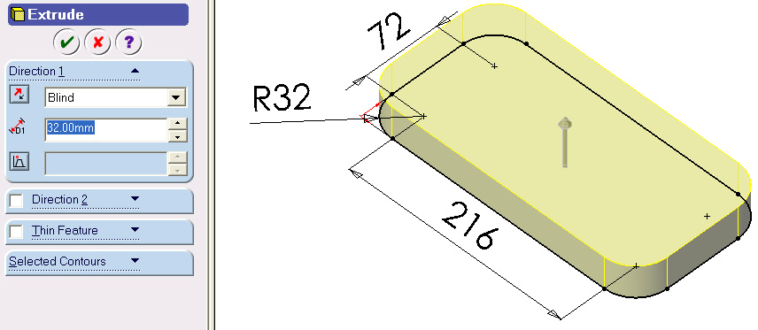

Figure 4 Base extrude

Create an Offset Plane and a Support Boss

1. Click Plane on the Reference Geometry toolbar, or click Insert, Reference
Geometry, Plane on the menu bar.

2. Select Offset Distance on the PropertyManager.

3. Select the side face of the base as shown in Figure 5. Its name appears in the
Selection text box.

4. Enter 140mm in the Distance text box.

5. Select the Reverse Direction check box.

6. Click OK. The Planel is created and displayed in the FeatureManager Design
Tree.

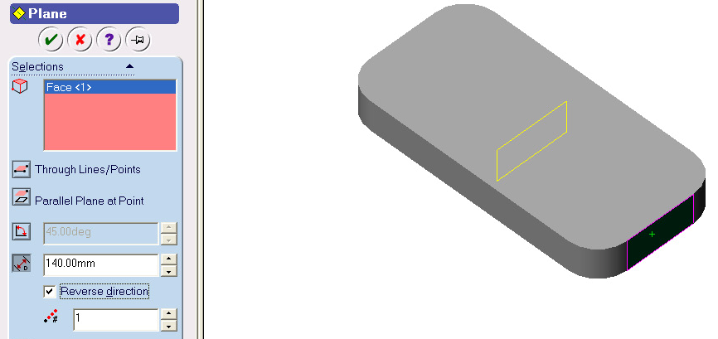

Figure 5 Offset plane

7. Select the Planel in the FeatureManager Design Tree or graphics window.

8. Select Sketch on the Sketch toolbar to open a new sketch.

9. Click Normal To on the Standard Views toolbar to make the sketch plane parallel to the screen.

10. Select Line on the Sketch Tools toolbar to draw a polygon at the left edge of the part. The right vertical line of the sketch should align with the left edge of the part. Its two endpoints should be coincident with the endpoints of left edge of the part.

11. Select Dimension on the Sketch Relation toolbar, and dimension the sketch as shown in Figure 6.

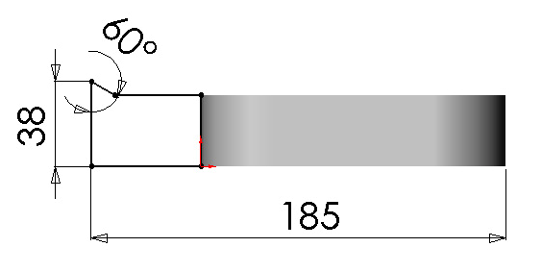

Figure 6 Boss sketch

12. Select Extrude Boss/Base on the Features toolbar.

13. Click Isometric to have 3-D visualization.

14. Select Mid Plane in the end condition drop down list box.

15. Type 130 mm in the distance 1 text box as shown in Figure 7.

16. Click OK to finish the boss extrusion.

Figure 7 Boss extrusion parameters
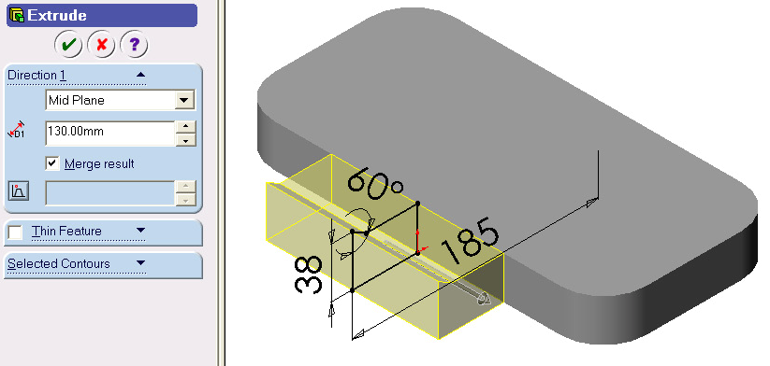

Create an Angle Plane and a Slot Body

1. Click Plane on the Reference Geometry toolbar, or click Insert, Reference
Geometry, Plane on the menu bar.

2. Click At Angle in the dialog box, and then select the front face of the boss in the graphics window. Its name appears in the Selections text box.

3. Select the edge of the boss tip as shown in Figure 8.

4. Type 30 in the Angle text box.

5. Click OK . The Plane2 is created and displayed in the FeatureManager Design
Tree.
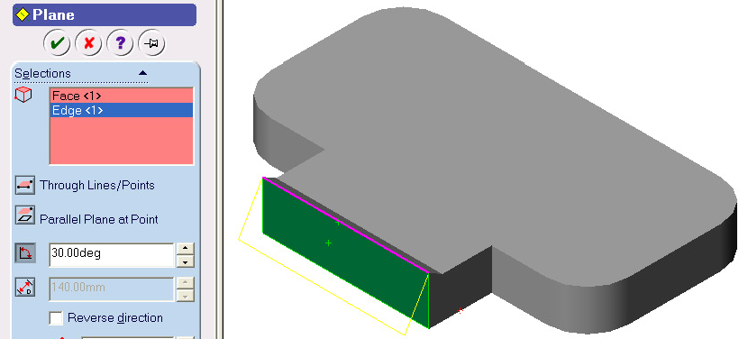

Figure 8 Plane At Angle for slot body

6. Select the Plane2 in the FeatureManager Design Tree or in the graphics window.

7. Select Sketch on the Sketch toolbar to open a new sketch.

8. Click Normal To on the Standard Views toolbar to make the sketch plane parallel to the screen.

9. Select Rectangle on the Sketch Tools toolbar and draw a rectangle whose top edge aligns with the top edge of the part.

10. Select Dimension on the Sketch Relation toolbar. Dimension the rectangle as shown in Figure 9. If the sketch is not fully constrained, apply collinear constraint to the vertical lines and edges.

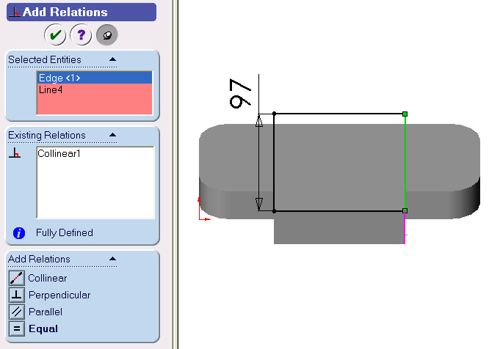

Figure 9 Slot body sketch

11. Select Extrude Boss/Base on the Features toolbar.

12. Select Blind in the end condition drop down list box.

13. Type 32 mm in the distance 1 text box as shown in Figure 10.

14. Click Reverse Directionto flip the extrusion direction

15. Click OK to finish the slot body extrusion.
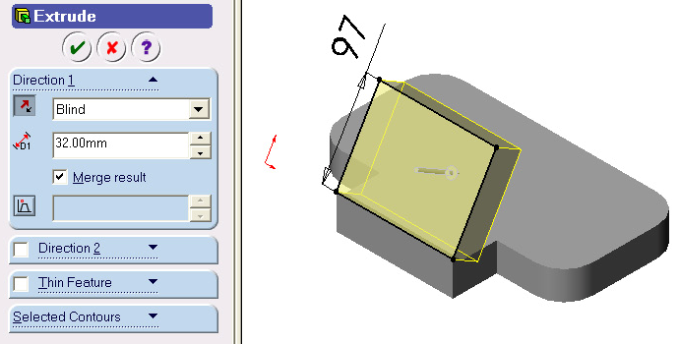

Figure 10Slot Body extrusion parameters

16. Select Fillet on the Features toolbar.

17. Select two top side edges of the slot body as shown in Figure 11.

18. Type 20 mm in the Radius text box.

19. Click OK to finish the fillet.

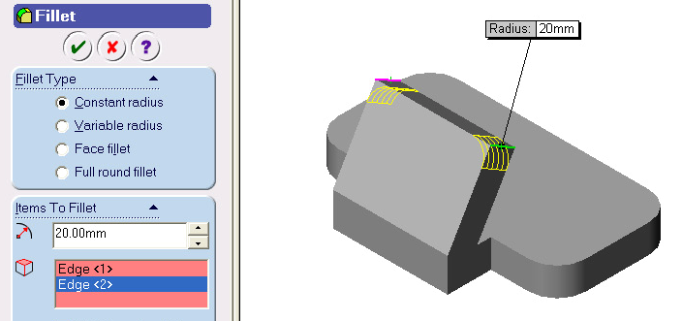

Cut Slots

Figure 11 Slot body fillets

1. Select the top face of the slot body as shown in Figure 12.

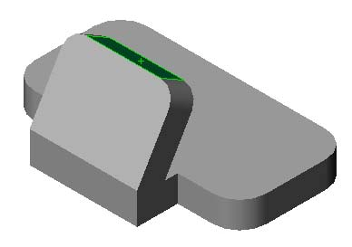

Figure 12 Sketch surface for slot cut

2. Select Sketch on the Sketch toolbar to open a new sketch.

3. Click Normal To on the Standard Views toolbar to make the sketch plane parallel to the screen.

4. Select Centerline on the Sketch Tools toolbar to draw a horizontal centerline as the symmetric axis of the sketch.

5. Select Line on the Sketch Tools toolbar to draw the sketch of the slot that is symmetric to the sketched centerline.

6. Select Add Relation on the Sketch Relation toolbar to add symmetric constraints to the sketch. (Note: Apply the symmetric constraint first to the centerline with the part edges to make the centerline symmetric to the part).

7. Select Dimension on the Sketch Relation toolbar, and dimension the sketch as shown in Figure 13. The sketch will be fully constrained. If not, apply more constraints.

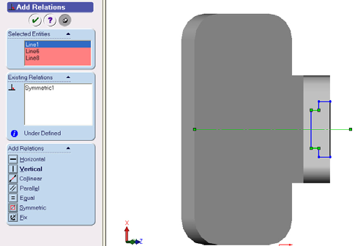

Figure 13 Slot sketch

8. Select Extruded Cut on the Features toolbar.

9. Select Through All in the end condition drop down list box as shown in the Figure
14.

10. Click OK to finish the slot cut.

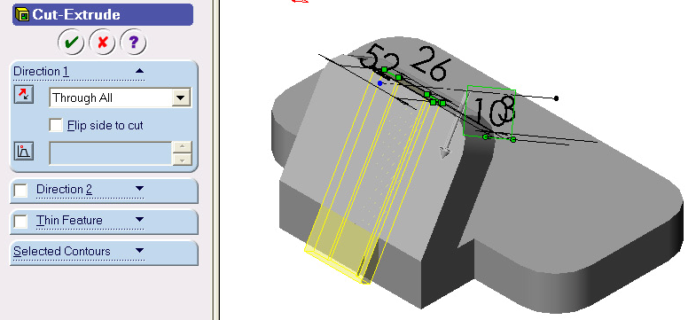

Figure 14 Slot cut parameters

11. Select back surface of the base feature as the sketch plane of the bottom as shown in Figure 15. You may rotate the part using Rotate View to make back surface directly visible.
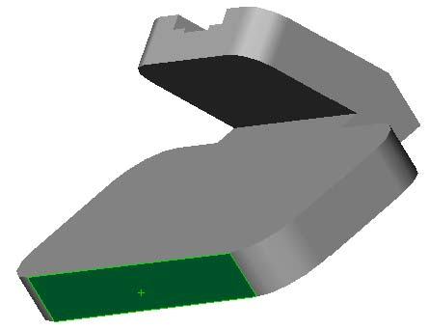

Figure 15 Sketch plane for bottom slot

12. Select Sketch on the Sketch toolbar to open a new sketch.

13. Click Normal To on the Standard Views toolbar to make the sketch plane parallel to the screen.

14. Select Centerline on the Sketch Tools toolbar to draw a horizontal centerline as the symmetric axis of the sketch.

15. Select Line on the Sketch Tools toolbar to draw a sketch of the slot that is symmetric to the sketched centerline.

16. Select Add Relation on the Sketch Relation toolbar to add symmetric constraints to the sketch. (Note: Apply the symmetric constraint first to the centerline of the part edge to make the centerline symmetric to the part).

17. Select Dimension on the Sketch Relation toolbar, and dimension the sketch as shown in Figure 16. The sketch will be fully constrained. If not, apply more constraints.

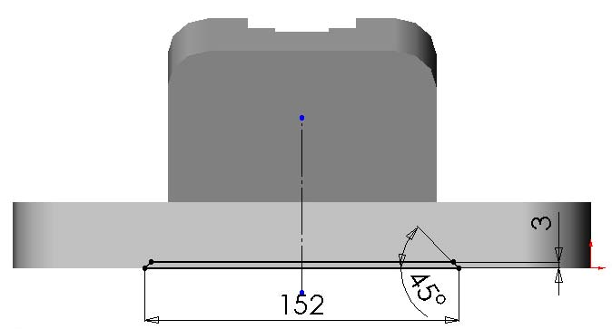

Figure 16 Bottom slot sketch

18. Select Extruded Cut on the Features toolbar.

19. Select Through All in the end condition drop down list box as shown in the Figure
17.

20. Click OK to finish the bottom slot cut.
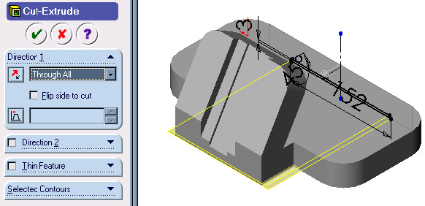

Figure 17 Bottom slot cut parameters

Create Bosses on the Base

1. Select the top face of the base as the sketch plane of the hole bosses as shown in
Figure 18.

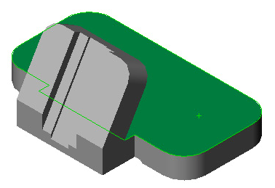

Figure 18 Sketch plane for hole boss

2. Select Sketch on the Sketch toolbar to open a new sketch.

3. Click Normal To on the Standard Views toolbar to make the sketch plane parallel to the screen.

4. Select Centerline on the Sketch Tools toolbar to draw a horizontal centerline as the symmetric axis of the sketch.

5. Select Centerpoint Arc on the Sketch Tools toolbar, and draw two arcs (two half-circles) to form the top and bottom edges of the sketch.

6. Select Add Relation on the Sketch Relation toolbar.

7. Click Keep Visible on the PropertyManager to activate the command.

8. Select two arcs, and apply equal constraint.

9. Select the top arc and the top edge arc of the part, and apply Concentric
constraint.

10. Select the bottom arc and the bottom edge arc of the part, and apply Concentric

constraint.

11. Select the centerline and the two outside edges of the part, and apply symmetric

constraint.

12. Select Line on the Sketch Tools toolbar, and draw two lines to close the sketch.

13. Select the sketch and the centerline by drawing a window around them (you may add entities to selection by holding the ‘Control’ key and clicking on he required entities one by one), and click Mirror on the Sketch Tools toolbar to mirror the sketch
to the other side.

14. Select Dimension on the Sketch Relation toolbar. Dimension the sketch as shown in Figure 19.

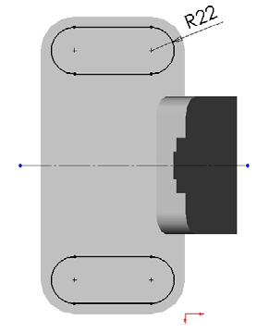

Figure 19 Hole boss sketch

15. Select Extruded Boss/Base on the Features toolbar.

16. Click Isometric to have 3-D visualization.

17. Select Blind in the end condition drop down list box.

18. Type 3 mm in the distance 1 box as shown in Figure 20.

19. Click OK .

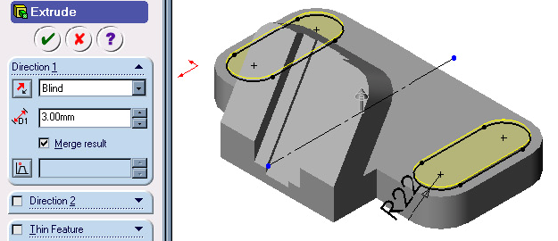

Figure 20 Hole Boss Extrusion Parameters
20. Select the back surface of the base as shown in Figure 21.

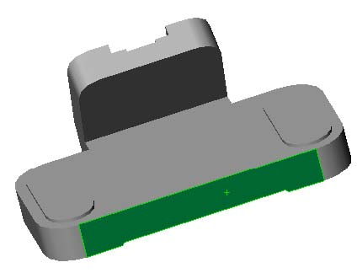

Figure 21 Sketch plane for the counterbored hole boss

21. Select Sketch on the Sketch toolbar to open a new sketch.

22. Click Normal To on the Standard Views toolbar to make the sketch plane parallel to the screen.

23. Select Centerline on the Sketch Tools toolbar to draw a horizontal centerline as the symmetric axis of the sketch.

24. Select Add Relation on the Sketch Relation toolbar. Select the centerline and the two side edges of the part, and apply Symmetric constraint.

25. Select Centerpoint Arc on the Sketch Tools toolbar, and draw a half circle whose center is coincident with the centerline.

26. Select Line on the Sketch Tools toolbar to draw three lines to close the sketch.

27. Select Dimension on the Sketch Relation toolbar, and dimension the sketch as shown in Figure 22.

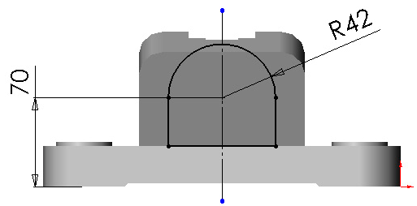

Figure 22 Sketch for counterbored hole boss

28. Select Extruded Boss/Base on the Features toolbar.

29. Click Isometric to have 3-D visualization.

30. Select Blind in the end condition drop down list box.

31. Type 70mm in the direction 1 box.

32. Click Reverse Direction to flip the extrusion direction as shown in Figure 23.

33. Click OK .

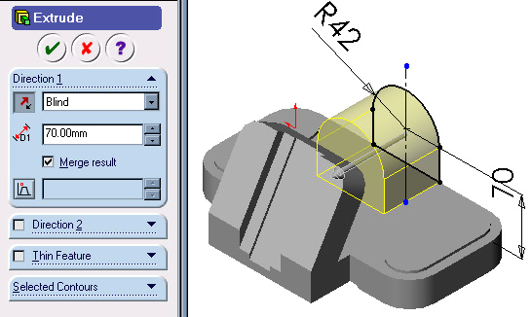

Figure 23 Counterbored hole boss

Create Holes and Fillets

1. Select the end surface of the counterbored hole boss.

2. Select the Hole Wizard on the Features toolbar, and select the Counterbore tab.

Note: Various types of holes can be created using corresponding tab.

3. Select Up To Next in the End Condition & Depth cell.

4. Type 22mm in the Hole Fit & Diameter cell. 45 mm and 50 mm in the Counterbore
Diameter & Depth cells as shown in Figure 24.

5. Click Next.

Figure 24 Counterbored Hole Parameters

6. Select Add Relation on the Sketch Relation toolbar.

7. | Select the hole center point and the arc edge of the boss, and click Concentric | .
8. | Click Finish to create the counterbored hole.
9. | Select the hole boss surface as shown in Figure 25.
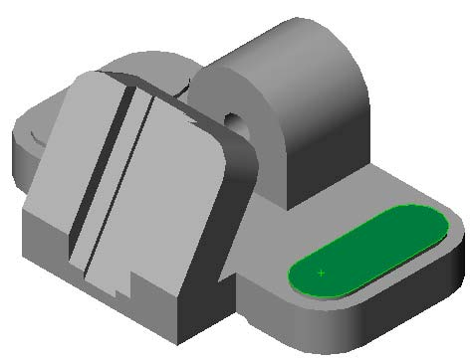

Figure 25 Sketch Plane for Base Holes

10. Select Sketch on the Sketch toolbar to open a new sketch.

11. Click Normal To on the Standard Views toolbar to make the sketch plane parallel to the screen.

12. Select Circle on the Sketch Tools toolbar, and draw one circle for the hole.

13. Select Add Relation on the Sketch Relation toolbar, and add concentric constraint to the circle with the arc edge of the base.

Remark: You may similarly draw three other circles, Add Equal constraint to the circles, but we will use another useful command to produce these circles.)

14. Select Dimension on the Sketch Relation toolbar. Dimension the circle diameter to 21mm as shown in Figure 26.

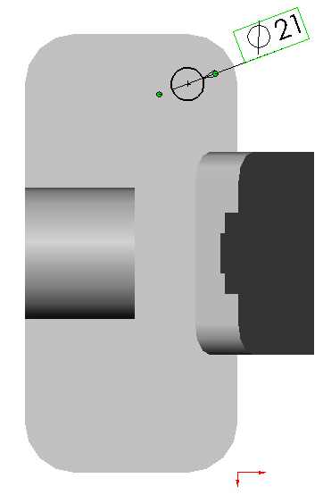

Figure 26 Base Hole Sketch

15. Select Extruded Cut on Features toolbar. Select Through All in the end condition drop down list box as shown in Figure 27.

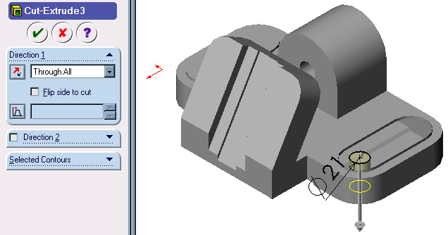

Figure 27 Base holes

16. Click 0K .

Copying Holes using Linear Pattern

17. Make sure that Hole you have just created is selected in FeatureManager Design
Tree. If not, select it by Clicking on it either in Graphic area or from FeatureManager
Design Tree.

18. Click Linear Pattern on Feature Toolbar, Linear Pattern Prperty Manager opens as shown in Figure 28.

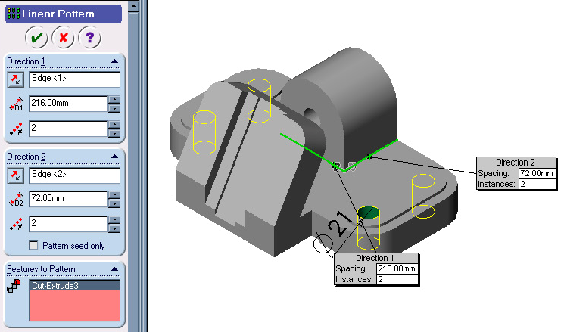

Figure 28 Copying Features using Linear Pattern.

19. Click on any edge parallel to Direction 1 as shown in Figure 28.

20. Type 216 mm for Spacing .

21. Type 2 for Number of Instances . A preview of the copied hole will appear as shown in Figure 28. Make sure that it is being copied in correct direction. If not, click on Reverse Direction.

22. Click on any edge parallel to Direction 2 as shown in Figure 28.

23. Type 72 mm for Spacing .

24. Type 2 for Number of Instances . A preview of the copied hole will appear as shown in Figure 28. Make sure that it is being copied in correct direction. If not, click on Reverse Direction.

25. Click OK .

26. Select the end face of the counterbored hole boss as shown in Figure 29. You may need to rotate the part.

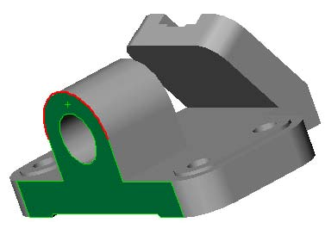

Figure 29 Sketch Plane for Reference Point

27. Select Sketch on the Sketch toolbar to open a new sketch.

28. Click Normal To on the Standard Views toolbar to make the sketch plane parallel to the screen.

29. Select Point on the Sketch Tools toolbar, and draw a point on the top edge of the counterbored hole boss.

30. Select View, Temporary Axes on the menu bar to show the temporary axis for adding relation.

31. Select Add Relation on the Sketch Relation toolbar.

32. Select the point and the edge. Click Coincident to make the point coincident with the arc edge.

33. Select the hole axis and the point as shown in Figure 30. Select Vertical .

34. Click Rebuild on the Standard toolbar to exit sketch.

35. Click Plane on the Reference Geometry toolbar, or click Insert, Reference
Geometry, Plane on the menu bar.

36. Select On Surface .
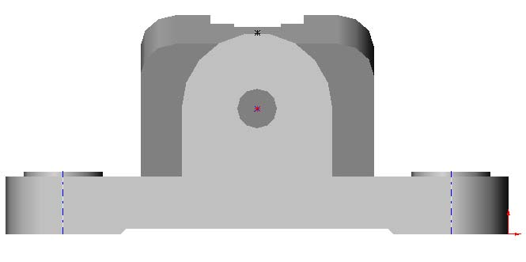

Figure 30 Sketch Point for Creating On Surface Plane

37. Select the cylindrical face of the boss and the sketch point as shown in Figure 31.
Their names appear in the Selections text box.

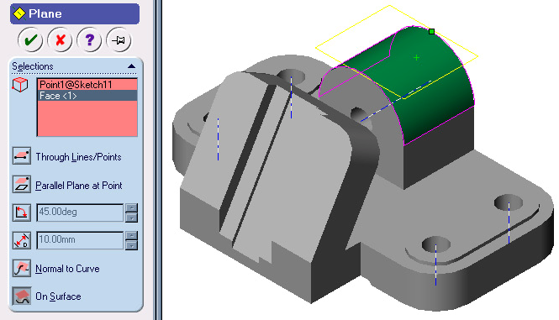

Figure 31 Top hole placement plane

38. Click OK . The Plane3 is created and displayed in the FeatureManager Design
Tree.

39. Select Plane 3 in the Feature Manager Design Tree or in the graphics windows.

40. Select Hole Wizard on the Features toolbar.

41. Select Tap tab in the Hole Definition dialog box.

42. Select the parameters as shown in Figure 32. Click Next.
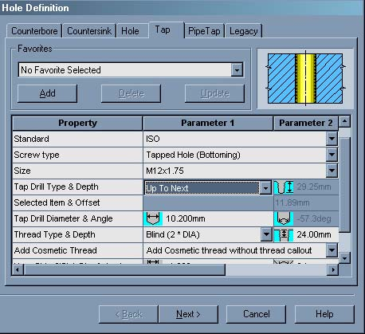

Figure 32 Top hole definition.

43. Click Normal To on the Standard Views toolbar to make the sketch plane parallel to the screen.

44. Add constraints and dimension the hole center as sown in Figure 33. Then click Finish in the Hole Placement dialog box. (Note: There will be an error message in the dialoge box. Click OK to ignore it.)

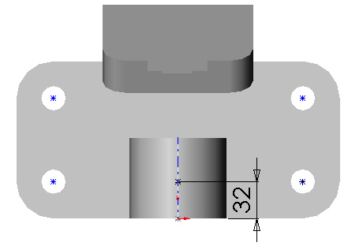

Figure 33 Top hole placement.

45. Select the front face of the slot body as shown in Figure 34.

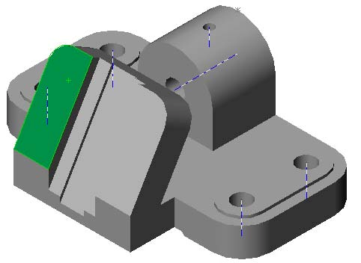

Figure 34 Slot hole sketch plane

46. Select Hole Wizard on the Features toolbar.

47. Set up the Hole Definition Dialog box as shown in Figure 35. Then click Next.

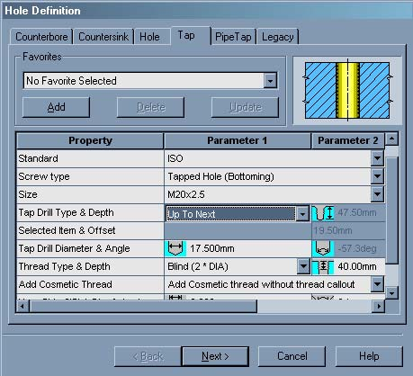

Figure 35 Slot hole definition

48. Sketch a centerline and a point for the other hole. Add Symmetric relation between two points and centerline. Dimension the hole centers as shown in figure 36.

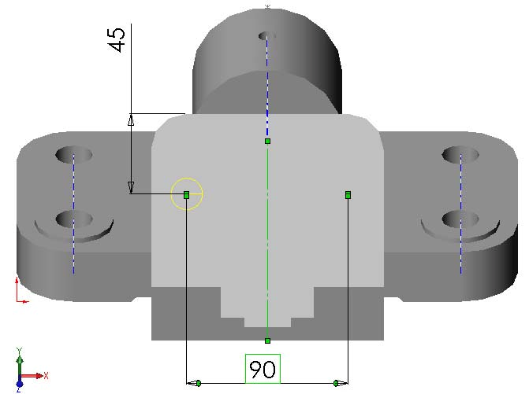

Figure 36 Slot hole placement.

49. Click Finish in the Hole Placement dialog box.

50. Add fillets as shown in Figure 37 and Figure 38 by using Fillet on Feature toolbar. Use fillet radius as 6 mm. Final model for Vertical Bearing Support is shown in Figure 39.

51. Save the file.
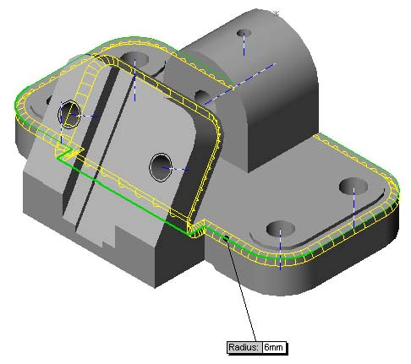

Figure 37 Base edge fillet.

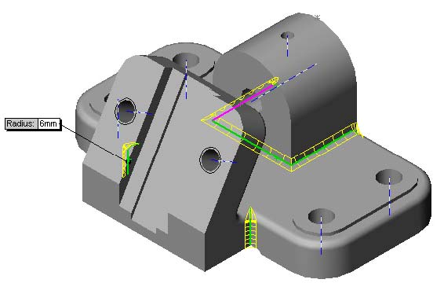

Figure 38 Slot body fillet.

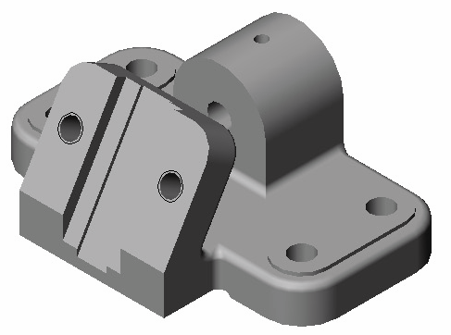

Figure 39 Vertical bearing support model

