**Test Based on Unit 2 اختبار الوحدة**

**Write the correct word under its picture:**

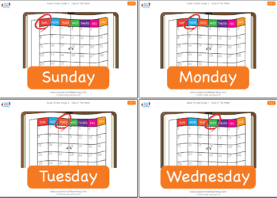**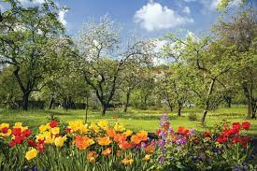 dolphin – elephant – parrot – days – turtle – spring**

**---------------------- -------------- ---------------- ---------------- ---------------- --------------**

**Choose the correct answer:**

**1. (**Am – Is – Are**) you a doctor?**

**2. He is a boy. (**Her – Their – His**) name is Ali.**

**3. They are happy. (**His – Its – Their**) class is nice.**

**4. I (**am not – isn’t – aren’t**) a teacher.**

**5. (**What – When – Where**) day is today?**

**6. (**What – Where – How**) old are you?**

**7. The final test is (**on – in – at**) December.**

**8. My test is (**in – on – at**) Monday.**

**9. May is the (**first – fifth – third**) month.**

**10. (**December – January – July**) is the last month.**

**Rearrange the following:**

**1. year. – Months – the – of** ---------------------------------------------------------.

**2. day – What – is – today?** ---------------------------------------------------------.

**3. old – How – you? - are** ---------------------------------------------------------.

**4. cute – so – is – He** ---------------------------------------------------------.

**5. call me – friends – My – Mike.** ---------------------------------------------------------.

**Punctuate the following:**

**1. what is the date tomorrow** ---------------------------------------------------------.

**2. it is monday** ---------------------------------------------------------.

**3. what month is it** ---------------------------------------------------------.

**Rearrange:** Thursday – Saturday – Tuesday – Monday – Wednesday – Sunday – Friday

**-----------------------------------------------------------------------------------------**

**Complete:**

**1. January, February, ………………, April, ………………., June, July, ……………………**

**2. sixth, ……………………………, eighth**

**3. January is the …………………… month of the year.**

**Supply the missing letters:**

**1. rabb__t 2. nam__ 3. surpri__e**