We Can! Book 6 Unit 6: My Dream Vacation

1. Listen and fill in the missing words and phrases. Then read and number the pictures.
[Play CD2 30 or read.]
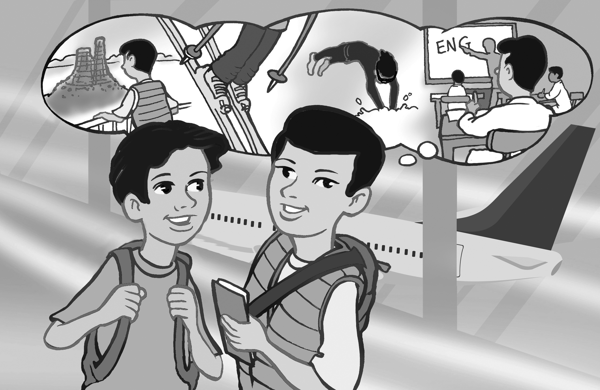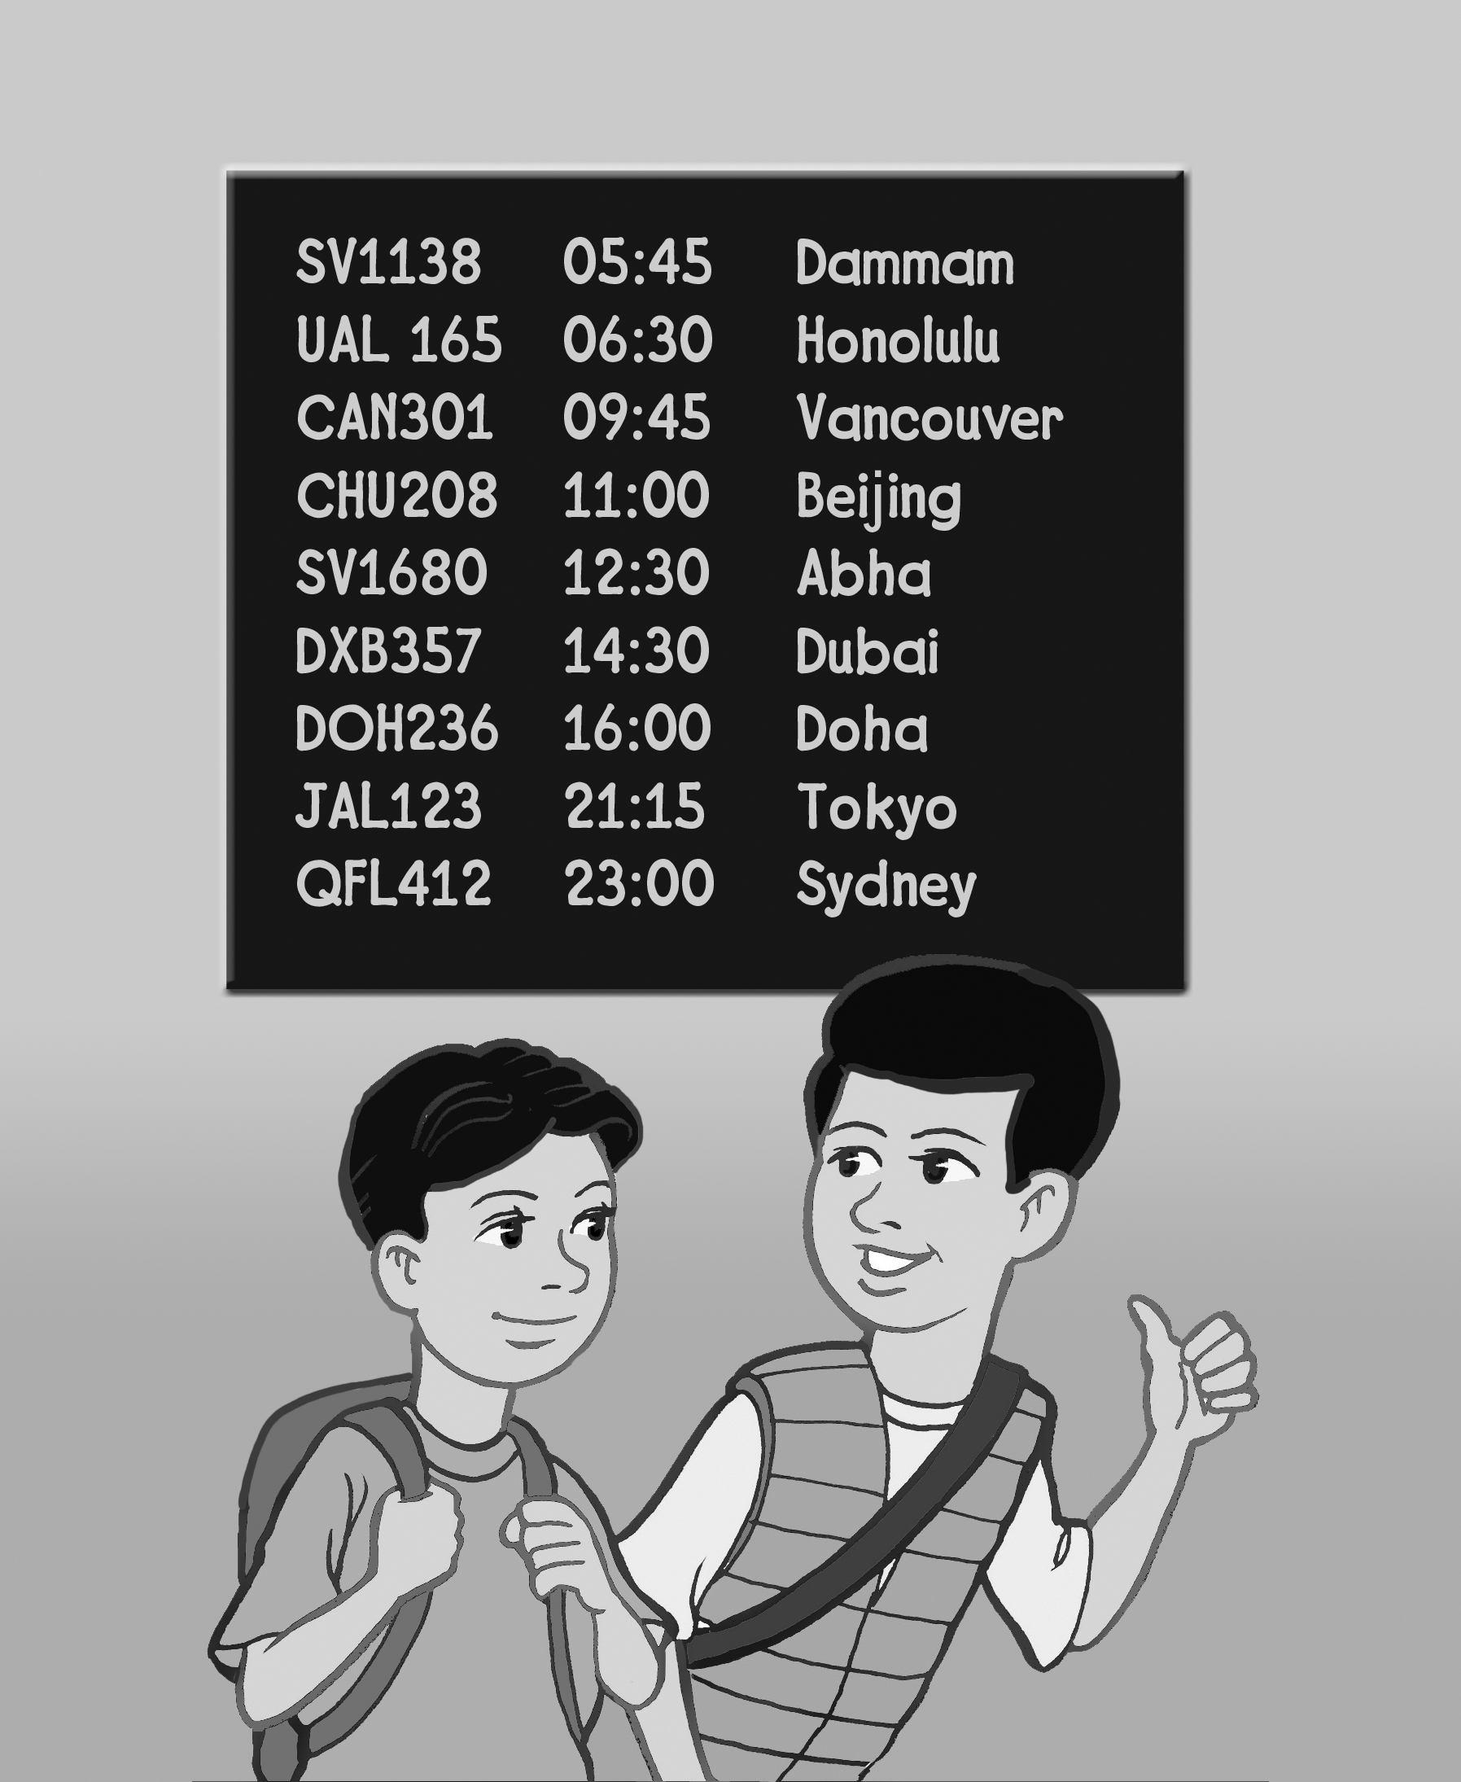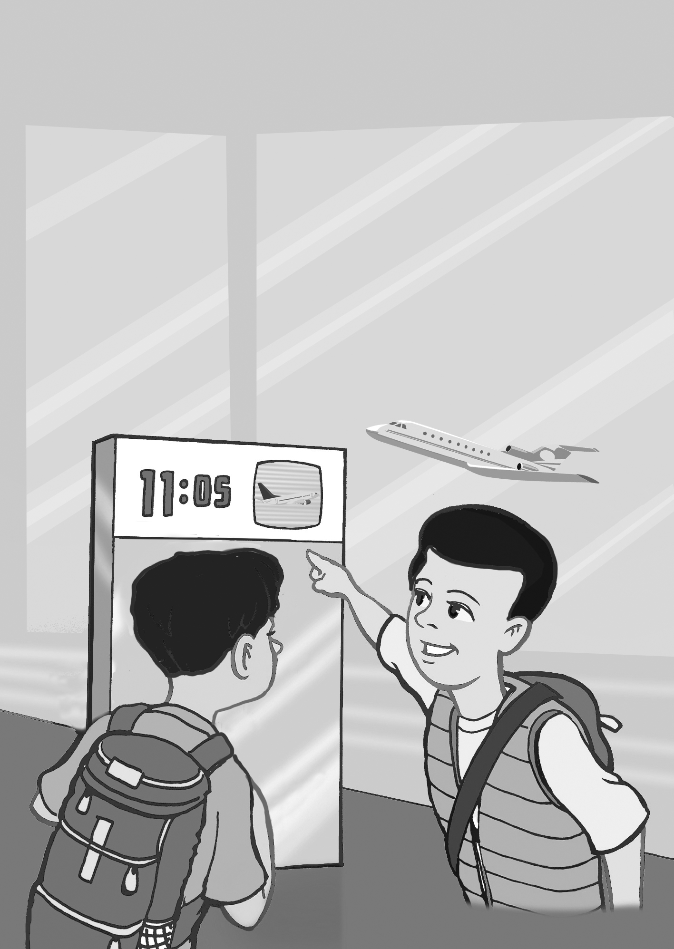
3 1 2

1)
A: Where are you going?
B: I’m going to Sydney / Paris / Seattle.
2)
A: How long does it take to get there?
B: It takes about fifteen / sixteen/ thirteen hours.
3)
A: What are you going to do there?
B: I’m going to go sightseeing/ skiing / stay at an English camp.

2. Read and answer the questions.

What are you going to do on the weekend?
______________(answers will vary)_____________
Where are you going to go?
________________________________________
How long does it take to get there?
______________(answers will vary)_____________

3. Read and put the sentences in order. Write numbers.

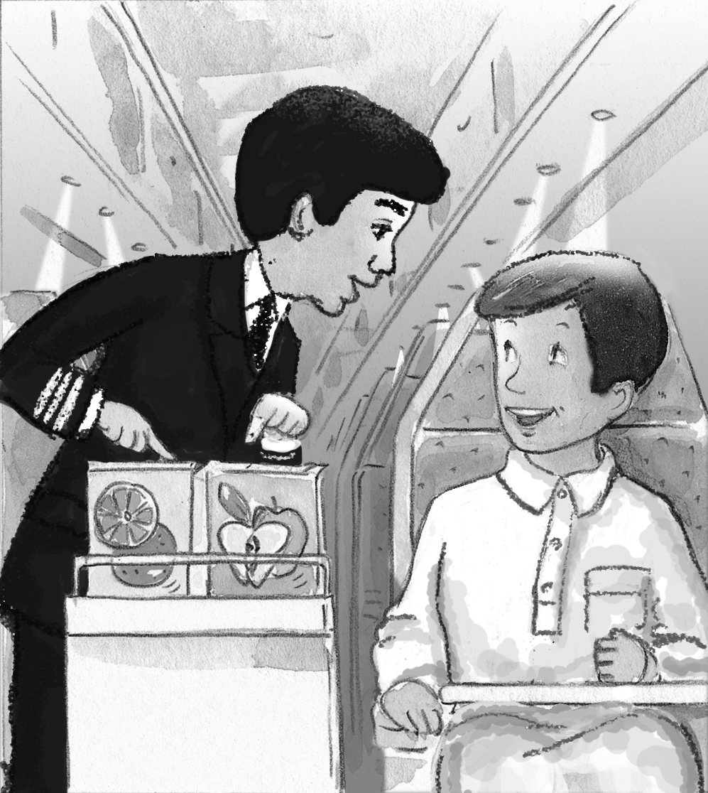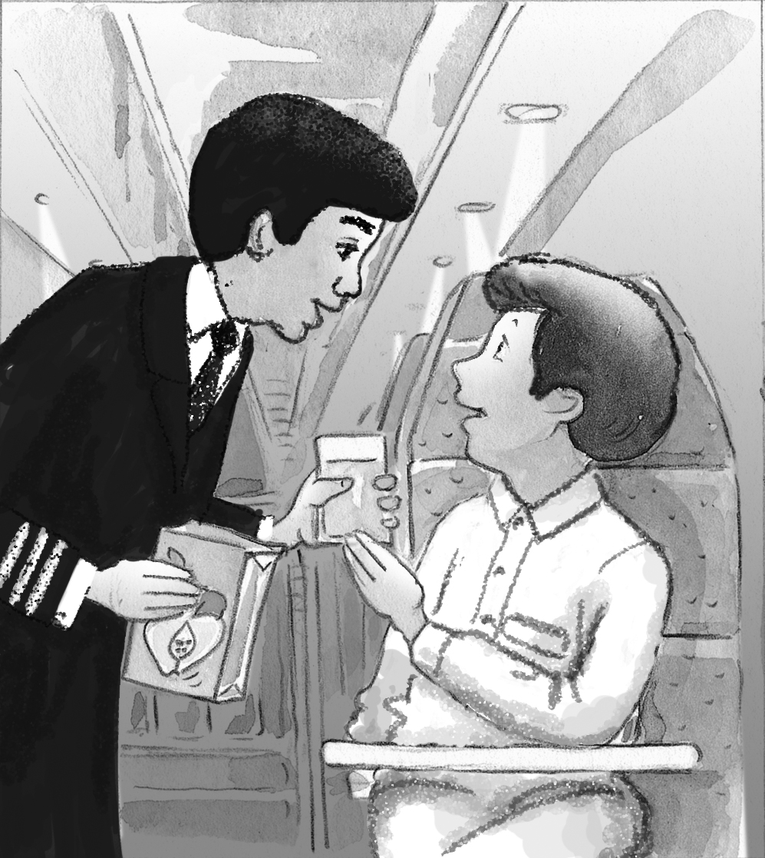

5 A: Here you go.
6 A: You’re welcome.
2 B: Hi. I’d like some juice, please.
1 A: Good evening. What would you like to drink?
3 A: Apple or orange juice?
5 B: Thank you.
4 B: Apple juice, please.
4. Write where they are going and what they plan to do there.

Example: Amal/ Dubai - shop/ for new clothes
Amal is going to Dubai. She’s going to shop for new clothes.
Jake/ Sydney – have / job interview
1. Jake is going to Sydney. He’s going to have a job interview.
Imad / Oman – swim / with the huge turtles
2. Imad is going to Oman. He’s going to swim with the huge turtles in the sea.
Aisha / Lebanon – eat / traditional dishes
3. Aisha is going to Lebanon. She’s going to eat traditional dishes.
5. Write about your plans for the weekend.

Next weekend, I ____________________________
______________(answers will vary)___________.
Next summer, we ____________________________
______________(answers will vary)___________.

5. Write about a place you want to travel to and what you plan to do there.
_________________________________________
______________(answers will vary)___________.
_________________________________________
_________________________________________
_________________________________________

