

Department of Biomedical Technology

BASIC MECHANICAL SKILLS
BMT 221 Lab Manual

Lab 8: Construct Bushes and Produce Detail Drawings

2nd Semester 1438-1439

Biomedical Technology
King Saud University
Riyadh, Kingdom of Saudi Arabia

Create models and detail drawing for the bushes given in Figures 1 and 2.

Figure 1 Bushing
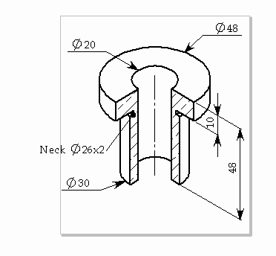

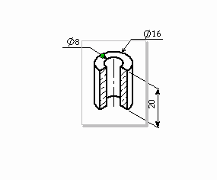

Figure 2 Plain Bus

