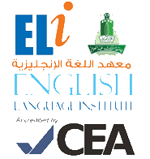
Grammar and
Vocabulary Practice
101
رؤية جامعة الملك عبد العزيز
منارة في المعرفة
تكامل في التكوين
ريادة في التنمية
رسالة جامعة الملك عبدالعزيز
الرقي بالمجتمع عبر تميز ثقافي و علمي و بحثي رائد

Student’s Name: ________________ Level: 101 Section: ____________

- Grammar Section (Units 1, 2 & 3)
Choose the correct answer:

- Where ____________ London?
a. are b. is c. was d. were

- This is ____________ family.
a. he b. they c. my d. she

- There ____________ an apple in the fridge. You can have it.
a. is b. are c. was d. were

- Vocabulary Section (Units 1, 2 & 3)
Choose the correct answer:

- He is a doctor. He works in a ____________.
a. school b. hospital c. hotel d. cafe

- My flat is ____________. I have one bedroom.
a. small b. big c. nice d. far

- See you ____________ afternoon.
a. in the b. at the c. on d. in

