


Worksheet – Top Goal 2

5th 6th grade Unit Glorious Food

Name ………………………………… Class ………………………………

__________________________________________________________________________________________

General Questions

1– What is your favorite dish?

A. My favorite dish is pizza . B. I am cooking pasta.
2 – How can you improve your eating habits?

A. I should sleep early. B. By eating enough fruit.
3 – What kind of food is pasta?
A. Starches. B. Proteins.


____________________________________________________________________________________________________

Reading short sentences

Wash your hands. | My favorite food is pasta. | She bakes a cake.
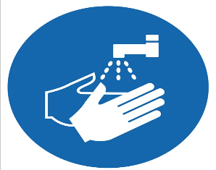 | 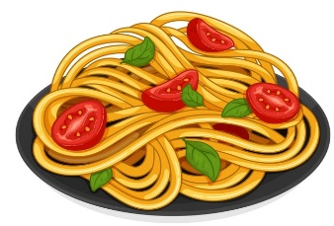 | 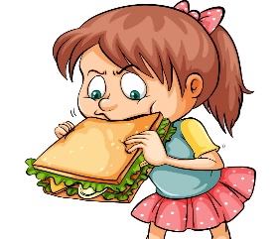

___________________________________________________________________________________________
Controlled writing


1- water/ lots /of/ Drink /. / ( Rearrange ) ………………………………………………………………………………………………..

Coffee | Water | Chips | 2 - _________ is good for your body . (choose)
should | Shouldn't | can't | You ________ eat enough vegetables . ( choose ) 3 -



turn | turned | 1- You should ________ the oven on .
using | use | 2- If I don't have sugar, I _____ honey.
Grammar

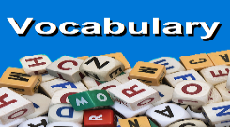
_____________________________________________________________________________________________________

Vocabulary

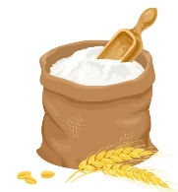 | 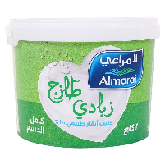 | 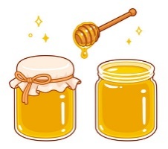 | 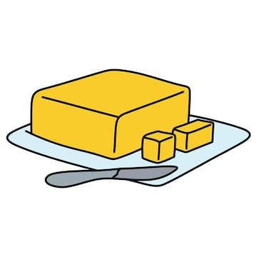 |   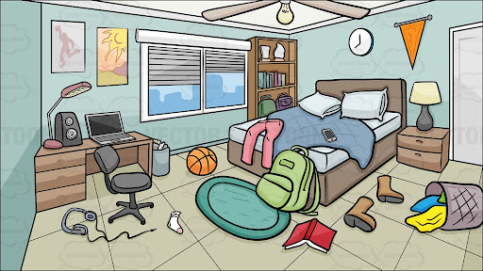    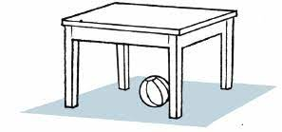
flour | fruit | sugar | butter | smell
cake | yogurt | honey | water | taste

_____________________________________________________________________________________________________
Orthography (spelling)

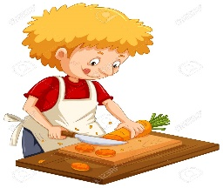 |  | 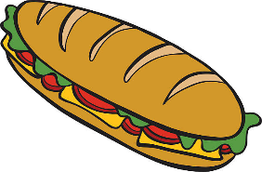
c_t | pou_ | san_wich
a | t | d
u | r | b

Controlled writing

4

Good luck T.



