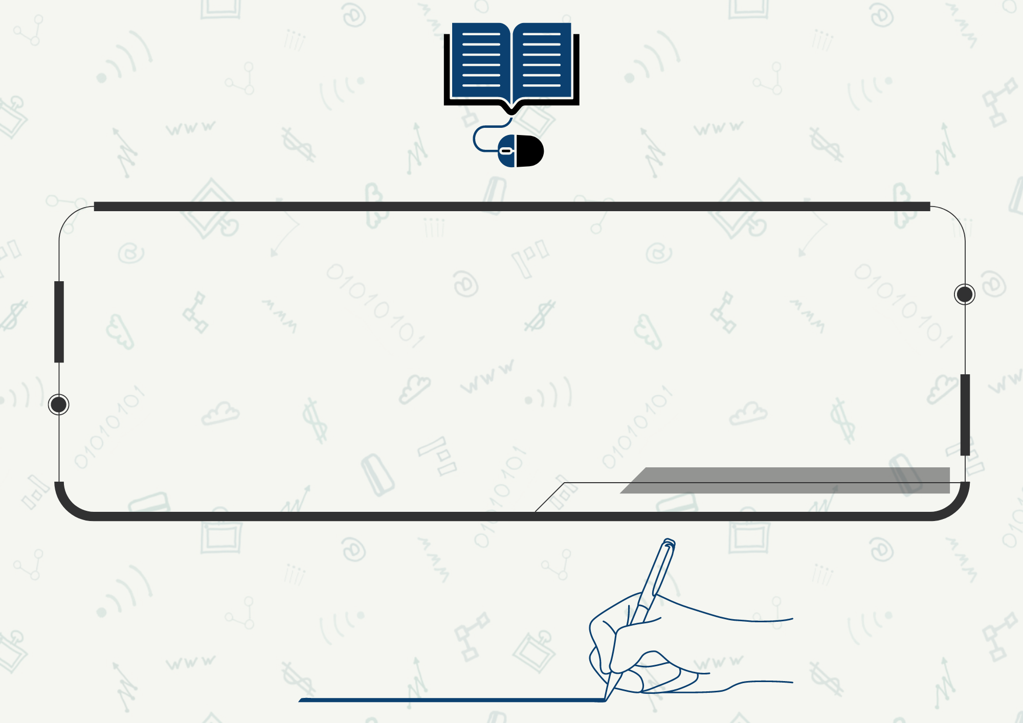

اسم المعلم/

**الفصل الدراسي الأول 1446هـ**

سجل المتابعة اليومي

المهارات الرقمية للمرحلة المتوسطة

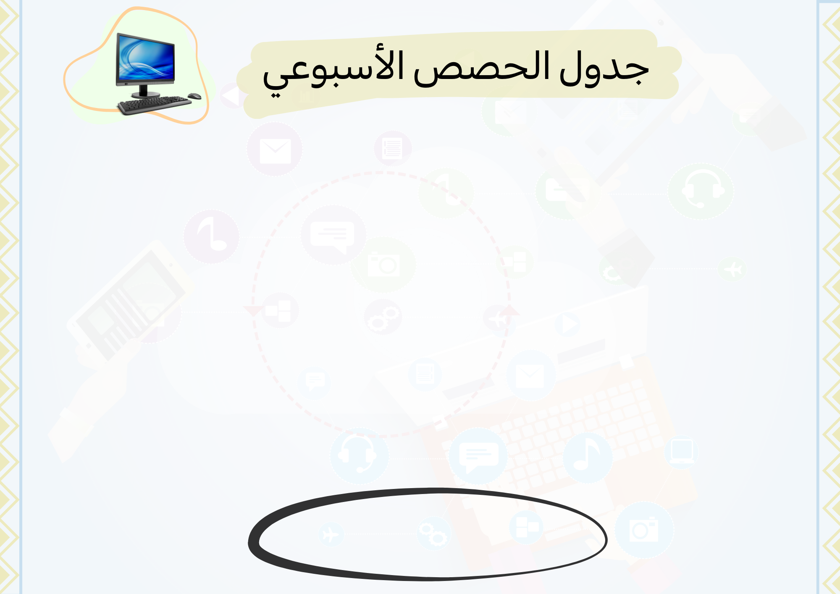

الحصة

اليوم

اسم المعلم/

|  |  |  |  |  |  |  |  |
| --- | --- | --- | --- | --- | --- | --- | --- |
|  | **الأولى** | **الثانية** | **الثالثة** | **الرابعة** | **الخامسة** | **السادسة** | **السابعة** |
| **الأحد** |  |  |  |  |  |  |  |
| **الأثنين** |  |  |  |  |  |  |  |
| **الثلاثاء** |  |  |  |  |  |  |  |
| **الأربعاء** |  |  |  |  |  |  |  |
| **الخميس** |  |  |  |  |  |  |  |

|  |  |  |  |  |  |  |  |  |  |  |  |  |  |  |  |  |  |  |  |  |  |  |  |  |  |  |  |  |
| --- | --- | --- | --- | --- | --- | --- | --- | --- | --- | --- | --- | --- | --- | --- | --- | --- | --- | --- | --- | --- | --- | --- | --- | --- | --- | --- | --- | --- |
| **م** | **الاسم** | **الواجبات** | | | | | | | | | | | **المشاركة والتفاعل** | | | | | | | | | | **مشروع** | **تطبيق عملي** | **تحريري قصير** | **عملي نهائي** | **نظري نهائي** | **المجموع** |
| **1** |  |  |  |  |  |  |  |  |  |  |  |  |  |  |  |  |  |  |  |  |  |  |  |  |  |  |  |  |
| **2** |  |  |  |  |  |  |  |  |  |  |  |  |  |  |  |  |  |  |  |  |  |  |  |  |  |  |  |  |
| **3** |  |  |  |  |  |  |  |  |  |  |  |  |  |  |  |  |  |  |  |  |  |  |  |  |  |  |  |  |
| **4** |  |  |  |  |  |  |  |  |  |  |  |  |  |  |  |  |  |  |  |  |  |  |  |  |  |  |  |  |
| **5** |  |  |  |  |  |  |  |  |  |  |  |  |  |  |  |  |  |  |  |  |  |  |  |  |  |  |  |  |
| **6** |  |  |  |  |  |  |  |  |  |  |  |  |  |  |  |  |  |  |  |  |  |  |  |  |  |  |  |  |
| **7** |  |  |  |  |  |  |  |  |  |  |  |  |  |  |  |  |  |  |  |  |  |  |  |  |  |  |  |  |
| **8** |  |  |  |  |  |  |  |  |  |  |  |  |  |  |  |  |  |  |  |  |  |  |  |  |  |  |  |  |
| **9** |  |  |  |  |  |  |  |  |  |  |  |  |  |  |  |  |  |  |  |  |  |  |  |  |  |  |  |  |
| **10** |  |  |  |  |  |  |  |  |  |  |  |  |  |  |  |  |  |  |  |  |  |  |  |  |  |  |  |  |
| **11** |  |  |  |  |  |  |  |  |  |  |  |  |  |  |  |  |  |  |  |  |  |  |  |  |  |  |  |  |
| **12** |  |  |  |  |  |  |  |  |  |  |  |  |  |  |  |  |  |  |  |  |  |  |  |  |  |  |  |  |
| **13** |  |  |  |  |  |  |  |  |  |  |  |  |  |  |  |  |  |  |  |  |  |  |  |  |  |  |  |  |
| **14** |  |  |  |  |  |  |  |  |  |  |  |  |  |  |  |  |  |  |  |  |  |  |  |  |  |  |  |  |
| **15** |  |  |  |  |  |  |  |  |  |  |  |  |  |  |  |  |  |  |  |  |  |  |  |  |  |  |  |  |
| **16** |  |  |  |  |  |  |  |  |  |  |  |  |  |  |  |  |  |  |  |  |  |  |  |  |  |  |  |  |

|  |  |  |  |  |  |  |
| --- | --- | --- | --- | --- | --- | --- |
| **الواجبات** | **المشاركة والتفاعل** | **مشروع /بحث/تقرير** | **تطبيق عملي** | **تحريري قصير** | **عملي نهائي** | **نظري نهائي** |
| **10** | **10** | **20** | **12** | **8** | **25** | **15** |

الصف/..................

|  |  |  |  |  |  |  |  |  |  |  |  |  |  |  |  |  |  |  |  |  |  |  |  |  |  |  |  |  |
| --- | --- | --- | --- | --- | --- | --- | --- | --- | --- | --- | --- | --- | --- | --- | --- | --- | --- | --- | --- | --- | --- | --- | --- | --- | --- | --- | --- | --- |
| **م** | **الاسم** | **الواجبات** | | | | | | | | | | | **المشاركة والتفاعل** | | | | | | | | | | **مشروع** | **تطبيق عملي** | **تحريري قصير** | **عملي نهائي** | **نظري نهائي** | **المجموع** |
| **17** |  |  |  |  |  |  |  |  |  |  |  |  |  |  |  |  |  |  |  |  |  |  |  |  |  |  |  |  |
| **18** |  |  |  |  |  |  |  |  |  |  |  |  |  |  |  |  |  |  |  |  |  |  |  |  |  |  |  |  |
| **19** |  |  |  |  |  |  |  |  |  |  |  |  |  |  |  |  |  |  |  |  |  |  |  |  |  |  |  |  |
| **20** |  |  |  |  |  |  |  |  |  |  |  |  |  |  |  |  |  |  |  |  |  |  |  |  |  |  |  |  |
| **21** |  |  |  |  |  |  |  |  |  |  |  |  |  |  |  |  |  |  |  |  |  |  |  |  |  |  |  |  |
| **22** |  |  |  |  |  |  |  |  |  |  |  |  |  |  |  |  |  |  |  |  |  |  |  |  |  |  |  |  |
| **23** |  |  |  |  |  |  |  |  |  |  |  |  |  |  |  |  |  |  |  |  |  |  |  |  |  |  |  |  |
| **24** |  |  |  |  |  |  |  |  |  |  |  |  |  |  |  |  |  |  |  |  |  |  |  |  |  |  |  |  |
| **25** |  |  |  |  |  |  |  |  |  |  |  |  |  |  |  |  |  |  |  |  |  |  |  |  |  |  |  |  |
| **26** |  |  |  |  |  |  |  |  |  |  |  |  |  |  |  |  |  |  |  |  |  |  |  |  |  |  |  |  |
| **27** |  |  |  |  |  |  |  |  |  |  |  |  |  |  |  |  |  |  |  |  |  |  |  |  |  |  |  |  |
| **28** |  |  |  |  |  |  |  |  |  |  |  |  |  |  |  |  |  |  |  |  |  |  |  |  |  |  |  |  |
| **29** |  |  |  |  |  |  |  |  |  |  |  |  |  |  |  |  |  |  |  |  |  |  |  |  |  |  |  |  |
| **30** |  |  |  |  |  |  |  |  |  |  |  |  |  |  |  |  |  |  |  |  |  |  |  |  |  |  |  |  |
| **31** |  |  |  |  |  |  |  |  |  |  |  |  |  |  |  |  |  |  |  |  |  |  |  |  |  |  |  |  |
| **32** |  |  |  |  |  |  |  |  |  |  |  |  |  |  |  |  |  |  |  |  |  |  |  |  |  |  |  |  |