المملكة العربية السعودية  وزارة التعليم  تبوك  المتوسطة الحادية والعشرون |  | اختبار الفصل الدراسي الأول  عام 1445  اللغة الإنجليزية  للصف الثالث متوسط  الزمن: 45 دقيقه

اسم الطالبة: الفصل:

20
1- Write at least 4 sentences about your pastime activities. Use guide words. [ free time – like – listening to music – going shopping – playing video games. With friends –]
20

……………………………………………………………………………………

…………………………………………………………………………………….

……………………………………………………………………………………..

…………………………………………………………………………………….
2-GRAMMAR/A. Choose the correct answer.
1- I always (do - does – doing) my homework in the afternoon.
2-How (many – old -much) time do you spend in the shower?
3-(last – ago – yesterday ) year I was in Canada.
4-where did they ( work- worked- working) ?

B. Do as shown between brackets. [ Correct]
a-Ahmad and Ali born in France but all of them could speak French ……………
b--The team was call The Lions………..
3- VOCABULARY: A-Choose the correct answer:
1- - Jake never eats meat. He’s ( an Internet addict- a vegetarian).
2- Ali is online all the time, even in the park! He is(an exercise freak- an Internet addict)
4- Fill in the missing letters:
1-g…..m [ t – o -y] 2- do…..or [ n - a -y]
3- tw….ns [ i – e -h] 4- holi….ay [ u – o -d]

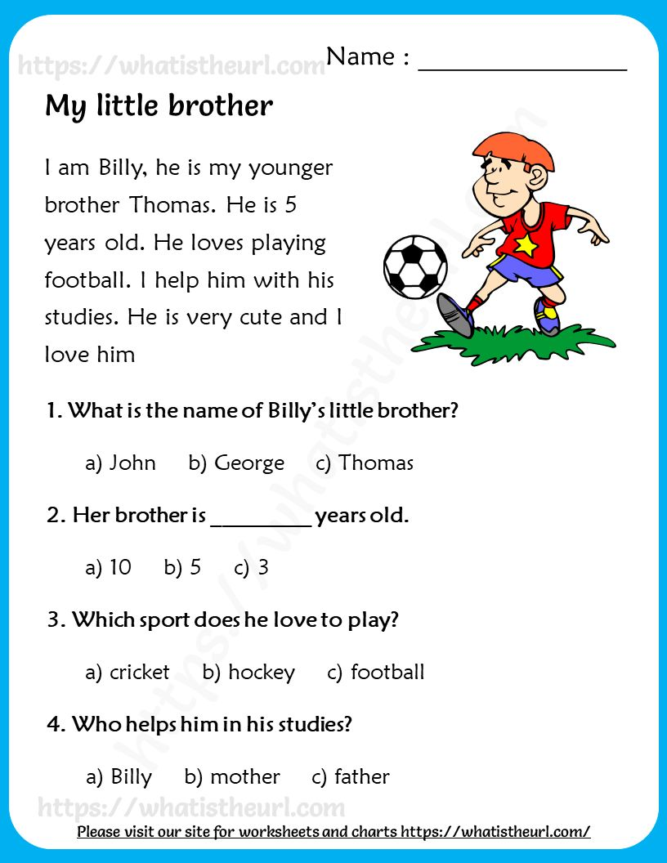
5-Read the following passage and choose the correct answers:
B- write the correct word[ herbal tea – infant – exercise freak -player - passport ]

………………. …………………… ……………………. …………………..
.
T.AFAF Salem

