Chapter 7
1- Which compound considered hydrocarbon
a. C₄H₁₀
b. NaCl
c. CaC₂
d. CCl4
2 - The General Formula of Alkane
a. C_{n}H_{2n}
b. C_{n}H_{2n+2}
c. C_{n}H_{2n-2}
d. C_{n}(H2O)_{n}
3- The General Formula of Alkene
a. C_{n}H_{2n}
b. C_{n}H_{2n+2}
c. C_{n}H_{2n-2}
d. C_{n}(H2O)_{n}
4- The General Formula of Alkyne
a. C_{n}H_{2n}
b. C_{n}H_{2n+2}
c. C_{n}H_{2n-2}
d. Cn(H₂O)n
5- Which compound of the following considered Alkane
a. C₄H₈
b. C₅H₈
c. C₃H₈
d. C₆(H₂O)₆
6- Which compound of the following considered Alkene
a. C₄H₈
b. C₅H₈
c. C₃H₈
d. C₆(H₂O)₆
7- Which compound of the following considered Alkyne
a. C₄H₈
b. C₅H₈
c. C₃H₈
d. C₆(H₂O)₆
8- Hydrocarbons consist of the following elements
a. C,H
b. Na,O
c. Cl, C
d. H,O
9- C₂H₆ considered
a. Alkane
b. Alkene
c. Alkyne
d. Benzene
10- C₃H₆ considered
a. Alkane
b. Alkene
c. Alkyne
d. Benzene
11- C₃H₄ Considered
a. Alkane
b. Alkene
c. Alkyne
d. Benzene
12- How many π bonds in the following compound
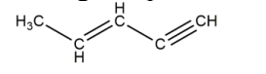
a. 1
b. 2
c. 3
d. 4
13- How many σ bonds in the following compound
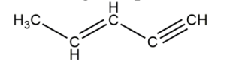
a. 4
b. 7
c. 10
d. 3
14- The name of the following compound
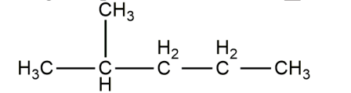
a. 4-methylpentane
b. 2-methylpentene
c. 2-methylpentane
d. 4-ethylpentane
15- The base name for hydrocarbon containing six carbon is
a. Meth b. Eth c. Prop d. Hex-
16- The products that released from combustion of Ethan in the following
Reaction
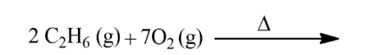
a. 4CO2(g) + 6H2O(l)
b. CH₃OH
c. C₂H₅OH
d. CH₃COCH₃

17- The Name of the following compounds
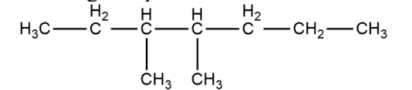
a.4,5-dimethylheptane
b. 4,5-methylheptane
c.3,4-dimethylheptane
d. 3.4-methylheptane
18- The correct structure of cis- isomer for 1,2-dichloroethene is
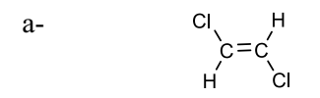
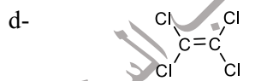
B

19- The structure of naphthalene is

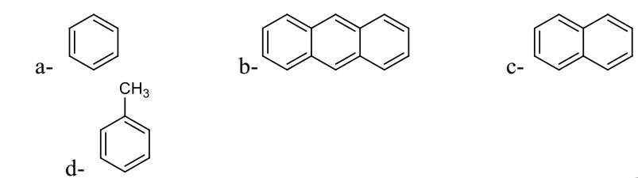
C
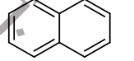
20- The structure of Toluene is
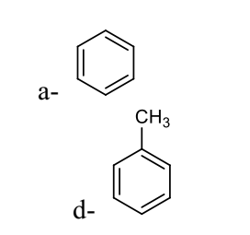
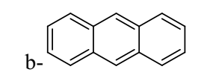

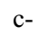

a

21- The structure of peptied bond is:
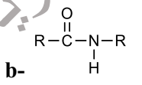
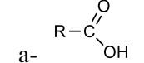 c- CH4

d- CH3NH2
B
22- The buiding blocks of all protiens is
a- α-amino acid b- amide c-ethers d- alcohols
23- The example of polysaccharides is
- Starch b- Glucose c- Fructose d- Sucrose
24- Which of the following considered biopolymer
a- DNA b- Toluene c- Ethanol d- Aniline
25- The correct structure of trans- isomer for 1,2-dichloroethene is

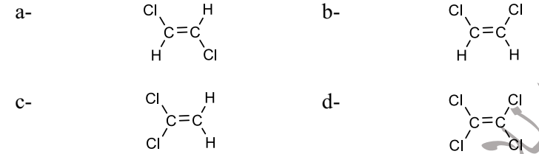
a
26- Which one of these structures represents a carboxylic acid functional group?
d
27- Which one of these compounds is an amine?
a- CH₃NH₂ b- CH₃OH c- CH₃OCH₃ dCH₃CONH₂
28- Which one of these structures represents a Ketone functional group?
b
29- Which one of these structures represents an aldehyde functional group?
c
30- Which one of these structures represents an alcohol functional group?
a
31- Which one of these compounds is alcohol?
a- CH₃NH₂ b- CH₃OH c- CH₃OCH₃ d- CH₃CONH₂
32- Which one of these compounds is ether?
a- CH₃NH₂ b- CH₃OH c- CH₃OCH₃ d- CH₃CONH₂
33- Which one of these compounds is an amide?
a- CH₃NH₂ b- CH₃OH c- CH₃OCH₃ d- CH₃CONH₂
34- The structure of benzene is
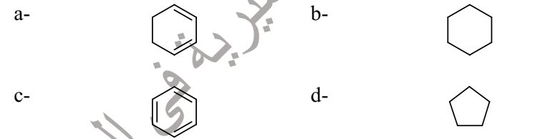
c
35- Which compound of the following considered carbohydrate
a. Glucose b. Protien c. DNA d. Lipidis
36- ________ is a monosaccharide.
(A) glucose B) Lactose C) Guanine D) Glycogen
37- Starch, glycogen, and cellulose are made of repeating units of ________.
(A) lactose B) glucose C) fructose D) sucrose
38- Which of the following considered organic compounds:
a.CH₃CHO b. CCl₄ c. PCl₅ d. NaCl
39- ________ could be cycloalkane.
A) C₃H₈ B) C₃H₆ C) C₆H₁₂ D) C₁₇H₃₆
40- 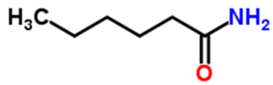is called ________.
A) amine B) amide C) ketone D) aldehyde
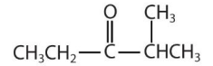
41- The following structure represents _ .

A) Ether B) ester C) ketone D) aldehyde
42- Which one of the following is not an alcohol?
A) acetone B) methanol C) ethanol D) propanol
43- Which compound of the following contain double bond
a. C₂H₂
b. C₂H₄
c. C₂H₆
d. CH₄
44- Which compound of the following contain Triple bond
a. C₂H₂
b. C₂H₄
c. C₂H₆
d. CH₄
45- The structure of methylamine is
a- CH₃-NH₂ b- CH₃-COOH c- CH₃-OH d- CH₃-O-CH₃
46- The simplest alkyne is ________.
A) ethylene B) ethane C) acetylene D) benzene
47- Hydrocarbons containing carbon-carbon triple bonds are called………
A) alkanes B) aromatic hydrocarbons C) alkynes D) alkenes
48- What is the number of π bond in the following compound?
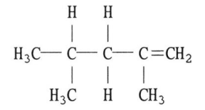
A) 1 B) 2 C) 4 D) 3
49- Molecular formula for benzene is..............................
a) C₆H₁₄ b) C₂H₆ c) C₆H₁₀ d) C₆H₆
50- All of the following is biopolymers except............................................
a) Protein b) Polysaccharides c) lipids d) Nucleic acid
51- The suffix used for organic molecules containing the carboxylic acid
functional group is
a- one b- oic acid c- amide d- ene
52- The following structure represents ________.

A) Ether B) ester C) ketone D) aldehyde
53- The addition of Br2 to propene produces ________.
(A) 1-bromopropane B) 2-bromopropane
C) 1,2-dibromopropane D) 2,3-dibromopropane
54- The products that released from combustion of Ethan in the following
reaction
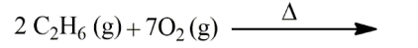

a. 4CO₂(g) + 6H₂O(l)
b. CH₃OH
c. C₂H₅OH
d. CH₃COCH₃

