Snell's Law Report

Objectives
- To verify Snell's Law
- To determine the refractive index of glass.

Theoretical Background
We saw in the reflection experiment that light travels in straight lines until it meets
the boundary of two media.
Refraction occurs when light meets the boundary of two media, and the light continues through the second. For example, when light hits the boundary between air and water, its path bends, but it continues through the water. If you stick a pen in
a glass of water, it appears to bend when it touches the water. This is because light travels at a different speed through water than it does through air.
In fact, light travels at a different speed in every medium. It travels fastest in a vacuum, the speed at which it travels is referred to as the speed of light, and is denoted c. The speed of light is known very accurately, but for most purposes, c =
3×108 m/s. The speed of light in any other medium (v) is defined as the speed of light
(in a vacuum, c) divided by the refractive index (n) of the medium. Mathematically,
U=^{c} and n=^{c} n u
The refractive index of any material is greater than or equal to one (n vacuum = 1 but
otherwise n > 1). The refractive index of air is very close to one, n air ≈ 1.008. The following figure shows the refraction of light as it passes from one medium to a denser medium. An analogy is to consider running from air to glass.
The direction of propagation of light in the second medium depends on the angle of
incidence (i), the refractive index of the first medium (n1), and the refractive index
of the second medium (n2). The Law of Refraction is known as Snell’s Law, and is given by:
𝑛𝑛1 sin 𝑖𝑖 = 𝑛𝑛2 sin 𝑟𝑟
Consider a ray of light passing from air (n air = 1) into another medium such as glass
with an index of refraction n (n >1). In this case, the ray is incoming (incident) on the air side and outgoing (refracted) on the glass side of the interface, and we have sin 𝑖 = 𝑛2 sin r 𝐧𝟐 = ^{𝐬𝐢𝐧 𝒊}
𝐬𝐢𝐧 𝒓
Equipment
Glass block, laser pointer, protractor and ruler, sketch paper.

Method
- Place a glass block on the page and mark its outline.
- Shine a ray of light from the ray-box into the glass block.
- Mark two dots on the incident ray and exit ray and draw the outline of the block.
- Remove the block and complete all lines including the normal, as indicated on the diagram.
- Measure the angle of incidence i and angle of refraction r using the protractor.
- Repeat for different values of i.
- Draw up a table as shown.
- Plot a graph of sin i against sin r. A straight line through the origin verifies Snell’s law of refraction i.e. sin i ∝ sin r.
- The slope of the line gives a value for the refractive index of glass.
10.The refractive index of glass is also equal to the average value of 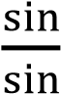

i  Degrees | 15 | 20 | 25 | 30 | 35 | 40 | 45
r  Degrees | 10 | 15 | 20 | 21 | 25 | 30 | 33
Sin i | Sin15  =0.25 | Sin20  =0.34 | Sin25  =0.42 | Sin30  =0.5 | Sin35  =0.57 | Sin40  =0.64 | Sin45  =0.70
Sin r | Sin10  =0.17 | Sin15  =0.25 | Sin20  =0.34 | Sin21  =0.35 | Sin25  =0.42 | Sin30  =0.5 | Sin33  =0.54
𝑛= 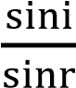 | 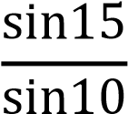  =1.49 | 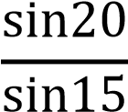  =1.32 | 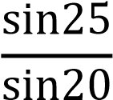  =1.23 | 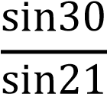  =1.39 | 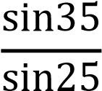  =1.35 | 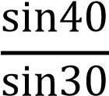  =1.28 | 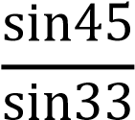  =1.29
Average value for refractive index of glass n₌
1.49+1.32+1.23+1.39+1.35+1.28+1.29
=1.33
7 Results
True Refractive Index of glass = n_{t} =1.523

Errors Analysis:
Relative error= nt−n % 1.523−1.33 = 1. 93%
100 100
Solpe=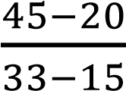=1.33

