صورة تحتوي على نص, لقطة شاشة, الخط, شعار

تم إنشاء الوصف تلقائياً

صورة تحتوي على نص, لقطة شاشة, الخط, برمجيات

تم إنشاء الوصف تلقائياً

صورة تحتوي على نص, لقطة شاشة, رقم, الخط

تم إنشاء الوصف تلقائياً

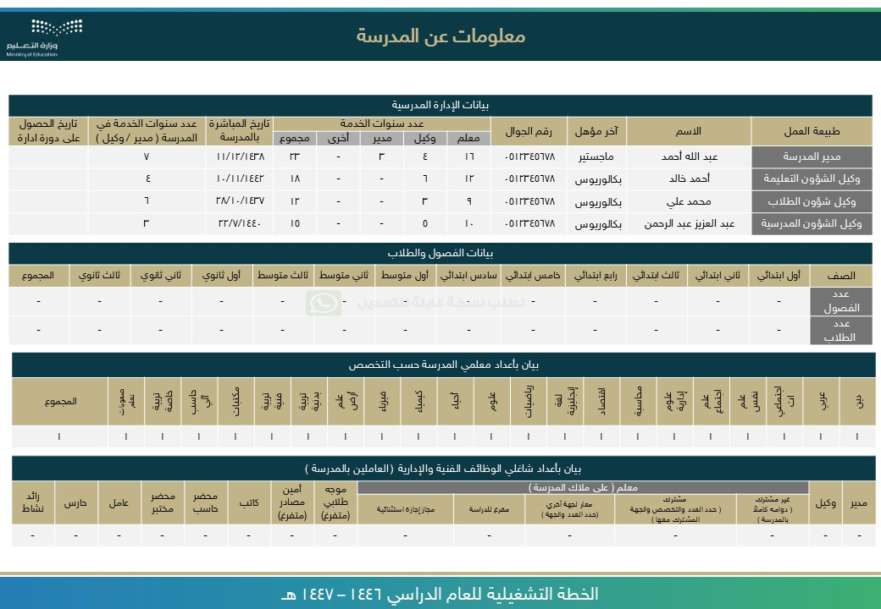

[ر](https://api.whatsapp.com/send/?phone=966541156989&text&type=phone_number&app_absent=0)

[ا](https://api.whatsapp.com/send/?phone=966541156989&text&type=phone_number&app_absent=0)

[ع](https://api.whatsapp.com/send/?phone=966541156989&text&type=phone_number&app_absent=0)

[ش](https://api.whatsapp.com/send/?phone=966541156989&text&type=phone_number&app_absent=0)

[,](https://api.whatsapp.com/send/?phone=966541156989&text&type=phone_number&app_absent=0)

[ز](https://api.whatsapp.com/send/?phone=966541156989&text&type=phone_number&app_absent=0)

[م](https://api.whatsapp.com/send/?phone=966541156989&text&type=phone_number&app_absent=0)

[ر](https://api.whatsapp.com/send/?phone=966541156989&text&type=phone_number&app_absent=0)

[,](https://api.whatsapp.com/send/?phone=966541156989&text&type=phone_number&app_absent=0)

[ة](https://api.whatsapp.com/send/?phone=966541156989&text&type=phone_number&app_absent=0)

[ي](https://api.whatsapp.com/send/?phone=966541156989&text&type=phone_number&app_absent=0)

[ن](https://api.whatsapp.com/send/?phone=966541156989&text&type=phone_number&app_absent=0)

[ف](https://api.whatsapp.com/send/?phone=966541156989&text&type=phone_number&app_absent=0)

[ة](https://api.whatsapp.com/send/?phone=966541156989&text&type=phone_number&app_absent=0)

[ص](https://api.whatsapp.com/send/?phone=966541156989&text&type=phone_number&app_absent=0)

[ا](https://api.whatsapp.com/send/?phone=966541156989&text&type=phone_number&app_absent=0)

[ص](https://api.whatsapp.com/send/?phone=966541156989&text&type=phone_number&app_absent=0)

[ق](https://api.whatsapp.com/send/?phone=966541156989&text&type=phone_number&app_absent=0)

[,](https://api.whatsapp.com/send/?phone=966541156989&text&type=phone_number&app_absent=0)

[ت](https://api.whatsapp.com/send/?phone=966541156989&text&type=phone_number&app_absent=0)

[ا](https://api.whatsapp.com/send/?phone=966541156989&text&type=phone_number&app_absent=0)

[م](https://api.whatsapp.com/send/?phone=966541156989&text&type=phone_number&app_absent=0)

[و](https://api.whatsapp.com/send/?phone=966541156989&text&type=phone_number&app_absent=0)

[س](https://api.whatsapp.com/send/?phone=966541156989&text&type=phone_number&app_absent=0)

[ر](https://api.whatsapp.com/send/?phone=966541156989&text&type=phone_number&app_absent=0)

[ل](https://api.whatsapp.com/send/?phone=966541156989&text&type=phone_number&app_absent=0)

[ا](https://api.whatsapp.com/send/?phone=966541156989&text&type=phone_number&app_absent=0)

[لى](https://api.whatsapp.com/send/?phone=966541156989&text&type=phone_number&app_absent=0)

[ع](https://api.whatsapp.com/send/?phone=966541156989&text&type=phone_number&app_absent=0)

[ي](https://api.whatsapp.com/send/?phone=966541156989&text&type=phone_number&app_absent=0)

[و](https://api.whatsapp.com/send/?phone=966541156989&text&type=phone_number&app_absent=0)

[ت](https://api.whatsapp.com/send/?phone=966541156989&text&type=phone_number&app_absent=0)

[ح](https://api.whatsapp.com/send/?phone=966541156989&text&type=phone_number&app_absent=0)

[ت](https://api.whatsapp.com/send/?phone=966541156989&text&type=phone_number&app_absent=0)

[ة](https://api.whatsapp.com/send/?phone=966541156989&text&type=phone_number&app_absent=0)

[ر](https://api.whatsapp.com/send/?phone=966541156989&text&type=phone_number&app_absent=0)

[و](https://api.whatsapp.com/send/?phone=966541156989&text&type=phone_number&app_absent=0)

[ص](https://api.whatsapp.com/send/?phone=966541156989&text&type=phone_number&app_absent=0)

[اً](https://api.whatsapp.com/send/?phone=966541156989&text&type=phone_number&app_absent=0)

[ي](https://api.whatsapp.com/send/?phone=966541156989&text&type=phone_number&app_absent=0)

[ئ](https://api.whatsapp.com/send/?phone=966541156989&text&type=phone_number&app_absent=0)

[ا](https://api.whatsapp.com/send/?phone=966541156989&text&type=phone_number&app_absent=0)

[ق](https://api.whatsapp.com/send/?phone=966541156989&text&type=phone_number&app_absent=0)

[ل](https://api.whatsapp.com/send/?phone=966541156989&text&type=phone_number&app_absent=0)

[ت](https://api.whatsapp.com/send/?phone=966541156989&text&type=phone_number&app_absent=0)

[ف](https://api.whatsapp.com/send/?phone=966541156989&text&type=phone_number&app_absent=0)

[ص](https://api.whatsapp.com/send/?phone=966541156989&text&type=phone_number&app_absent=0)

[و](https://api.whatsapp.com/send/?phone=966541156989&text&type=phone_number&app_absent=0)

[ل](https://api.whatsapp.com/send/?phone=966541156989&text&type=phone_number&app_absent=0)

[ا](https://api.whatsapp.com/send/?phone=966541156989&text&type=phone_number&app_absent=0)

[ء](https://api.whatsapp.com/send/?phone=966541156989&text&type=phone_number&app_absent=0)

[ا](https://api.whatsapp.com/send/?phone=966541156989&text&type=phone_number&app_absent=0)

[ش](https://api.whatsapp.com/send/?phone=966541156989&text&type=phone_number&app_absent=0)

[ن](https://api.whatsapp.com/send/?phone=966541156989&text&type=phone_number&app_absent=0)

[إ](https://api.whatsapp.com/send/?phone=966541156989&text&type=phone_number&app_absent=0)

[م](https://api.whatsapp.com/send/?phone=966541156989&text&type=phone_number&app_absent=0)

[ت](https://api.whatsapp.com/send/?phone=966541156989&text&type=phone_number&app_absent=0)



صورة تحتوي على نص, لقطة شاشة, برمجيات, الخط

تم إنشاء الوصف تلقائياً

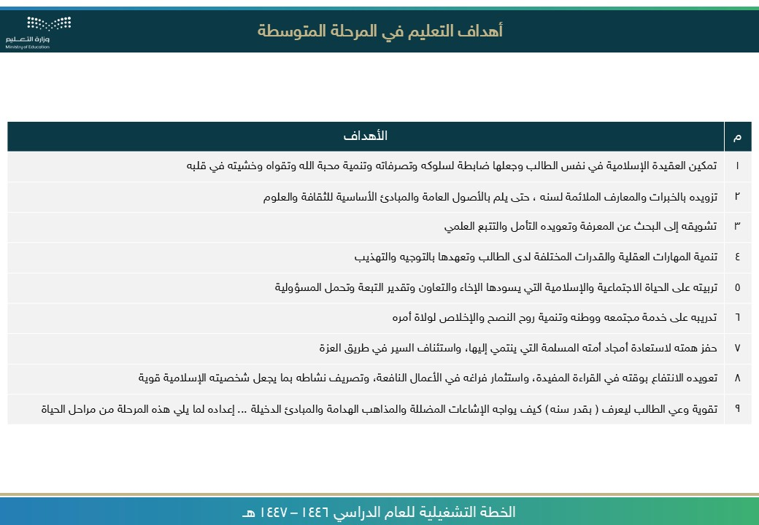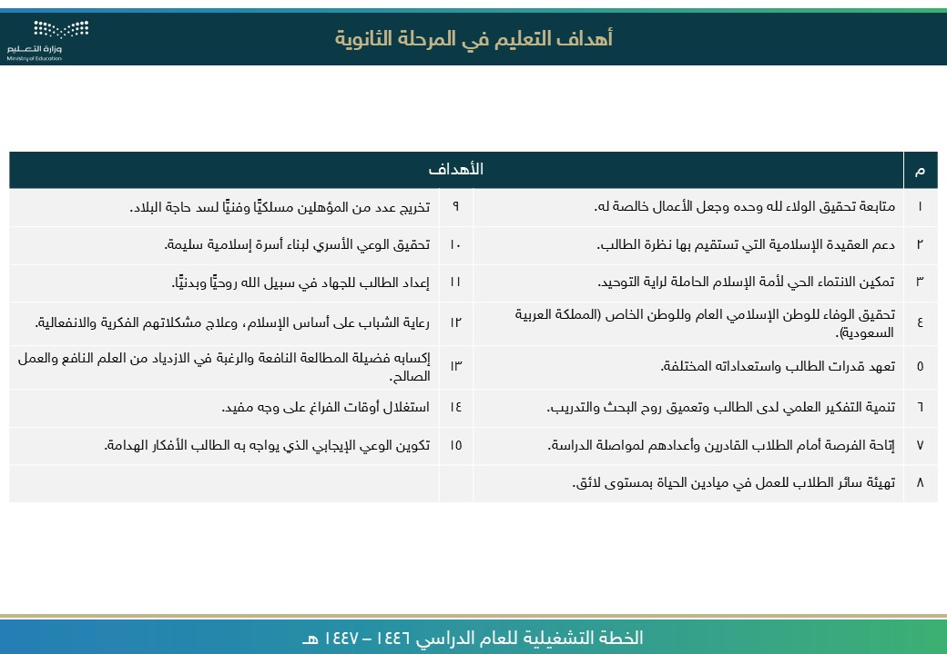

صورة تحتوي على نص, لقطة شاشة, الخط, برمجيات

تم إنشاء الوصف تلقائياً

صورة تحتوي على نص, لقطة شاشة, الخط, رقم

تم إنشاء الوصف تلقائياً

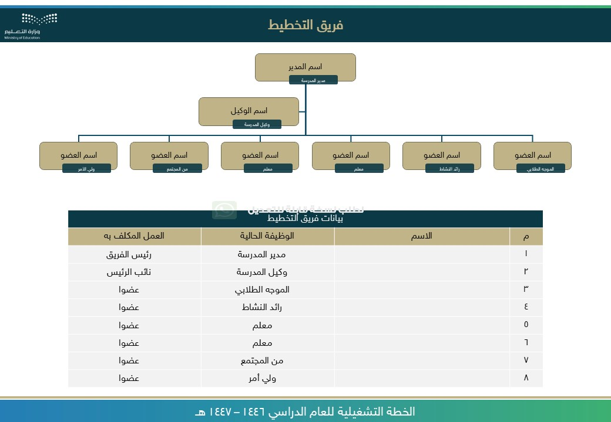

[ر](https://api.whatsapp.com/send/?phone=966541156989&text&type=phone_number&app_absent=0)

[ا](https://api.whatsapp.com/send/?phone=966541156989&text&type=phone_number&app_absent=0)

[ع](https://api.whatsapp.com/send/?phone=966541156989&text&type=phone_number&app_absent=0)

[ش](https://api.whatsapp.com/send/?phone=966541156989&text&type=phone_number&app_absent=0)

[,](https://api.whatsapp.com/send/?phone=966541156989&text&type=phone_number&app_absent=0)

[ز](https://api.whatsapp.com/send/?phone=966541156989&text&type=phone_number&app_absent=0)

[م](https://api.whatsapp.com/send/?phone=966541156989&text&type=phone_number&app_absent=0)

[ر](https://api.whatsapp.com/send/?phone=966541156989&text&type=phone_number&app_absent=0)

[,](https://api.whatsapp.com/send/?phone=966541156989&text&type=phone_number&app_absent=0)

[ة](https://api.whatsapp.com/send/?phone=966541156989&text&type=phone_number&app_absent=0)

[ي](https://api.whatsapp.com/send/?phone=966541156989&text&type=phone_number&app_absent=0)

[ن](https://api.whatsapp.com/send/?phone=966541156989&text&type=phone_number&app_absent=0)

[ف](https://api.whatsapp.com/send/?phone=966541156989&text&type=phone_number&app_absent=0)

[ة](https://api.whatsapp.com/send/?phone=966541156989&text&type=phone_number&app_absent=0)

[ص](https://api.whatsapp.com/send/?phone=966541156989&text&type=phone_number&app_absent=0)

[ا](https://api.whatsapp.com/send/?phone=966541156989&text&type=phone_number&app_absent=0)

[ص](https://api.whatsapp.com/send/?phone=966541156989&text&type=phone_number&app_absent=0)

[ق](https://api.whatsapp.com/send/?phone=966541156989&text&type=phone_number&app_absent=0)

[,](https://api.whatsapp.com/send/?phone=966541156989&text&type=phone_number&app_absent=0)

[ت](https://api.whatsapp.com/send/?phone=966541156989&text&type=phone_number&app_absent=0)

[ا](https://api.whatsapp.com/send/?phone=966541156989&text&type=phone_number&app_absent=0)

[م](https://api.whatsapp.com/send/?phone=966541156989&text&type=phone_number&app_absent=0)

[و](https://api.whatsapp.com/send/?phone=966541156989&text&type=phone_number&app_absent=0)

[س](https://api.whatsapp.com/send/?phone=966541156989&text&type=phone_number&app_absent=0)

[ر](https://api.whatsapp.com/send/?phone=966541156989&text&type=phone_number&app_absent=0)

[ل](https://api.whatsapp.com/send/?phone=966541156989&text&type=phone_number&app_absent=0)

[ا](https://api.whatsapp.com/send/?phone=966541156989&text&type=phone_number&app_absent=0)

[لى](https://api.whatsapp.com/send/?phone=966541156989&text&type=phone_number&app_absent=0)

[ع](https://api.whatsapp.com/send/?phone=966541156989&text&type=phone_number&app_absent=0)

[ي](https://api.whatsapp.com/send/?phone=966541156989&text&type=phone_number&app_absent=0)

[و](https://api.whatsapp.com/send/?phone=966541156989&text&type=phone_number&app_absent=0)

[ت](https://api.whatsapp.com/send/?phone=966541156989&text&type=phone_number&app_absent=0)

[ح](https://api.whatsapp.com/send/?phone=966541156989&text&type=phone_number&app_absent=0)

[ت](https://api.whatsapp.com/send/?phone=966541156989&text&type=phone_number&app_absent=0)

[ة](https://api.whatsapp.com/send/?phone=966541156989&text&type=phone_number&app_absent=0)

[ر](https://api.whatsapp.com/send/?phone=966541156989&text&type=phone_number&app_absent=0)

[و](https://api.whatsapp.com/send/?phone=966541156989&text&type=phone_number&app_absent=0)

[ص](https://api.whatsapp.com/send/?phone=966541156989&text&type=phone_number&app_absent=0)

[اً](https://api.whatsapp.com/send/?phone=966541156989&text&type=phone_number&app_absent=0)

[ي](https://api.whatsapp.com/send/?phone=966541156989&text&type=phone_number&app_absent=0)

[ئ](https://api.whatsapp.com/send/?phone=966541156989&text&type=phone_number&app_absent=0)

[ا](https://api.whatsapp.com/send/?phone=966541156989&text&type=phone_number&app_absent=0)

[ق](https://api.whatsapp.com/send/?phone=966541156989&text&type=phone_number&app_absent=0)

[ل](https://api.whatsapp.com/send/?phone=966541156989&text&type=phone_number&app_absent=0)

[ت](https://api.whatsapp.com/send/?phone=966541156989&text&type=phone_number&app_absent=0)

[ف](https://api.whatsapp.com/send/?phone=966541156989&text&type=phone_number&app_absent=0)

[ص](https://api.whatsapp.com/send/?phone=966541156989&text&type=phone_number&app_absent=0)

[و](https://api.whatsapp.com/send/?phone=966541156989&text&type=phone_number&app_absent=0)

[ل](https://api.whatsapp.com/send/?phone=966541156989&text&type=phone_number&app_absent=0)

[ا](https://api.whatsapp.com/send/?phone=966541156989&text&type=phone_number&app_absent=0)

[ء](https://api.whatsapp.com/send/?phone=966541156989&text&type=phone_number&app_absent=0)

[ا](https://api.whatsapp.com/send/?phone=966541156989&text&type=phone_number&app_absent=0)

[ش](https://api.whatsapp.com/send/?phone=966541156989&text&type=phone_number&app_absent=0)

[ن](https://api.whatsapp.com/send/?phone=966541156989&text&type=phone_number&app_absent=0)

[إ](https://api.whatsapp.com/send/?phone=966541156989&text&type=phone_number&app_absent=0)

[م](https://api.whatsapp.com/send/?phone=966541156989&text&type=phone_number&app_absent=0)

[ت](https://api.whatsapp.com/send/?phone=966541156989&text&type=phone_number&app_absent=0)



صورة تحتوي على نص, لقطة شاشة, الخط, رقم

تم إنشاء الوصف تلقائياً

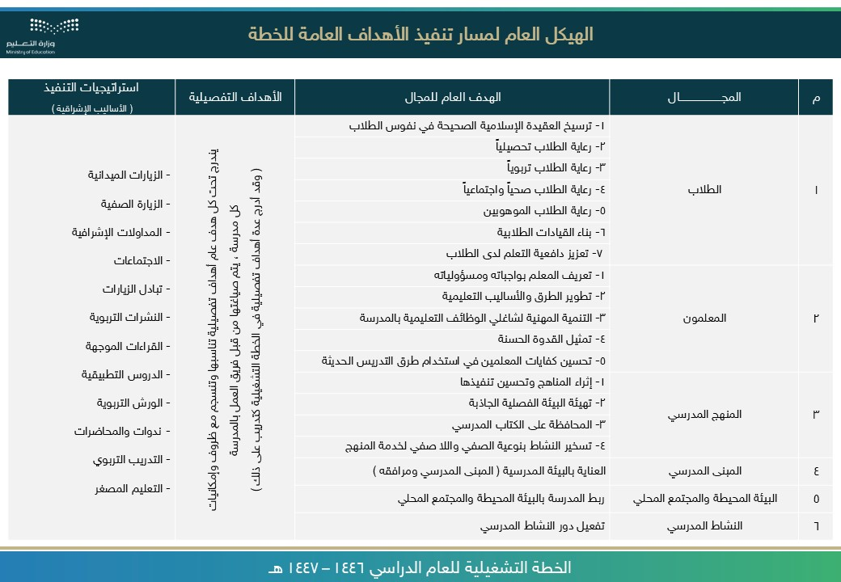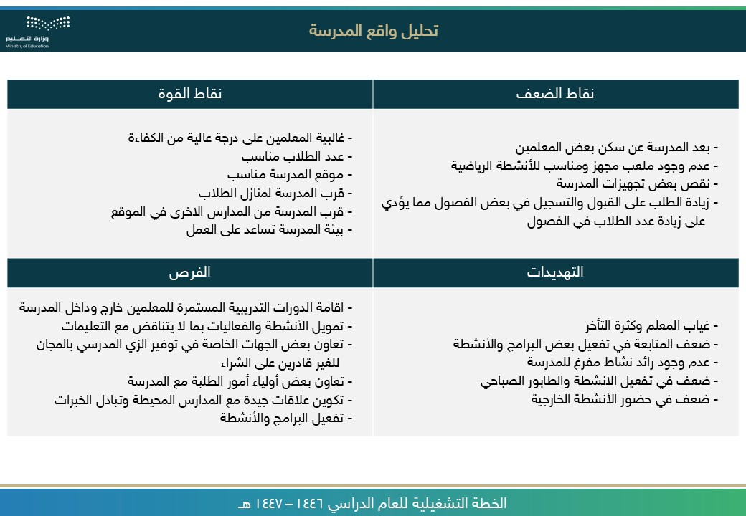

صورة تحتوي على نص, لقطة شاشة, رقم, الخط

تم إنشاء الوصف تلقائياً

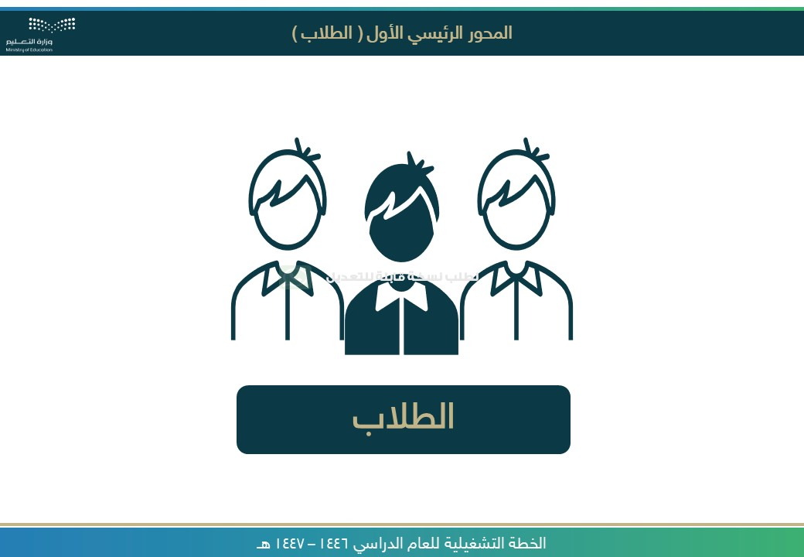

[ر](https://api.whatsapp.com/send/?phone=966541156989&text&type=phone_number&app_absent=0)

[ا](https://api.whatsapp.com/send/?phone=966541156989&text&type=phone_number&app_absent=0)

[ع](https://api.whatsapp.com/send/?phone=966541156989&text&type=phone_number&app_absent=0)

[ش](https://api.whatsapp.com/send/?phone=966541156989&text&type=phone_number&app_absent=0)

[,](https://api.whatsapp.com/send/?phone=966541156989&text&type=phone_number&app_absent=0)

[ز](https://api.whatsapp.com/send/?phone=966541156989&text&type=phone_number&app_absent=0)

[م](https://api.whatsapp.com/send/?phone=966541156989&text&type=phone_number&app_absent=0)

[ر](https://api.whatsapp.com/send/?phone=966541156989&text&type=phone_number&app_absent=0)

[,](https://api.whatsapp.com/send/?phone=966541156989&text&type=phone_number&app_absent=0)

[ة](https://api.whatsapp.com/send/?phone=966541156989&text&type=phone_number&app_absent=0)

[ي](https://api.whatsapp.com/send/?phone=966541156989&text&type=phone_number&app_absent=0)

[ن](https://api.whatsapp.com/send/?phone=966541156989&text&type=phone_number&app_absent=0)

[ف](https://api.whatsapp.com/send/?phone=966541156989&text&type=phone_number&app_absent=0)

[ة](https://api.whatsapp.com/send/?phone=966541156989&text&type=phone_number&app_absent=0)

[ص](https://api.whatsapp.com/send/?phone=966541156989&text&type=phone_number&app_absent=0)

[ا](https://api.whatsapp.com/send/?phone=966541156989&text&type=phone_number&app_absent=0)

[ص](https://api.whatsapp.com/send/?phone=966541156989&text&type=phone_number&app_absent=0)

[ق](https://api.whatsapp.com/send/?phone=966541156989&text&type=phone_number&app_absent=0)

[,](https://api.whatsapp.com/send/?phone=966541156989&text&type=phone_number&app_absent=0)

[ت](https://api.whatsapp.com/send/?phone=966541156989&text&type=phone_number&app_absent=0)

[ا](https://api.whatsapp.com/send/?phone=966541156989&text&type=phone_number&app_absent=0)

[م](https://api.whatsapp.com/send/?phone=966541156989&text&type=phone_number&app_absent=0)

[و](https://api.whatsapp.com/send/?phone=966541156989&text&type=phone_number&app_absent=0)

[س](https://api.whatsapp.com/send/?phone=966541156989&text&type=phone_number&app_absent=0)

[ر](https://api.whatsapp.com/send/?phone=966541156989&text&type=phone_number&app_absent=0)

[ل](https://api.whatsapp.com/send/?phone=966541156989&text&type=phone_number&app_absent=0)

[ا](https://api.whatsapp.com/send/?phone=966541156989&text&type=phone_number&app_absent=0)

[لى](https://api.whatsapp.com/send/?phone=966541156989&text&type=phone_number&app_absent=0)

[ع](https://api.whatsapp.com/send/?phone=966541156989&text&type=phone_number&app_absent=0)

[ي](https://api.whatsapp.com/send/?phone=966541156989&text&type=phone_number&app_absent=0)

[و](https://api.whatsapp.com/send/?phone=966541156989&text&type=phone_number&app_absent=0)

[ت](https://api.whatsapp.com/send/?phone=966541156989&text&type=phone_number&app_absent=0)

[ح](https://api.whatsapp.com/send/?phone=966541156989&text&type=phone_number&app_absent=0)

[ت](https://api.whatsapp.com/send/?phone=966541156989&text&type=phone_number&app_absent=0)

[ة](https://api.whatsapp.com/send/?phone=966541156989&text&type=phone_number&app_absent=0)

[ر](https://api.whatsapp.com/send/?phone=966541156989&text&type=phone_number&app_absent=0)

[و](https://api.whatsapp.com/send/?phone=966541156989&text&type=phone_number&app_absent=0)

[ص](https://api.whatsapp.com/send/?phone=966541156989&text&type=phone_number&app_absent=0)

[اً](https://api.whatsapp.com/send/?phone=966541156989&text&type=phone_number&app_absent=0)

[ي](https://api.whatsapp.com/send/?phone=966541156989&text&type=phone_number&app_absent=0)

[ئ](https://api.whatsapp.com/send/?phone=966541156989&text&type=phone_number&app_absent=0)

[ا](https://api.whatsapp.com/send/?phone=966541156989&text&type=phone_number&app_absent=0)

[ق](https://api.whatsapp.com/send/?phone=966541156989&text&type=phone_number&app_absent=0)

[ل](https://api.whatsapp.com/send/?phone=966541156989&text&type=phone_number&app_absent=0)

[ت](https://api.whatsapp.com/send/?phone=966541156989&text&type=phone_number&app_absent=0)

[ف](https://api.whatsapp.com/send/?phone=966541156989&text&type=phone_number&app_absent=0)

[ص](https://api.whatsapp.com/send/?phone=966541156989&text&type=phone_number&app_absent=0)

[و](https://api.whatsapp.com/send/?phone=966541156989&text&type=phone_number&app_absent=0)

[ل](https://api.whatsapp.com/send/?phone=966541156989&text&type=phone_number&app_absent=0)

[ا](https://api.whatsapp.com/send/?phone=966541156989&text&type=phone_number&app_absent=0)

[ء](https://api.whatsapp.com/send/?phone=966541156989&text&type=phone_number&app_absent=0)

[ا](https://api.whatsapp.com/send/?phone=966541156989&text&type=phone_number&app_absent=0)

[ش](https://api.whatsapp.com/send/?phone=966541156989&text&type=phone_number&app_absent=0)

[ن](https://api.whatsapp.com/send/?phone=966541156989&text&type=phone_number&app_absent=0)

[إ](https://api.whatsapp.com/send/?phone=966541156989&text&type=phone_number&app_absent=0)

[م](https://api.whatsapp.com/send/?phone=966541156989&text&type=phone_number&app_absent=0)

[ت](https://api.whatsapp.com/send/?phone=966541156989&text&type=phone_number&app_absent=0)



صورة تحتوي على نص, لقطة شاشة, برمجيات, رقم

تم إنشاء الوصف تلقائياً

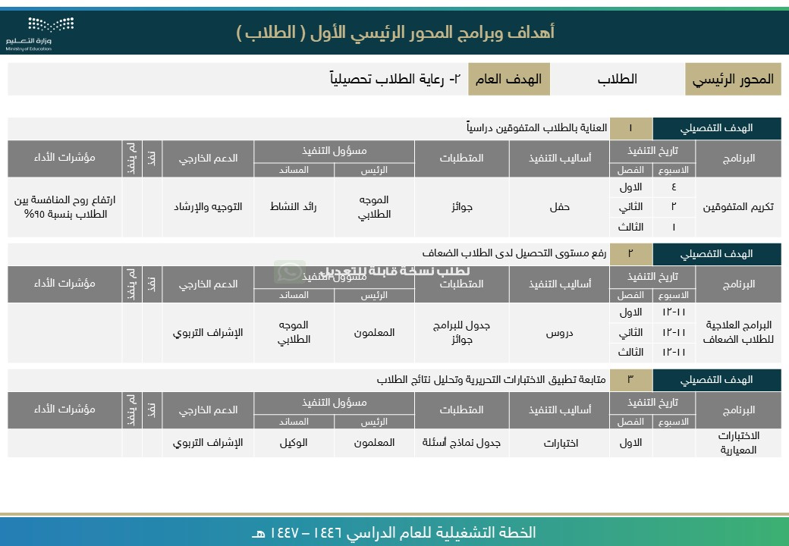

[ر](https://api.whatsapp.com/send/?phone=966541156989&text&type=phone_number&app_absent=0)

[ا](https://api.whatsapp.com/send/?phone=966541156989&text&type=phone_number&app_absent=0)

[ع](https://api.whatsapp.com/send/?phone=966541156989&text&type=phone_number&app_absent=0)

[ش](https://api.whatsapp.com/send/?phone=966541156989&text&type=phone_number&app_absent=0)

[,](https://api.whatsapp.com/send/?phone=966541156989&text&type=phone_number&app_absent=0)

[ز](https://api.whatsapp.com/send/?phone=966541156989&text&type=phone_number&app_absent=0)

[م](https://api.whatsapp.com/send/?phone=966541156989&text&type=phone_number&app_absent=0)

[ر](https://api.whatsapp.com/send/?phone=966541156989&text&type=phone_number&app_absent=0)

[,](https://api.whatsapp.com/send/?phone=966541156989&text&type=phone_number&app_absent=0)

[ة](https://api.whatsapp.com/send/?phone=966541156989&text&type=phone_number&app_absent=0)

[ي](https://api.whatsapp.com/send/?phone=966541156989&text&type=phone_number&app_absent=0)

[ن](https://api.whatsapp.com/send/?phone=966541156989&text&type=phone_number&app_absent=0)

[ف](https://api.whatsapp.com/send/?phone=966541156989&text&type=phone_number&app_absent=0)

[ة](https://api.whatsapp.com/send/?phone=966541156989&text&type=phone_number&app_absent=0)

[ص](https://api.whatsapp.com/send/?phone=966541156989&text&type=phone_number&app_absent=0)

[ا](https://api.whatsapp.com/send/?phone=966541156989&text&type=phone_number&app_absent=0)

[ص](https://api.whatsapp.com/send/?phone=966541156989&text&type=phone_number&app_absent=0)

[ق](https://api.whatsapp.com/send/?phone=966541156989&text&type=phone_number&app_absent=0)

[,](https://api.whatsapp.com/send/?phone=966541156989&text&type=phone_number&app_absent=0)

[ت](https://api.whatsapp.com/send/?phone=966541156989&text&type=phone_number&app_absent=0)

[ا](https://api.whatsapp.com/send/?phone=966541156989&text&type=phone_number&app_absent=0)

[م](https://api.whatsapp.com/send/?phone=966541156989&text&type=phone_number&app_absent=0)

[و](https://api.whatsapp.com/send/?phone=966541156989&text&type=phone_number&app_absent=0)

[س](https://api.whatsapp.com/send/?phone=966541156989&text&type=phone_number&app_absent=0)

[ر](https://api.whatsapp.com/send/?phone=966541156989&text&type=phone_number&app_absent=0)

[ل](https://api.whatsapp.com/send/?phone=966541156989&text&type=phone_number&app_absent=0)

[ا](https://api.whatsapp.com/send/?phone=966541156989&text&type=phone_number&app_absent=0)

[لى](https://api.whatsapp.com/send/?phone=966541156989&text&type=phone_number&app_absent=0)

[ع](https://api.whatsapp.com/send/?phone=966541156989&text&type=phone_number&app_absent=0)

[ي](https://api.whatsapp.com/send/?phone=966541156989&text&type=phone_number&app_absent=0)

[و](https://api.whatsapp.com/send/?phone=966541156989&text&type=phone_number&app_absent=0)

[ت](https://api.whatsapp.com/send/?phone=966541156989&text&type=phone_number&app_absent=0)

[ح](https://api.whatsapp.com/send/?phone=966541156989&text&type=phone_number&app_absent=0)

[ت](https://api.whatsapp.com/send/?phone=966541156989&text&type=phone_number&app_absent=0)

[ة](https://api.whatsapp.com/send/?phone=966541156989&text&type=phone_number&app_absent=0)

[ر](https://api.whatsapp.com/send/?phone=966541156989&text&type=phone_number&app_absent=0)

[و](https://api.whatsapp.com/send/?phone=966541156989&text&type=phone_number&app_absent=0)

[ص](https://api.whatsapp.com/send/?phone=966541156989&text&type=phone_number&app_absent=0)

[اً](https://api.whatsapp.com/send/?phone=966541156989&text&type=phone_number&app_absent=0)

[ي](https://api.whatsapp.com/send/?phone=966541156989&text&type=phone_number&app_absent=0)

[ئ](https://api.whatsapp.com/send/?phone=966541156989&text&type=phone_number&app_absent=0)

[ا](https://api.whatsapp.com/send/?phone=966541156989&text&type=phone_number&app_absent=0)

[ق](https://api.whatsapp.com/send/?phone=966541156989&text&type=phone_number&app_absent=0)

[ل](https://api.whatsapp.com/send/?phone=966541156989&text&type=phone_number&app_absent=0)

[ت](https://api.whatsapp.com/send/?phone=966541156989&text&type=phone_number&app_absent=0)

[ف](https://api.whatsapp.com/send/?phone=966541156989&text&type=phone_number&app_absent=0)

[ص](https://api.whatsapp.com/send/?phone=966541156989&text&type=phone_number&app_absent=0)

[و](https://api.whatsapp.com/send/?phone=966541156989&text&type=phone_number&app_absent=0)

[ل](https://api.whatsapp.com/send/?phone=966541156989&text&type=phone_number&app_absent=0)

[ا](https://api.whatsapp.com/send/?phone=966541156989&text&type=phone_number&app_absent=0)

[ء](https://api.whatsapp.com/send/?phone=966541156989&text&type=phone_number&app_absent=0)

[ا](https://api.whatsapp.com/send/?phone=966541156989&text&type=phone_number&app_absent=0)

[ش](https://api.whatsapp.com/send/?phone=966541156989&text&type=phone_number&app_absent=0)

[ن](https://api.whatsapp.com/send/?phone=966541156989&text&type=phone_number&app_absent=0)

[إ](https://api.whatsapp.com/send/?phone=966541156989&text&type=phone_number&app_absent=0)

[م](https://api.whatsapp.com/send/?phone=966541156989&text&type=phone_number&app_absent=0)

[ت](https://api.whatsapp.com/send/?phone=966541156989&text&type=phone_number&app_absent=0)



صورة تحتوي على نص, لقطة شاشة, برمجيات, صفحة ويب

تم إنشاء الوصف تلقائياً

صورة تحتوي على نص, لقطة شاشة, برمجيات, صفحة ويب

تم إنشاء الوصف تلقائياً

صورة تحتوي على نص, لقطة شاشة, برمجيات, صفحة ويب

تم إنشاء الوصف تلقائياً

صورة تحتوي على نص, لقطة شاشة, برمجيات, صفحة ويب

تم إنشاء الوصف تلقائياً

صورة تحتوي على نص, لقطة شاشة, برمجيات, صفحة ويب

تم إنشاء الوصف تلقائياً

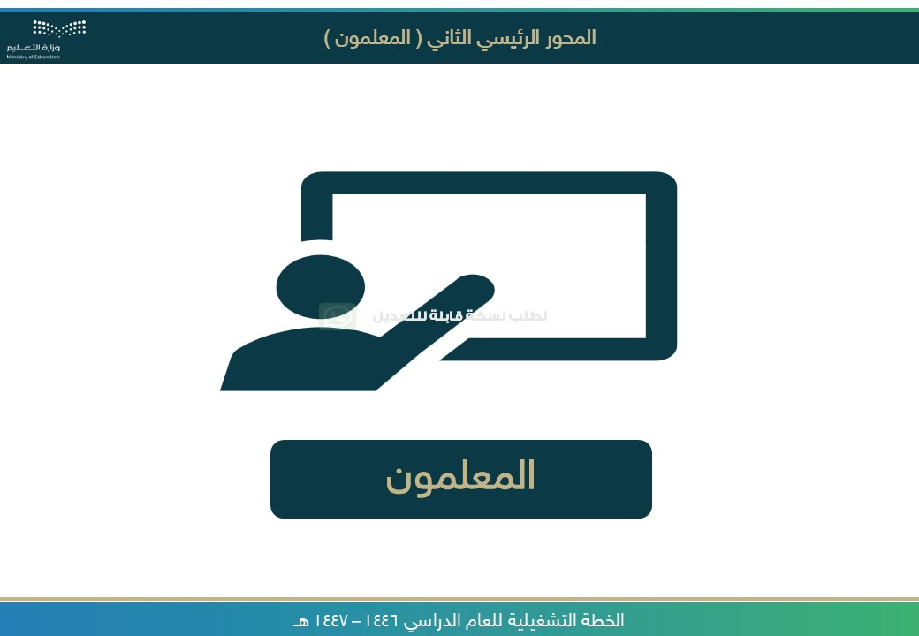

[ر](https://api.whatsapp.com/send/?phone=966541156989&text&type=phone_number&app_absent=0)

[ا](https://api.whatsapp.com/send/?phone=966541156989&text&type=phone_number&app_absent=0)

[ع](https://api.whatsapp.com/send/?phone=966541156989&text&type=phone_number&app_absent=0)

[ش](https://api.whatsapp.com/send/?phone=966541156989&text&type=phone_number&app_absent=0)

[,](https://api.whatsapp.com/send/?phone=966541156989&text&type=phone_number&app_absent=0)

[ز](https://api.whatsapp.com/send/?phone=966541156989&text&type=phone_number&app_absent=0)

[م](https://api.whatsapp.com/send/?phone=966541156989&text&type=phone_number&app_absent=0)

[ر](https://api.whatsapp.com/send/?phone=966541156989&text&type=phone_number&app_absent=0)

[,](https://api.whatsapp.com/send/?phone=966541156989&text&type=phone_number&app_absent=0)

[ة](https://api.whatsapp.com/send/?phone=966541156989&text&type=phone_number&app_absent=0)

[ي](https://api.whatsapp.com/send/?phone=966541156989&text&type=phone_number&app_absent=0)

[ن](https://api.whatsapp.com/send/?phone=966541156989&text&type=phone_number&app_absent=0)

[ف](https://api.whatsapp.com/send/?phone=966541156989&text&type=phone_number&app_absent=0)

[ة](https://api.whatsapp.com/send/?phone=966541156989&text&type=phone_number&app_absent=0)

[ص](https://api.whatsapp.com/send/?phone=966541156989&text&type=phone_number&app_absent=0)

[ا](https://api.whatsapp.com/send/?phone=966541156989&text&type=phone_number&app_absent=0)

[ص](https://api.whatsapp.com/send/?phone=966541156989&text&type=phone_number&app_absent=0)

[ق](https://api.whatsapp.com/send/?phone=966541156989&text&type=phone_number&app_absent=0)

[,](https://api.whatsapp.com/send/?phone=966541156989&text&type=phone_number&app_absent=0)

[ت](https://api.whatsapp.com/send/?phone=966541156989&text&type=phone_number&app_absent=0)

[ا](https://api.whatsapp.com/send/?phone=966541156989&text&type=phone_number&app_absent=0)

[م](https://api.whatsapp.com/send/?phone=966541156989&text&type=phone_number&app_absent=0)

[و](https://api.whatsapp.com/send/?phone=966541156989&text&type=phone_number&app_absent=0)

[س](https://api.whatsapp.com/send/?phone=966541156989&text&type=phone_number&app_absent=0)

[ر](https://api.whatsapp.com/send/?phone=966541156989&text&type=phone_number&app_absent=0)

[ل](https://api.whatsapp.com/send/?phone=966541156989&text&type=phone_number&app_absent=0)

[ا](https://api.whatsapp.com/send/?phone=966541156989&text&type=phone_number&app_absent=0)

[لى](https://api.whatsapp.com/send/?phone=966541156989&text&type=phone_number&app_absent=0)

[ع](https://api.whatsapp.com/send/?phone=966541156989&text&type=phone_number&app_absent=0)

[ي](https://api.whatsapp.com/send/?phone=966541156989&text&type=phone_number&app_absent=0)

[و](https://api.whatsapp.com/send/?phone=966541156989&text&type=phone_number&app_absent=0)

[ت](https://api.whatsapp.com/send/?phone=966541156989&text&type=phone_number&app_absent=0)

[ح](https://api.whatsapp.com/send/?phone=966541156989&text&type=phone_number&app_absent=0)

[ت](https://api.whatsapp.com/send/?phone=966541156989&text&type=phone_number&app_absent=0)

[ة](https://api.whatsapp.com/send/?phone=966541156989&text&type=phone_number&app_absent=0)

[ر](https://api.whatsapp.com/send/?phone=966541156989&text&type=phone_number&app_absent=0)

[و](https://api.whatsapp.com/send/?phone=966541156989&text&type=phone_number&app_absent=0)

[ص](https://api.whatsapp.com/send/?phone=966541156989&text&type=phone_number&app_absent=0)

[اً](https://api.whatsapp.com/send/?phone=966541156989&text&type=phone_number&app_absent=0)

[ي](https://api.whatsapp.com/send/?phone=966541156989&text&type=phone_number&app_absent=0)

[ئ](https://api.whatsapp.com/send/?phone=966541156989&text&type=phone_number&app_absent=0)

[ا](https://api.whatsapp.com/send/?phone=966541156989&text&type=phone_number&app_absent=0)

[ق](https://api.whatsapp.com/send/?phone=966541156989&text&type=phone_number&app_absent=0)

[ل](https://api.whatsapp.com/send/?phone=966541156989&text&type=phone_number&app_absent=0)

[ت](https://api.whatsapp.com/send/?phone=966541156989&text&type=phone_number&app_absent=0)

[ف](https://api.whatsapp.com/send/?phone=966541156989&text&type=phone_number&app_absent=0)

[ص](https://api.whatsapp.com/send/?phone=966541156989&text&type=phone_number&app_absent=0)

[و](https://api.whatsapp.com/send/?phone=966541156989&text&type=phone_number&app_absent=0)

[ل](https://api.whatsapp.com/send/?phone=966541156989&text&type=phone_number&app_absent=0)

[ا](https://api.whatsapp.com/send/?phone=966541156989&text&type=phone_number&app_absent=0)

[ء](https://api.whatsapp.com/send/?phone=966541156989&text&type=phone_number&app_absent=0)

[ا](https://api.whatsapp.com/send/?phone=966541156989&text&type=phone_number&app_absent=0)

[ش](https://api.whatsapp.com/send/?phone=966541156989&text&type=phone_number&app_absent=0)

[ن](https://api.whatsapp.com/send/?phone=966541156989&text&type=phone_number&app_absent=0)

[إ](https://api.whatsapp.com/send/?phone=966541156989&text&type=phone_number&app_absent=0)

[م](https://api.whatsapp.com/send/?phone=966541156989&text&type=phone_number&app_absent=0)

[ت](https://api.whatsapp.com/send/?phone=966541156989&text&type=phone_number&app_absent=0)



صورة تحتوي على نص, لقطة شاشة, برمجيات, صفحة ويب

تم إنشاء الوصف تلقائياً

صورة تحتوي على نص, لقطة شاشة, برمجيات, صفحة ويب

تم إنشاء الوصف تلقائياً

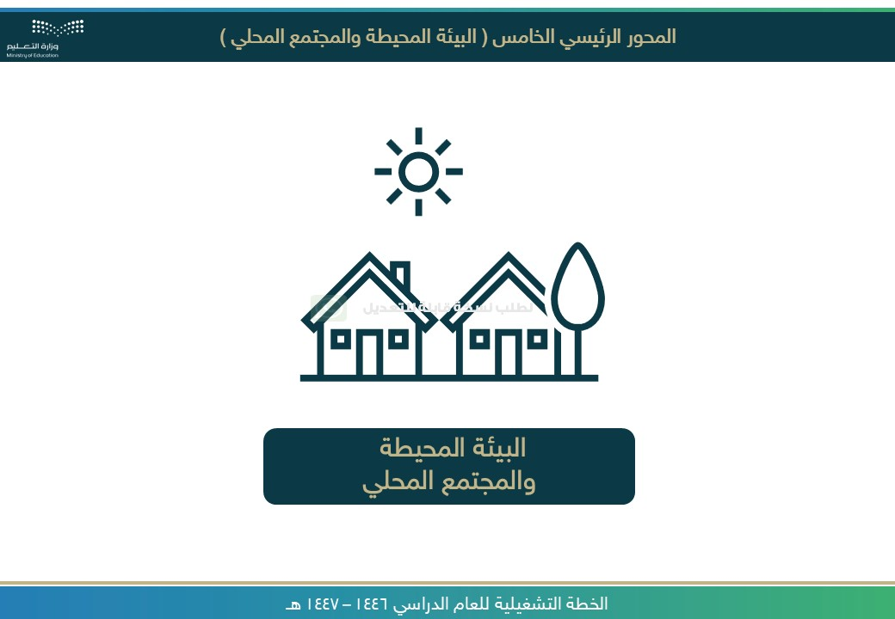

[ر](https://api.whatsapp.com/send/?phone=966541156989&text&type=phone_number&app_absent=0)

[ا](https://api.whatsapp.com/send/?phone=966541156989&text&type=phone_number&app_absent=0)

[ع](https://api.whatsapp.com/send/?phone=966541156989&text&type=phone_number&app_absent=0)

[ش](https://api.whatsapp.com/send/?phone=966541156989&text&type=phone_number&app_absent=0)

[,](https://api.whatsapp.com/send/?phone=966541156989&text&type=phone_number&app_absent=0)

[ز](https://api.whatsapp.com/send/?phone=966541156989&text&type=phone_number&app_absent=0)

[م](https://api.whatsapp.com/send/?phone=966541156989&text&type=phone_number&app_absent=0)

[ر](https://api.whatsapp.com/send/?phone=966541156989&text&type=phone_number&app_absent=0)

[,](https://api.whatsapp.com/send/?phone=966541156989&text&type=phone_number&app_absent=0)

[ة](https://api.whatsapp.com/send/?phone=966541156989&text&type=phone_number&app_absent=0)

[ي](https://api.whatsapp.com/send/?phone=966541156989&text&type=phone_number&app_absent=0)

[ن](https://api.whatsapp.com/send/?phone=966541156989&text&type=phone_number&app_absent=0)

[ف](https://api.whatsapp.com/send/?phone=966541156989&text&type=phone_number&app_absent=0)

[ة](https://api.whatsapp.com/send/?phone=966541156989&text&type=phone_number&app_absent=0)

[ص](https://api.whatsapp.com/send/?phone=966541156989&text&type=phone_number&app_absent=0)

[ا](https://api.whatsapp.com/send/?phone=966541156989&text&type=phone_number&app_absent=0)

[ص](https://api.whatsapp.com/send/?phone=966541156989&text&type=phone_number&app_absent=0)

[ق](https://api.whatsapp.com/send/?phone=966541156989&text&type=phone_number&app_absent=0)

[,](https://api.whatsapp.com/send/?phone=966541156989&text&type=phone_number&app_absent=0)

[ت](https://api.whatsapp.com/send/?phone=966541156989&text&type=phone_number&app_absent=0)

[ا](https://api.whatsapp.com/send/?phone=966541156989&text&type=phone_number&app_absent=0)

[م](https://api.whatsapp.com/send/?phone=966541156989&text&type=phone_number&app_absent=0)

[و](https://api.whatsapp.com/send/?phone=966541156989&text&type=phone_number&app_absent=0)

[س](https://api.whatsapp.com/send/?phone=966541156989&text&type=phone_number&app_absent=0)

[ر](https://api.whatsapp.com/send/?phone=966541156989&text&type=phone_number&app_absent=0)

[ل](https://api.whatsapp.com/send/?phone=966541156989&text&type=phone_number&app_absent=0)

[ا](https://api.whatsapp.com/send/?phone=966541156989&text&type=phone_number&app_absent=0)

[لى](https://api.whatsapp.com/send/?phone=966541156989&text&type=phone_number&app_absent=0)

[ع](https://api.whatsapp.com/send/?phone=966541156989&text&type=phone_number&app_absent=0)

[ي](https://api.whatsapp.com/send/?phone=966541156989&text&type=phone_number&app_absent=0)

[و](https://api.whatsapp.com/send/?phone=966541156989&text&type=phone_number&app_absent=0)

[ت](https://api.whatsapp.com/send/?phone=966541156989&text&type=phone_number&app_absent=0)

[ح](https://api.whatsapp.com/send/?phone=966541156989&text&type=phone_number&app_absent=0)

[ت](https://api.whatsapp.com/send/?phone=966541156989&text&type=phone_number&app_absent=0)

[ة](https://api.whatsapp.com/send/?phone=966541156989&text&type=phone_number&app_absent=0)

[ر](https://api.whatsapp.com/send/?phone=966541156989&text&type=phone_number&app_absent=0)

[و](https://api.whatsapp.com/send/?phone=966541156989&text&type=phone_number&app_absent=0)

[ص](https://api.whatsapp.com/send/?phone=966541156989&text&type=phone_number&app_absent=0)

[اً](https://api.whatsapp.com/send/?phone=966541156989&text&type=phone_number&app_absent=0)

[ي](https://api.whatsapp.com/send/?phone=966541156989&text&type=phone_number&app_absent=0)

[ئ](https://api.whatsapp.com/send/?phone=966541156989&text&type=phone_number&app_absent=0)

[ا](https://api.whatsapp.com/send/?phone=966541156989&text&type=phone_number&app_absent=0)

[ق](https://api.whatsapp.com/send/?phone=966541156989&text&type=phone_number&app_absent=0)

[ل](https://api.whatsapp.com/send/?phone=966541156989&text&type=phone_number&app_absent=0)

[ت](https://api.whatsapp.com/send/?phone=966541156989&text&type=phone_number&app_absent=0)

[ف](https://api.whatsapp.com/send/?phone=966541156989&text&type=phone_number&app_absent=0)

[ص](https://api.whatsapp.com/send/?phone=966541156989&text&type=phone_number&app_absent=0)

[و](https://api.whatsapp.com/send/?phone=966541156989&text&type=phone_number&app_absent=0)

[ل](https://api.whatsapp.com/send/?phone=966541156989&text&type=phone_number&app_absent=0)

[ا](https://api.whatsapp.com/send/?phone=966541156989&text&type=phone_number&app_absent=0)

[ء](https://api.whatsapp.com/send/?phone=966541156989&text&type=phone_number&app_absent=0)

[ا](https://api.whatsapp.com/send/?phone=966541156989&text&type=phone_number&app_absent=0)

[ش](https://api.whatsapp.com/send/?phone=966541156989&text&type=phone_number&app_absent=0)

[ن](https://api.whatsapp.com/send/?phone=966541156989&text&type=phone_number&app_absent=0)

[إ](https://api.whatsapp.com/send/?phone=966541156989&text&type=phone_number&app_absent=0)

[م](https://api.whatsapp.com/send/?phone=966541156989&text&type=phone_number&app_absent=0)

[ت](https://api.whatsapp.com/send/?phone=966541156989&text&type=phone_number&app_absent=0)



صورة تحتوي على نص, لقطة شاشة, برمجيات, صفحة ويب

تم إنشاء الوصف تلقائياً

صورة تحتوي على نص, لقطة شاشة, برمجيات, صفحة ويب

تم إنشاء الوصف تلقائياً

صورة تحتوي على نص, لقطة شاشة, برمجيات, صفحة ويب

تم إنشاء الوصف تلقائياً

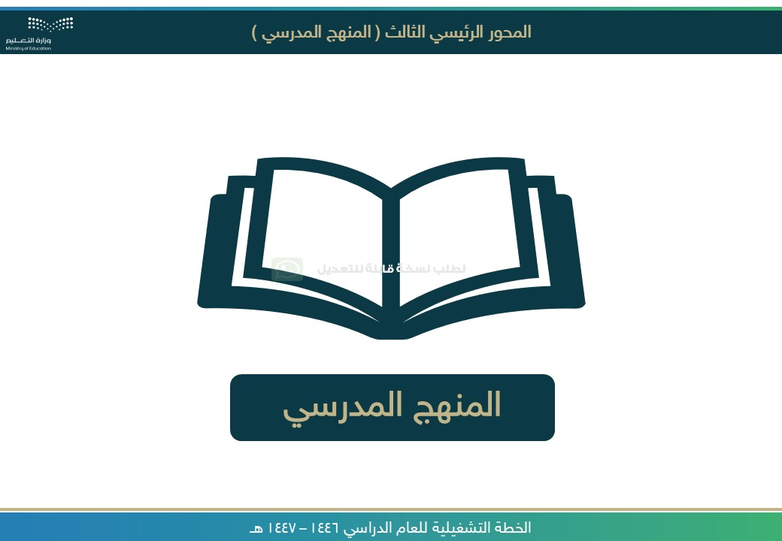

[ر](https://api.whatsapp.com/send/?phone=966541156989&text&type=phone_number&app_absent=0)

[ا](https://api.whatsapp.com/send/?phone=966541156989&text&type=phone_number&app_absent=0)

[ع](https://api.whatsapp.com/send/?phone=966541156989&text&type=phone_number&app_absent=0)

[ش](https://api.whatsapp.com/send/?phone=966541156989&text&type=phone_number&app_absent=0)

[,](https://api.whatsapp.com/send/?phone=966541156989&text&type=phone_number&app_absent=0)

[ز](https://api.whatsapp.com/send/?phone=966541156989&text&type=phone_number&app_absent=0)

[م](https://api.whatsapp.com/send/?phone=966541156989&text&type=phone_number&app_absent=0)

[ر](https://api.whatsapp.com/send/?phone=966541156989&text&type=phone_number&app_absent=0)

[,](https://api.whatsapp.com/send/?phone=966541156989&text&type=phone_number&app_absent=0)

[ة](https://api.whatsapp.com/send/?phone=966541156989&text&type=phone_number&app_absent=0)

[ي](https://api.whatsapp.com/send/?phone=966541156989&text&type=phone_number&app_absent=0)

[ن](https://api.whatsapp.com/send/?phone=966541156989&text&type=phone_number&app_absent=0)

[ف](https://api.whatsapp.com/send/?phone=966541156989&text&type=phone_number&app_absent=0)

[ة](https://api.whatsapp.com/send/?phone=966541156989&text&type=phone_number&app_absent=0)

[ص](https://api.whatsapp.com/send/?phone=966541156989&text&type=phone_number&app_absent=0)

[ا](https://api.whatsapp.com/send/?phone=966541156989&text&type=phone_number&app_absent=0)

[ص](https://api.whatsapp.com/send/?phone=966541156989&text&type=phone_number&app_absent=0)

[ق](https://api.whatsapp.com/send/?phone=966541156989&text&type=phone_number&app_absent=0)

[,](https://api.whatsapp.com/send/?phone=966541156989&text&type=phone_number&app_absent=0)

[ت](https://api.whatsapp.com/send/?phone=966541156989&text&type=phone_number&app_absent=0)

[ا](https://api.whatsapp.com/send/?phone=966541156989&text&type=phone_number&app_absent=0)

[م](https://api.whatsapp.com/send/?phone=966541156989&text&type=phone_number&app_absent=0)

[و](https://api.whatsapp.com/send/?phone=966541156989&text&type=phone_number&app_absent=0)

[س](https://api.whatsapp.com/send/?phone=966541156989&text&type=phone_number&app_absent=0)

[ر](https://api.whatsapp.com/send/?phone=966541156989&text&type=phone_number&app_absent=0)

[ل](https://api.whatsapp.com/send/?phone=966541156989&text&type=phone_number&app_absent=0)

[ا](https://api.whatsapp.com/send/?phone=966541156989&text&type=phone_number&app_absent=0)

[لى](https://api.whatsapp.com/send/?phone=966541156989&text&type=phone_number&app_absent=0)

[ع](https://api.whatsapp.com/send/?phone=966541156989&text&type=phone_number&app_absent=0)

[ي](https://api.whatsapp.com/send/?phone=966541156989&text&type=phone_number&app_absent=0)

[و](https://api.whatsapp.com/send/?phone=966541156989&text&type=phone_number&app_absent=0)

[ت](https://api.whatsapp.com/send/?phone=966541156989&text&type=phone_number&app_absent=0)

[ح](https://api.whatsapp.com/send/?phone=966541156989&text&type=phone_number&app_absent=0)

[ت](https://api.whatsapp.com/send/?phone=966541156989&text&type=phone_number&app_absent=0)

[ة](https://api.whatsapp.com/send/?phone=966541156989&text&type=phone_number&app_absent=0)

[ر](https://api.whatsapp.com/send/?phone=966541156989&text&type=phone_number&app_absent=0)

[و](https://api.whatsapp.com/send/?phone=966541156989&text&type=phone_number&app_absent=0)

[ص](https://api.whatsapp.com/send/?phone=966541156989&text&type=phone_number&app_absent=0)

[اً](https://api.whatsapp.com/send/?phone=966541156989&text&type=phone_number&app_absent=0)

[ي](https://api.whatsapp.com/send/?phone=966541156989&text&type=phone_number&app_absent=0)

[ئ](https://api.whatsapp.com/send/?phone=966541156989&text&type=phone_number&app_absent=0)

[ا](https://api.whatsapp.com/send/?phone=966541156989&text&type=phone_number&app_absent=0)

[ق](https://api.whatsapp.com/send/?phone=966541156989&text&type=phone_number&app_absent=0)

[ل](https://api.whatsapp.com/send/?phone=966541156989&text&type=phone_number&app_absent=0)

[ت](https://api.whatsapp.com/send/?phone=966541156989&text&type=phone_number&app_absent=0)

[ف](https://api.whatsapp.com/send/?phone=966541156989&text&type=phone_number&app_absent=0)

[ص](https://api.whatsapp.com/send/?phone=966541156989&text&type=phone_number&app_absent=0)

[و](https://api.whatsapp.com/send/?phone=966541156989&text&type=phone_number&app_absent=0)

[ل](https://api.whatsapp.com/send/?phone=966541156989&text&type=phone_number&app_absent=0)

[ا](https://api.whatsapp.com/send/?phone=966541156989&text&type=phone_number&app_absent=0)

[ء](https://api.whatsapp.com/send/?phone=966541156989&text&type=phone_number&app_absent=0)

[ا](https://api.whatsapp.com/send/?phone=966541156989&text&type=phone_number&app_absent=0)

[ش](https://api.whatsapp.com/send/?phone=966541156989&text&type=phone_number&app_absent=0)

[ن](https://api.whatsapp.com/send/?phone=966541156989&text&type=phone_number&app_absent=0)

[إ](https://api.whatsapp.com/send/?phone=966541156989&text&type=phone_number&app_absent=0)

[م](https://api.whatsapp.com/send/?phone=966541156989&text&type=phone_number&app_absent=0)

[ت](https://api.whatsapp.com/send/?phone=966541156989&text&type=phone_number&app_absent=0)



صورة تحتوي على نص, لقطة شاشة, برمجيات, صفحة ويب

تم إنشاء الوصف تلقائياً

صورة تحتوي على نص, لقطة شاشة, برمجيات, صفحة ويب

تم إنشاء الوصف تلقائياً

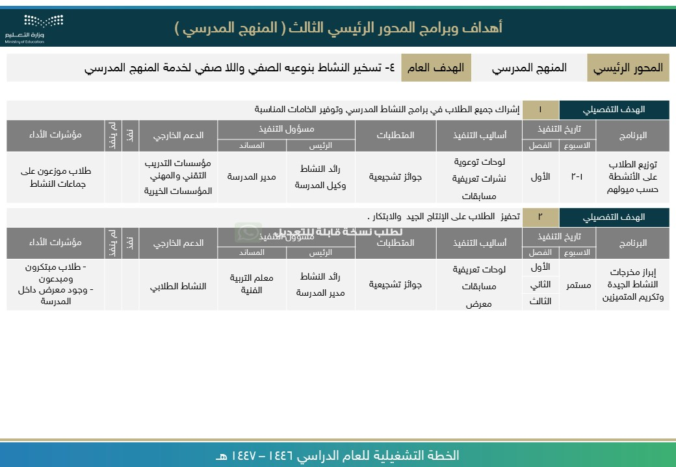

[ر](https://api.whatsapp.com/send/?phone=966541156989&text&type=phone_number&app_absent=0)

[ا](https://api.whatsapp.com/send/?phone=966541156989&text&type=phone_number&app_absent=0)

[ع](https://api.whatsapp.com/send/?phone=966541156989&text&type=phone_number&app_absent=0)

[ش](https://api.whatsapp.com/send/?phone=966541156989&text&type=phone_number&app_absent=0)

[,](https://api.whatsapp.com/send/?phone=966541156989&text&type=phone_number&app_absent=0)

[ز](https://api.whatsapp.com/send/?phone=966541156989&text&type=phone_number&app_absent=0)

[م](https://api.whatsapp.com/send/?phone=966541156989&text&type=phone_number&app_absent=0)

[ر](https://api.whatsapp.com/send/?phone=966541156989&text&type=phone_number&app_absent=0)

[,](https://api.whatsapp.com/send/?phone=966541156989&text&type=phone_number&app_absent=0)

[ة](https://api.whatsapp.com/send/?phone=966541156989&text&type=phone_number&app_absent=0)

[ي](https://api.whatsapp.com/send/?phone=966541156989&text&type=phone_number&app_absent=0)

[ن](https://api.whatsapp.com/send/?phone=966541156989&text&type=phone_number&app_absent=0)

[ف](https://api.whatsapp.com/send/?phone=966541156989&text&type=phone_number&app_absent=0)

[ة](https://api.whatsapp.com/send/?phone=966541156989&text&type=phone_number&app_absent=0)

[ص](https://api.whatsapp.com/send/?phone=966541156989&text&type=phone_number&app_absent=0)

[ا](https://api.whatsapp.com/send/?phone=966541156989&text&type=phone_number&app_absent=0)

[ص](https://api.whatsapp.com/send/?phone=966541156989&text&type=phone_number&app_absent=0)

[ق](https://api.whatsapp.com/send/?phone=966541156989&text&type=phone_number&app_absent=0)

[,](https://api.whatsapp.com/send/?phone=966541156989&text&type=phone_number&app_absent=0)

[ت](https://api.whatsapp.com/send/?phone=966541156989&text&type=phone_number&app_absent=0)

[ا](https://api.whatsapp.com/send/?phone=966541156989&text&type=phone_number&app_absent=0)

[م](https://api.whatsapp.com/send/?phone=966541156989&text&type=phone_number&app_absent=0)

[و](https://api.whatsapp.com/send/?phone=966541156989&text&type=phone_number&app_absent=0)

[س](https://api.whatsapp.com/send/?phone=966541156989&text&type=phone_number&app_absent=0)

[ر](https://api.whatsapp.com/send/?phone=966541156989&text&type=phone_number&app_absent=0)

[ل](https://api.whatsapp.com/send/?phone=966541156989&text&type=phone_number&app_absent=0)

[ا](https://api.whatsapp.com/send/?phone=966541156989&text&type=phone_number&app_absent=0)

[لى](https://api.whatsapp.com/send/?phone=966541156989&text&type=phone_number&app_absent=0)

[ع](https://api.whatsapp.com/send/?phone=966541156989&text&type=phone_number&app_absent=0)

[ي](https://api.whatsapp.com/send/?phone=966541156989&text&type=phone_number&app_absent=0)

[و](https://api.whatsapp.com/send/?phone=966541156989&text&type=phone_number&app_absent=0)

[ت](https://api.whatsapp.com/send/?phone=966541156989&text&type=phone_number&app_absent=0)

[ح](https://api.whatsapp.com/send/?phone=966541156989&text&type=phone_number&app_absent=0)

[ت](https://api.whatsapp.com/send/?phone=966541156989&text&type=phone_number&app_absent=0)

[ة](https://api.whatsapp.com/send/?phone=966541156989&text&type=phone_number&app_absent=0)

[ر](https://api.whatsapp.com/send/?phone=966541156989&text&type=phone_number&app_absent=0)

[و](https://api.whatsapp.com/send/?phone=966541156989&text&type=phone_number&app_absent=0)

[ص](https://api.whatsapp.com/send/?phone=966541156989&text&type=phone_number&app_absent=0)

[اً](https://api.whatsapp.com/send/?phone=966541156989&text&type=phone_number&app_absent=0)

[ي](https://api.whatsapp.com/send/?phone=966541156989&text&type=phone_number&app_absent=0)

[ئ](https://api.whatsapp.com/send/?phone=966541156989&text&type=phone_number&app_absent=0)

[ا](https://api.whatsapp.com/send/?phone=966541156989&text&type=phone_number&app_absent=0)

[ق](https://api.whatsapp.com/send/?phone=966541156989&text&type=phone_number&app_absent=0)

[ل](https://api.whatsapp.com/send/?phone=966541156989&text&type=phone_number&app_absent=0)

[ت](https://api.whatsapp.com/send/?phone=966541156989&text&type=phone_number&app_absent=0)

[ف](https://api.whatsapp.com/send/?phone=966541156989&text&type=phone_number&app_absent=0)

[ص](https://api.whatsapp.com/send/?phone=966541156989&text&type=phone_number&app_absent=0)

[و](https://api.whatsapp.com/send/?phone=966541156989&text&type=phone_number&app_absent=0)

[ل](https://api.whatsapp.com/send/?phone=966541156989&text&type=phone_number&app_absent=0)

[ا](https://api.whatsapp.com/send/?phone=966541156989&text&type=phone_number&app_absent=0)

[ء](https://api.whatsapp.com/send/?phone=966541156989&text&type=phone_number&app_absent=0)

[ا](https://api.whatsapp.com/send/?phone=966541156989&text&type=phone_number&app_absent=0)

[ش](https://api.whatsapp.com/send/?phone=966541156989&text&type=phone_number&app_absent=0)

[ن](https://api.whatsapp.com/send/?phone=966541156989&text&type=phone_number&app_absent=0)

[إ](https://api.whatsapp.com/send/?phone=966541156989&text&type=phone_number&app_absent=0)

[م](https://api.whatsapp.com/send/?phone=966541156989&text&type=phone_number&app_absent=0)

[ت](https://api.whatsapp.com/send/?phone=966541156989&text&type=phone_number&app_absent=0)

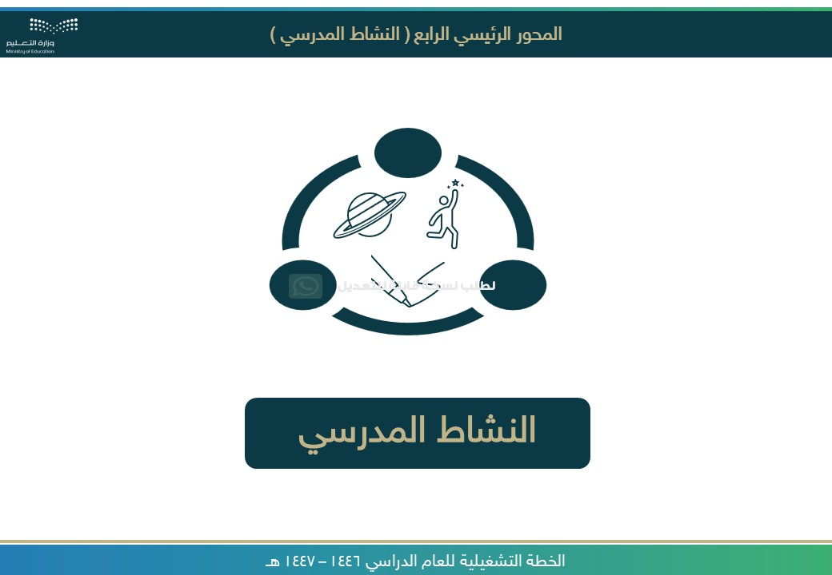

[ر](https://api.whatsapp.com/send/?phone=966541156989&text&type=phone_number&app_absent=0)

[ا](https://api.whatsapp.com/send/?phone=966541156989&text&type=phone_number&app_absent=0)

[ع](https://api.whatsapp.com/send/?phone=966541156989&text&type=phone_number&app_absent=0)

[ش](https://api.whatsapp.com/send/?phone=966541156989&text&type=phone_number&app_absent=0)

[,](https://api.whatsapp.com/send/?phone=966541156989&text&type=phone_number&app_absent=0)

[ز](https://api.whatsapp.com/send/?phone=966541156989&text&type=phone_number&app_absent=0)

[م](https://api.whatsapp.com/send/?phone=966541156989&text&type=phone_number&app_absent=0)

[ر](https://api.whatsapp.com/send/?phone=966541156989&text&type=phone_number&app_absent=0)

[,](https://api.whatsapp.com/send/?phone=966541156989&text&type=phone_number&app_absent=0)

[ة](https://api.whatsapp.com/send/?phone=966541156989&text&type=phone_number&app_absent=0)

[ي](https://api.whatsapp.com/send/?phone=966541156989&text&type=phone_number&app_absent=0)

[ن](https://api.whatsapp.com/send/?phone=966541156989&text&type=phone_number&app_absent=0)

[ف](https://api.whatsapp.com/send/?phone=966541156989&text&type=phone_number&app_absent=0)

[ة](https://api.whatsapp.com/send/?phone=966541156989&text&type=phone_number&app_absent=0)

[ص](https://api.whatsapp.com/send/?phone=966541156989&text&type=phone_number&app_absent=0)

[ا](https://api.whatsapp.com/send/?phone=966541156989&text&type=phone_number&app_absent=0)

[ص](https://api.whatsapp.com/send/?phone=966541156989&text&type=phone_number&app_absent=0)

[ق](https://api.whatsapp.com/send/?phone=966541156989&text&type=phone_number&app_absent=0)

[,](https://api.whatsapp.com/send/?phone=966541156989&text&type=phone_number&app_absent=0)

[ت](https://api.whatsapp.com/send/?phone=966541156989&text&type=phone_number&app_absent=0)

[ا](https://api.whatsapp.com/send/?phone=966541156989&text&type=phone_number&app_absent=0)

[م](https://api.whatsapp.com/send/?phone=966541156989&text&type=phone_number&app_absent=0)

[و](https://api.whatsapp.com/send/?phone=966541156989&text&type=phone_number&app_absent=0)

[س](https://api.whatsapp.com/send/?phone=966541156989&text&type=phone_number&app_absent=0)

[ر](https://api.whatsapp.com/send/?phone=966541156989&text&type=phone_number&app_absent=0)

[ل](https://api.whatsapp.com/send/?phone=966541156989&text&type=phone_number&app_absent=0)

[ا](https://api.whatsapp.com/send/?phone=966541156989&text&type=phone_number&app_absent=0)

[لى](https://api.whatsapp.com/send/?phone=966541156989&text&type=phone_number&app_absent=0)

[ع](https://api.whatsapp.com/send/?phone=966541156989&text&type=phone_number&app_absent=0)

[ي](https://api.whatsapp.com/send/?phone=966541156989&text&type=phone_number&app_absent=0)

[و](https://api.whatsapp.com/send/?phone=966541156989&text&type=phone_number&app_absent=0)

[ت](https://api.whatsapp.com/send/?phone=966541156989&text&type=phone_number&app_absent=0)

[ح](https://api.whatsapp.com/send/?phone=966541156989&text&type=phone_number&app_absent=0)

[ت](https://api.whatsapp.com/send/?phone=966541156989&text&type=phone_number&app_absent=0)

[ة](https://api.whatsapp.com/send/?phone=966541156989&text&type=phone_number&app_absent=0)

[ر](https://api.whatsapp.com/send/?phone=966541156989&text&type=phone_number&app_absent=0)

[و](https://api.whatsapp.com/send/?phone=966541156989&text&type=phone_number&app_absent=0)

[ص](https://api.whatsapp.com/send/?phone=966541156989&text&type=phone_number&app_absent=0)

[اً](https://api.whatsapp.com/send/?phone=966541156989&text&type=phone_number&app_absent=0)

[ي](https://api.whatsapp.com/send/?phone=966541156989&text&type=phone_number&app_absent=0)

[ئ](https://api.whatsapp.com/send/?phone=966541156989&text&type=phone_number&app_absent=0)

[ا](https://api.whatsapp.com/send/?phone=966541156989&text&type=phone_number&app_absent=0)

[ق](https://api.whatsapp.com/send/?phone=966541156989&text&type=phone_number&app_absent=0)

[ل](https://api.whatsapp.com/send/?phone=966541156989&text&type=phone_number&app_absent=0)

[ت](https://api.whatsapp.com/send/?phone=966541156989&text&type=phone_number&app_absent=0)

[ف](https://api.whatsapp.com/send/?phone=966541156989&text&type=phone_number&app_absent=0)

[ص](https://api.whatsapp.com/send/?phone=966541156989&text&type=phone_number&app_absent=0)

[و](https://api.whatsapp.com/send/?phone=966541156989&text&type=phone_number&app_absent=0)

[ل](https://api.whatsapp.com/send/?phone=966541156989&text&type=phone_number&app_absent=0)

[ا](https://api.whatsapp.com/send/?phone=966541156989&text&type=phone_number&app_absent=0)

[ء](https://api.whatsapp.com/send/?phone=966541156989&text&type=phone_number&app_absent=0)

[ا](https://api.whatsapp.com/send/?phone=966541156989&text&type=phone_number&app_absent=0)

[ش](https://api.whatsapp.com/send/?phone=966541156989&text&type=phone_number&app_absent=0)

[ن](https://api.whatsapp.com/send/?phone=966541156989&text&type=phone_number&app_absent=0)

[إ](https://api.whatsapp.com/send/?phone=966541156989&text&type=phone_number&app_absent=0)

[م](https://api.whatsapp.com/send/?phone=966541156989&text&type=phone_number&app_absent=0)

[ت](https://api.whatsapp.com/send/?phone=966541156989&text&type=phone_number&app_absent=0)



صورة تحتوي على نص, لقطة شاشة, برمجيات, صفحة ويب

تم إنشاء الوصف تلقائياً



[ر](https://api.whatsapp.com/send/?phone=966541156989&text&type=phone_number&app_absent=0)

[ا](https://api.whatsapp.com/send/?phone=966541156989&text&type=phone_number&app_absent=0)

[ع](https://api.whatsapp.com/send/?phone=966541156989&text&type=phone_number&app_absent=0)

[ش](https://api.whatsapp.com/send/?phone=966541156989&text&type=phone_number&app_absent=0)

[,](https://api.whatsapp.com/send/?phone=966541156989&text&type=phone_number&app_absent=0)

[ز](https://api.whatsapp.com/send/?phone=966541156989&text&type=phone_number&app_absent=0)

[م](https://api.whatsapp.com/send/?phone=966541156989&text&type=phone_number&app_absent=0)

[ر](https://api.whatsapp.com/send/?phone=966541156989&text&type=phone_number&app_absent=0)

[,](https://api.whatsapp.com/send/?phone=966541156989&text&type=phone_number&app_absent=0)

[ة](https://api.whatsapp.com/send/?phone=966541156989&text&type=phone_number&app_absent=0)

[ي](https://api.whatsapp.com/send/?phone=966541156989&text&type=phone_number&app_absent=0)

[ن](https://api.whatsapp.com/send/?phone=966541156989&text&type=phone_number&app_absent=0)

[ف](https://api.whatsapp.com/send/?phone=966541156989&text&type=phone_number&app_absent=0)

[ة](https://api.whatsapp.com/send/?phone=966541156989&text&type=phone_number&app_absent=0)

[ص](https://api.whatsapp.com/send/?phone=966541156989&text&type=phone_number&app_absent=0)

[ا](https://api.whatsapp.com/send/?phone=966541156989&text&type=phone_number&app_absent=0)

[ص](https://api.whatsapp.com/send/?phone=966541156989&text&type=phone_number&app_absent=0)

[ق](https://api.whatsapp.com/send/?phone=966541156989&text&type=phone_number&app_absent=0)

[,](https://api.whatsapp.com/send/?phone=966541156989&text&type=phone_number&app_absent=0)

[ت](https://api.whatsapp.com/send/?phone=966541156989&text&type=phone_number&app_absent=0)

[ا](https://api.whatsapp.com/send/?phone=966541156989&text&type=phone_number&app_absent=0)

[م](https://api.whatsapp.com/send/?phone=966541156989&text&type=phone_number&app_absent=0)

[و](https://api.whatsapp.com/send/?phone=966541156989&text&type=phone_number&app_absent=0)

[س](https://api.whatsapp.com/send/?phone=966541156989&text&type=phone_number&app_absent=0)

[ر](https://api.whatsapp.com/send/?phone=966541156989&text&type=phone_number&app_absent=0)

[ل](https://api.whatsapp.com/send/?phone=966541156989&text&type=phone_number&app_absent=0)

[ا](https://api.whatsapp.com/send/?phone=966541156989&text&type=phone_number&app_absent=0)

[لى](https://api.whatsapp.com/send/?phone=966541156989&text&type=phone_number&app_absent=0)

[ع](https://api.whatsapp.com/send/?phone=966541156989&text&type=phone_number&app_absent=0)

[ي](https://api.whatsapp.com/send/?phone=966541156989&text&type=phone_number&app_absent=0)

[و](https://api.whatsapp.com/send/?phone=966541156989&text&type=phone_number&app_absent=0)

[ت](https://api.whatsapp.com/send/?phone=966541156989&text&type=phone_number&app_absent=0)

[ح](https://api.whatsapp.com/send/?phone=966541156989&text&type=phone_number&app_absent=0)

[ت](https://api.whatsapp.com/send/?phone=966541156989&text&type=phone_number&app_absent=0)

[ة](https://api.whatsapp.com/send/?phone=966541156989&text&type=phone_number&app_absent=0)

[ر](https://api.whatsapp.com/send/?phone=966541156989&text&type=phone_number&app_absent=0)

[و](https://api.whatsapp.com/send/?phone=966541156989&text&type=phone_number&app_absent=0)

[ص](https://api.whatsapp.com/send/?phone=966541156989&text&type=phone_number&app_absent=0)

[اً](https://api.whatsapp.com/send/?phone=966541156989&text&type=phone_number&app_absent=0)

[ي](https://api.whatsapp.com/send/?phone=966541156989&text&type=phone_number&app_absent=0)

[ئ](https://api.whatsapp.com/send/?phone=966541156989&text&type=phone_number&app_absent=0)

[ا](https://api.whatsapp.com/send/?phone=966541156989&text&type=phone_number&app_absent=0)

[ق](https://api.whatsapp.com/send/?phone=966541156989&text&type=phone_number&app_absent=0)

[ل](https://api.whatsapp.com/send/?phone=966541156989&text&type=phone_number&app_absent=0)

[ت](https://api.whatsapp.com/send/?phone=966541156989&text&type=phone_number&app_absent=0)

[ف](https://api.whatsapp.com/send/?phone=966541156989&text&type=phone_number&app_absent=0)

[ص](https://api.whatsapp.com/send/?phone=966541156989&text&type=phone_number&app_absent=0)

[و](https://api.whatsapp.com/send/?phone=966541156989&text&type=phone_number&app_absent=0)

[ل](https://api.whatsapp.com/send/?phone=966541156989&text&type=phone_number&app_absent=0)

[ا](https://api.whatsapp.com/send/?phone=966541156989&text&type=phone_number&app_absent=0)

[ء](https://api.whatsapp.com/send/?phone=966541156989&text&type=phone_number&app_absent=0)

[ا](https://api.whatsapp.com/send/?phone=966541156989&text&type=phone_number&app_absent=0)

[ش](https://api.whatsapp.com/send/?phone=966541156989&text&type=phone_number&app_absent=0)

[ن](https://api.whatsapp.com/send/?phone=966541156989&text&type=phone_number&app_absent=0)

[إ](https://api.whatsapp.com/send/?phone=966541156989&text&type=phone_number&app_absent=0)

[م](https://api.whatsapp.com/send/?phone=966541156989&text&type=phone_number&app_absent=0)

[ت](https://api.whatsapp.com/send/?phone=966541156989&text&type=phone_number&app_absent=0)

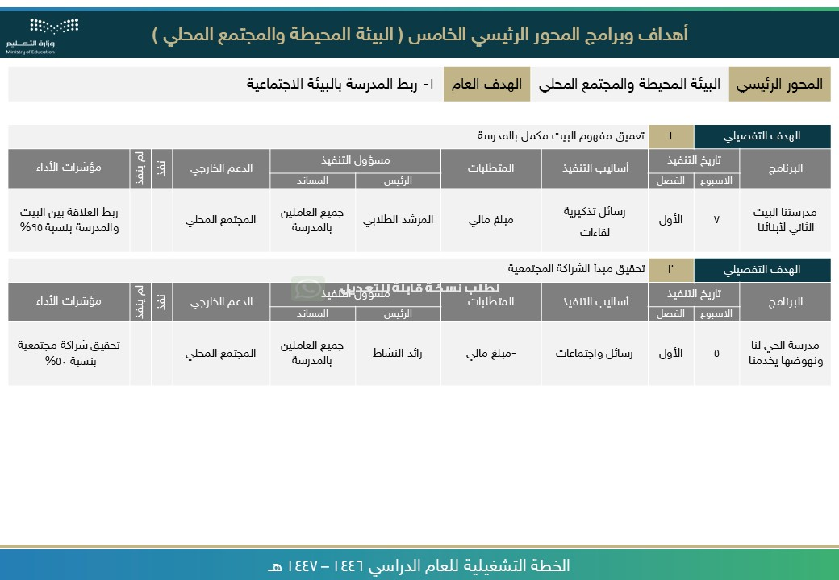

[ر](https://api.whatsapp.com/send/?phone=966541156989&text&type=phone_number&app_absent=0)

[ا](https://api.whatsapp.com/send/?phone=966541156989&text&type=phone_number&app_absent=0)

[ع](https://api.whatsapp.com/send/?phone=966541156989&text&type=phone_number&app_absent=0)

[ش](https://api.whatsapp.com/send/?phone=966541156989&text&type=phone_number&app_absent=0)

[,](https://api.whatsapp.com/send/?phone=966541156989&text&type=phone_number&app_absent=0)

[ز](https://api.whatsapp.com/send/?phone=966541156989&text&type=phone_number&app_absent=0)

[م](https://api.whatsapp.com/send/?phone=966541156989&text&type=phone_number&app_absent=0)

[ر](https://api.whatsapp.com/send/?phone=966541156989&text&type=phone_number&app_absent=0)

[,](https://api.whatsapp.com/send/?phone=966541156989&text&type=phone_number&app_absent=0)

[ة](https://api.whatsapp.com/send/?phone=966541156989&text&type=phone_number&app_absent=0)

[ي](https://api.whatsapp.com/send/?phone=966541156989&text&type=phone_number&app_absent=0)

[ن](https://api.whatsapp.com/send/?phone=966541156989&text&type=phone_number&app_absent=0)

[ف](https://api.whatsapp.com/send/?phone=966541156989&text&type=phone_number&app_absent=0)

[ة](https://api.whatsapp.com/send/?phone=966541156989&text&type=phone_number&app_absent=0)

[ص](https://api.whatsapp.com/send/?phone=966541156989&text&type=phone_number&app_absent=0)

[ا](https://api.whatsapp.com/send/?phone=966541156989&text&type=phone_number&app_absent=0)

[ص](https://api.whatsapp.com/send/?phone=966541156989&text&type=phone_number&app_absent=0)

[ق](https://api.whatsapp.com/send/?phone=966541156989&text&type=phone_number&app_absent=0)

[,](https://api.whatsapp.com/send/?phone=966541156989&text&type=phone_number&app_absent=0)

[ت](https://api.whatsapp.com/send/?phone=966541156989&text&type=phone_number&app_absent=0)

[ا](https://api.whatsapp.com/send/?phone=966541156989&text&type=phone_number&app_absent=0)

[م](https://api.whatsapp.com/send/?phone=966541156989&text&type=phone_number&app_absent=0)

[و](https://api.whatsapp.com/send/?phone=966541156989&text&type=phone_number&app_absent=0)

[س](https://api.whatsapp.com/send/?phone=966541156989&text&type=phone_number&app_absent=0)

[ر](https://api.whatsapp.com/send/?phone=966541156989&text&type=phone_number&app_absent=0)

[ل](https://api.whatsapp.com/send/?phone=966541156989&text&type=phone_number&app_absent=0)

[ا](https://api.whatsapp.com/send/?phone=966541156989&text&type=phone_number&app_absent=0)

[لى](https://api.whatsapp.com/send/?phone=966541156989&text&type=phone_number&app_absent=0)

[ع](https://api.whatsapp.com/send/?phone=966541156989&text&type=phone_number&app_absent=0)

[ي](https://api.whatsapp.com/send/?phone=966541156989&text&type=phone_number&app_absent=0)

[و](https://api.whatsapp.com/send/?phone=966541156989&text&type=phone_number&app_absent=0)

[ت](https://api.whatsapp.com/send/?phone=966541156989&text&type=phone_number&app_absent=0)

[ح](https://api.whatsapp.com/send/?phone=966541156989&text&type=phone_number&app_absent=0)

[ت](https://api.whatsapp.com/send/?phone=966541156989&text&type=phone_number&app_absent=0)

[ة](https://api.whatsapp.com/send/?phone=966541156989&text&type=phone_number&app_absent=0)

[ر](https://api.whatsapp.com/send/?phone=966541156989&text&type=phone_number&app_absent=0)

[و](https://api.whatsapp.com/send/?phone=966541156989&text&type=phone_number&app_absent=0)

[ص](https://api.whatsapp.com/send/?phone=966541156989&text&type=phone_number&app_absent=0)

[اً](https://api.whatsapp.com/send/?phone=966541156989&text&type=phone_number&app_absent=0)

[ي](https://api.whatsapp.com/send/?phone=966541156989&text&type=phone_number&app_absent=0)

[ئ](https://api.whatsapp.com/send/?phone=966541156989&text&type=phone_number&app_absent=0)

[ا](https://api.whatsapp.com/send/?phone=966541156989&text&type=phone_number&app_absent=0)

[ق](https://api.whatsapp.com/send/?phone=966541156989&text&type=phone_number&app_absent=0)

[ل](https://api.whatsapp.com/send/?phone=966541156989&text&type=phone_number&app_absent=0)

[ت](https://api.whatsapp.com/send/?phone=966541156989&text&type=phone_number&app_absent=0)

[ف](https://api.whatsapp.com/send/?phone=966541156989&text&type=phone_number&app_absent=0)

[ص](https://api.whatsapp.com/send/?phone=966541156989&text&type=phone_number&app_absent=0)

[و](https://api.whatsapp.com/send/?phone=966541156989&text&type=phone_number&app_absent=0)

[ل](https://api.whatsapp.com/send/?phone=966541156989&text&type=phone_number&app_absent=0)

[ا](https://api.whatsapp.com/send/?phone=966541156989&text&type=phone_number&app_absent=0)

[ء](https://api.whatsapp.com/send/?phone=966541156989&text&type=phone_number&app_absent=0)

[ا](https://api.whatsapp.com/send/?phone=966541156989&text&type=phone_number&app_absent=0)

[ش](https://api.whatsapp.com/send/?phone=966541156989&text&type=phone_number&app_absent=0)

[ن](https://api.whatsapp.com/send/?phone=966541156989&text&type=phone_number&app_absent=0)

[إ](https://api.whatsapp.com/send/?phone=966541156989&text&type=phone_number&app_absent=0)

[م](https://api.whatsapp.com/send/?phone=966541156989&text&type=phone_number&app_absent=0)

[ت](https://api.whatsapp.com/send/?phone=966541156989&text&type=phone_number&app_absent=0)

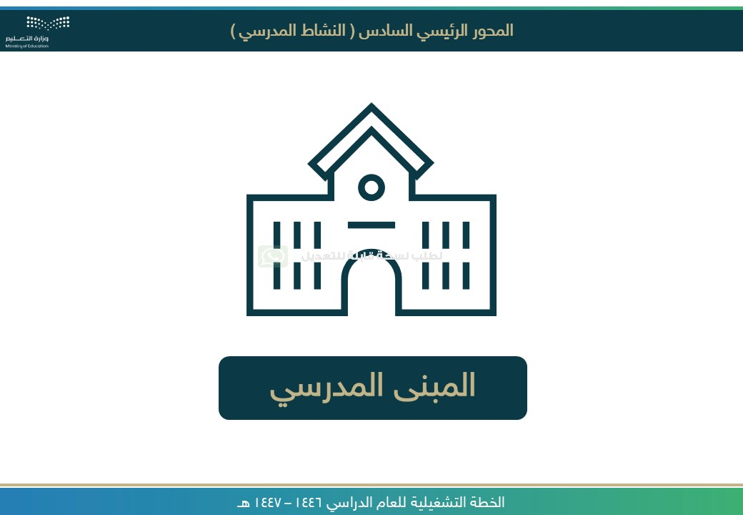

[ر](https://api.whatsapp.com/send/?phone=966541156989&text&type=phone_number&app_absent=0)

[ا](https://api.whatsapp.com/send/?phone=966541156989&text&type=phone_number&app_absent=0)

[ع](https://api.whatsapp.com/send/?phone=966541156989&text&type=phone_number&app_absent=0)

[ش](https://api.whatsapp.com/send/?phone=966541156989&text&type=phone_number&app_absent=0)

[,](https://api.whatsapp.com/send/?phone=966541156989&text&type=phone_number&app_absent=0)

[ز](https://api.whatsapp.com/send/?phone=966541156989&text&type=phone_number&app_absent=0)

[م](https://api.whatsapp.com/send/?phone=966541156989&text&type=phone_number&app_absent=0)

[ر](https://api.whatsapp.com/send/?phone=966541156989&text&type=phone_number&app_absent=0)

[,](https://api.whatsapp.com/send/?phone=966541156989&text&type=phone_number&app_absent=0)

[ة](https://api.whatsapp.com/send/?phone=966541156989&text&type=phone_number&app_absent=0)

[ي](https://api.whatsapp.com/send/?phone=966541156989&text&type=phone_number&app_absent=0)

[ن](https://api.whatsapp.com/send/?phone=966541156989&text&type=phone_number&app_absent=0)

[ف](https://api.whatsapp.com/send/?phone=966541156989&text&type=phone_number&app_absent=0)

[ة](https://api.whatsapp.com/send/?phone=966541156989&text&type=phone_number&app_absent=0)

[ص](https://api.whatsapp.com/send/?phone=966541156989&text&type=phone_number&app_absent=0)

[ا](https://api.whatsapp.com/send/?phone=966541156989&text&type=phone_number&app_absent=0)

[ص](https://api.whatsapp.com/send/?phone=966541156989&text&type=phone_number&app_absent=0)

[ق](https://api.whatsapp.com/send/?phone=966541156989&text&type=phone_number&app_absent=0)

[,](https://api.whatsapp.com/send/?phone=966541156989&text&type=phone_number&app_absent=0)

[ت](https://api.whatsapp.com/send/?phone=966541156989&text&type=phone_number&app_absent=0)

[ا](https://api.whatsapp.com/send/?phone=966541156989&text&type=phone_number&app_absent=0)

[م](https://api.whatsapp.com/send/?phone=966541156989&text&type=phone_number&app_absent=0)

[و](https://api.whatsapp.com/send/?phone=966541156989&text&type=phone_number&app_absent=0)

[س](https://api.whatsapp.com/send/?phone=966541156989&text&type=phone_number&app_absent=0)

[ر](https://api.whatsapp.com/send/?phone=966541156989&text&type=phone_number&app_absent=0)

[ل](https://api.whatsapp.com/send/?phone=966541156989&text&type=phone_number&app_absent=0)

[ا](https://api.whatsapp.com/send/?phone=966541156989&text&type=phone_number&app_absent=0)

[لى](https://api.whatsapp.com/send/?phone=966541156989&text&type=phone_number&app_absent=0)

[ع](https://api.whatsapp.com/send/?phone=966541156989&text&type=phone_number&app_absent=0)

[ي](https://api.whatsapp.com/send/?phone=966541156989&text&type=phone_number&app_absent=0)

[و](https://api.whatsapp.com/send/?phone=966541156989&text&type=phone_number&app_absent=0)

[ت](https://api.whatsapp.com/send/?phone=966541156989&text&type=phone_number&app_absent=0)

[ح](https://api.whatsapp.com/send/?phone=966541156989&text&type=phone_number&app_absent=0)

[ت](https://api.whatsapp.com/send/?phone=966541156989&text&type=phone_number&app_absent=0)

[ة](https://api.whatsapp.com/send/?phone=966541156989&text&type=phone_number&app_absent=0)

[ر](https://api.whatsapp.com/send/?phone=966541156989&text&type=phone_number&app_absent=0)

[و](https://api.whatsapp.com/send/?phone=966541156989&text&type=phone_number&app_absent=0)

[ص](https://api.whatsapp.com/send/?phone=966541156989&text&type=phone_number&app_absent=0)

[اً](https://api.whatsapp.com/send/?phone=966541156989&text&type=phone_number&app_absent=0)

[ي](https://api.whatsapp.com/send/?phone=966541156989&text&type=phone_number&app_absent=0)

[ئ](https://api.whatsapp.com/send/?phone=966541156989&text&type=phone_number&app_absent=0)

[ا](https://api.whatsapp.com/send/?phone=966541156989&text&type=phone_number&app_absent=0)

[ق](https://api.whatsapp.com/send/?phone=966541156989&text&type=phone_number&app_absent=0)

[ل](https://api.whatsapp.com/send/?phone=966541156989&text&type=phone_number&app_absent=0)

[ت](https://api.whatsapp.com/send/?phone=966541156989&text&type=phone_number&app_absent=0)

[ف](https://api.whatsapp.com/send/?phone=966541156989&text&type=phone_number&app_absent=0)

[ص](https://api.whatsapp.com/send/?phone=966541156989&text&type=phone_number&app_absent=0)

[و](https://api.whatsapp.com/send/?phone=966541156989&text&type=phone_number&app_absent=0)

[ل](https://api.whatsapp.com/send/?phone=966541156989&text&type=phone_number&app_absent=0)

[ا](https://api.whatsapp.com/send/?phone=966541156989&text&type=phone_number&app_absent=0)

[ء](https://api.whatsapp.com/send/?phone=966541156989&text&type=phone_number&app_absent=0)

[ا](https://api.whatsapp.com/send/?phone=966541156989&text&type=phone_number&app_absent=0)

[ش](https://api.whatsapp.com/send/?phone=966541156989&text&type=phone_number&app_absent=0)

[ن](https://api.whatsapp.com/send/?phone=966541156989&text&type=phone_number&app_absent=0)

[إ](https://api.whatsapp.com/send/?phone=966541156989&text&type=phone_number&app_absent=0)

[م](https://api.whatsapp.com/send/?phone=966541156989&text&type=phone_number&app_absent=0)

[ت](https://api.whatsapp.com/send/?phone=966541156989&text&type=phone_number&app_absent=0)

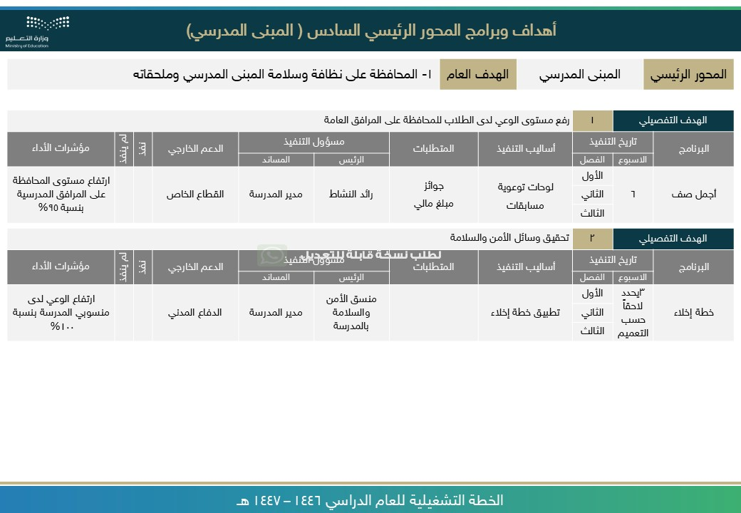

[ر](https://api.whatsapp.com/send/?phone=966541156989&text&type=phone_number&app_absent=0)

[ا](https://api.whatsapp.com/send/?phone=966541156989&text&type=phone_number&app_absent=0)

[ع](https://api.whatsapp.com/send/?phone=966541156989&text&type=phone_number&app_absent=0)

[ش](https://api.whatsapp.com/send/?phone=966541156989&text&type=phone_number&app_absent=0)

[,](https://api.whatsapp.com/send/?phone=966541156989&text&type=phone_number&app_absent=0)

[ز](https://api.whatsapp.com/send/?phone=966541156989&text&type=phone_number&app_absent=0)

[م](https://api.whatsapp.com/send/?phone=966541156989&text&type=phone_number&app_absent=0)

[ر](https://api.whatsapp.com/send/?phone=966541156989&text&type=phone_number&app_absent=0)

[,](https://api.whatsapp.com/send/?phone=966541156989&text&type=phone_number&app_absent=0)

[ة](https://api.whatsapp.com/send/?phone=966541156989&text&type=phone_number&app_absent=0)

[ي](https://api.whatsapp.com/send/?phone=966541156989&text&type=phone_number&app_absent=0)

[ن](https://api.whatsapp.com/send/?phone=966541156989&text&type=phone_number&app_absent=0)

[ف](https://api.whatsapp.com/send/?phone=966541156989&text&type=phone_number&app_absent=0)

[ة](https://api.whatsapp.com/send/?phone=966541156989&text&type=phone_number&app_absent=0)

[ص](https://api.whatsapp.com/send/?phone=966541156989&text&type=phone_number&app_absent=0)

[ا](https://api.whatsapp.com/send/?phone=966541156989&text&type=phone_number&app_absent=0)

[ص](https://api.whatsapp.com/send/?phone=966541156989&text&type=phone_number&app_absent=0)

[ق](https://api.whatsapp.com/send/?phone=966541156989&text&type=phone_number&app_absent=0)

[,](https://api.whatsapp.com/send/?phone=966541156989&text&type=phone_number&app_absent=0)

[ت](https://api.whatsapp.com/send/?phone=966541156989&text&type=phone_number&app_absent=0)

[ا](https://api.whatsapp.com/send/?phone=966541156989&text&type=phone_number&app_absent=0)

[م](https://api.whatsapp.com/send/?phone=966541156989&text&type=phone_number&app_absent=0)

[و](https://api.whatsapp.com/send/?phone=966541156989&text&type=phone_number&app_absent=0)

[س](https://api.whatsapp.com/send/?phone=966541156989&text&type=phone_number&app_absent=0)

[ر](https://api.whatsapp.com/send/?phone=966541156989&text&type=phone_number&app_absent=0)

[ل](https://api.whatsapp.com/send/?phone=966541156989&text&type=phone_number&app_absent=0)

[ا](https://api.whatsapp.com/send/?phone=966541156989&text&type=phone_number&app_absent=0)

[لى](https://api.whatsapp.com/send/?phone=966541156989&text&type=phone_number&app_absent=0)

[ع](https://api.whatsapp.com/send/?phone=966541156989&text&type=phone_number&app_absent=0)

[ي](https://api.whatsapp.com/send/?phone=966541156989&text&type=phone_number&app_absent=0)

[و](https://api.whatsapp.com/send/?phone=966541156989&text&type=phone_number&app_absent=0)

[ت](https://api.whatsapp.com/send/?phone=966541156989&text&type=phone_number&app_absent=0)

[ح](https://api.whatsapp.com/send/?phone=966541156989&text&type=phone_number&app_absent=0)

[ت](https://api.whatsapp.com/send/?phone=966541156989&text&type=phone_number&app_absent=0)

[ة](https://api.whatsapp.com/send/?phone=966541156989&text&type=phone_number&app_absent=0)

[ر](https://api.whatsapp.com/send/?phone=966541156989&text&type=phone_number&app_absent=0)

[و](https://api.whatsapp.com/send/?phone=966541156989&text&type=phone_number&app_absent=0)

[ص](https://api.whatsapp.com/send/?phone=966541156989&text&type=phone_number&app_absent=0)

[اً](https://api.whatsapp.com/send/?phone=966541156989&text&type=phone_number&app_absent=0)

[ي](https://api.whatsapp.com/send/?phone=966541156989&text&type=phone_number&app_absent=0)

[ئ](https://api.whatsapp.com/send/?phone=966541156989&text&type=phone_number&app_absent=0)

[ا](https://api.whatsapp.com/send/?phone=966541156989&text&type=phone_number&app_absent=0)

[ق](https://api.whatsapp.com/send/?phone=966541156989&text&type=phone_number&app_absent=0)

[ل](https://api.whatsapp.com/send/?phone=966541156989&text&type=phone_number&app_absent=0)

[ت](https://api.whatsapp.com/send/?phone=966541156989&text&type=phone_number&app_absent=0)

[ف](https://api.whatsapp.com/send/?phone=966541156989&text&type=phone_number&app_absent=0)

[ص](https://api.whatsapp.com/send/?phone=966541156989&text&type=phone_number&app_absent=0)

[و](https://api.whatsapp.com/send/?phone=966541156989&text&type=phone_number&app_absent=0)

[ل](https://api.whatsapp.com/send/?phone=966541156989&text&type=phone_number&app_absent=0)

[ا](https://api.whatsapp.com/send/?phone=966541156989&text&type=phone_number&app_absent=0)

[ء](https://api.whatsapp.com/send/?phone=966541156989&text&type=phone_number&app_absent=0)

[ا](https://api.whatsapp.com/send/?phone=966541156989&text&type=phone_number&app_absent=0)

[ش](https://api.whatsapp.com/send/?phone=966541156989&text&type=phone_number&app_absent=0)

[ن](https://api.whatsapp.com/send/?phone=966541156989&text&type=phone_number&app_absent=0)

[إ](https://api.whatsapp.com/send/?phone=966541156989&text&type=phone_number&app_absent=0)

[م](https://api.whatsapp.com/send/?phone=966541156989&text&type=phone_number&app_absent=0)

[ت](https://api.whatsapp.com/send/?phone=966541156989&text&type=phone_number&app_absent=0)



صورة تحتوي على نص, لقطة شاشة, الخط, برمجيات

تم إنشاء الوصف تلقائياً

صورة تحتوي على نص, لقطة شاشة, رقم, الخط

تم إنشاء الوصف تلقائياً

صورة تحتوي على نص, لقطة شاشة, رقم, الخط

تم إنشاء الوصف تلقائياً

صورة تحتوي على نص, لقطة شاشة, رقم, الخط

تم إنشاء الوصف تلقائياً

صورة تحتوي على نص, لقطة شاشة, رقم, الخط

تم إنشاء الوصف تلقائياً

صورة تحتوي على نص, الخط, لقطة شاشة, التصميم

تم إنشاء الوصف تلقائياً