General Questions

1 – What does your dad do ?
A . I am playing. B . He is a doctor.
2 – What does the firefighter do?
A. He puts out fires . B. He flies plane .
3 – What does your mom do?
A . She is sleeping . B. She is a nurse .

Reading short sentences

1. He is a pilot.

2. She works in a school.

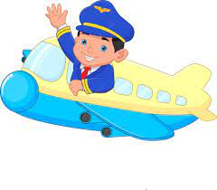

Controlled writing

______________________ | 1– she - a – teacher – is. ( rearrange )
____________ | 2.One _______. ( complete )

Grammar

who | which | what | 1 – ____ is he ? He is a teacher.
where | what | who | 2- ____ does she do ? She is a nurse .
under | in | on | 3. He works ___ a hospital .
brushes | brushs | brush | 4- She ______ her teeth .

Three hundred – doctor – firefighter – baker

Vocabulary
 |  | 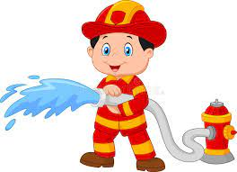
---------- | ---------- | --------- | ---------

Orthography (spelling)

Choose the correct letter: ( kn - gh )

 | 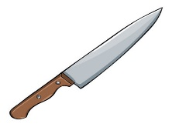 | 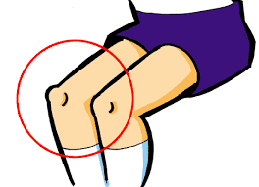
_ _ ock | _ _ ife | _ _ ee | li_ _t | r_ _t

Controlled writing

4

------------------------------------------------------------------------------------------------------------------------------------------------------------

Good luck.

M_zaid0

