اختبار نهاية الفصل الدراسي الثالث ( الدور الأول ) للعام الدراسي 1443 ه للغة الإنجليزية للصف السادس الإبتدائي
المادة : اللغة الإنجليزية
المدرسة :
زمن الإختبار: ساعة و نصف
المملكة العربية السعودية
وزارة التعليم
إدارة التعليم

السؤال | الدرجة رقماً | الدرجة كتابة | المصحح/ة
General Questions | 6 |  | الاسم :
Controlled writing | 5 |  | التوقيع :
Reading short s. | 4 |  | المراجع/ة
Grammar | 5 |  | الاسم :
Vocabulary | 6 |  | التوقيع :
Orthography | 4
مجموع الاختبار التحريري | 30
Listening | 5 |  | المدقق/ة
Speaking | 5 |  | الاسم :
المجموع النهائي | 40 |  | التوقيع :
Q1- General Questions

6

Choose the correct answer : A \
Which subject do you like most this year ? 1 -
C Artistic | B PE | Math |  | A
2 – Which grade ware you in last year?
C 4TH Grade | B 5TH grade | 6TH grade | A
3- Did you eat breakfast this morning?
C No , I'm | B Yes , I drank | No , I didn't drank | A
4 -Which city do you live in ?
C Abqaiq | B School | garden | A

1
It is just ……………………………………………… | 1-Where's the post office?
 | 2-What should you do to live in a healthy life?
Because I was ………………………………….. | 3-Why did you eat all the soup ?
Because I was ………………………………….. | 4 -Why did you sleep in my bed ?
Q2- Controlled writing
I should …………………………………………………
B - Answer the following questions :
5

A - Complete the following blanks:
200 – have – 6th Elementary school – has – 7 : 00 o'clock – have

Hi! Let me introduce my school.
The name of my school is _________________________ .
There are about _________ students in my school .
We _________ school lunch at our school .
Our school _________ a school bus .
We _________ a school uniform .
Our school starts at ______________________ .
B – Rearrange :
........................................................ | 1- English – speak - class – in
........................................................ | 2 - a – I – sweater – want
4
Q3 - Reading short sentences
A - Match
Ask 5 -
2
To the teacher. |  | 1 – Don't shout;
To do your homework . |  | 2 – Listen
Speak clearly. | English in class ! | 3 – Speak  Don't shout 4 -
❌ ✔️
❌ ✔️
I brushed my teeth . 4 -
I like PE this year . 3 -
I'd like some juice . 2 -
. I have an earache 1 -
B - Read and put ✔️ or ❌ :
B - Read and put ✔ or ❌ :
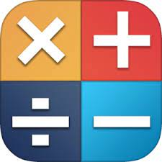
❌ ✔️
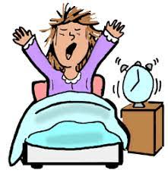
❌ ✔️
Q4 - Grammar
5
A- Read and choose the correct answer:
am
was
is
1- Last year I _______ in the 5th grade
4- He ___ going to the doctor.
am
were
should
There is There are Is there
am
are
is
gets up
got up
get up
liking
liked
like
6- you _____ get up early .
5- ____ ____ two floors.
3- The PAST of ( get up ) is
2- This year I _______ English .

B- Do as shown between bracketd :
Change the verb to the past))
(Correct the verb )

1 – Rana has a little lamb. _____________
2- She's going to shopping in Dubai. ___________
Q5 - Vocabulary

6
A- Write the correct word under each picture :
Box – bottle – fish – book – doll – letter - globe
 | 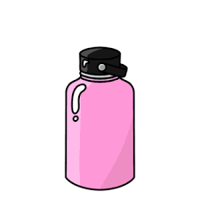 |  | 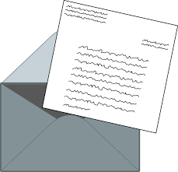 | 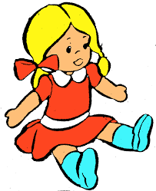
_________________ | ________________ | _______________ | _______________ | _____________ | ______________

B- Circle the odd word :
3
2 - great – pizza – funny – happy | 1 – Math – Einglish – car - PE
4 - white – black – candies – blue | 3 - played – cleaned – got – kicked
C – Match :
1-
2-
3-
4-
5-
No eating
No shouting
Library
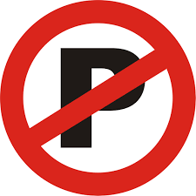 1
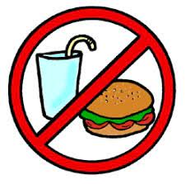
No Parking
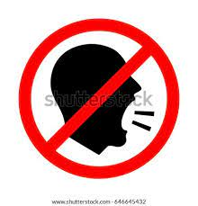
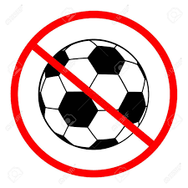

D – Write the missing words:
. ___________ , Monday , _____________ , Wednesday, _____________ , Friday , ____________
Orthography Q5 -

4
Choose the correct letter: ( sq – sc – sk – ir – u_e - ur - or) A –
 |  | 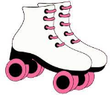
ger__ __B | uare__ __ | ate__ __ | arf__ __ | rd__ __P | C_t_
B- Complete :
1- _ _ y ( Sk – Ll – Sg ) 2- g _ _ l ( ir – u – m )

3- bl _ e ( u – g – n ) 4 – Hu _ e ( e – g – a )

C – Choose the correct spelling:
2.
1.
a – Bus a – rid 3. a - huoso
b – Bys B – rod b - heesa
c – Bis c – red c – house

D - Fill in the missing letters :
1 -
Good luck T.
4
Tu _ tle glu _ D _ d store
3 -
2 -

