

اسم الطالب ……………………………………………………………………….……………………………….……………………الصف……………………………….


Match the questions to the answers:ضع رقم السؤال في مربع الجواب المناسب

1-What are you going to be in the future? My favorite dish is pasta.

2- What’s your favorite dish? I am going to be a robot manager.

Choose the correct answer:ضع دائرة على الإجابة الصحيحة


- She doesn’t like TV. She (may – may not ) be an actor.
- He likes news. He ( might not – may) be a journalist.
- I like fashion. I am ( not going to – going to ) be a fashion designer.
4-You aren’t tired, ( are – aren’t ) you?
5- We are happy, (are – aren’t) we?
6- He is a teacher, ( is – isn’t ) he?
7-They can’t sleep, ( can – can’t ) they?
8- She (should - shouldn’t) eat too many candies.
9- You (should - shouldn’t) get your ingredients ready first.
10-You ( had better – had better not ) make a mess!

sandwich

cookies
Circle the correct word:ضع دائرة على الكلمة المناسبة
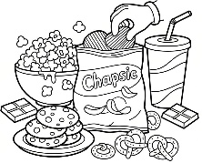  snacks  dinner | pilot  doctor | 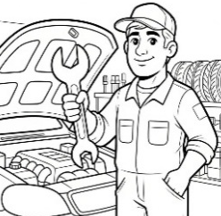  mechanic  teacher | 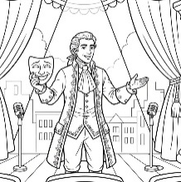  actor  manager | 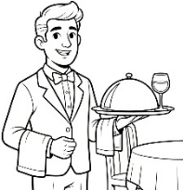  a  vet  waiter | 