

Kingdom of Saudi Arabia

Ministry of Education

……..Education Directorate

………………… School

English Language

elementary Grade …..

period Exam

…………….\20

Student's Name : class:

……\ 4 marks

General questions

**A.Answer the questions**

[](https://t.me/Asmaworld)**1-How many students are there in your school?**

a-About 500 b- sorry c- Littlerock Elementary School.

**2-** **What‘s the matter?**

a-I like pizza. b-I have a stomachache. c-I'm 12 years old.

**3-Which city do you live in?**

a-I'm 11 years old b- I live in Najran c-We bring our own.

**4-Did you drink milk this morning?**

a-Yes, I can b- Yes, I do c-Yes, I drank milk this morning.

……\ 1 marks

Controlled Writing

**A. Choose the correct answer**

|  |  |  |  |
| --- | --- | --- | --- |
| kitchen | bed room | library | 1-The best place in our school is ………… |
| write | book | drink | 2- I should …………a lot of water. |

Reading short sentence

……\ 4 marks

|  |  |  |
| --- | --- | --- |
| Free stomach aches, Download Free stomach aches png images, Free ClipArts  on Clipart Library | 1- I have a headache ( ) | |
| Kids Sports Day clipart | 2- This year I like P.E ( ) |

**A-Put (** ✔ **) or (**  X  **)**

**B.Match**

|  |  |  |
| --- | --- | --- |
| English in class! |  | 1- She has a toothache |
| because she never goes to the dentist. |  | 2-Use |

……\ 4 marks

Grammar

[](https://t.me/Asmaworld)**A-Choose the correct answer.**

1- You should ( do – did – does ) some exercise.

2- Last year we( go - went - goes ) to Riyadh.

3- I didn‘t (brush – brushes – brushed )my teeth this morning.

4-( Who – When - Which )subject do you like most this year?

……\ 5 marks

Vocabulary

**A.write the correct word under each picture**

**( scan – sweater - lamb - science - soda )**

**)**

|  |  |  |  |  |
| --- | --- | --- | --- | --- |
| Free Science Class Cliparts, Download Free Science Class Cliparts png  images, Free ClipArts on Clipart Library | 28 Pepsi Stock Illustrations | Depositphotos |  | Sheep Lamb Watercolor Clipart AI Generated 24637624 PNG | Cartoon knitted hand made autumn sweater. Vector ugly autumn sweater clipart  28003408 Vector Art at Vecteezy |
|  |  |  |  |  |

Orthography

……\ 2 marks

**A. Fill in the missing letters**

ir sq sk ur

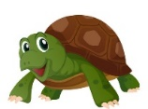

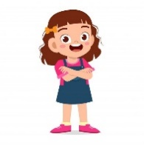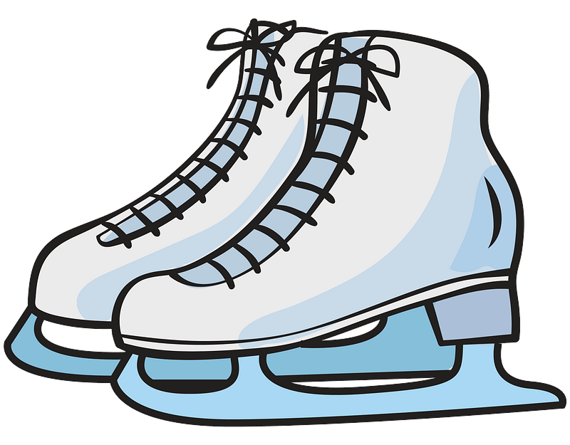

g…..l

….uare

….ate

t….tle

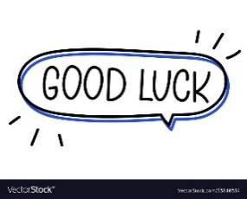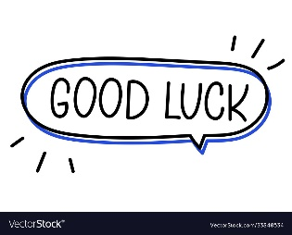

Your teacher:

Your teacher …..:…………………………….

**1- Choose the correct answer:**

|  |
| --- |
|  |
| 2 |

|  |  |  |
| --- | --- | --- |
| **المملكة العربية السعودية** |  | **المادة: انجليزي** |
| **وزارة التعليم** |
| **إدارة التعليم بمنطقة** |
| **مكتب تعليم** | **الزمن : حصة دراسية** |
| **مدرسة :** |
| **اسم المعلم / هـ:** | **20**  **المجموع** |
| **اختبار فتري لغة انجليزية - الفصل الدراسي الثالث – الصف ابتدائي** | | |
| **اسم الطالب / هـ :** | | |

|  |  |
| --- | --- |
| 1. **How many students are there in your school?** | |
| 1. **No, I am not .** | 1. **About 500** | | 1. **I should skip breakfast.** |
| 1. **What should you do to live a healthy life ?** | |
| 1. **I should go to bed early**. | 1. **Yes, he is.** | | 1. **I should skip breakfast.** |

__________________________________________________________________________________

|  |
| --- |
|  |
| **3** |

2- **Read the sentence then choose ☑ or 🗵** :

|  |  |  |
| --- | --- | --- |
| **Our school has a school bus .** | **I shouldn't do some exercise** | **Don't shout** |
|  | Free Exercise Clipart Black And White, Download Free Exercise Clipart Black  And White png images, Free ClipArts on Clipart Library |  |
| **🗸 🗴** | **🗸 🗴** | **🗸 🗴** |

_________________________________________________________________________________

3- **Do as shown between brackets:**

|  |
| --- |
|  |
| **2** |

|  |  |  |  |
| --- | --- | --- | --- |
|  | | | **1- in – live – I - Riyadh . ( rearrange )** |
| **earache** | **toothache** | **headache** | Headache icon hi-res stock photography and images - Alamy  **2– I have a _______**. **( choose )** |

________________________________________________________________________________

4- **Choose the correct word:**

|  |
| --- |
|  |
| **3** |

|  |  |  |  |
| --- | --- | --- | --- |
| **did** | **does** | **do** | **1- Which subject ______ you like this year ?** |
| **got up** | **get up** | **do** | **2- Did you ____ early this morning ?** |
| **plays** | **played** | **was** | **3- The PAST of ( play ) is ____** |

5- **Choose the right word under its picture:**

|  |
| --- |
|  |
| **5** |

|  |  |  |  |  |
| --- | --- | --- | --- | --- |
| Black And White Cartoon Math Symbols Stock Illustration - Download Image  Now - Bizarre, Book, Clip Art - iStock |  |  | Kid, Little Boy, Get Pain At Toothache. Vector Illustration Character,  Outline Hand Draw Style, Sketching, Doodle, Cartoon Design. Royalty Free  SVG, Cliparts, Vectors, And Stock Illustration. Image 82344304. | Vintage Clipart 159 Cartoon Man Listening To His Right Stock Illustration -  Illustration of monochrome, white: 177149499 |
| **Math** | **Science** | **stomachache** | **Headache** | **Don't shout** |
| **English** | **PE** | **earache** | **toothache** | **Listen** |

_____________________________________________________________________________________________

6- **Fill in the missing letters:**

|  |
| --- |
|  |
| **5** |

|  |  |  |  |  |
| --- | --- | --- | --- | --- |
| Cartoon Cute Bird Isolated On White Background Stock Vector Image by  ©Aratehortua #177005352  **b_ _ d** | 2,200+ Black And White Scarves Illustrations, Royalty-Free Vector Graphics  & Clip Art - iStock  **_ _arf** | Free Square Clipart & Cartoon｜Illustoon  **_ _uare** | Hand Drawn Women Skirt Doodle Isolated On White Background Stock  Illustration - Download Image Now - iStock  **_ _ irt** | Pin em Free Clipart Download  **b_ _ger** |
| **ur** | **sk** | **sq** | **sk** | **ar** |
| **ir** | **sc** | **sk** | **sc** | **ur** |

_______________________________________________________________________________

Good luck

### The Grade



|  |  |  |  |  |  |
| --- | --- | --- | --- | --- | --- |
| **الاسم ثلاثي:** |  | **الفصل** | **/** | **الدرجة** |  |

Unit 1& 2 Exam

|  |  |  |  |  |  |  |  |  |  |  |
| --- | --- | --- | --- | --- | --- | --- | --- | --- | --- | --- |
| **I. CHOOSE**   |  |  | | --- | --- | | 1. **How many students are there in your school?** | | | 1. No, I am not . | 1. About 500 | | | 1. **What should you do to live a healthy life ?** | | | 1. I should go to bed early. | 1. I should skip breakfast. | | |
| 222  **II. CHOOSE 🗸 OR 🗴**   |  |  |  | | --- | --- | --- | | Our school has a school bus . | I shouldn't do some exercise . | Don't shout | |  |  |  | | **🗸 🗴** | **🗸 🗴** | **🗸 🗴** | |
| **III. DO AS SHOWN BETWEEN BRACKETS**     |  |  |  |  | | --- | --- | --- | --- | | **...................................................................................................** | | | **1- in – live – I - Riyadh . ( rearrange )** | | earache | toothache | headache | **2– I have a _______**. **( choose )** | |
| |  |  |  |  | | --- | --- | --- | --- | | **did** | **does** | **do** | **1- Which subject ______ you like this year ?** | | **got up** | **get up** | **do** | **2- Did you ____ early this morning ?** | | **plays** | **played** | **was** | **3- The PAST of ( play ) is ____** |   **IV. CHOOSE** |
| |  |  |  |  |  | | --- | --- | --- | --- | --- | |  |  |  |  |  | | Math | Science | stomachache | Headache | Don't shout | | Engilsh | PE | earache | toothache | Listen |   **V. CHOOSE** |
| |  |  |  |  |  | | --- | --- | --- | --- | --- | | b_ _ d | _ _arf | _ _uare | _ _ irt | b_ _ger | | ur | sk | sq | sk | ar | | ir | sc | sk | sc | ur |   **VI. CHOOSE THE CORRECT LTTER** |
| **TEACHER :** |

### The Grade



|  |  |  |  |  |  |
| --- | --- | --- | --- | --- | --- |
| **الاسم ثلاثي:** |  | **الفصل** | **/** | **الدرجة** |  |

Unit 1 Exam

|  |  |  |  |  |  |  |  |  |  |  |
| --- | --- | --- | --- | --- | --- | --- | --- | --- | --- | --- |
| **I. CHOOSE**   |  |  | | --- | --- | | 1. **How many students are there in your school?** | | | 1. No, I am not . | 1. About 500 | | | 1. **What time does your school start?** | | | 1. It starts at 6:30. | 1. Yes, he is. | | |
| 222  **II. CHOOSE 🗸 OR 🗴**   |  |  |  | | --- | --- | --- | | Our school has a school bus . | This year I like math . | Don't shout | |  |  |  | | **🗸 🗴** | **🗸 🗴** | **🗸 🗴** | |
| **III. DO AS SHOWN BETWEEN BRACKETS**     |  |  |  |  | | --- | --- | --- | --- | | **...................................................................................................** | | | **1- in – live – I - Riyadh . ( rearrange )** | | **Listen** | **Speak** | **Do** | **2– ____ English in class .( choose )** | |
| |  |  |  |  | | --- | --- | --- | --- | | **did** | **does** | **do** | **1- Which subject ______ you like this year ?** | | **went** | **goes** | **go** | **2- Last year we ______ to Abha .** | | **were** | **are** | **was** | **3- The PAST of ( are ) is ____** |   **IV. CHOOSE** |
| |  |  |  |  |  | | --- | --- | --- | --- | --- | |  |  |  |  |  | | Math | Science | History | Social studies | Don't shout | | Engilsh | PE | Language | art | Listen |   **V. CHOOSE** |
| |  |  |  |  |  | | --- | --- | --- | --- | --- | | _ _ y | _ _arf | _ _uare | _ _ irt | _ _an | | sk | sk | sq | sk | sq | | sc | sc | sk | sc | sc |   **VI. CHOOSE THE CORRECT LTTER** |
| **TEACHER :** |

