1. Write can or can't :
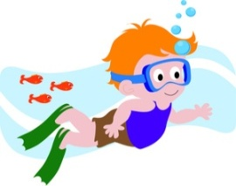
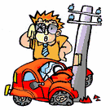
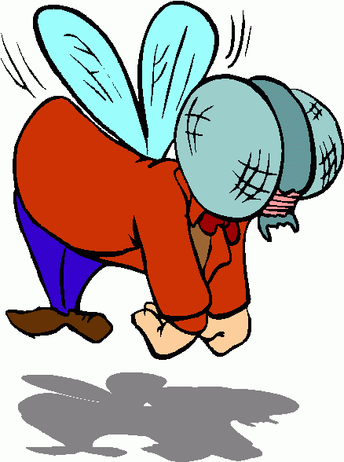
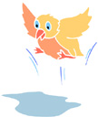

it can fly . he _____ fly. he _______ drive. he _______ swim.
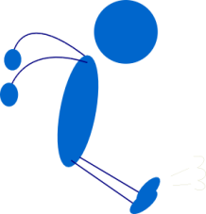

he _____ climb a tree . she _____ run . he ______ jump .

2. Look and write the answers into the bubbles:
______________________
______________________

Can / swim / He not / can / I /touch
______________________
______________________

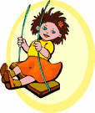
Play / I /can /tennis She /swing /can

Miss :

