We Can! Book 4 Unit 1: Wild Animals

1. Listen and match pictures and words. Number the words.
[Play CD2 03 or read.]
7 chimpanzee | 12 koala | 3 ostrich | 4 lion
6 elephant | 8 hippo | 10 snake | 1 giraffe
11 kangaroo | 2 zebra | 13 iguana | 14 polar bear
5 hyena | 15 tiger | 9 rhinoceros

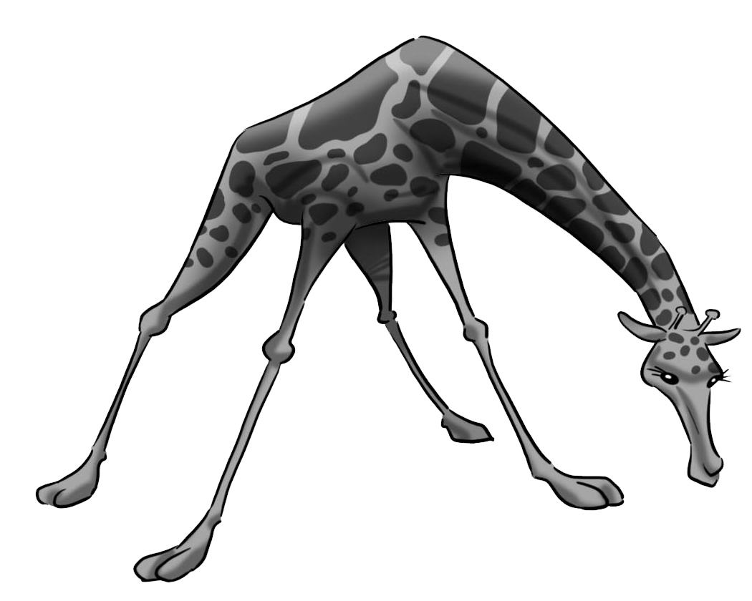  1. | 2. 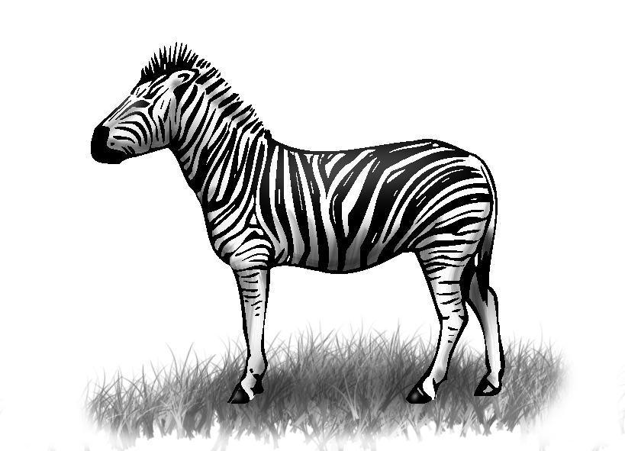 | 3. 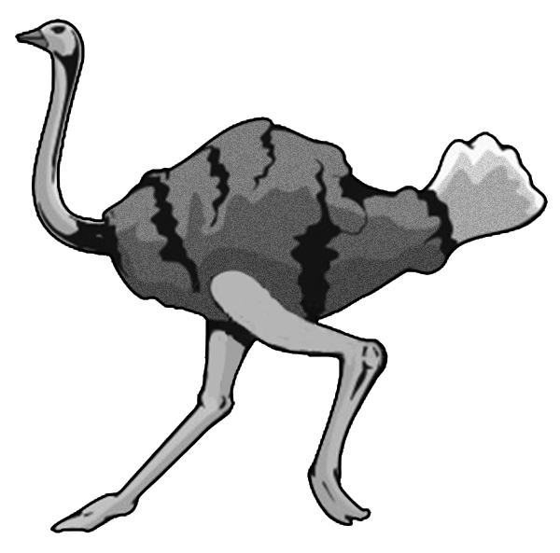
4. 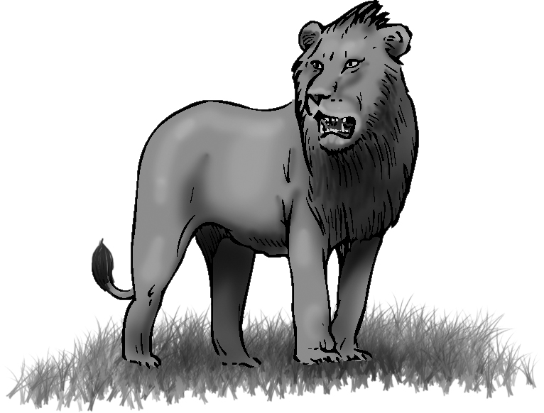 | 5. 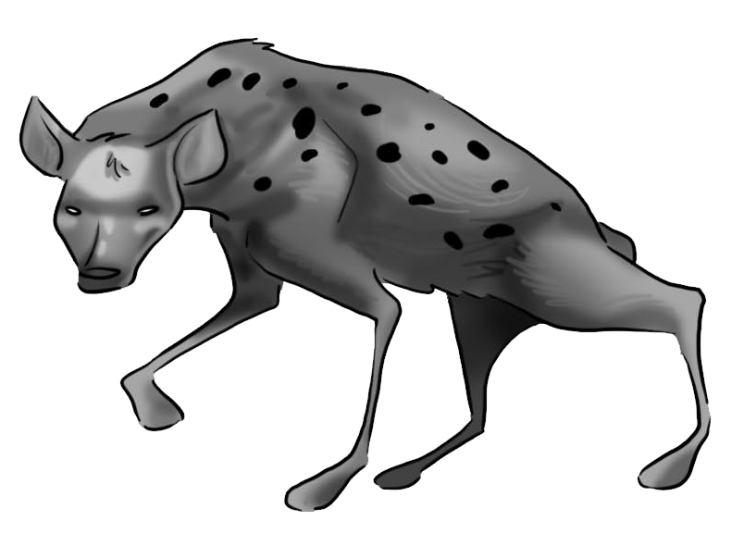 | 6. 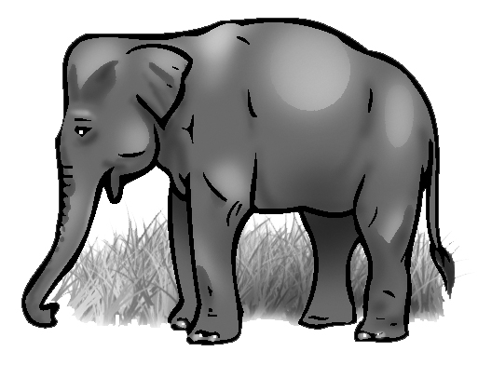
7. 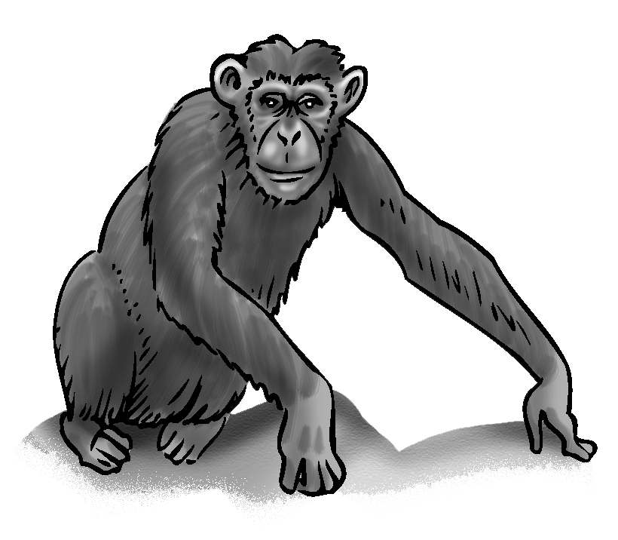 | 8. 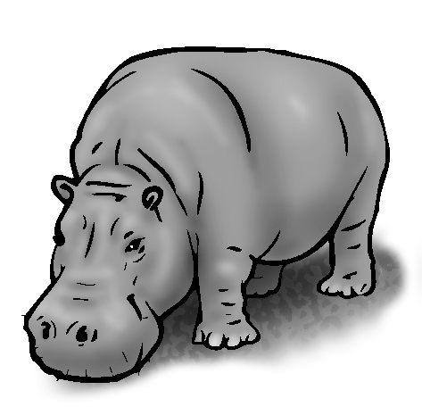 | 9. 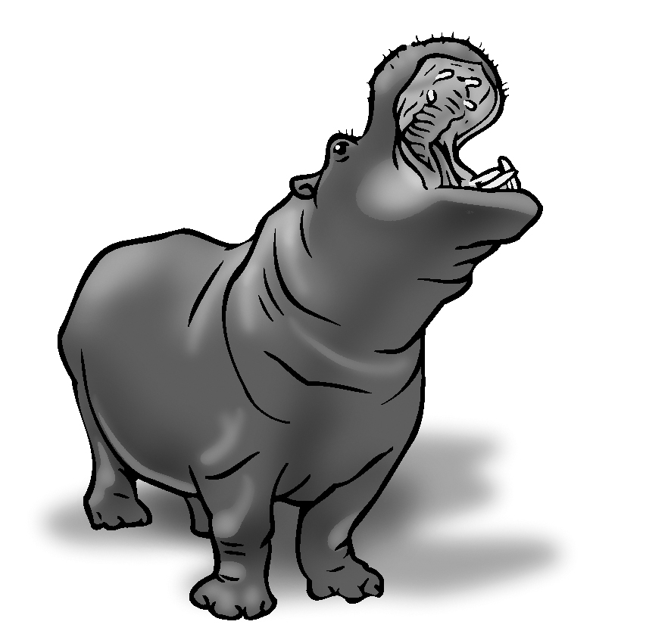
10. 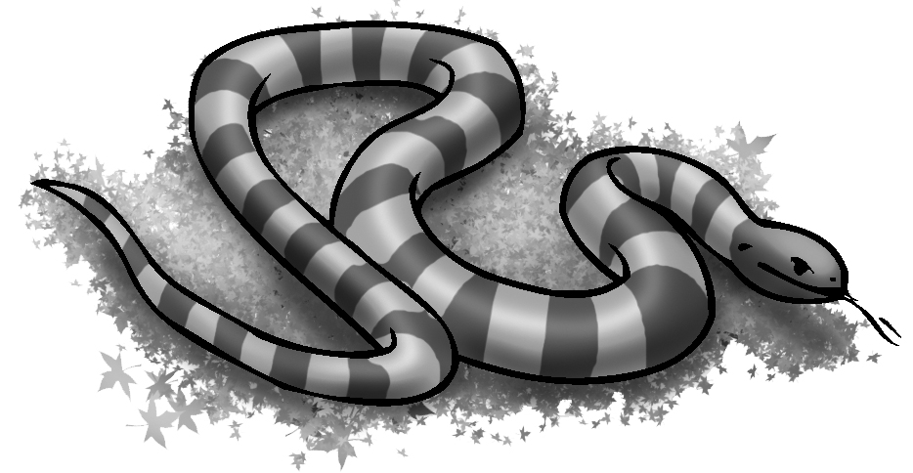 | 11. 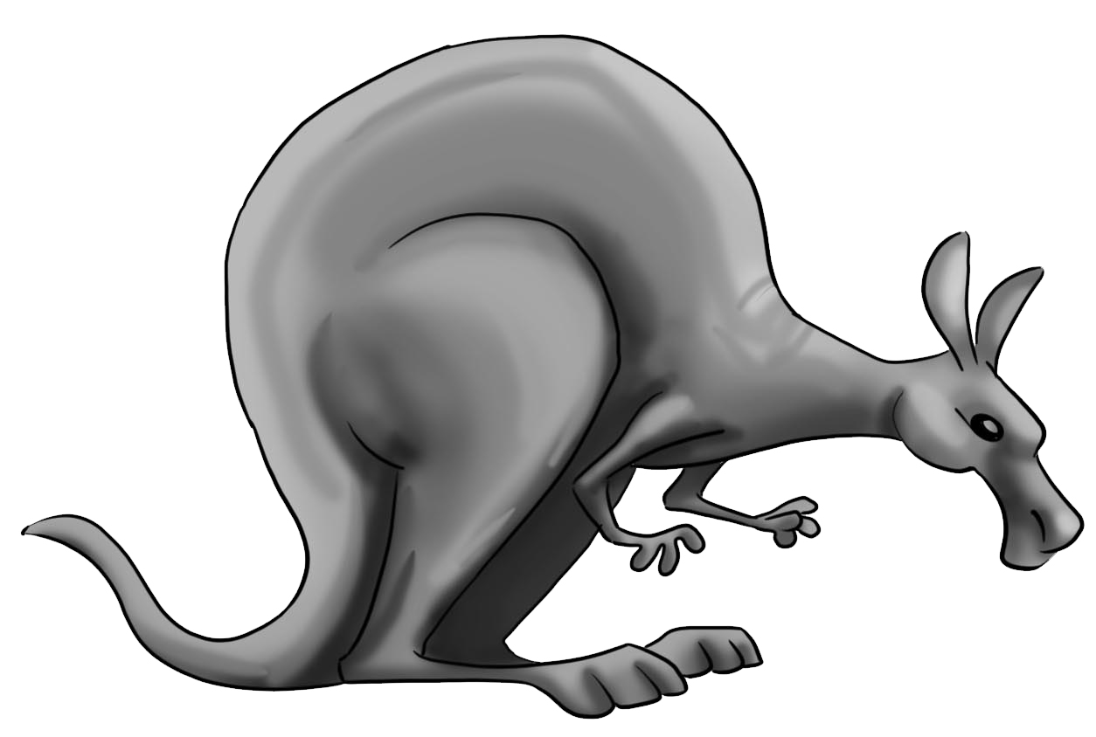 | 12. 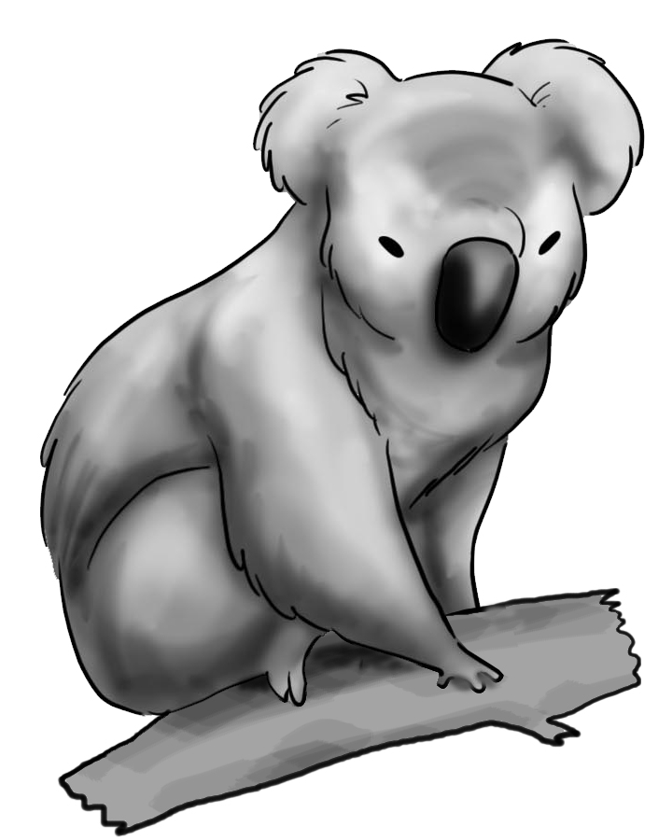
13. 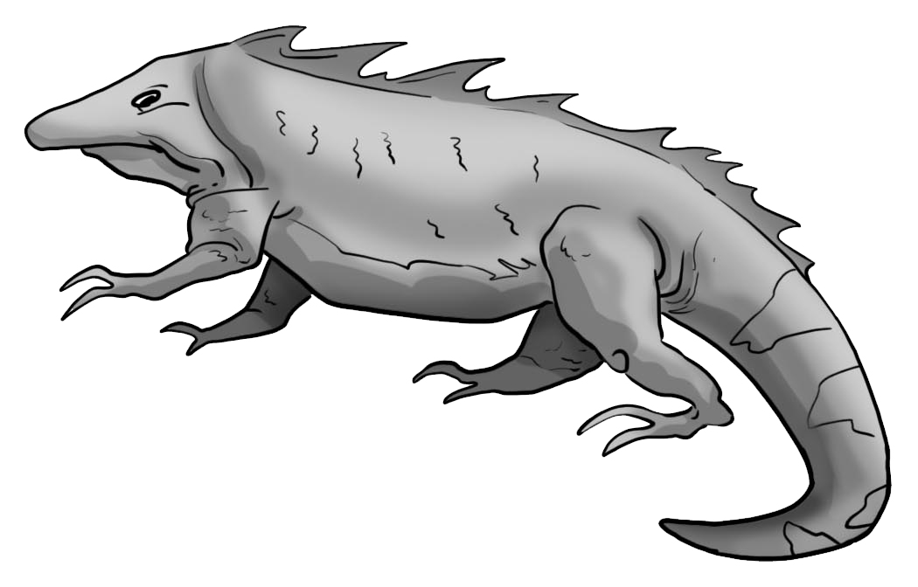 | 14. 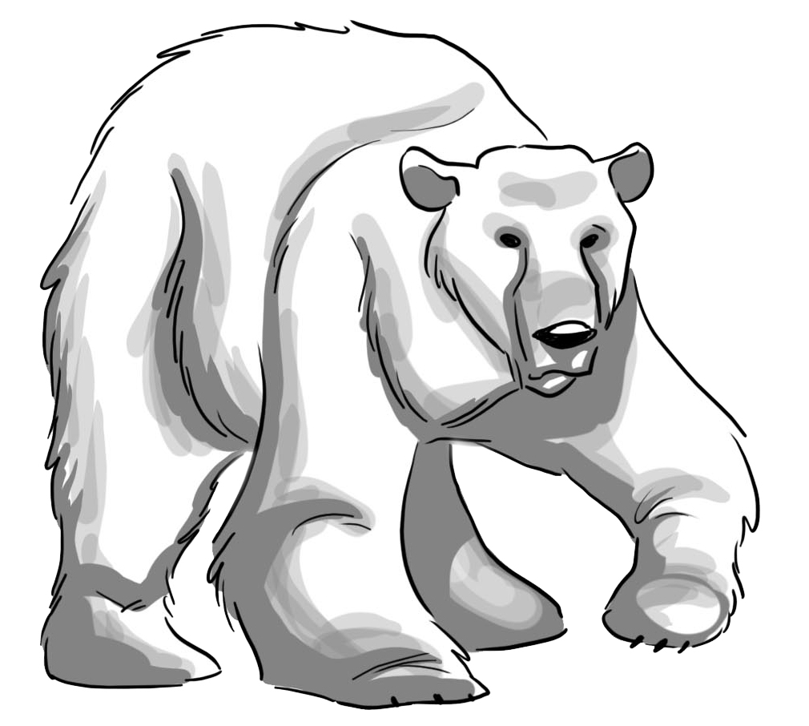 | 15. 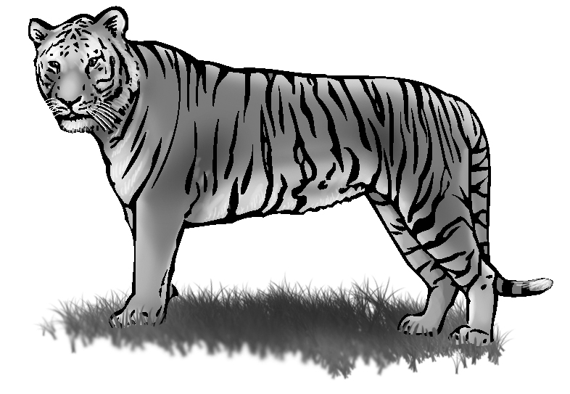
2. Listen and write about the animals. Use these words.
[Play CD1 07 or read.]
big / trunks black and white/ stripes scary/ big teeth

smart/ long arms long/ no arms or legs fat/ big mouths.

1. Elephants are big.  They have big trunks. | 2. Zebras are black and white.They have stripes.
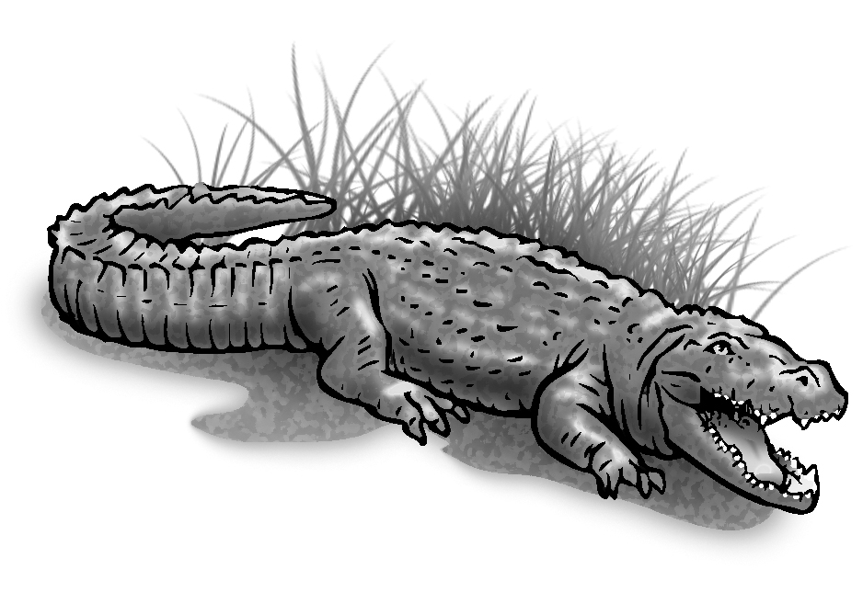  3. Crocodiles are scary.  They have big teeth. | 4. Chimpanzees are smart. They have long arms.
5. Snakes are long.  They have no arms or legs. | 6. Hippos are fat.  They have big mouths.
3. Read and answer. Check √ YES or NO. Then write.

Can kangaroos jump?  Can kangaroos fly? | YES √ NO  YES NO √
Can crocodiles fly?  Can crocodiles swim? | YES NO √  YES √ NO

Kangaroos can jump but they can’t fly.
Crocodiles can swim but they can’t fly.

