**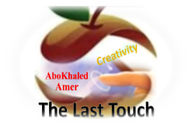****المملكة العربية السعودية**

**Kingdom of Saudi Arabia**

**Ministry of Education**

**------- Educational Directorate**

**------- Future Educational Schools**

**3rd grade intermediate 2022**

**3rd Term – Final Exam**

**وزارة التعليم**

**الإدارة العامة للتعليم بن**

**مدارس م ن التعليمية**

**الصف الثالث المتوسط**

**الاختبار النهائي للفصل الدراسي الثالث1445**

|  |  |  |  |  |  |  |  |
| --- | --- | --- | --- | --- | --- | --- | --- |
| **Total**  **written** | **5 spelling** | **4 Vocabulary** | **3 Grammar** | **2 Comprehension** | | **1 Composition** | **Q. NO.** |
|  |  |  |  |  | |  | **Mark Given** |
| **30** | **4** | **7** | **7** | **6** | | **6** | **Mark** |
|  | | | **Reviser** | |  | | **Corrector** |
|  | |

**زمن الاختبار: ساعتان**

**اسم الطالب: ------------------------------------ رقم الجلوس: ------------- الصف الثالث المتوسط**

**6**

1) **Composition**

**1- Write a paragraph about “Your Favorite Place "**

**You may use these words: Abha – last summer – family – shopping – friends - …**

…………………………………………

………………………………………………………………………………………………………………………………………………………………………………………………………………………………………………………………………………………………………………………………………………………………………………………………………………………………………………………………………………………………………………………………………………………………………………………………………………………………….

**2) Comprehension**

**6**

**2- Read the following passage then answer the questions:**

**Culture Shock**

**Standing in a line at checkout counters at the supermarket. Listening to people talking on phones in restaurants. It's annoying. When people talk on their cell phones and drive. Rushing to phone and out it's a telemarketer who's calling. People who lost weight now and try to control what others eat. People who are always late, and don't apologize. When salespeople try talk you into buying something you don't want or need. People who don't say "Please" or "Thank you". When people enter a door or an elevator and don't hold it open for the others who are right behind them. I can't stand people who chew with their mouths. People who borrow stuff without give it back. People who don’t give up their subway or bus to seats seniors or to those with disabilities.**

**A- Put ( ) or ( x ):**

**1.Listening to people talking on cellphones in restaurants is annoying. ( )**

**2. People who are always late, and don't apologize is good. ( )**

**3. People who don't say "Please" or "Thank you" is good. ( )**

**4.It's bad when people talk on their phone while driving. ( )**

**5. We should give up our seats to people with disabilities. ( )**

**B- Choose the correct answer:**

**1. Standing in a (**lion – line – lone**) at the supermarket is good.**

**2. People who don't hold the (**elevator – escalator – book**) door.**

**3. "Call up" means (**phone – learn – let someone have**).**

**4. "Give back" means (**phone – learn - return**).**

**C- Answer the following questions:**

**1. What we should do at the supermarket?........................**

**2. Is it OK you chew with your mouth open?.........................**

**3. What should you do when you borrow a stuff? .................**

**3) Grammar**

**A: Choose the correct answer:**

**7**

**1. A rude person is someone (**who – which - where**) isn't polite.**

**2. While I (**watched – watching – was watching**) TV, my mom was cooking lunch.**

**3. She hasn't cleaned her room (**just – already – yet**).**

**4. We enjoy (**watched – watching – watches**) movies with our friends.**

**5. Your shoes are dirty. Please, take (**it – us – them**) off.**

**6. If you help me, I (**thanked – thanks – will thank**) you.**

**7. I choose to (**eats – eating – eat**) burger for lunch.**

**8. (**Swim – Swims – Swimming**) is my favorite sport.**

**B: Chang into Negative:**

**1. It is a good idea to work at night.**

…………………………………………………………………………………………………………………………………………………………………………………………………………………

**2. He was making the bed.**

……………………………………………………………………………………………………………………………………

3. **I have helped my little brother.**

……………………………………………………………………………………………………………………………………

**C: Make Yes/No question:**

**1. They will set the table.**

……………………………………………………………………..……………………………………………………………

**2. He was helping the lady.**

……………………………………………………………………………………………………………………………………

**3. She has studied English.**

……………………………………………………………………………………………………………………………………

**4) vocabulary:**

**7**

**A- Match the words with the pictures:**

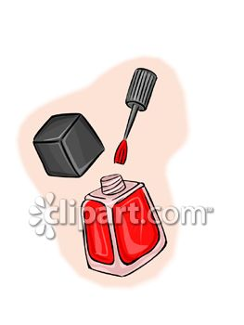**chopsticks – airshow – nail polish – garbage – police officer – gold fish**

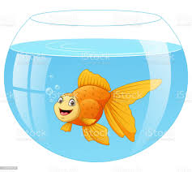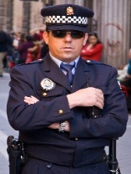



**……………. ……………. ……..……. ………..…… …………… …………..**

**B- Match the answers:**

|  |  |
| --- | --- |
| a. thief | **1. A talkative person is someone who -------** |
| b. ticket | **2. He tried to steal the boy's backpack; he is a ---------** |
| c. speaks a lot | **3. He was driving so fast, so he took a ----------** |
| d. No kidding | **4. When you are undecided, you are ----------** |
| e. up in the air | **5. When you are surprised and can't believe, you say ------** |

**C- Circle the correct spelling:**

**1. scissors - sicossrs – sicorsses**

**2. chioces – choices - shoices**

**3. geust – guset – guest**

**5) Orthography**:

**4**

**A- Fill in the missing letters:**

**1- wat__h**

**o – m – t – c – f**

**2- mirr__r**

**3- environ__ent**

**4- cus__oms**

**B- Choose the odd one out:**

**1. athletic clever friendly book**

**2. thief police officer work guide**

**3. done go eaten gotten**

**4. pedal cab taxi bus doctor**

**End of Questions**

**Best of Luck https://t.me/abokhaledamer**