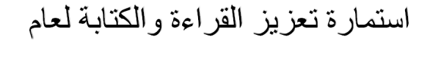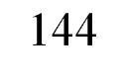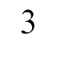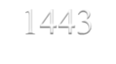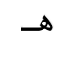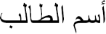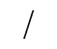هـ1443 / / : التاريخ
المملكة العربية السعودية وزارة التعليم
مدارس سما الينابيع األهلية رياض أطفال - ابتدائي

............................................: اليوم

تصويب الخطأ | اسم المعلمة | المادة | النص الكتابي | الحصة
...........................................................................................  ........................................................................................... | .......................................... | ...................................... | ............................................................................................ .............................................................................................................................  ....................................................................................................................................................................................................................... | 1
...........................................................................................  ........................................................................................... | ................................................. | ...................................... | .........................................................................................................................................................................................................................  .......................................................................................... ............................................................................................................................. | 2
...........................................................................................  ........................................................................................... | ................................................. | .................................... | .........................................................................................................................................................................................................................  ........................................................................................................... ............................................................................................................ | 3
...........................................................................................  ........................................................................................... | ................................................. | ...................................... | ............................................................................................ .............................................................................................................................  ....................................................................................................................................................................................................................... | 4

اليوم
هـ1443 /
/
التاريخ :
............................................................ :

تصويب الخطأ | اسم المعلمة | المادة | النص الكتابي | الحصة
...........................................................................................  ........................................................................................... | .......................................... | ..................................... | ............................................................................................ .............................................................................................................................  .......................................................................................... ............................................................................................................................. | 1
...........................................................................................  ........................................................................................... | ................................................. | ...................................... | .........................................................................................................................................................................................................................  .......................................................................................... ............................................................................................................................. | 2
...........................................................................................  ........................................................................................... | ................................................. | .................................... | ............................................................................................ .............................................................................................................................  ....................................................................................................................................................................................................................... | 3
...........................................................................................  ........................................................................................... | ................................................. | ...................................... | .........................................................................................................................................................................................................................  .......................................................................................... ............................................................................................................................. | 4

