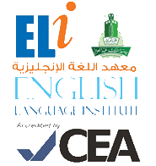

**Grammar and**

**Vocabulary Practice**

**101**

**رؤية جامعة الملك عبد العزيز**

**منارة في المعرفة**

**تكامل في التكوين**

**ريادة في التنمية**

**رسالة جامعة الملك عبدالعزيز**

**الرقي بالمجتمع عبر تميز ثقافي و علمي و بحثي رائد**

**Student’s Name:** _____________________ **Level:** 101 **Section:** ____________

1. **Grammar Section (Units 4 & 5)**

**Fill in the blanks to complete the sentences. Use the words in the box below:**

read Do have sings Does watches travel drinks walk eats don't doesn't

1. John ________________ breakfast at six o’clock in the morning.
2. I often ________________ books in my free time.
3. **A.** ________________ you like to study English? **B.** Yes, I do.
4. My sister always ________________ songs loudly.
5. **A.** Does Julie work on Saturdays? **B.** No, she ________________.
6. Do you want to ________________ to London next holiday?
7. I live close to my company, so I can ________________ to work.
8. Mr. Smith always ________________ tea in the afternoon.
9. My father ________________ his favorite TV show every evening.
10. I’m sorry. I ________________ have time to talk to you.
11. **A.** ________________ your cousin have a job? **B.** Yes, she does.
12. I don’t ________________ a pen. Can I borrow yours?

**Choose the correct answers:**

1. Dalia (cooking – cooks – cook – cooked) on Wednesday sometimes.
2. Mona and I (cook – cooks – cooking – cooked) every Friday.
3. Sam (washing – washes – wash – washed) his car every Sunday.
4. They usually (cleans – clean – cleaning – cleaned) their house.
5. She (don’t study – doesn’t study – doesn’t studies – doesn't studying) English on Thursday.
6. Thomas (studys – studies – study – study's) math on Friday.
7. Rickie never (plays – play – don’t play – playing) golf and tennis.
8. We always (goes – go – going – gone) shopping with our parents.
9. Kim likes to (read – reading – reads – has read) books.
10. Richard and David (don’t read – doesn’t read – no reads – read never) the newspaper.
11. **Vocabulary Section (Unit 2)**

**Look at the family tree and complete the sentences:**

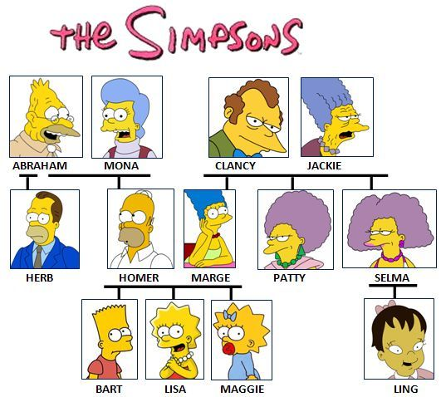

1. My name's Lisa. My _______________’s name is Homer and my _______________'s name is Marge.
2. Our mum’s mum is Jackie. She's our _______________.
3. My dad and Herb are brothers. Herb's my _______________.
4. I'm Maggie. Patty is my mum's sister. She's my _______________.
5. Lisa and Maggie are _______________. Bart is their _______________.
6. My mum is Ling's aunt, and she's my _______________.