**المملكة العربية السعودية**

**Kingdom of Saudi Arabia**

**Ministry of Education**

**------- Educational Directorate**

**------- Future Educational Schools**

**2nd Grade High School 2022**

**2nd Term – Final Exam**

**وزارة التعليم**

**الإدارة العامة للتعليم بن**

**مدارس م ن التعليمية**

**الصف الثاني الثانوي**

**الاختبار النهائي للفصل الدراسي الثاني1445هـ**

|  |  |  |  |  |  |  |  |
| --- | --- | --- | --- | --- | --- | --- | --- |
| **Total**  **written** | **5**  **Vocabulary** | **4**  **Grammar** | **3**  **Free Composition** | **2**  **Guided Composition** | | **1 Comprehension** | **Q. NO.** |
|  |  |  |  |  | |  | **Mark Given** |
| **30** | **6** | **6** | **6** | **6** | | **6** | **Mark** |
| **6** | | | **Reviser** | |  | | **Corrector** |
|  | |

**زمن الاختبار: 3 ساعات**

**اسم الطالب: ------------------------------------ رقم الجلوس: ------------- الصف الثاني الثانوي**

**1.Comprehension**

**Read the following passage then answer the questions**

**The Benefits of Exercise**

**Getting regular exercise is good for you. Everyone knows that. But, then why doesn't everyone exercise? Some people say they don't have enough time because they are busy with work, school, and family obligations. However, making time for some exercise should be a priority for everyone. The following are just a few of the reasons why:**

**1) Exercising makes you feel good. When you have a bad day, or you feel stressed or angry about something, a little exercise can help you relax and improve your mood. Also, getting regular exercise can help prevent depression.**

**2) Physical exercise helps prevent some diseases such as high blood pressure, diabetes, and certain types of cancer. A walk a day can help keep you healthy!**

**3) Exercising helps you maintain a healthy weight and keeps you strong.**

**4) Exercising gives you more energy. You will feel less tired during the day if you are physically stronger and more active.**

**5) Exercising helps you sleep better. If you have been active during the day, you sleep better. And when you have slept better at night, you feel better during the day.**

**6) Find an activity that you enjoy. You don't have to go to the gym. You can go for a walk or a hike. Whenever you are active, you are doing something good for both your physical and mental health.**

***A)* Answer the following questions*:*  
1. What is the passage about? ----------------------------------------------------------------------------.**

**2. Does exercising help you sleep better? -------------------------------------------------------------.**

**3. Why do some people say they don't have enough time? -------------------------------------------.**

**4. What can you do if you don’t go to the gym? -------------------------------------------------------.**

***B)* Put ( √ ) or ( X ):  
5. Exercising helps you to keep strong. ( )**

**6. Exercising is good for both your physical and mental health. ( )**

**7. Cancer is a kind of disease. ( )**

**8. Exercising doesn't make you feel good. ( )  
*C)* Complete*:*  
9. Exercising gives you more** -------------------------.

**10. Physical exercise helps prevent some** ------------------------------.

**D) Choose the correct answer:**

**11. Getting regular exercise can help prevent (**happiness **–** depression – devasted – drown**)**

**12. The underlined word “they" refers to: (** school – exercise – work – people )

**2) Guided Composition**

**6**

**Playing sports is a must to keep fit.**

**Write a paragraph about “ Your Favorite Sport”:**

**You many use the guiding words:**

Favorite – club – gym – friends – free time – build muscles – keep fit – feel happy

-------------------------------------------------------

-------------------------------------------------------------------------------------------------------------------------------------------------------------------------------------------------------------------------------------------------------------------------------------------------------------------------------------------------------------------------------------------------------------------------------------------------------------------------------------------------------------------------------------------------------------------------------------------------------------------------------------------------------------------------------------------------------------------------------------------------------------------------------------------------------------------------------------------------------------------------------------------------------------------------------------------------------------------------------------------------------------------------------------------------------------------------------------------------------------------------------------------------------------------------------------------------------------------------------------------------------------------------------------------

**3) Free Composition**

**6**

**Choose one topic from the following to write about.**

**1. Recycling is a must to keep our environment clean**

**2. Write a paragraph about "Your Dream House" in which you describe which kind of you want to live in, where, who live with, …**

-------------------------------------------------------

---------------------------------------------------------------------------------------------------------------------------------------------------------------------------------------------------------------------------------------------------------------------------------------------------------------------------------------------------------------------------------------------------------------------------------------------------------------------------------------------------------------------------------------------------------------------------------------------------------------------------------------------------------------------------------------------------------------------------------------------------------------------------------------------------------------------------------------------------------------------------------------------------------------------------------------------------------------------------------------------------------------------------------------------------------------------------------------------------------------------------------------------------------------------------------------------------------------------------------------------------------------------------------------------

**4) Grammar**

**6**

**A: Choose the correct answer:**

**1. The manager insisted that he (** worked – works – work – working **) late.**

**2. Quit (** using – to use – used – use **) disposable batteries.**

**3. She is not (** enough tall – tall enough – tall too – tall so **) to reach the shelf.**

**4. (** Not Warming – Not warm – Not warms – Not warmed **) up is bad.**

**5. This is the (** most – more – less – many **) exciting sporting event.**

**6. I want you (** opened – opening – open – to open **) the window.**

**B- Do as shown between brackets:**

**1. you / applying for the job / to consider / I’d like (**Unscramble**)**

-------------------------------------------------------------------------------.

**2. to buy – a hybrid – Do they – car? – intend (**Unscramble**)**

----------------------------------------------------------------------------.

**3. I bought (yellow – big – Japanese – expensive) car. (**Reorder the adjectives**)**

-------------------------------------------------------------------.

**4. She is short to play basketball. (**Use**: too)**

---------------------------------------------------------------------------.

**5. Ali is the nicest boy I (see). (**Correct in present perfect**)**

--------------------------------------------------------------------------------.

**6. (Swim) uses more muscles of the body. (**Correct**)**

---------------------------------------------------------------------------.

**5) vocabulary:**

**6**

**A- Match the words with the pictures:**

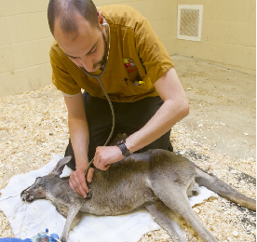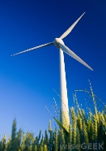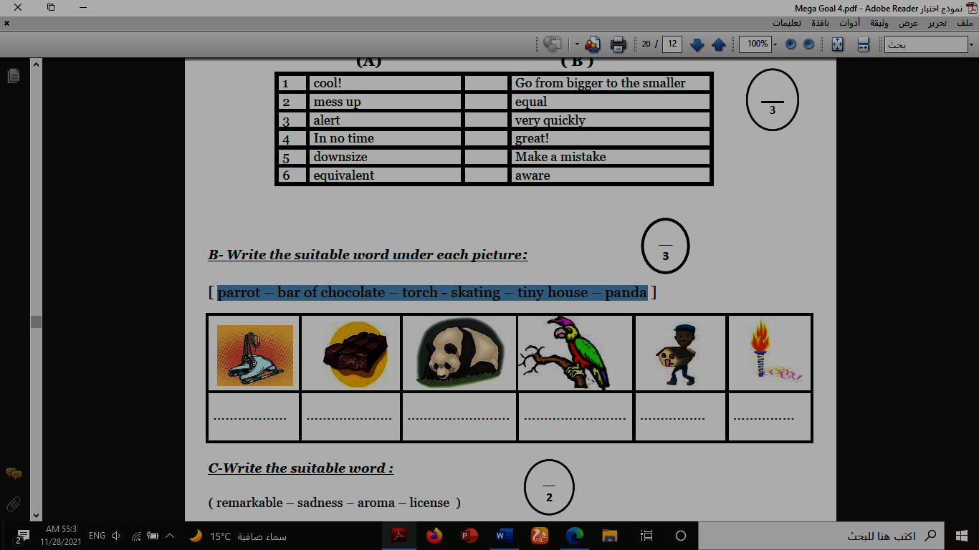**1.recycle 2.torch 3.zoologist 4.medal 5.canyon 6.windmill**

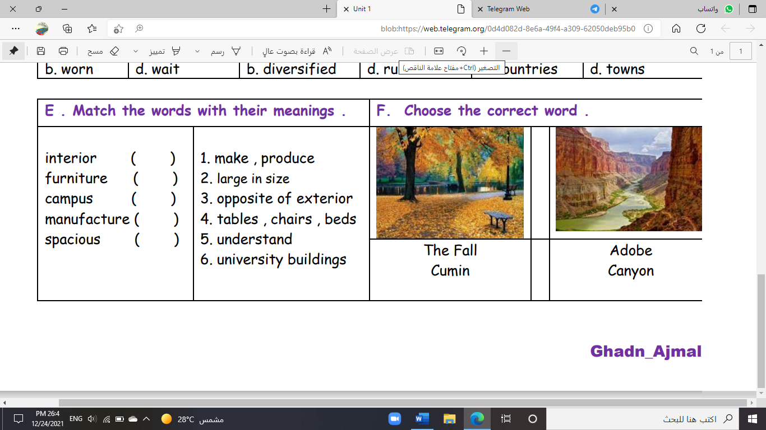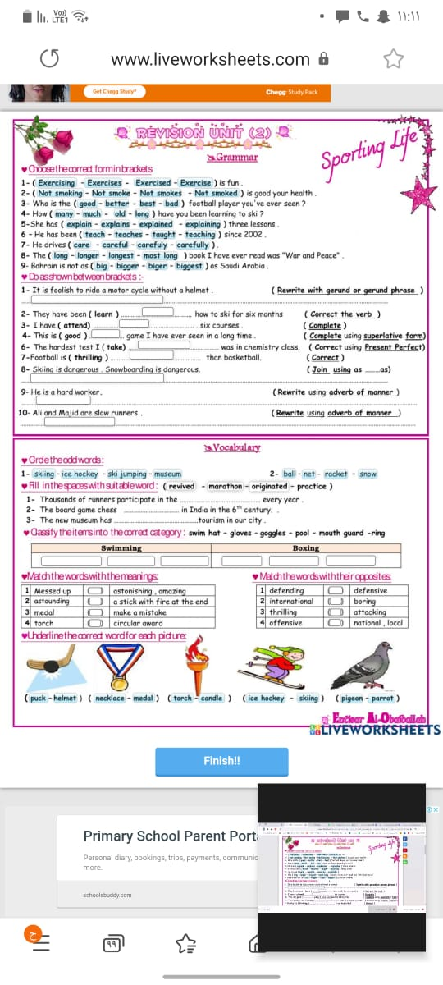

**( ) ( ) ( ) ( ) ( ) ( )**

**B- Match to form new words or expressions:**

**1. satisfaction ------ a. take one’s place, often in work**

**2. cover ------ b. feeling of contentment**

**3. a piece of cake ------ c. without a soul**

**4. cool ------ d. ready for**

**5. soulless ------ e. very easy**

**6. up for ------ f. great**

**End of Questions**

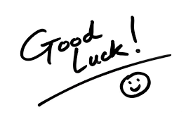**Best of Luck** [**https://t.me/abokhaledamer**](https://t.me/abokhaledamer)

**المملكة العربية السعودية**

**Kingdom of Saudi Arabia**

**Ministry of Education**

**------- Educational Directorate**

**------- Future Educational Schools**

**2nd Grade High School 2022**

**2nd Term – Final Exam**

**وزارة التعليم**

**الإدارة العامة للتعليم بن**

**مدارس م ن التعليمية**

**الصف الثاني الثانوي**

**الاختبار النهائي للفصل الدراسي الثاني1445هـ**

|  |  |  |  |  |  |  |  |
| --- | --- | --- | --- | --- | --- | --- | --- |
| **Total**  **written** | **5**  **Vocabulary** | **4**  **Grammar** | **3**  **Free Composition** | **2**  **Guided Composition** | | **1 Comprehension** | **Q. NO.** |
|  |  |  |  |  | |  | **Mark Given** |
| **30** | **6** | **6** | **6** | **6** | | **6** | **Mark** |
| **6** | | | **Reviser** | |  | | **Corrector** |
|  | |

**زمن الاختبار: 3 ساعات**

**اسم الطالب: ------------------------------------ رقم الجلوس: ------------- الصف الثاني الثانوي**

**1.Comprehension**

**Read the following passage then answer the questions**

**The Benefits of Exercise**

**Getting regular exercise is good for you. Everyone knows that. But, then why doesn't everyone exercise? Some people say they don't have enough time because they are busy with work, school, and family obligations. However, making time for some exercise should be a priority for everyone. The following are just a few of the reasons why:**

**1) Exercising makes you feel good. When you have a bad day, or you feel stressed or angry about something, a little exercise can help you relax and improve your mood. Also, getting regular exercise can help prevent depression.**

**2) Physical exercise helps prevent some diseases such as high blood pressure, diabetes, and certain types of cancer. A walk a day can help keep you healthy!**

**3) Exercising helps you maintain a healthy weight and keeps you strong.**

**4) Exercising gives you more energy. You will feel less tired during the day if you are physically stronger and more active.**

**5) Exercising helps you sleep better. If you have been active during the day, you sleep better. And when you have slept better at night, you feel better during the day.**

**6) Find an activity that you enjoy. You don't have to go to the gym. You can go for a walk or a hike. Whenever you are active, you are doing something good for both your physical and mental health.**

***A)* Answer the following questions*:*  
1. What is the passage about? --------- The Benefits of Exercise ---------.**

**2. Does exercising help you sleep better? ------Yes, it does. ---------------------------.**

**3. Why do some people say they don't have enough time?**

**-- because they are busy with work, school, and family obligations.--.**

**4. What can you do if you don’t go to the gym? - You can go for a walk or a hike. ---.**

***B)* Put ( √ ) or ( X ):  
5. Exercising helps you to keep strong. ( √ )**

**6. Exercising is good for both your physical and mental health. ( √ )**

**7. Cancer is a kind of disease. ( √ )**

**8. Exercising doesn't make you feel good. ( X )  
*C)* Complete*:*  
9. Exercising gives you more** --- **energy** ----.

**10. Physical exercise helps prevent some** --- **diseases**---.

**D) Choose the correct answer:**

**11. Getting regular exercise can help prevent (**happiness **– depression** – devasted – drown**)**

**12. The underlined word “they" refers to: (** school – exercise – work – **people** )

**2) Guided Composition**

**6**

**Playing sports is a must to keep fit.**

**Write a paragraph about “ Your Favorite Sport”:**

**You many use the guiding words:**

Favorite – club – gym – friends – free time – build muscles – keep fit – feel happy

-------------------------------------------------------

-------------------------------------------------------------------------------------------------------------------------------------------------------------------------------------------------------------------------------------------------------------------------------------------------------------------------------------------------------------------------------------------------------------------------------------------------------------------------------------------------------------------------------------------------------------------------------------------------------------------------------------------------------------------------------------------------------------------------------------------------------------------------------------------------------------------------------------------------------------------------------------------------------------------------------------------------------------------------------------------------------------------------------------------------------------------------------------------------------------------------------------------------------------------------------------------------------------------------------------------------------------------------------------------

**3) Free Composition**

**6**

**Choose one topic from the following to write about.**

**1. Recycling is a must to keep our environment clean**

**2. Write a paragraph about "Your Dream House" in which you describe which kind of you want to live in, where, who live with, …**

-------------------------------------------------------

-------------------------------------------------------------------------------------------------------------------------------------------------------------------------------------------------------------------------------------------------------------------------------------------------------------------------------------------------------------------------------------------------------------------------------------------------------------------------------------------------------------------------------------------------------------------------------------------------------------------------------------------------------------------------------------------------------------------------------------------------------------------------------------------------------------------------------------------------------------------------------------------------------------------------------------------------------------------------------------------------------------------------------------------------------------------------------------------------------------------------------------

**4) Grammar**

**6**

**A: Choose the correct answer:**

**1. The manager insisted that he (** worked – works – **work** – working **) late.**

**2. Quit ( using** – to use – used – use **) disposable batteries.**

**3. She is not (** enough tall – **tall enough** – tall too – tall so **) to reach the shelf.**

**4. ( Not Warming** – Not warm – Not warms – Not warmed **) up is bad.**

**5. This is the ( most** – more – less – many **) exciting sporting event.**

**6. I want you (** opened – opening – open – **to open ) the window.**

**B- Do as shown between brackets:**

**1. you / applying for the job / to consider / I’d like (**Unscramble**)**

-----**I'd like to consider applying for the job**. -----.

**2. to buy – a hybrid – Do they – car? – intend (**Unscramble**)**

----**Do they intend to buy a hybrid car?** ----.

**3. I bought (yellow – big – Japanese – expensive) car. (**Reorder the adjectives**)**

--------(**expensive, big, yellow, Japanese**) ---------------.

**4. She is short to play basketball. (**Use**: too)**

--------**She is too short to play..** ---------.

**5. Ali is the nicest boy I (see). (**Correct in present perfect**)**

------**have seen**-------.

**6. (Swim) uses more muscles of the body. (**Correct**)**

---------**Swimming**--------.

**5) vocabulary:**

**6**

**A- Match the words with the pictures:**

**1.recycle 2.torch 3.zoologist 4.medal 5.canyon 6.windmill**



**(2) (1) (6) (3) (4) (5)**

**B- Match to form new words or expressions:**

**1. satisfaction -b- a. take one’s place, often in work**

**2. cover -a- b. feeling of contentment**

**3. a piece of cake -e- c. without a soul**

**4. cool -f- d. ready for**

**5. soulless -c- e. very easy**

**6. up for -d- f. great**

**End of Questions**

**Best of Luck** [**https://t.me/abokhaledamer**](https://t.me/abokhaledamer)

**المملكة العربية السعودية**

**Kingdom of Saudi Arabia**

**Ministry of Education**

**------- Educational Directorate**

**------- Future Educational Schools**

**2nd Grade High School 2022**

**2nd Term – Final Exam**

**وزارة التعليم**

**الإدارة العامة للتعليم بن**

**مدارس م ن التعليمية**

**الصف الثاني الثانوي**

**الاختبار النهائي للفصل الدراسي الثاني1445هـ**

|  |  |  |  |  |  |  |  |
| --- | --- | --- | --- | --- | --- | --- | --- |
| **Total**  **written** | **5**  **Vocabulary** | **4**  **Grammar** | **3**  **Free Composition** | **2**  **Guided Composition** | | **1 Comprehension** | **Q. NO.** |
|  |  |  |  |  | |  | **Mark Given** |
| **30** | **6** | **6** | **6** | **6** | | **6** | **Mark** |
| **6** | | | **Reviser** | |  | | **Corrector** |
|  | |

**زمن الاختبار: 3 ساعات**

**اسم الطالب: ------------------------------------ رقم الجلوس: ------------- الصف الثاني الثانوي**

**1.Comprehension**

**Read the following passage then answer the questions**

**Water is life and the lack of water means death. Any living thing cannot go on living without water. Plants need water to grow. Animals need water to drink. People need water to drink and to use in cleaning, cooking, farming and irrigating their lands. We can get water from rivers and lakes. But the main source of water is the rain.  In the desert, people dig deep wells to get water. For keeping water from being wasted, people build dams for storing water in reservoirs that form behind the dams. Water is stored in water towers that supply all the houses with pure water. Our government has set up desalination plants for treating seawater and removing the salt. Thanks be to God, the Merciful, who has created water for us. We don't need to pay for it as it is neither sold nor bought.**

**A) Answer the following questions:  
1. What does the lack of water mean?** ----------------------------------------.

**2. Why do people need water?** ------------------------------------------.

**3. What is the main source of water?**  ------------------------------------------.

**4. Who has created water for us?** -------------------------------------------.

**B) Put ( √ ) or ( X ):**

**5. Water is life and the lack of it means death. ( )**

**6.We cannot get water from rivers and lakes. ( )**

**7. We don't need to pay for it as it is neither sold nor bought. ( )**

**8. Water is stored in water towers that supply all the houses with pure water. ( )  
C) Complete:  
9. We can get pure water from** --------------------------.

**10. A reservoir is formed** --------------------- **a dam:**

**D) Choose the correct answer:**

**11. Plants need water to (**wash – grow – remove – read**).**

**12. In the (**farms – deserts – cities – skies**), people dig deep wells for getting their water.**

**2) Guided Composition**

**6**

**There is no place like home**

**Write a paragraph about "Your Dream Home" in which you describe which kind of**

**home you want to live in, where, who live with…**

-------------------------------------------------------

-----------------------------------------------------------------------------------------------------------------------------------------------------------------------------------------------------------------------------------------------------------------------------------------------------------------------------------------------------------------------------------------------------------------------------------------------------------------------------------------------------------------------------------------------------------------------------------------------------------------------------------------------------------------------------------------------------------------------------------------------------------------------------------------------------------------------------------------------------------------------------------------------------------------------------------------------------------------------------------------------------------------------------------------------------------------------------------------------------------------------------------------------------------------------------------------------------------------------------------------------------------------------------------------------------------------------------------------------------------------------------------------------------------------------------------------------------------------------------------------------------------------------------------------------------------------------------------------------------------------------------------------------------------------------------------------------------------------------------------------------------------------------------------------------------------------------------------------------------------------------------------------------------------------------------------------------

**3) Free Composition**

**6**

**Choose one topic from the following to write about:**

**1. “Pollution” is a serious problem that we should try to eliminate.**

**2. Write a paragraph about "Your Favorite Sport"**

-------------------------------------------------------

---------------------------------------------------------------------------------------------------------------------------------------------------------------------------------------------------------------------------------------------------------------------------------------------------------------------------------------------------------------------------------------------------------------------------------------------------------------------------------------------------------------------------------------------------------------------------------------------------------------------------------------------------------------------------------------------------------------------------------------------------------------------------------------------------------------------------------------------------------------------------------------------------------------------------------------------------------------------------------------------------------------------------------------------------------------------------------------------------------------------------------------------------------------------------------------------------------------------------------------------------------------------------------------------------------------------------------------------------------------------------------------------------------------------------------------------------------

**4) Grammar**

**6**

**A: Choose the correct answer:**

**1. It is important that you (** played – plays – play – playing **) well.**

**2. I enjoy (** watch – to watch – watches – watching **) TV.**

**3. I have two (**large brown wooden – brown large wooden – wooden brown large**) tables.**

**4. The film was** (too – enough – to – that**) boring to watch so we left the cinema early**

**5. (** Reading – Read – Reads – Readed **) is my favorite hobby.**

**6. Who is the (** good – better – best–most **) football player you’ve ever seen?**

**B- Do as shown between brackets:**

**1. this afternoon – I want you – the report – to finish (**Unscramble**)**

------------------------------------------------------------------------.

**2. to reuse – plastic – Don’t forget – containers** **(**Unscramble**)**

---------------------------------------------------------------------.

**3. I bought (yellow – big – Japanese – expensive) car. (**Reorder the adjectives**)**

---------------------------------------------------------------------.

**4. She is tall to play basketball. (**Use**: enough)**

-----------------------------------------------------------------.

**5. It is interesting to play tennis. (**Rewrite using **“Gerund")**

---------------------------------------------------------------------------.

**6. Nora is the most beautiful girl I (meet).**  (Correct in present perfect)

----------------------------------------------------------------------------.

**5) vocabulary:**

**6**

**A- Match the words with the pictures:**

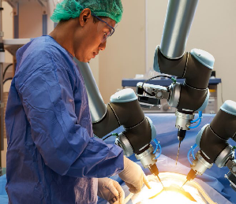**1.marathon 2.grid 3.surgeon 4.mortar 5.grocireies 6.Olympics**

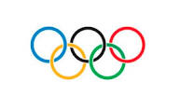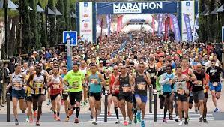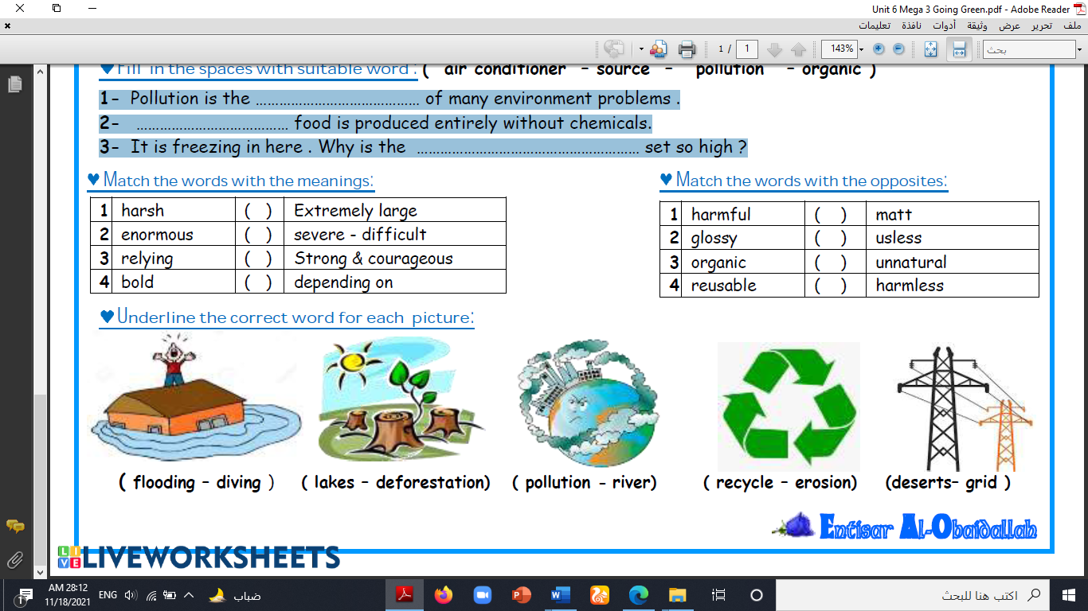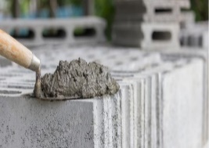

**( ) ( ) ( ) ( ) ( ) ( )**

**B- Match to form new words or expressions:**

**1. status ------ a. in a difficult situation**

**2. in a bind ------ b. state or condition**

**3. a hassle ------ c. Stop for a moment!**

**4. lodge ------ d. make a mistake**

**5. Hold on ------ e. something that is inconvenient to do**

**6. mess up ------ f. provide accommodation**

**End of Questions**

**Best of Luck** [**https://t.me/abokhaledamer**](https://t.me/abokhaledamer)

**المملكة العربية السعودية**

**Kingdom of Saudi Arabia**

**Ministry of Education**

**------- Educational Directorate**

**------- Future Educational Schools**

**2nd Grade High School 2022**

**2nd Term – Final Exam**

**وزارة التعليم**

**الإدارة العامة للتعليم بن**

**مدارس م ن التعليمية**

**الصف الثاني الثانوي**

**الاختبار النهائي للفصل الدراسي الثاني1445هـ**

|  |  |  |  |  |  |  |  |
| --- | --- | --- | --- | --- | --- | --- | --- |
| **Total**  **written** | **5**  **Vocabulary** | **4**  **Grammar** | **3**  **Free Composition** | **2**  **Guided Composition** | | **1 Comprehension** | **Q. NO.** |
|  |  |  |  |  | |  | **Mark Given** |
| **30** | **6** | **6** | **6** | **6** | | **6** | **Mark** |
| **6** | | | **Reviser** | |  | | **Corrector** |
|  | |

**زمن الاختبار: 3 ساعات**

**اسم الطالب: ------------------------------------ رقم الجلوس: ------------- الصف الثاني الثانوي**

**1.Comprehension**

**Read the following passage then answer the questions**

**Water is life and the lack of water means death. Any living thing cannot go on living without water. Plants need water to grow. Animals need water to drink. People need water to drink and to use in cleaning, cooking, farming and irrigating their lands. We can get water from rivers and lakes. But the main source of water is the rain.  In the desert, people dig deep wells to get water. For keeping water from being wasted, people build dams for storing water in reservoirs that form behind the dams. Water is stored in water towers that supply all the houses with pure water. Our government has set up desalination plants for treating seawater and removing the salt. Thanks be to God, the Merciful, who has created water for us. We don't need to pay for it as it is neither sold nor bought.**

**A) Answer the following questions:  
1. What does the lack of water mean?** ----- **It means death**. ---.

**2. Why do people need water?** -- **to drink and to use in cleaning, cooking, farming**--.

**3. What is the main source of water?**  ---- **the rain** ----.

**4. Who has created water for us?** ----- **God, the Merciful** ----.

**B) Put ( √ ) or ( X ):**

**5. Water is life and the lack of it means death. ( √ )**

**6.We cannot get water from rivers and lakes. (X)**

**7. We don't need to pay for water as it is neither sold nor bought. ( √ )**

**8. Water is stored in water towers that supply all the houses with pure water. (√)  
C) Complete:  
9. We can get pure water from** -- **rivers and lakes** --.

**10. A reservoir is formed** ---- **behind** --- **a dam:**

**D) Choose the correct answer:**

**11. Plants need water to (**wash – **grow** – remove – read**).**

**12. In the (farms** – deserts – cities – skies**), people dig deep wells for getting their water.**

**2) Guided Composition**

**6**

**There is no place like home**

**Write a paragraph about "Your Dream Home" in which you describe which kind of**

**home you want to live in, where, who live with…**

-------------------------------------------------------

-----------------------------------------------------------------------------------------------------------------------------------------------------------------------------------------------------------------------------------------------------------------------------------------------------------------------------------------------------------------------------------------------------------------------------------------------------------------------------------------------------------------------------------------------------------------------------------------------------------------------------------------------------------------------------------------------------------------------------------------------------------------------------------------------------------------------------------------------------------------------------------------------------------------------------------------------------------------------------------------------------------------------------------------------------------------------------------------------------------------------------------------------------------------------------------------------------------------------------------------------------------------------------------------------------------------------------------------------------------------------------------------------------------------------------------------------------------------------------------------------------------------------------------------------------------------------------------------------------------------------------------------------------------------------------------------------------------------------------------------------------------------------------------------------------------------------------------------------------------------------------------------------------------------------------------------------

**3) Free Composition**

**6**

**Choose one topic from the following to write about:**

**1. “Pollution” is a serious problem that we should try to eliminate.**

**2. Write a paragraph about "Your Favorite Sport"**

-------------------------------------------------------

---------------------------------------------------------------------------------------------------------------------------------------------------------------------------------------------------------------------------------------------------------------------------------------------------------------------------------------------------------------------------------------------------------------------------------------------------------------------------------------------------------------------------------------------------------------------------------------------------------------------------------------------------------------------------------------------------------------------------------------------------------------------------------------------------------------------------------------------------------------------------------------------------------------------------------------------------------------------------------------------------------------------------------------------------------------------------------------------------------------------------------------------------------------------------------------------------------------------------------------------------------------------------------------------------------------------------------------------------------------------------------------------------------------------------------------------------------

**4) Grammar**

**6**

**A: Choose the correct answer:**

**1. It is important that you (** played – plays – **play** – playing **) well.**

**2. I enjoy (** watch – to watch – watches – **watching ) TV.**

**3. I have two (large brown wooden**– brown large wooden– wooden brown large**) tables.**

**4. The film was** (**too** – enough – to – that**) boring to watch so we left the cinema early**

**5. ( Reading** – Read – Reads – Readed **) is my favorite hobby.**

**6. Who is the (** good – better – **best** –most **) football player you’ve ever seen?**

**B- Do as shown between brackets:**

**1. this afternoon – I want you – the report – to finish (**Unscramble**)**

---**I want you to finish the report this afternoon**. ----.

**2. to reuse – plastic – Don’t forget – containers** **(**Unscramble**)**

-------**Don't forget to refuse plastic containers**. --------.

**3. I bought (yellow – big – Japanese – expensive) car. (**Reorder the adjectives**)**

--------(**expensive, big, yellow, Japanese**) -------.

**4. She is tall to play basketball. (**Use**: enough)**

-------**She is tall enough to play** … ------------.

**5. It is interesting to play tennis. (**Rewrite using **“Gerund")**

-------**Playing tennis is interesting**. ------------.

**6. Nora is the most beautiful girl I (meet).**  (Correct in present perfect)

----------------**have met** ---------------.

**5) vocabulary:**

**6**

**A- Match the words with the pictures:**

**1.marathon 2.grid 3.surgeon 4.mortar 5.grocireies 6.Olympics**

********

**( 3 ) ( 4 ) ( 2 ) ( 4 ) ( 1 ) ( 6 )**

**B- Match to form new words or expressions:**

**1. status -b- a. in a difficult situation**

**2. in a bind -a- b. state or condition**

**3. a hassle -e- c. Stop for a moment!**

**4. lodge -f- d. make a mistake**

**5. Hold on -c- e. something that is inconvenient to do**

**6. mess up -d- f. provide accommodation**

**End of Questions**

**Best of Luck** [**https://t.me/abokhaledamer**](https://t.me/abokhaledamer)

|  |  |  |  |  |  |
| --- | --- | --- | --- | --- | --- |
| شعار وزارة التربية والتعليم بدون خلفية عالي الدقة.png Kingdom of Saudi Arabia English Language Final Listening Exam  Ministry of Education Grade: ___ (Model A)  ____________________ GSecondary.D. of Education School Term: Time: 25 minutes 2nd – 1445   |  |  |  |  | | --- | --- | --- | --- | | Mark out of  5 |  | _____________________________________  _____________________________________ | Graded by: | | Revised by: |     **اختبار استماع مادة )اللغة الإنجليزية 2.2 - الفصل الدراس ي الثاني ( للصف الثاني ثانوي - للعام الدراسي 1445هـ - نظام المسارات**  **اسـم الطالب : ____________________________________________________________ رقم الجلوس : ___________ اللجنة: ___________**  **رَ ِّبِ اشْرحَْ لِي صَدْرِي وَيَ ِّسِرْ لِي أَمْرِ ي** |
| |  | | --- | | Listen to the interview, and then answer the following questions |     1) **Choose the correct answer:**  (½ mark each)     1. The interviewer is talking to ___________Baker  |  |  |  |  |  |  |  |  | | --- | --- | --- | --- | --- | --- | --- | --- | | a- | chef | b- | teacher | c- | doctor | d- | worker | | **2)** | Maintaining body temperature is one of ___________ | | | | | |  | | a- | body function | b- | physical activity | c- | digesting food | d- | energy | | **3)** | Sports, manual work, or housework are examples of ___________ | | | | | |  | | a- | body function | b- | physical activity | c- | digestive food | d- | Physical Education |      1. **Match each activity with its used percentage:**  (½ mark each)      |  |  |  | | --- | --- | --- | | **Activity** |  | **Percentage** | | **1.** Body function ( | ) | a. 10% - 20% | | **2.** Physical activities ( | ) | b. 16% - 17% | | **3.** Digesting food ( | ) | 1. 20% - 30% 2. 60% - 70% |      1. **Put ( T ) for true or ( F ) for false sentences :** (½ mark each)      * 1. [_____] ¾ of our energy is used to keep the body working.   2. [_____] We get calories from food.   3. [_____] Energy is used only to eat.   4. [_____] We use more energy if we don't do any kind of physical activity.     Finished – Best Wishes  - Essa Al Hussaini -  to listen to / download the audio |

|  |
| --- |
| شعار وزارة التربية والتعليم بدون خلفية عالي الدقة.png Kingdom of Saudi Arabia English Language Final Listening Exam Ministry of Education Grade: ___ (Model A)  ____________________ GSecondary School.D. of Education Term: Time: 25 minutes 2nd – 1445      **اختبار استماع مادة )اللغة الإنجليزية 2.2 - الفصل الدراس ي الثاني ( للصف الثاني ثانوي**  **- للعام الدراسي 1445هـ - نظام المسارات** |
| Audio Script |
| **Energy our Bodies Use**    **Interviewer**: Dr Baker, can you tell us 20 to 30 percent of the total energy about the energy our bodies use? output of the body .  **Dr** **Baker**: Sure. Many people **Interviewer**: That leaves about don’t realize that most of the 10 to 20 per cent. How do we body’s energy– 60 to 70 per use that? cent – is used just for body  **Dr** **Baker**: That last 10 to  functions like heartbeat,  20 per cent of energy is  respiration, and used to digest food. maintaining body  temperature. **Interviewer**: So, we  use energy to eat? **Interviewer**: Really?  Almost three quarters of **Dr** **Baker**: Yes, to eat our energy is used just to keep the and to digest our food. body working?  **Interviewer**: Right. Where does our **Dr** **Baker**: That’s right. Of course, if we energy come from? do any kind of physical activity, we  **Dr** **Baker**: Mainly from calories, which  use more energy. I’m thinking of we get from different types of food. things like sports, manual work, or housework. This represents another Interviewer: That’s very interesting. What ….      Finished  –    Best Wishes    -    Essa Al Hussaini  -    to listen to / download the audio |